**Bug Report**

**Bug ID**:  
001-TENDABLE-CONTACT-FORM

**Title**:  
"Contact" form does not display an error message when the "Message" field is left empty.

**Summary**:  
During testing of the "Contact" form on the Tendable website, it was observed that no error message is displayed when the "Message" field is left blank and the form is submitted. It’s showing error message at end that is “Form Submission Failed”. It’s not showing due to which field it’s failed. This behaviour violates standard form validation expectations and can result in incomplete.

**Steps to Reproduce**:

1. Navigate to the Tendable website: <https://www.tendable.com/>.
2. Go to the "Contact" section.
3. Fill out all required fields except the "Message" field:
   * Email: john.doe@example.com
   * First Name: John
   * Last Name: Doe
   * Company: xyz technologies, Ltd
   * Select **"Marketing"** from the dropdown.
4. Click the **Submit** button.
5. Bug No Error Message screenshot

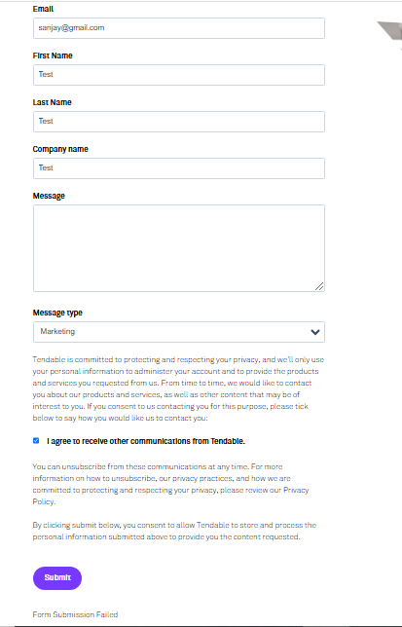

**Expected Result**:  
An error message should appear indicating that the "Message" field is required (e.g., "Please fill out this field.").

**Actual Result**:  
No error message is displayed for “Message” filed, and the form submission fails silently.

**Impact**:

1. Users may submit incomplete or irrelevant information.
2. Form validation inconsistency could negatively affect user experience.
3. Potential loss of leads due to lack of form completion enforcement.

**Test Environment**:

* **Browser**: Google Chrome 117.0.5938.92
* **OS**: Windows 11
* **Test URL**: https://www.tendable.com/contact-us
* **Selenium Version**: 4.4.0
* **TestNG Version**: 7.10.2

**Attachments**:

1. **Steps to reproduce** (with screenshots).
2. **Test Automation Script** (ContactUsFormTest.java).
3. Screenshot of the missing error message after submission (attached as Bug_NoErrorMessage.png).

**Severity**:  
Medium

**Priority**:  
High

**Proposed Solution**:  
Implement client-side or server-side validation for the "Message" field to ensure it cannot be left empty. An appropriate error message should be displayed when the field is blank.

**Reported By**: Sanjay (QA)

**Date**: 25/11/2024

**Assigned To**: Santosh (Developer)

**Status**: Open