Operating Systems Lab - Day 1
Program vs Process, PID/PPID, and Linux /proc Observation
Goal | Observe how a program becomes a live process and inspect it through Linux tools.
Lab focus | Practical-first learning using C, ps, pstree, and /proc.

Lesson flow: setup -> main experiment -> output observation -> internal OS explanation -> embedded mapping -> debugging -> interview practice

1. Topic
- Program vs Process, PID/PPID, and observing a running process through Linux.

2. Practical setup needed
- Ubuntu/Linux terminal
- gcc
- ps
- cat
- /proc
- top or htop
Quick verification commands:
gcc --version
ps --version
top -v

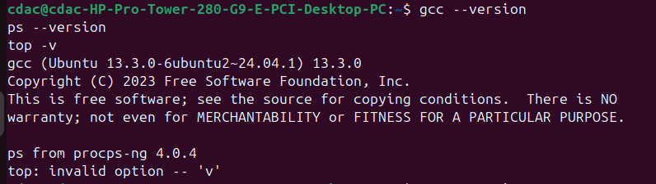

not top -v it should be top -V
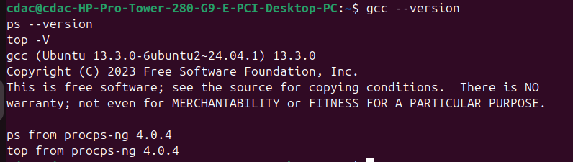

3. Main experiment
Create a simple C program that prints its PID, PPID, variable addresses, and then sleeps long enough for inspection from a second terminal.
Objective | Understand how Linux turns a disk file into a managed process with identity, memory layout, and observable kernel state.

4. Hands-on experiment

Step 1: Create the C program
nano process_observe.c
See in this repo:

EmbeddedWorld/EmbeddedLinux/os_lab/week1/day1$

Step 2: Compile
gcc -Wall -o process_observe process_observe.c

Step 3: Run it
./process_observe

Expected style of output:

1st run:

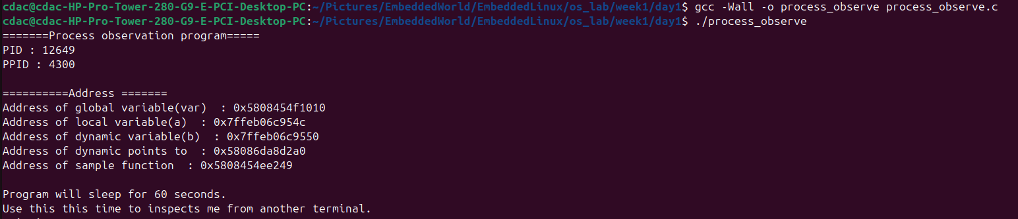
2nd run:

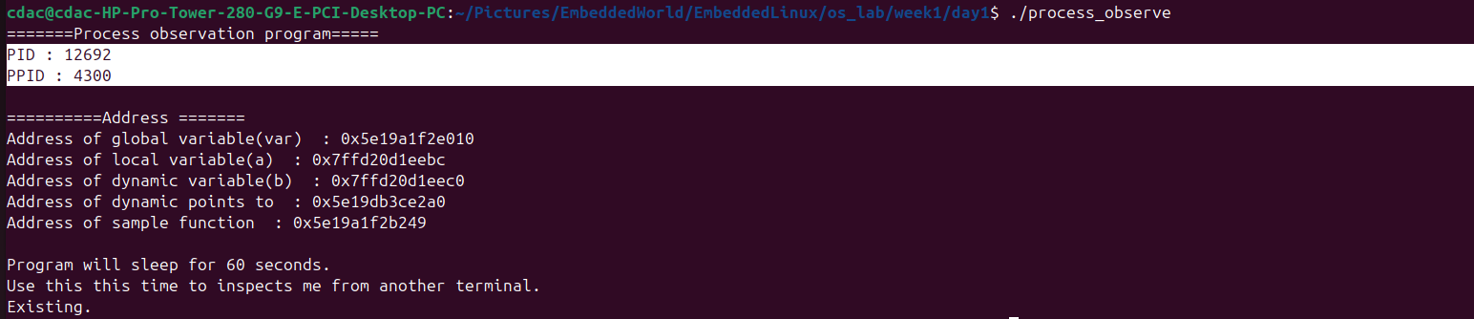

Note:
1. observe that 1st and 2nd run PID is different different and PPID is same.
2. Observation- at multiple times run (Address of global variable(var), Address of dynamic points to, Address of dynamic points to) always same others are different

Address of global variable(var) : 0x5f98ca984010
Address of local variable(a) : 0x7ffef4c65aac
Address of dynamic variable(b) : 0x7ffef4c65ab0
Address of dynamic points to : 0x5f98eb2e12a0
Address of sample function : 0x5f98ca981249

- global variable → data segment
- local variable → stack
- malloc memory → heap
- function address → code/text section

Step 4: Predict before explanation
- Is process_observe still just a file, or is it now a process?
- Why does it have a PID?
- Why is the local variable address different from the global variable address?
- Why is the heap address different from the stack-like local variable address?
- Why does Linux allow us to inspect it from outside?

Step 5: Inspect from another terminal

A. Check the process using ps
ps -p 13218 -f

1. when code run
2. after exit

B. View process tree
pstree -p | grep process_observe

C. Read process status
cat /proc/13399/status

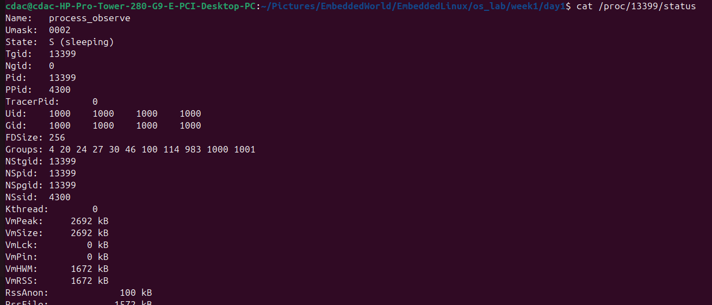

What to observe carefully
- State may show S = sleeping
- Threads is likely 1
- memory values exist even for this tiny program

D. Read memory map
cat /proc/13515/maps

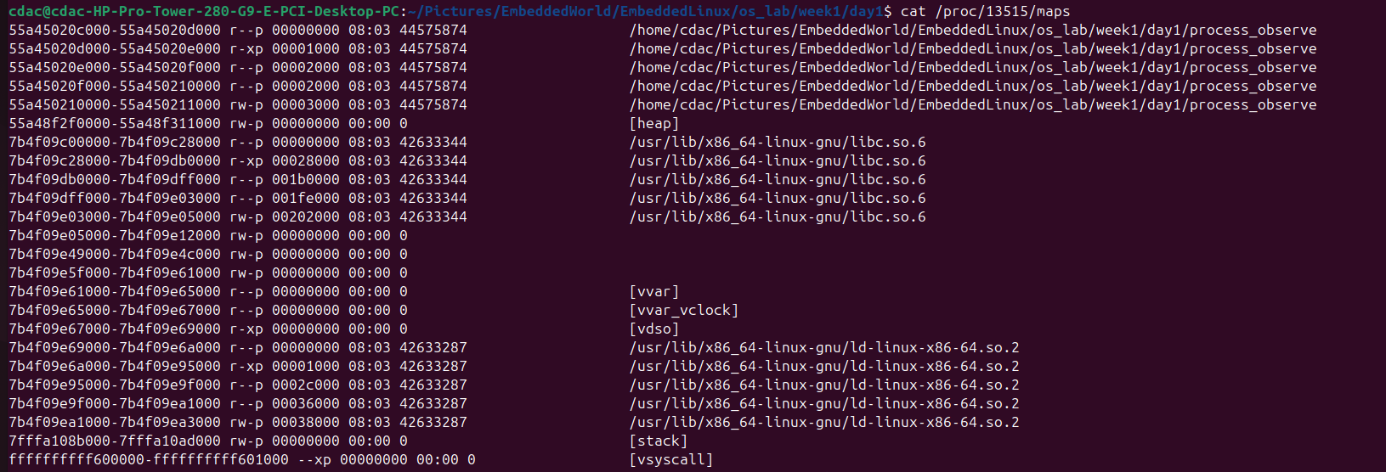
Look for words like:
- your binary name
- [heap]
- [stack]

5. What to observe carefully
Observation point | Why it matters
PID and PPID | Show process identity and parent-child relation.
State in /proc/13399/status | Confirms whether the process is sleeping, running, or blocked.
[heap] and [stack] in /proc/13515/maps | Shows the process is not one flat memory blob.
Threads count | A simple program usually starts with one thread.
VmSize and VmRSS | Shows allocated virtual memory versus resident physical memory.

6. What is happening internally
Program vs process: the file on disk is passive; once executed it becomes an active process managed by the kernel.
Linux creates a process control structure, assigns a PID, sets up the virtual address space, loads code and data, prepares the stack, and starts execution at the entry point.
Different addresses come from different regions: function -> code/text, global variable -> data segment, local variable -> stack, malloc allocation -> heap.
The /proc filesystem is virtual. Its contents are generated by the kernel when you read them, not stored as normal text files on disk.

7. Why OS needs this concept
Without a process abstraction, the operating system could not manage CPU time, memory, resource ownership, isolation, or clean termination.
Process abstraction allows scheduling, protection, accounting, and debugging.

8. Real-world system scenario
On a Linux machine, a browser, terminal, editor, logger, and updater can all run as separate processes. The OS tracks and controls each independently.

9. Embedded systems parallel
Bare-metal MCUs usually run one firmware image with one primary execution flow.
RTOS systems usually run multiple tasks/threads, often sharing one address space with separate stacks.
Embedded Linux systems commonly run multiple processes such as sensor daemons, loggers, communication services, and watchdogs.

10. Common bug or failure scenarios
Output buffering can make it look like the process did not print anything even though it ran.
If the program exits too quickly, ps or /proc inspection may fail because the process is already gone.
Assuming all variables live close together in memory is a mistake because different regions serve different purposes.
If the parent exits early, the PPID relationship may change because the process can be re-parented.

11. Debugging approach
First confirm the process exists using ps.
Then inspect state using /proc/<pid>/status.
Inspect memory layout using /proc/<pid>/maps.
Use pstree to verify parent-child relationships and top/htop for live behavior.

12. Interview questions
- What is the difference between a program and a process?
- What are PID and PPID?
- Why does a process need its own memory layout?
- What are stack, heap, data segment, and code segment?
- What is /proc in Linux?
- Is /proc/<pid>/status a normal file?
- Why is process abstraction important in OS?
- How is a Linux process different from an RTOS task?
- Why is the local variable address typically different from the global variable address?
- Why is observing a sleeping process useful for learning OS?

13. Small exercise for you
- Change the sleep time from 60 to 120 seconds and repeat the inspection.
- Add one more global variable and one more local variable, then compare their addresses.
- Create a second malloc allocation and compare both heap addresses.
- While the program is sleeping, run ls -l /proc/<PID>/fd and inspect file descriptors.
- Run the same program twice in different terminals and compare PID, PPID, and memory addresses.

14. Mini prediction task
Question | Your prediction
Will two runs have the same PID? | No
Will two runs have the same stack address? | Yes
Will two runs have the same heap address? | No
Will the parent PID always be the same? | Yes

15. Short recap
- A program is a file on disk; a process is its running instance.
- A process gets PID and PPID for identity and lineage.
- Memory is organized into regions such as code, data, heap, and stack.
- Linux exposes process internals through the virtual /proc filesystem.
- This observation-based model maps strongly to embedded Linux and partly to RTOS task thinking.

Daily debugging task
Run the program and inspect it before it exits using:
ps -p <PID> -f
cat /proc/<PID>/status
cat /proc/<PID>/maps
ls -l /proc/<PID>/fd

Then answer:
1. What state did you see?
2. Did you find [heap] and [stack]?
3. What was the PPID?
4. Why is /proc useful?

