Operating Systems Lab — Day 2
System calls in practice: observing printf, write, sleep, and exit using strace
Lab focus | Primary tools | Embedded mapping
Practical-first OS learning | gcc, strace, ps, /proc | User space vs kernel and RTOS service APIs

1. Topic
Today you will learn one of the most important OS ideas: your C program usually interacts with the operating system through system calls. We will start by observing that boundary directly instead of memorizing definitions first.

2. Practical setup needed
Create the working directory and confirm the required tools are available.
~/Pictures/EmbeddedWorld/EmbeddedLinux/os_lab/week1/day2
gcc --version
strace -V

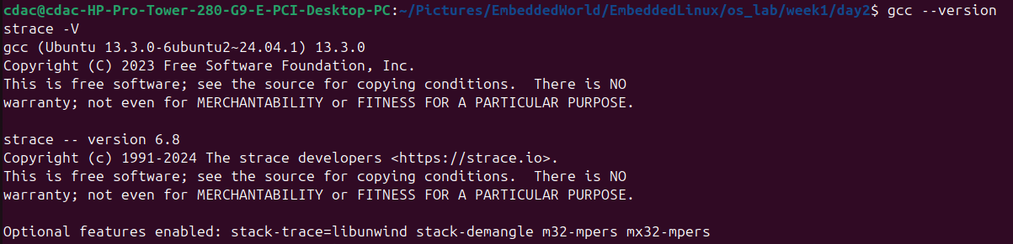
If strace is missing:
sudo apt update
sudo apt install strace

3. What we will observe practically today
- printf() is not itself a system call.
- write() maps much more directly to kernel interaction.
- sleep() causes a process to block instead of continuously using CPU.
- exit() ends the process through the kernel-managed termination path.
- Even a tiny C program can trigger many kernel interactions.

4. Hands-on experiment

Experiment 1 — printf() vs write()

Objective
Observe the difference between a C library function, printf(), and a lower-level output path using write().

Step 1: Create the program
gedit Experiment1.c

#include <stdio.h>
#include <unistd.h>
#include <string.h>
int main() {
printf("Hello from printf\n");
const char *msg = "Hello from write\n";
write(1, msg, strlen(msg));
return 0;
}

Step 2: Compile
gcc -Wall -o Experiment1 Experiment1.c

Step 3: Run normally
./Experiment1

Expected output:
Hello from printf
Hello from write

Step 4: Trace it with strace
strace ./Experiment1

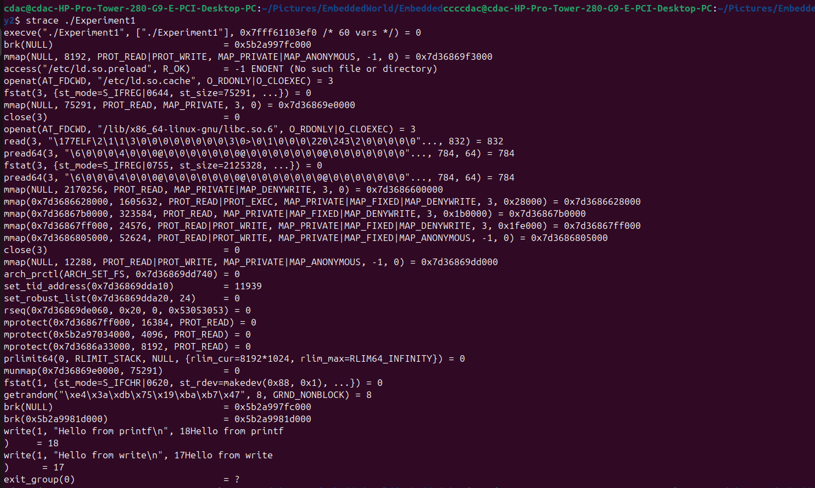
Look mainly for execve(...), write(...), and exit_group(...). You may see multiple setup calls before the actual write calls because the process and runtime environment must be prepared first.

Step 5: Trace only write-related calls
strace -e write ./syscall_demo1

Typical style of output:
write(1, "Hello from write\n", 17) = 17
write(1, "Hello from printf\n", 18) = 18
+++ exited with 0 +++

What to observe carefully
- You wrote one printf() in source code.
- You do not see printf() as a system call in strace output.
- You do see write().
- That means printf() is a user-space library function that may eventually call write().

Experiment 2 — Buffered output behavior

Objective
Understand why printf() and write() may appear to behave differently at runtime.

Step 1: Create the second program
gedit Experiment2.c

#include <stdio.h>
#include <unistd.h>
int main() {
printf("A");
sleep(5);
write(1, "B\n", 2);
return 0;
}

Step 2: Compile and run
gcc -Wall -o Experiment2 Experiment2.c
./Experiment2

Predict before running: will you see A immediately, or only after five seconds? In many terminal cases, A does not appear immediately because printf("A") may remain buffered.

Step 3: Fix buffering with newline
#include <stdio.h>
#include <unistd.h>
int main() {
printf("A\n");
sleep(5);
write(1, "B\n", 2);
return 0;
}

With the newline, A is much more likely to appear immediately because terminal output through printf() is often line buffered.

Experiment 3 — Observe sleep() as blocking behavior

Objective
See that a process can be alive but not actively consuming CPU because it is blocked or sleeping.

Step 1: Create the program
edit Experiment3.c

#include <stdio.h>
#include <unistd.h>
int main() {
printf("PID: %d\n", getpid());
printf("Going to sleep for 20 seconds...\n");
sleep(20);
printf("Woke up and exiting.\n");
return 0;
}

Step 2: Compile
gcc -Wall -o Experiment3 Experiment3.c

Step 3: Run it
./Experiment3

While it is sleeping, open another terminal and run:
ps -p 18577 -o pid,ppid,stat,comm

Typical style:
PID PPID STAT COMMAND
4321 4000 S syscall_demo3

After sleep completed-
ps -p 18577 -o pid,ppid,stat,comm

The S state indicates the process exists but is sleeping or blocked.

Step 4: Trace sleep-related calls
strace ./Experiment3
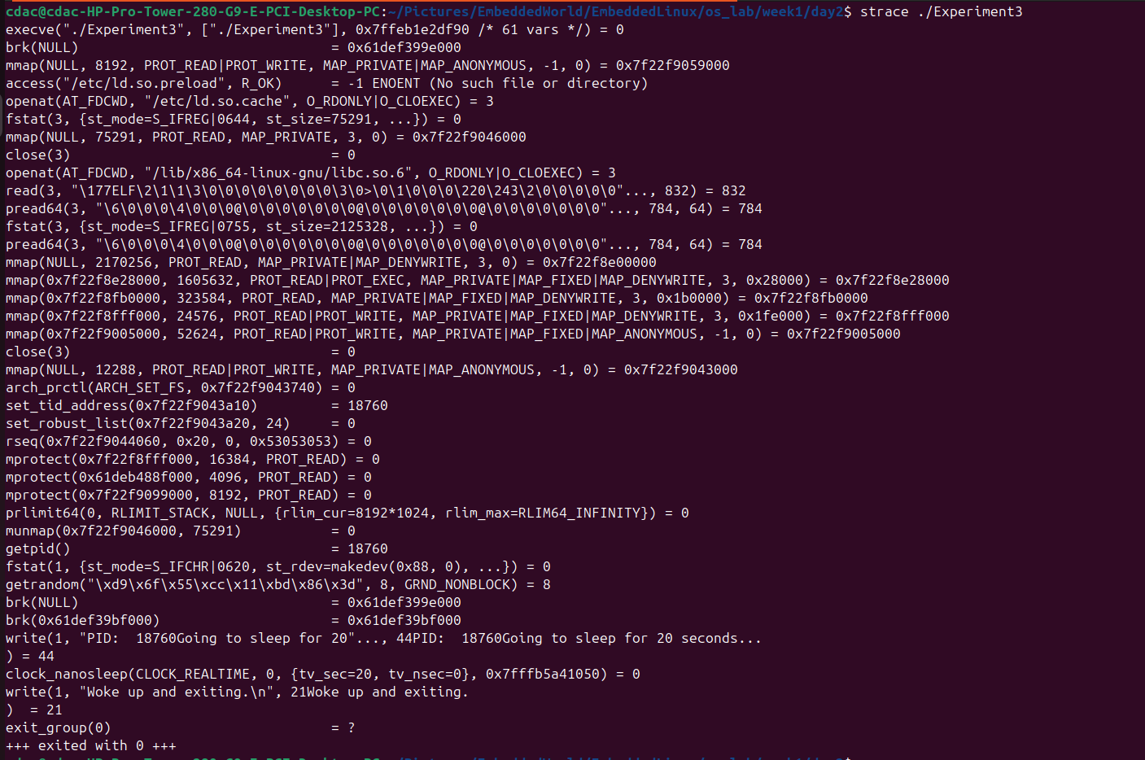
Look for nanosleep(...) or clock_nanosleep(...), depending on your libc and kernel combination.

Step 5: Check status during sleep
cat /proc/18898/status

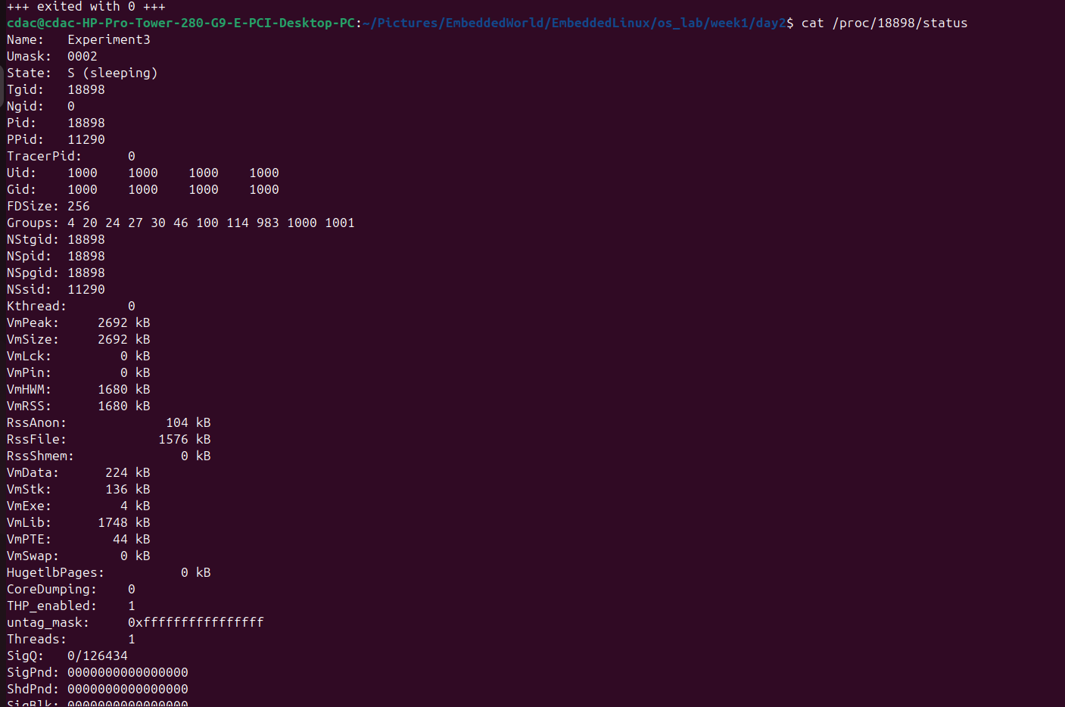
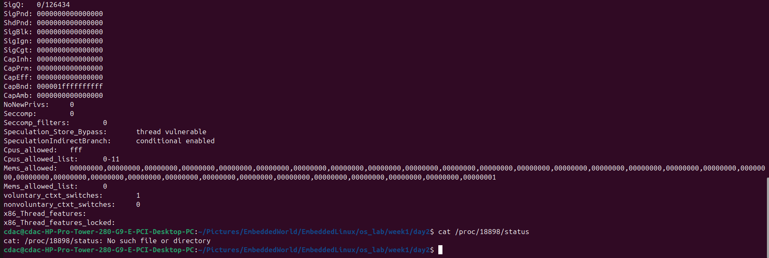

Look for a state line similar to: State: S (sleeping).

— Observe the exit path

Objective
See how return 0 from main eventually becomes process termination.

Step 1: Trace exit only
strace -e exit_group ./Experiment3

Typical style:
exit_group(0) = ?
+++ exited with 0 +++

5. Output observation
- Function names in source code do not always appear as syscalls.
- printf() is generally library-level behavior.
- write() is directly visible in syscall traces.
- sleep() moves a process into a sleeping or blocked state.
- return 0 leads to kernel-managed process termination.

6. What is happening internally
A system call is the controlled interface through which a user-space program requests kernel services. The kernel does not know printf(); it knows lower-level operations such as write(). printf() belongs to the C library and performs formatting and buffering before eventually using a syscall when needed. When a process calls sleep(), the scheduler can mark it non-runnable for a duration so the CPU can be used by other tasks.

7. Why OS needs this concept
Without a syscall interface, user programs would require uncontrolled direct access to devices, memory, timers, and process control. That would break protection, stability, fairness, and security. System calls enforce a clear boundary: user programs request services, and the kernel decides how those services are carried out.

8. Real-world system scenario
A Linux logging application may call fprintf() or printf()-like routines, but the actual file or terminal output ultimately reaches the kernel through write()-style system calls. An application waiting for a timeout or a device response may block in a sleep or read call, allowing the scheduler to run other processes efficiently.

9. Embedded systems parallel
- Bare-metal embedded systems often use direct register access, polling, and interrupts instead of a full syscall boundary.
- RTOS environments provide OS services through APIs such as delays, queues, mutexes, and semaphores.
- Embedded Linux uses a strong user-space to kernel boundary, so system call understanding becomes directly useful for driver and application debugging.

10. Common bug/failure scenario
- Output does not appear immediately because stdio buffering delayed printf().
- A developer assumes printf() itself is a syscall.
- A process is alive but seems idle because it is blocked in sleep(), read(), or another waiting syscall.
- A program seems hung, and the missing insight is simply the last syscall it entered.

11. Debugging approach
When a Linux program behaves strangely, use strace first. It helps reveal whether the program is writing, waiting, opening files, blocking on I/O, or repeatedly failing a syscall.
strace ./program
strace -e write,read,open,close ./program
strace -p <PID>
ps -p <PID> -o pid,ppid,stat,comm
cat /proc/<PID>/status

12. Mini task
Create syscall_demo4.c with this behavior: print PID, print one line using printf(), print one line using write(), sleep for ten seconds, then exit. Compile and run it, trace it, inspect its process state, and answer which operations appeared directly as syscalls.
gcc -Wall -o Demo Demo.c
./Demo
strace ./Demo
ps -p <PID> -o pid,ppid,stat,comm
cat /proc/<PID>/status

Program:
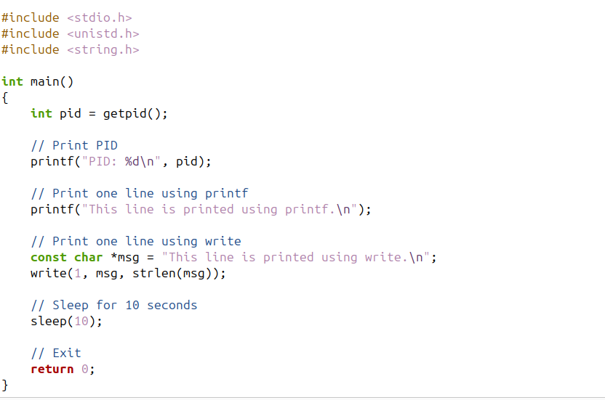

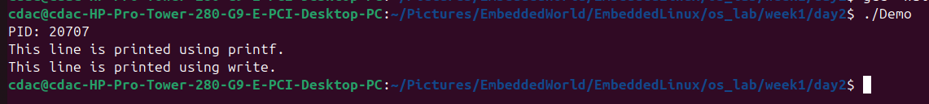
15. Short recap
Today you learned practically that user programs interact with the kernel through system calls, printf() is a library function rather than a syscall, write() is directly visible in syscall traces, sleep() blocks a process without continuously consuming CPU, and strace is one of the most useful debugging tools for understanding real Linux process behavior.

