Project Overview
This project involves an in-depth exploratory data analysis of a pizza restaurant's sales records to uncover actionable business intelligence. The primary objective is to evaluate overall business performance by calculating core Key Performance Indicators (KPIs) such as total revenue, average order value, and total sales volume. Furthermore, the analysis identifies customer purchasing patterns, including temporal sales trends (daily and monthly), category and size preferences, and the best- and worst-performing menu items. These insights provide a data-driven foundation for optimizing menu offerings, refining inventory management, and targeting marketing strategies.

Dataset Summary
The analysis is based on the pizza_sales.csv dataset, which contains granular, transaction-level records of pizza orders. Based on the executed SQL queries, the dataset features the following primary attributes:

- order_id: A unique identifier for each distinct customer order.
- order_date: The date the transaction occurred, utilized to track daily and monthly seasonal trends.
- quantity: The number of pizzas purchased in a specific order line item.
- total_price: The total monetary value/revenue generated from the specific pizzas sold.
- pizza_category: The menu classification for the pizza, divided into Classic, Supreme, Chicken, and Veggie.
- pizza_size: The size of the pizza ordered, ranging from Small (S) to Extra-Extra-Large (XXL).
- pizza_name: The specific recipe/name of the pizza (e.g., The Thai Chicken Pizza, The Brie Carre Pizza).

Key Findings

High-Level KPIs
- Total Revenue: $817,860.05
- Total Orders: 21,350 orders resulting in 49,574 total pizzas sold.
- Average Order Value: $38.31, with customers ordering an average of 2.32 pizzas per transaction.

Sales Trends & Customer Preferences

- Busiest Times: Order volume peaks late in the week, specifically on Fridays (3,538 orders) and Thursdays (3,239 orders). July is the strongest month for overall sales.
- Category Breakdown: The "Classic" category is the most popular, generating 26.91% of total revenue, closely followed by the "Supreme" category at 25.46%.
- Size Preferences: Large (L) pizzas overwhelmingly dominate customer preference, accounting for 45.89% of all revenue, while XXL pizzas make up a negligible 0.12%.

Menu Performance

- Top Performers: "The Thai Chicken Pizza" is the highest revenue generator ($43,434.25), while "The Classic Deluxe Pizza" is the most ordered item by both raw quantity (2,453) and total distinct orders (2,329).
- Bottom Performers: "The Brie Carre Pizza" is consistently the lowest-performing item across all metrics, bringing in only $11,588.50 in revenue and selling just 490 units

PIZZA SALES SQL QUERIES
A. KPI’s
1. Total Revenue:
SELECT SUM(total_price) AS Total_Revenue FROM pizza_sales;
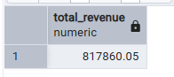
2. Average Order Value
SELECT CAST(CAST(SUM(total_price) AS DECIMAL(10,2)) /
CAST(COUNT(DISTINCT order_id) AS DECIMAL(10,2))
AS DECIMAL(10,2)) AS Avg_Pizzas_per_order
FROM pizza_sales;
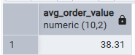
3. Total Pizzas Sold
SELECT SUM(quantity) AS Total_pizza_sold FROM pizza_sales;
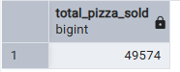
4. Total Orders
SELECT COUNT(DISTINCT order_id) AS Total_Orders FROM pizza_sales;
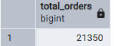
5. Average Pizzas Per Order
SELECT CAST(CAST(SUM(quantity) AS DECIMAL(10,2)) /
CAST(COUNT(DISTINCT order_id) AS DECIMAL(10,2)) AS DECIMAL(10,2))
AS Avg_Pizzas_per_order
FROM pizza_sales;
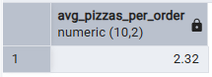

B. Visuals
1. Daily Trend for Total Orders
SELECT TO_CHAR( Order_date, 'DAY') AS order_day, COUNT(DISTINCT order_id) AS total_orders
FROM pizza_sales
GROUP BY TO_CHAR( Order_date, 'DAY');
Output:
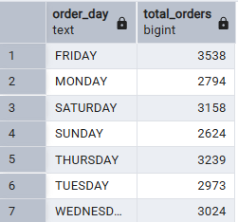
2. Monthly Trend for Orders
SELECT TO_CHAR( Order_date, 'MONTH') AS order_day,
COUNT(DISTINCT order_id) AS total_orders
FROM pizza_sales
GROUP BY TO_CHAR( Order_date, 'MONTH');
Output
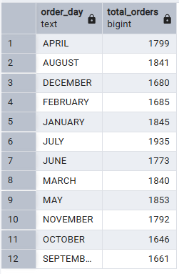
3. % of Sales by Pizza Category
SELECT pizza_category,
CAST(SUM(total_price) AS DECIMAL(10,2)) as total_revenue,
CAST(SUM(total_price) * 100 / (SELECT SUM(total_price) from pizza_sales) AS DECIMAL(10,2)) AS PCT
FROM pizza_sales
GROUP BY pizza_category;
Output
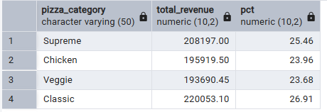
4. % of Sales by Pizza Size
SELECT pizza_size,
CAST(SUM(total_price) AS DECIMAL(10,2)) as total_revenue,
CAST(SUM(total_price) * 100 / (SELECT SUM(total_price) from pizza_sales) AS DECIMAL(10,2)) AS PCT FROM pizza_sales
GROUP BY pizza_size
ORDER BY pizza_size;
Output
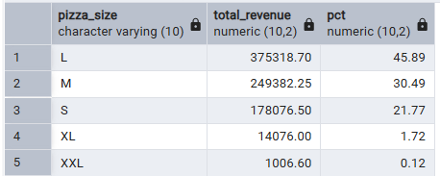
5. Total Pizzas Sold by Pizza Category
SELECT pizza_category, SUM(quantity) as Total_Quantity_Sold
FROM pizza_sales
WHERE EXTRACT(MONTH FROM order_date) = 1
GROUP BY pizza_category
ORDER BY Total_Quantity_Sold DESC;
Output
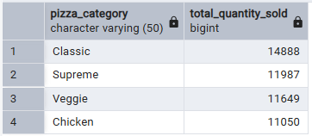
6. Top 5 Pizzas by Revenue
SELECT pizza_name, SUM(total_price) AS Total_Revenue
FROM pizza_sales
GROUP BY pizza_name
ORDER BY Total_Revenue DESC
LIMIT 5;
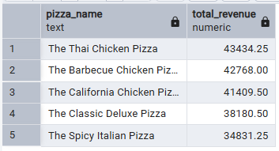
7. Bottom 5 Pizzas by Revenue
SELECT pizza_name, SUM(total_price) AS Total_Revenue
FROM pizza_sales
GROUP BY pizza_name
ORDER BY Total_Revenue ASC;
LIMIT 5;
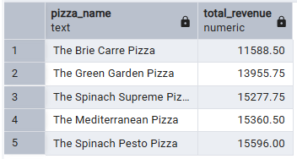
8. Top 5 Pizzas by Quantity
SELECT pizza_name, SUM(quantity) AS Total_Pizza_Sold
FROM pizza_sales
GROUP BY pizza_name
ORDER BY Total_Pizza_Sold DESC
LIMIT 5;
Output
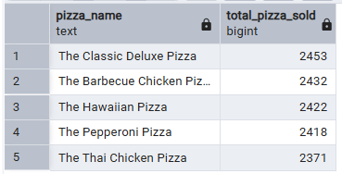
9. Bottom 5 Pizzas by Quantity
SELECT pizza_name, SUM(quantity) AS Total_Pizza_Sold
FROM pizza_sales
GROUP BY pizza_name
ORDER BY Total_Pizza_Sold ASC
LIMIT 5;
Output
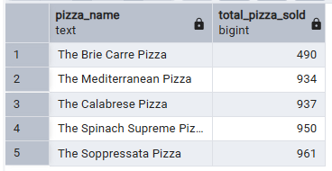
10. Top 5 Pizzas by Total Orders
SELECT pizza_name, COUNT(DISTINCT order_id) AS Total_Orders
FROM pizza_sales
GROUP BY pizza_name
ORDER BY Total_Orders DESC
LIMIT 5;

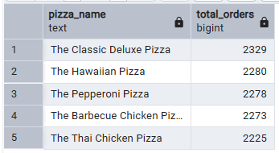
11. Bottom 5 Pizzas by Total Orders
SELECT pizza_name, COUNT(DISTINCT order_id) AS Total_Orders
FROM pizza_sales
GROUP BY pizza_name
ORDER BY Total_Orders ASC
Limit 5;
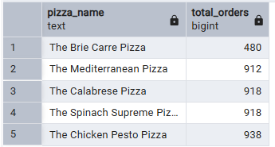
NOTE
If you want to apply the pizza_category or pizza_size filters to the above queries you can use WHERE clause. Follow some of below examples
SELECT pizza_name, COUNT(DISTINCT order_id) AS Total_Orders
FROM pizza_sales
WHERE pizza_category = 'Classic'
GROUP BY pizza_name
ORDER BY Total_Orders ASC
LIMIT 5;

