Physiological Changes in a Mother’s Body During Pregnancy

By

Harshini Srividya P

Bonafide certicate

Acknowlegement

Introduction 1
What is Pregnancy? 3
Hormonal Changes During Pregnancy 4
Physical (External) Changes 6
Internal Organ Changes 8
Trimester-wise Changes 10
Changes in Major Body Systems 12
Conclusion 20
Bibliography 22

Introduction

Pregnancy is one of the most significant and complex
biological processes in the human life cycle. It marks the
period during which a fertilised ovum develops into a fully
formed baby inside the uterus of a woman. This process
involves not only the growth of the fetus but also
extensive changes in the mother’s body to provide
nutrition, oxygen, protection, and a suitable environment
for development.

From the moment fertilisation occurs, the female body
begins to undergo remarkable adjustments. Hormones are
released in large quantities, organs shift their position,
metabolism increases, and emotional responses change.
These changes are not random but are carefully regulated
by the endocrine and nervous systems. Every organ
system—circulatory, respiratory, digestive, excretory,
skeletal, and nervous—participates in maintaining a
healthy pregnancy.

Understanding the physiological changes during
pregnancy is important not only from an academic
perspective but also for creating awareness about
maternal health. Knowledge of these changes helps in
early identification of complications, ensures proper
prenatal care, and promotes the well-being of both
mother and child. Hence, pregnancy is not just a
reproductive event but a highly coordinated biological
phenomenon.

What is Pregnancy?

Pregnancy is defined as the condition in which a woman carries a developing embryo or fetus within her uterus after fertilisation. Fertilisation occurs when a male gamete (sperm) fuses with a female gamete (ovum) in the fallopian tube, forming a zygote. This zygote undergoes repeated cell divisions and implants itself into the uterine wall, marking the beginning of pregnancy.

The total duration of pregnancy is approximately 40 weeks or 280 days, calculated from the first day of the last menstrual cycle. For better understanding and medical monitoring, pregnancy is divided into three trimesters, each lasting about three months. Each trimester represents a specific phase of fetal development and is associated with distinct physiological changes in the mother.

During pregnancy, the placenta develops as a vital organ that connects the fetus to the mother. It allows the exchange of nutrients, oxygen, and waste materials between maternal and fetal blood without mixing them directly.

Hormonal Changes During Pregnancy

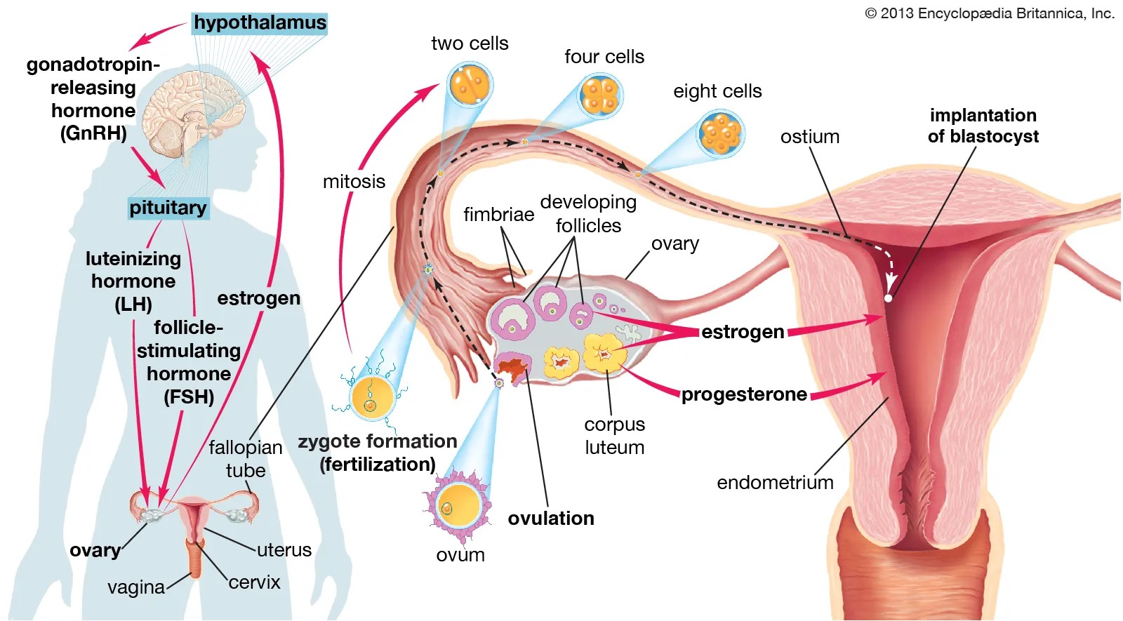
Hormones play a central role in maintaining pregnancy and regulating the changes occurring in the mother’s body. Pregnancy is characterised by a dramatic increase in the secretion of several hormones produced by the ovaries, placenta, and pituitary gland. These hormones ensure proper implantation, fetal growth, and preparation for childbirth.

Progesterone is one of the most important pregnancy hormones. It helps maintain the uterine lining, prevents premature uterine contractions, and supports the attachment of the embryo. Progesterone also relaxes smooth muscles, which affects digestion and causes constipation.

Estrogen promotes the growth of the uterus and increases blood flow to maternal organs. It also stimulates breast development and enhances the growth of milk ducts. Estrogen contributes to skin pigmentation and vascular changes during pregnancy.

Human Chorionic Gonadotropin (hCG): is secreted by the developing placenta and is responsible for maintaining the corpus luteum during early pregnancy. It prevents menstruation and is the hormone detected in pregnancy test kits.

Prolactin: prepares the mammary glands for milk production after childbirth, while Oxytocin plays a vital role during labor by stimulating uterine contractions and later aiding in milk ejection during breastfeeding.

These hormonal fluctuations also influence the emotional state of the mother, leading to mood swings, fatigue, and increased sensitivity.

Physical (External) Changes

As pregnancy progresses, several visible physical changes
occur in the woman’s body. The most noticeable change is
the gradual enlargement of the abdomen due to the
growing uterus and fetus. This change becomes more
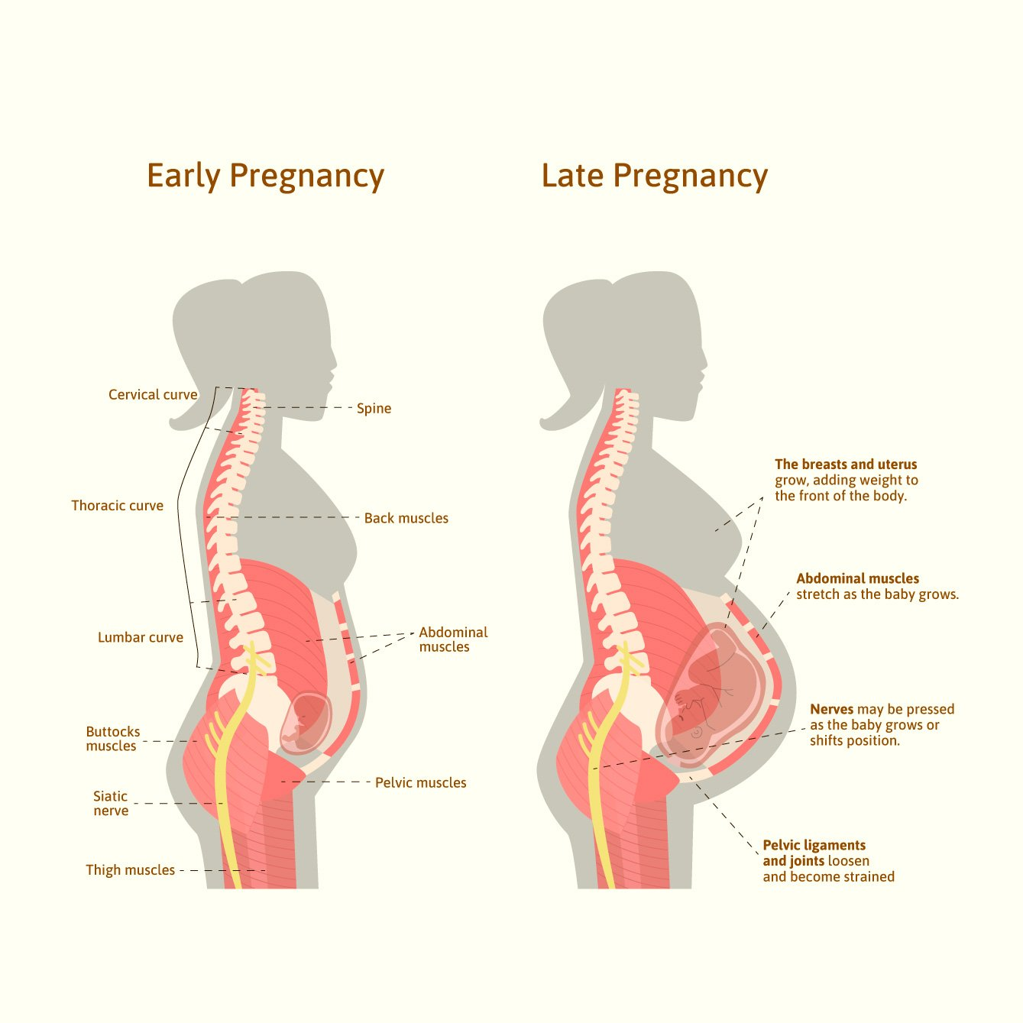
prominent during the second and third trimesters.

The breasts increase in size and become tender as
mammary glands develop in preparation for lactation. The
nipples and areola darken due to increased melanin
deposition under the influence of hormones. Veins on the
breast surface may also become more visible.
Weight gain is a normal and essential part of pregnancy,
as it includes the weight of the fetus, placenta, amniotic
fluid, and increased blood volume. Stretch marks may
appear on the abdomen, thighs, hips, and breasts due to
stretching of the skin.
Swelling of feet and hands, known as edema, occurs due
to fluid retention and pressure on blood vessels. Changes
in hair growth, skin pigmentation, and nail texture are also
commonly observed.

Internal Organ Changes

Pregnancy causes major internal adjustments to meet the
increased metabolic demands of the mother and fetus.
The uterus undergoes the most dramatic change,
enlarging up to twenty times its normal size to
accommodate the growing baby.

The heart increases its pumping capacity, and blood
volume rises significantly to supply oxygen and nutrients
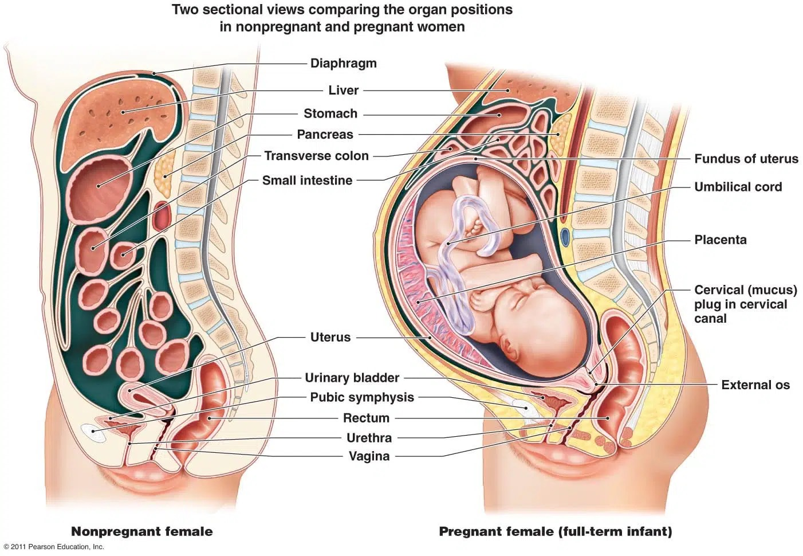
to the placenta. This increased workload may cause mild

breathlessness.
The lungs adapt by increasing respiratory rate and oxygen
intake. The kidneys filter more blood, leading to increased
urine production. Digestive organs such as the stomach
and intestines are displaced due to the expanding uterus,
often resulting in indigestion and constipation.

These internal changes demonstrate how the body
prioritises fetal development while maintaining maternal
health.

Trimester-wise Changes

First Trimester (0–3 months)

The first trimester is a critical period marked by
implantation and organ formation. Hormonal changes are
intense, leading to nausea, vomiting, fatigue, and mood
swings. Major organs such as the heart, brain, and limbs
of the embryo begin to form during this stage.

Second Trimester (4–6 months)

The second trimester is often considered the most
comfortable phase. Fetal movements are felt, the
abdomen becomes visibly enlarged, and energy levels
improve. Rapid growth and differentiation of fetal organs
occur during this period.

Third Trimester (7–9 months)

The third trimester involves rapid fetal growth and
maturation of organs. The mother may experience
discomfort, back pain, and frequent urination. The body
prepares for childbirth through hormonal changes and
uterine contractions.

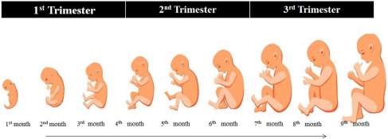

Changes in Major Body Systems

During pregnancy, the mother’s body undergoes extensive
changes in various organ systems to meet the increased
metabolic demands of the growing fetus. These
adaptations ensure adequate supply of oxygen, nutrients,
and energy while also preparing the body for childbirth.
The major body systems affected during pregnancy are
discussed below in detail.

- Circulatory System

The circulatory system shows some of the most significant
changes during pregnancy. The total blood volume in the
mother’s body increases by about 30–50%, which helps
in supplying sufficient oxygen and nutrients to the fetus
through the placenta. This increase also acts as a
protective mechanism to compensate for blood loss
during childbirth.
The heart works harder to pump the increased volume of
blood, leading to a rise in heart rate and cardiac output.
As a result, some women may experience mild
palpitations or fatigue. Blood pressure may slightly
decrease during early pregnancy due to hormonal effects
but usually returns to normal later. These circulatory
changes are essential for maintaining an efficient
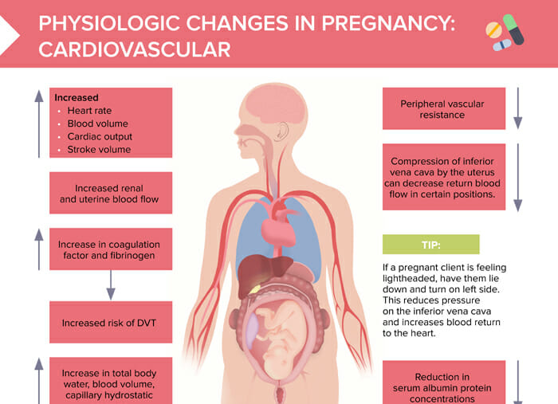
connection between the mother and the developing baby.

b) Respiratory System

Pregnancy increases the oxygen requirement of the body
because the mother has to supply oxygen not only to her
own tissues but also to the growing fetus. To meet this
demand, the respiratory rate increases, and breathing
may become faster and deeper.

As the uterus enlarges, it pushes the diaphragm upward,
reducing the space available for lung expansion. This
often leads to a sensation of breathlessness, especially
during the later stages of pregnancy. However, the lungs
adapt efficiently, and oxygen exchange remains sufficient
to support both maternal and fetal needs.
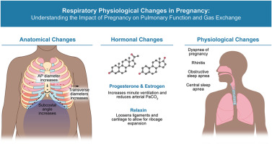

c) Digestive System

The digestive system undergoes several changes due to
hormonal influence, particularly progesterone.
Progesterone relaxes smooth muscles, which slows down
the movement of food through the digestive tract. As a
result, digestion becomes slower, leading to problems
such as constipation, indigestion, and heartburn.
The growing uterus also presses against the stomach and
intestines, further affecting digestion. Despite these
discomforts, nutrient absorption increases to meet the
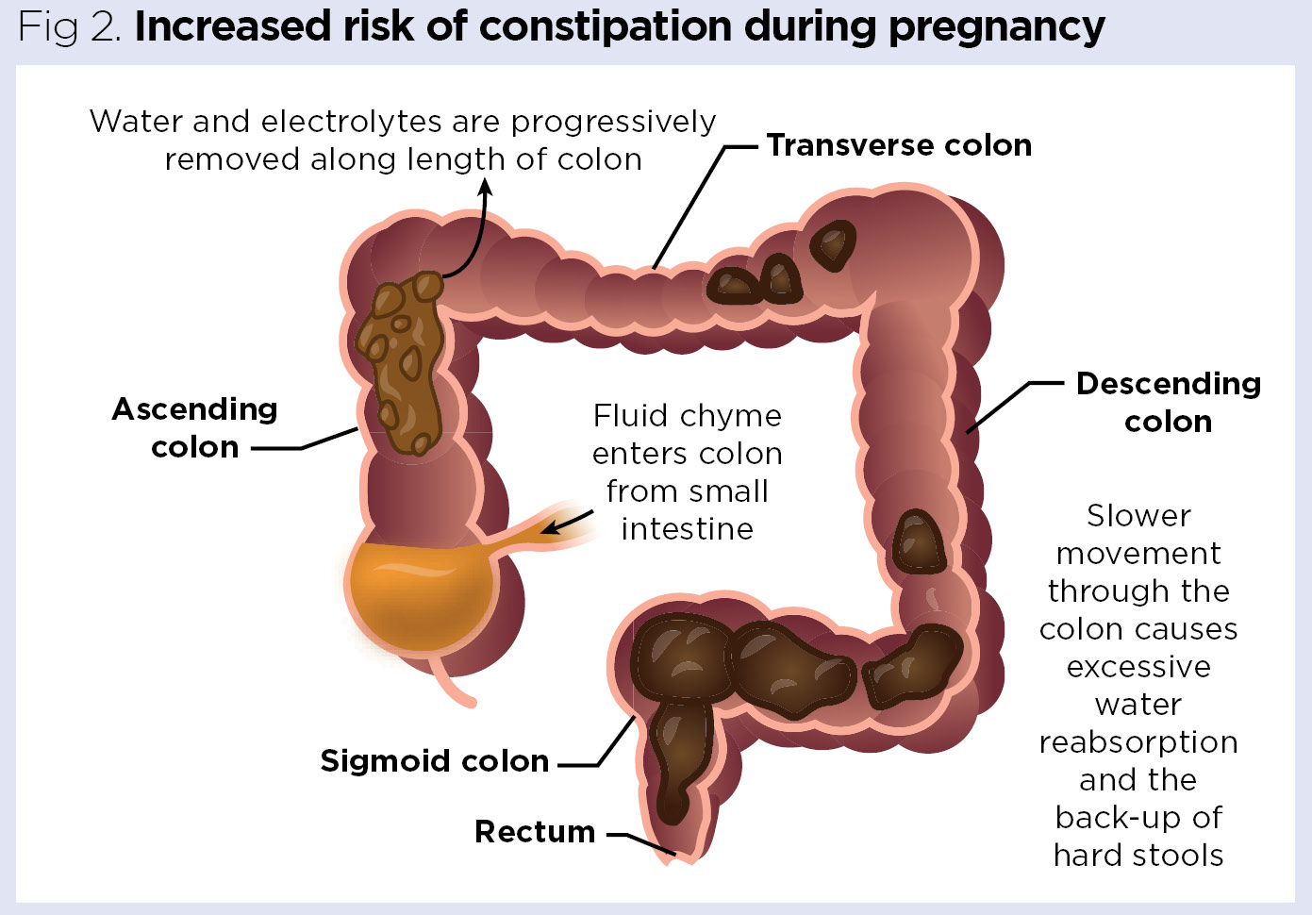
nutritional demands of the fetus
d) Excretory System

The kidneys become more active during pregnancy to
remove increased waste products produced by both the
mother and the fetus. Blood flow to the kidneys increases,
leading to higher urine production. This is the reason
pregnant women experience frequent urination,
especially during the first and third trimesters.
The urinary bladder is also compressed by the enlarging
uterus, contributing to this condition. Proper hydration is
essential during pregnancy to support kidney function
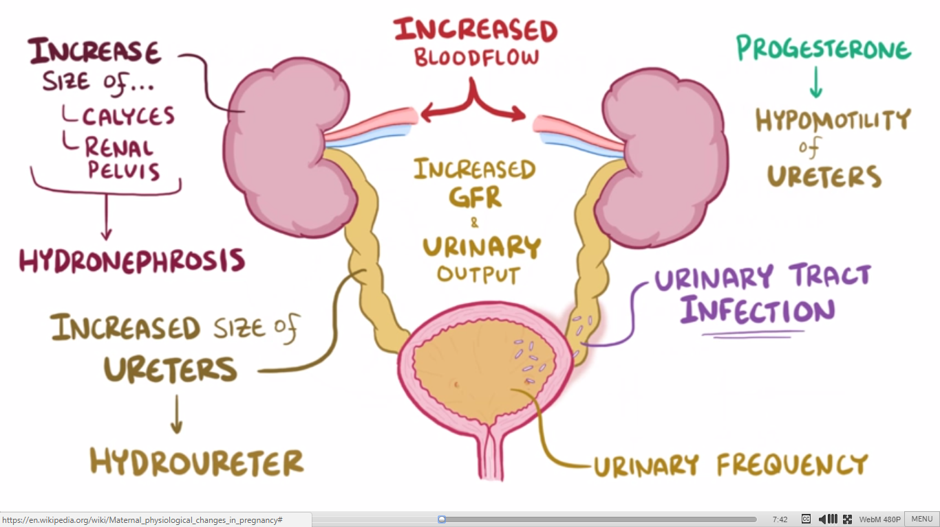
and prevent urinary tract infections.

e) Skeletal and Muscular System
The skeletal and muscular systems undergo structural
changes to support the increasing body weight and
prepare for childbirth. Hormones such as relaxin cause the
ligaments of the pelvic region to loosen, allowing
flexibility during delivery.
Postural changes occur due to the forward shift of the
center of gravity, often resulting in back pain. Muscles of
the abdomen stretch to accommodate the growing
uterus, and joints become more flexible. These changes,
though uncomfortable, are necessary for a successful
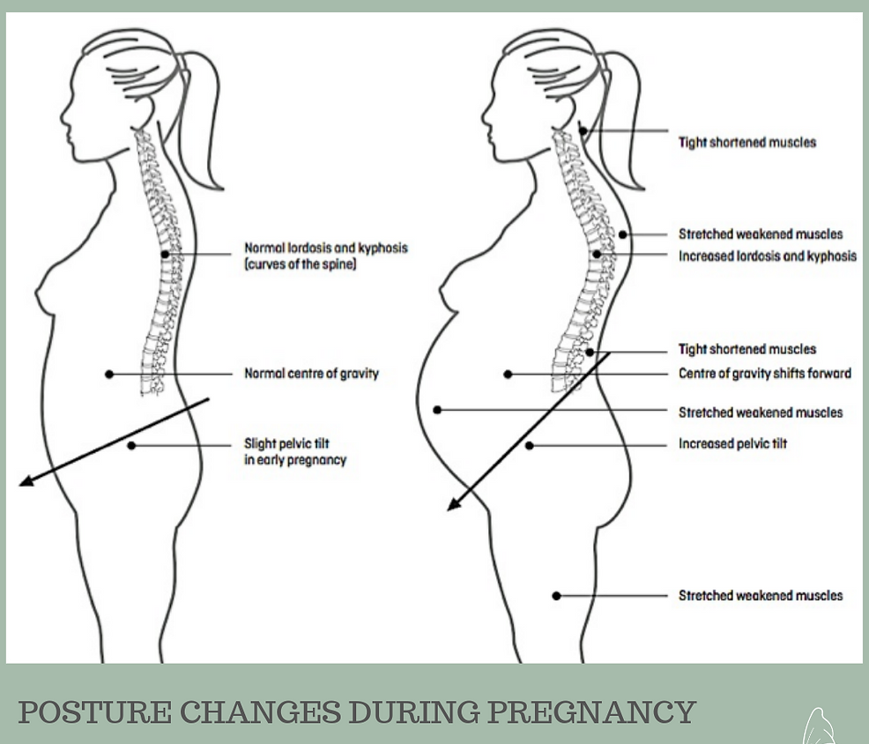

pregnancy and childbirth.
Emotional and Psychological Changes
Pregnancy brings emotional changes such as mood
swings, anxiety, excitement, and emotional bonding with
the baby. These changes are mainly influenced by
hormonal fluctuations and physical stress.
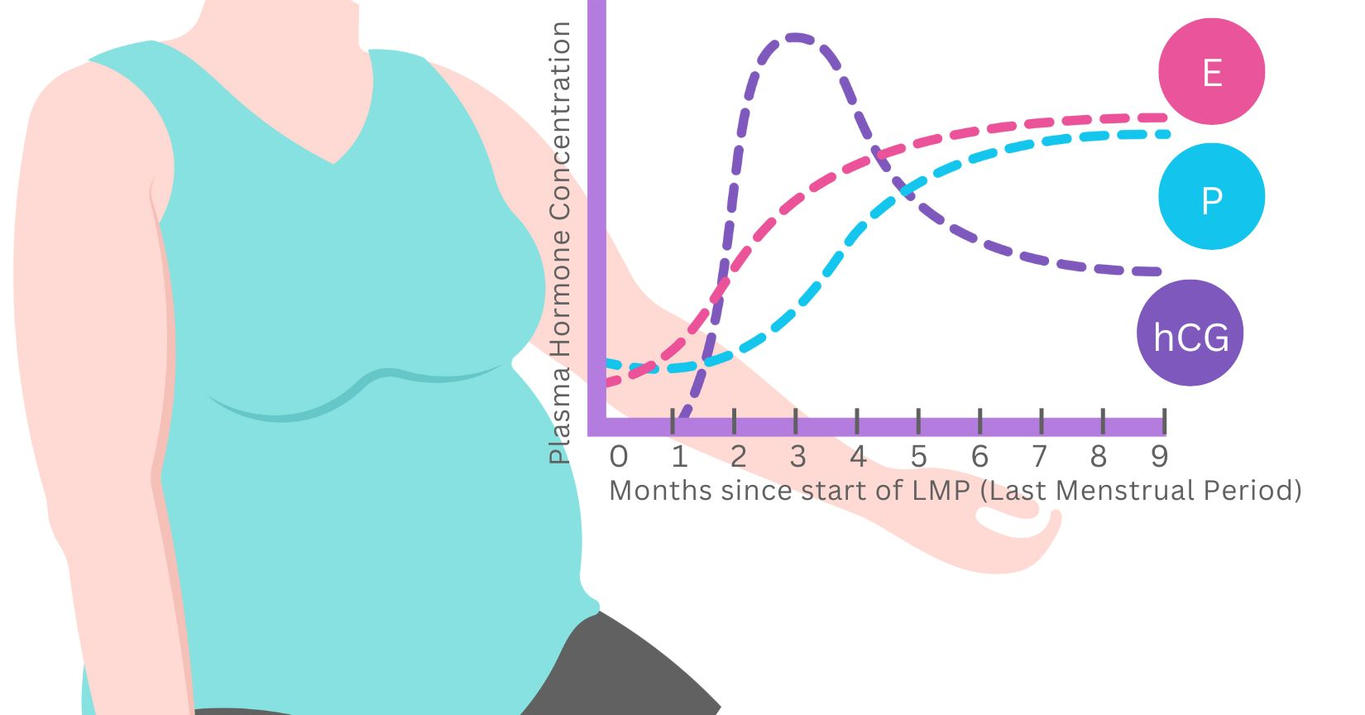

Importance of Proper Care During Pregnancy

Proper prenatal care is essential to ensure a healthy
pregnancy and the well-being of both the mother and the
developing baby. During pregnancy, the nutritional and
physical demands of the body increase significantly,
making it necessary for the mother to follow a balanced
and nutritious diet rich in proteins, vitamins, minerals,
iron, calcium, and folic acid. These nutrients support fetal
growth, prevent anemia, and help in the proper
development of organs and bones.
Regular medical check-ups play a crucial role in
monitoring the progress of pregnancy. Through routine
examinations, doctors can track fetal growth, detect
abnormalities at an early stage, and manage
complications such as high blood pressure or gestational
diabetes. Adequate rest and sleep are equally important
as they help the body recover from physical strain and
maintain hormonal balance.
Managing stress and maintaining emotional well-being are
also vital aspects of prenatal care. Excessive stress can
negatively affect both the mother and fetus, while a calm
and positive environment promotes healthy development.
Avoiding harmful substances such as alcohol, smoking,
and drugs, along with taking prescribed prenatal
supplements, further reduces health risks. Thus, proper
care during pregnancy ensures a safe pregnancy, healthy
childbirth, and the long-term well-being of the mother and
child.

Conclusion

Pregnancy is a remarkable and highly coordinated
biological process that brings about profound changes in
a woman’s body. From the moment of fertilization until
childbirth, almost every organ system undergoes
structural and functional modifications to support the
growth, nourishment, and protection of the developing
fetus. These changes are not accidental but are carefully
regulated by hormones such as progesterone, estrogen,
hCG, prolactin, and oxytocin, which ensure the smooth
progression of pregnancy.

The physiological adaptations of the circulatory,
respiratory, digestive, excretory, skeletal, and muscular
systems highlight the body’s ability to adjust to increased
demands. Increased blood volume, higher oxygen
requirements, changes in posture, and altered metabolism
all work together to maintain a stable internal environment
for the fetus. At the same time, emotional and
psychological changes prepare the mother mentally for
childbirth and motherhood, emphasizing that pregnancy
affects both the body and the mind.

Understanding the changes that occur during pregnancy
is important not only for academic learning but also for
promoting maternal health awareness. Knowledge of
these changes helps in early recognition of complications,
encourages timely medical care, and reduces health risks
for both mother and child. Proper prenatal care, balanced
nutrition, emotional support, and regular medical
supervision play a vital role in ensuring a healthy
pregnancy and safe delivery.

In conclusion, pregnancy is not merely a reproductive
event but a complex physiological journey that reflects
the efficiency and adaptability of the human body.
Studying these changes deepens our appreciation for
human reproduction and highlights the importance of
providing proper care, respect, and support to expectant
mothers, ensuring the well-being of future generations.

Bibliography

- NCERT. (2025–26 Reprint). Biology — Class XII. National Council of Educational Research and Training (NCERT), New Delhi.

- World Health Organization (WHO) Health Resources

- Medical textbooks on Human Physiology and Reproductive Biology

