SOFTWARE REQUIREMENTS SPECIFICATION (SRS)
A Template for Student Mini Projects

Project Title: | Hostel Management System
Document Version: | 1.0 Draft
Author(s) / Team: | Samuthrika shree S – 24BCS237  Sanjay A – 24BCS239  Shakthi Shree K G – 24BCS258
Date of Release: | 03/08/26

1. Introduction
Overview
The Hostel Management System (HMS) is a web-based application designed to automate and simplify hostel administration. The system manages student registrations, room allocations, fee payments, complaints, visitor records, attendance, and administrative activities through a centralized platform.
Traditional hostel management relies heavily on manual records and paperwork, making it time-consuming and error-prone. This software provides a digital solution that improves efficiency, accuracy, transparency, and security.
1.1 Purpose
The purpose of this Software Requirements Specification (SRS) document is to describe the functional and non-functional requirements of the Hostel Management System.
This document serves as a reference for:
- Software Developers
- Test Engineers
- Project Evaluators
- Faculty Members
- Future Maintenance Teams
- The software aims to solve problems such as:
- Manual room allocation
- Paper-based student records
- Difficult fee tracking
- Inefficient complaint management
- Poor communication between students and hostel administration

1.2 Document Conventions
The following conventions are used throughout this document:
- Bold – Section headings
- Italic – Important notes
- HMS – Hostel Management System
- Admin – Hostel Administrator
- Student – Hostel Resident
- Requirement Priority:
- High (H) – Essential requirement
- Medium (M) – Important but optional
- Low (L) – Additional feature
Requirement numbering follows:
Functional Requirement 3.1.1
Functional Requirement 3.1.2
Functional Requirement 3.2.1
1.3 Intended Audience and Reading Suggestions
List the different readers of this document and guide them on which sections are most relevant to them
Audience | Recommended Sections
Project Manager | Section 1 & Section 2
Developers | Section 3 & Section 4
Test Engineers | Section 3 & Section 5
Faculty/Evaluators | Entire Document
Future Maintenance Team | Section 3, 4 & 5

1.4 Product Scope
The Hostel Management System provides a centralized platform for hostel administration.
Major functionalities include:
- Student Registration
- Secure Login
- Room Allocation
- Hostel Fee Management
- Complaint Management
- Visitor Management
- Attendance Monitoring
- Notice Board
- Admin Dashboard
- Reports Generation
Benefits
- Eliminates paperwork
- Faster room allocation
- Better record management
- Secure student information
- Improved communication
- Reduced administrative workload
- Out of Scope
- Online food ordering
- Laundry management
- CCTV monitoring
- Biometric attendance
- Mobile application (Version 1)
1.5 References
IEEE 830 Software Requirements Specification Standard
- UML 2.5 Specification
- MySQL Documentation
- Node.js Documentation
- Express.js Documentation
- React Documentation
- MongoDB Documentation
- REST API Design Guidelines
2. Overall Description
2.1 Product Perspective
The Hostel Management System is a standalone web application.
It follows a client-server architecture where:
- Frontend communicates through REST APIs.
- Backend processes business logic.
- Database stores hostel information securely.
The system can later integrate with:
- College ERP
- Payment Gateway
- Email Services
- SMS Gateway
2.2 Product Functions
The system provides the following functions:
- User Authentication
- Student Registration
- Room Management
- Room Allocation
- Fee Management
- Complaint Registration
- Complaint Resolution
- Visitor Entry Management
- Attendance Management
- Notifications
- Reports Generation
- User Management
2.3 User Classes and Characteristics
Admin
Responsibilities:
- Manage students
- Allocate rooms
- Manage fees
- View reports
- Resolve complaints
Technical Knowledge:
Intermediate computer skills
Security Level:
Full Access
Student
Responsibilities:
- Login
- View room details
- Pay hostel fees
- Register complaints
- View notices
Technical Knowledge:
Basic computer knowledge
Security Level:
- Limited Access
- Warden
Responsibilities:
- Monitor attendance
- Approve complaints
- Visitor approval
- Student supervision
Technical Knowledge:
Basic computer knowledge
Security Level:
- Moderate Access
- Guest
Responsibilities:
View hostel information
Security Level:
Read-only
2.4 Operating Environment
- Hardware
- Intel i3 or above
- 4 GB RAM minimum
- 20 GB Storage
- Operating Systems
- Windows 10/11
- Linux
- macOS
- Browsers
- Google Chrome
- Microsoft Edge
- Mozilla Firefox
- Database
- MongoDB / MySQL
- Technologies
- React.js
- Node.js
- Express.js
- Bootstrap
- REST API
2.5 Design and Implementation Constraints
- Developed using JavaScript
- Uses REST architecture
- Responsive design
- Internet connection required
- Passwords stored securely
- College project deadline constraints
2.6 Assumptions and Dependencies
Assumptions:
- Users have internet access.
- Admin maintains student records.
- Email service remains active.
- Database server is operational.
Dependencies:
- MongoDB Server
- Node.js Runtime
- Internet Connection
- Browser Compatibility
3. System Features (Specific Requirements)
This section breaks down the software requirements by individual features, modules, or functional use cases. Copy and adapt the template below for each major feature.
3.1 User Authentication
Priority: High
Description:
- Provides secure login and registration.
- Inputs
- Email
- Password
- Outputs
- Successful Login
- Error Message
Functional Requirements
FR 3.1.1
The system shall allow students and administrators to register.
FR 3.1.2
The system shall validate password strength.
FR 3.1.3
The system shall authenticate users securely.
FR 3.1.4
The system shall redirect users based on roles.
3.2 Student Management
Priority: High
Description
Manage hostel student records.
Functional Requirements
FR 3.2.1
The admin shall add new students.
FR 3.2.2
The admin shall update student information.
FR 3.2.3
The admin shall remove student records.
FR 3.2.4
The system shall search students using ID or name.
3.3 Room Management
Priority: High
Description
Manage hostel rooms.
Functional Requirements
FR 3.3.1
The admin shall create hostel rooms.
FR 3.3.2
The system shall display room availability.
FR 3.3.3
The admin shall edit room information.
FR 3.3.4
The system shall prevent over-allocation.
3.4 Room Allocation
Priority: High
- Functional Requirements
- Allocate room to student
- Prevent duplicate allocation
- Vacate room
- View allocation history
3.5 Hostel Fee Management
Priority: High
- Functional Requirements
- Record fee payment
- Generate payment receipt
- Display pending dues
- Generate fee reports
3.6 Complaint Management
Priority: Medium
- Functional Requirements
- Student submits complaint
- Admin views complaint
- Warden updates complaint status
- Student tracks complaint
3.7 Visitor Management
Priority: Medium
Functional Requirements
- Register visitor
- Record check-in
- Record check-out
- Generate visitor reports
3.8 Attendance Management
Priority: Medium
Functional Requirements
- Mark attendance
- View attendance
- Generate attendance report
3.9 Notice Board
Priority: Low
Functional Requirements
- Admin posts notice
- Students view notice
- Edit/Delete notices

3.10 Reports
Priority: Medium
Functional Requirements
Generate reports for:
- Students
- Fees
- Complaints
- Visitors
- Attendance
- Room Occupancy

4. External Interface Requirements
4.1 User Interface
Features
- Responsive Web Design
- Bootstrap UI
- Dashboard Layout
- Sidebar Navigation
- Light Color Theme
- Mobile Friendly
- Accessible Forms
4.2 Hardware Interface
N/A
No special hardware is required.
4.3 Software Interfaces
- External Software
- MongoDB
- Node.js
- Express.js
- React.js
- Bootstrap
- REST APIs
- JWT Authentication
4.4 Communication Interfaces
Protocols
- HTTPS
- HTTP
- REST API
- TCP/IP
5. Non-Functional Requirements
5.1 Performance Requirements
- Page loads within 2 seconds.
- Support at least 500 concurrent users.
- API response time below 500 ms.
- Database query execution below 1 second.
5.2 Reliability & Availability
- 99.5% uptime
- Automatic error logging
- Daily database backup
- Data recovery after failures
5.3 Security Requirements
- Password hashing using bcrypt
- JWT Authentication
- HTTPS communication
- Role-Based Access Control (RBAC)
- Input validation
- SQL/NoSQL Injection prevention
- Cross-Site Scripting (XSS) protection
- CSRF protection
5.4 Maintainability and Scalability
- Modular architecture
- Easy feature addition
- MVC design pattern
- RESTful APIs
- Horizontal scalability
- Cloud deployment support
6. Appendix: UML Diagrams
The following UML diagrams should be included:
- Use Case Diagram
- Activity Diagram
- Sequence Diagram
- Class Diagram
Entity Relationship (ER) Diagram
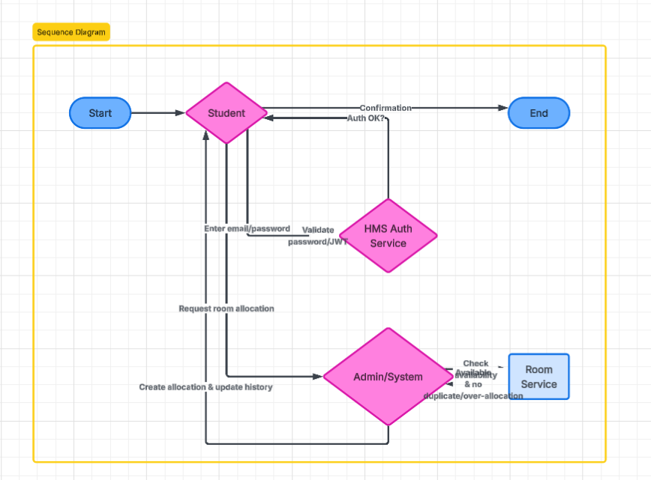
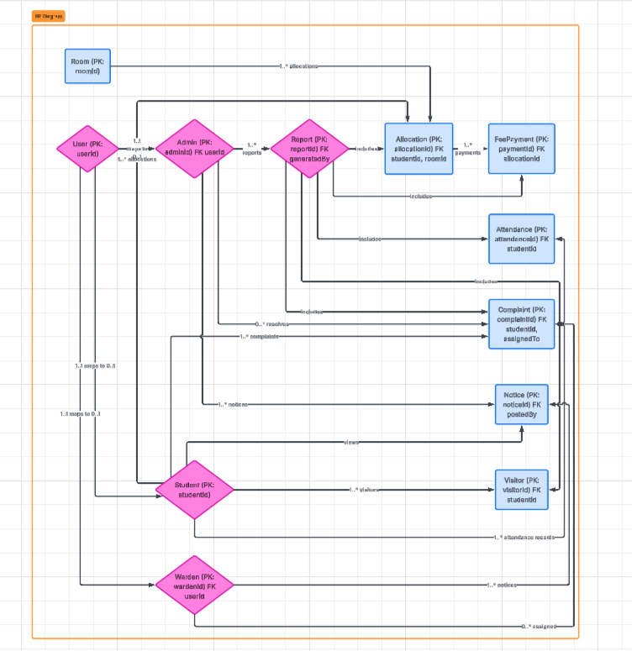
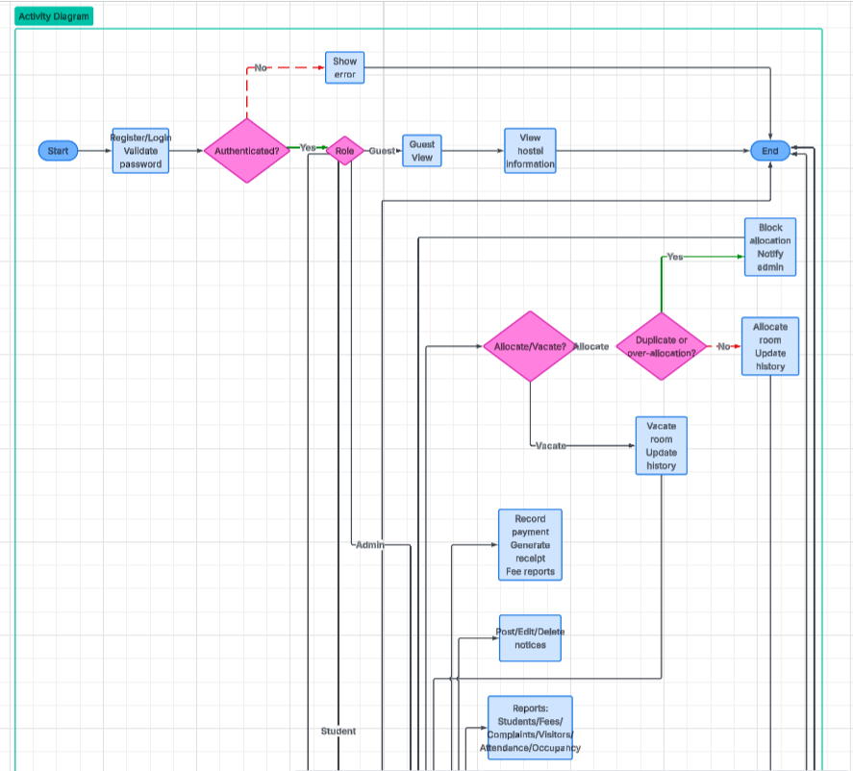
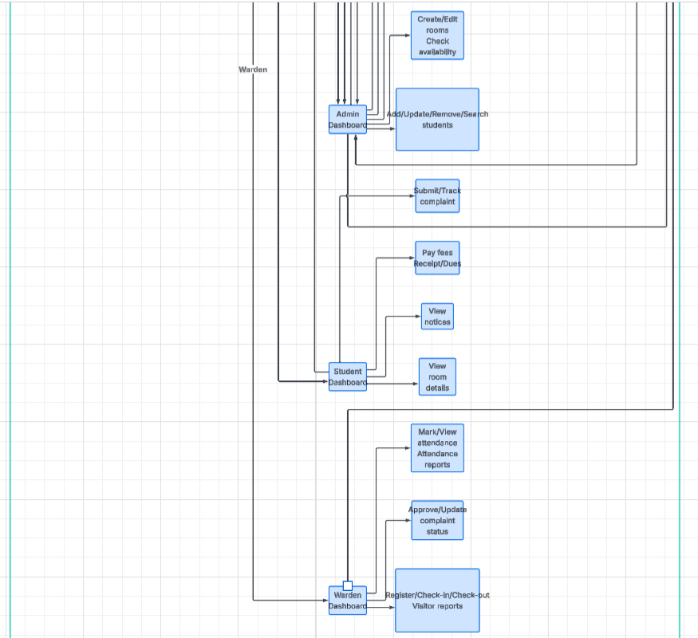
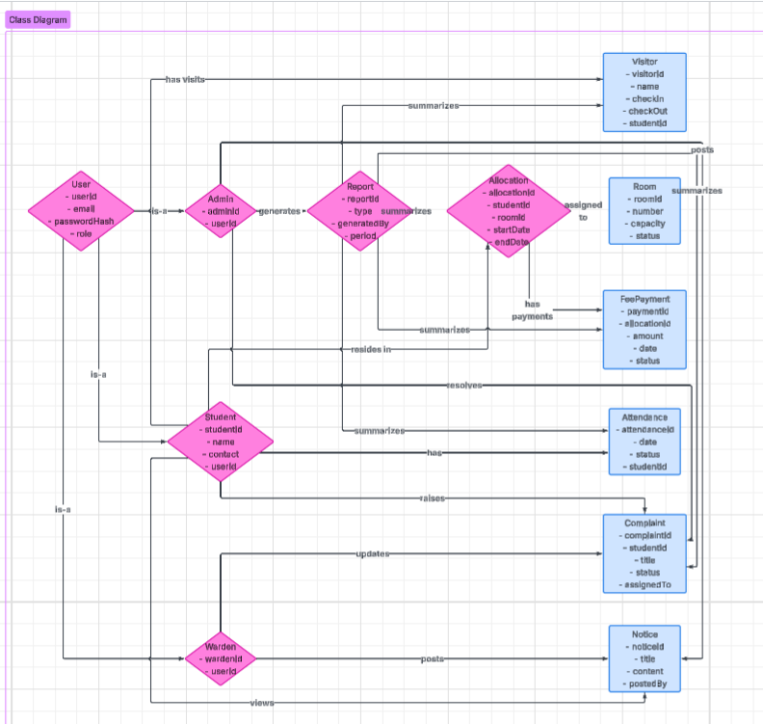
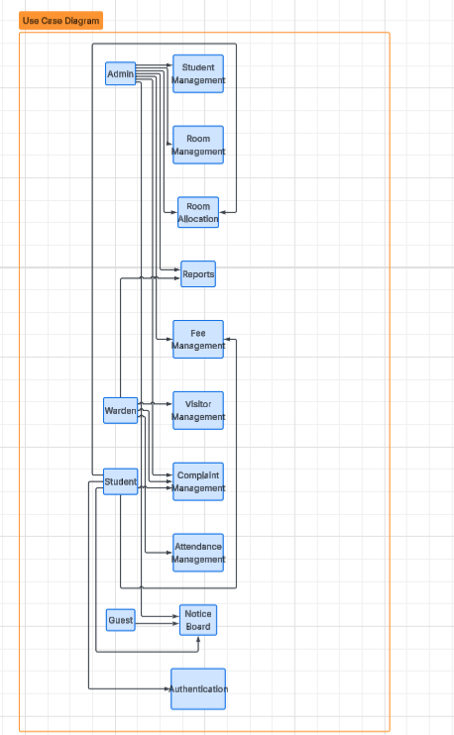
7. Glossary & Acronyms
Term | Definition
SRS | Software Requirements Specification
UML | Unified Modeling Language
API | Application Programming Interface
DBMS | Database Management System
RBAC | Role-Based Access Control
JWT | JSON Web Token
HTTPS | HyperText Transfer Protocol Secure
GUI | Graphical User Interface
ER Diagram | Entity Relationship Diagram
CRUD | Create, Read, Update, Delete
HMS | Hostel Management System

Conclusion
The Hostel Management System is intended to automate hostel operations by providing secure, efficient, and user-friendly management of students, rooms, fees, complaints, attendance, visitors, and reports. The system improves operational efficiency, reduces manual effort, enhances data security, and provides a scalable foundation for future enhancements.

