

**Virtual mouse using Hand gesture control**

**Real Time Analytics**

**(CSE3069)**

**Slot: E2**

## Team Members

**20MIA1031 - Sanjay.M**

**20MIA1117 - Pilaram Manoj**

**TABLE OF CONTENTS**

|  |  |
| --- | --- |
| **SL.NO** | **LIST OF CONTENTS** |
| 1. | Abstract |
| 2. | Introduction about the project |
| 3. | Background study |
| 4. | Proposed System |
| 5. | Methodolgy |
| 6. | Implementation |
| 7. | Results and Discussion |
| 8. | Conclusion and Future works |
| 9. | References |

**Key words:** Hand recognition, MediaPipe,OpenCV, Virtual mouse, Gesture control.

**Abstract:**

Gesture Controlled Virtual Mouse is a technology that allows people to control their computers with hand gestures. This system employs a webcam to track the user's hand movements and converts them into computer commands. Users can use this technology to quickly navigate through system functions, perform actions such as left clicking and dragging and moving the documents and folders. The system is built with advanced Python packages such as MediaPipe and OpenCV, which recognise hand movements using machine learning and computer vision techniques. This means that the technology can work without any additional computer hardware. Hand gestures are a simple and natural way for people to communicate with computers. The Gesture Controlled Virtual Mouse system simplifies and makes computer use more accessible to everyone.

**Introduction:**

In recent years, computer technology has advanced rapidly, resulting in the development of various input devices. The virtual mouse is one of the most commonly used input devices for controlling the movement of the cursor on a computer screen. However, the traditional mouse has some limitations, such as the need for a flat surface and the need to physically move the mouse. Because of these constraints, alternative input devices such as touch screens and trackpads have been developed. These devices, however, have some limitations, such as a lack of precision and sensitivity.

Mouse functions such as moving a visual item are now controlled by hand gestures. Our goal is to be low-cost, so it uses low-cost input devices like a webcam to capture hand movements as input. Predetermined command-based movements are used to manipulate materials. There are a number of existing systems. To navigate around the screen, one uses a standard mouse (hardware tool). Hand gestures are not permitted to access the monitor screen. The gesture system, on the other hand, recognises gestures using colour tapes. Furthermore, the functions performed are fundamental and static in nature. By using a laptop or computer with a web camera and microphone, we can control the mouse and perform simple operations without the need for additional computer hardware.

Hand gesture recognition research has been conducted in order to develop virtual mouse control using hand gestures. The research involves the use of computer vision techniques to track hand movement and interpret hand gestures to control cursor movement. Cameras are used to capture the movement of the hand, and specialised software is used to interpret the hand gestures.

Virtual mouse control developed using hand gesture recognition technology has several potential advantages over traditional input devices such as the mouse. Firstly, the technology has the potential to provide a more natural and intuitive way to control the computer interface. Users can control the cursor with natural hand gestures rather than making physical contact with an input device. Secondly, the technology has the potential to provide greater mobility and flexibility. Users can control the cursor from a distance, eliminating the need to be physically close to the computer screen. This is especially useful when the user is presenting information to a group of people or using the computer in a public place.

Finally, the technology has the potential to provide a more sanitary method of controlling the computer interface. Hand gestures for cursor control eliminate the need for physical contact with an input device, which can be a breeding ground for germs and bacteria. The development of virtual mouse control using hand gesture recognition technology is still in its early stages, and several challenges must be overcome. One of the most difficult challenges is creating accurate and dependable hand gesture recognition algorithms. The technology must be capable of accurately interpreting the user's hand gestures and translating them into cursor movements on the screen.

**Background study:**

Prasanna Khuje and Kalyani Pendke: “Computer cursor control mechanism by hand gesture recognition” this paper proposes a system for using hand gestures to control the computer cursor. The system captures images of the user's hand with a camera and then processes them with image processing algorithms to recognise hand gestures. The gestures that have been recognised are then mapped to cursor movements and actions such as left-click, right-click, and double-click.

The goal of this paper is to create a system for controlling the computer cursor with hand gestures, providing an alternative and intuitive method of interacting with the computer. The authors intend to create a system that is accurate, fast, and capable of recognising a wide range of hand gestures. The proposed system may benefit users with physical disabilities who have difficulty using traditional computer interfaces such as a mouse.

Onkar Yadav, Sagar Makwana: “Cursor Movement by Hand Gesture” in there paper they conveyed that the traditional mouse and keyboard interaction with a computer can be tiring and uncomfortable for users, particularly those who work for long periods of time. As a result, there is a need to develop a more intuitive and efficient method of cursor movement. They present a novel approach to cursor movement via hand gesture in this paper. Their system tracks hand movements with a camera and converts them to cursor movements on the screen. We created a gesture recognition algorithm that can detect simple hand movements like swipes, taps, and pinches. They also conducted user studies to assess there system's performance and usability. The results show that system recognises hand gestures with high accuracy and provides an effective solution.

Hritik Joshi: “Towards controlling mouse through Hand Gestures: A novel and efficient approach “ This paper presents a Hand gesture-based virtual mouse on a window exploitation camera, using finger detection and easy computer programs to reduce time and effort.As technology advances, new devices are being developed to improve the experience of interacting with computers. Traditional mouse and keyboard computer interaction can be tiring and inconvenient for users. In this paper, they propose a novel method for controlling a computer mouse with hand gestures. They created a gesture recognition algorithm that can recognise different hand movements like swipes, taps, and pinches and they conducted user studies to assess the performance and usability of the system. The results show that their system recognises hand gestures with high accuracy and provides an intuitive and efficient way for users to interact.

**Proposed System:**

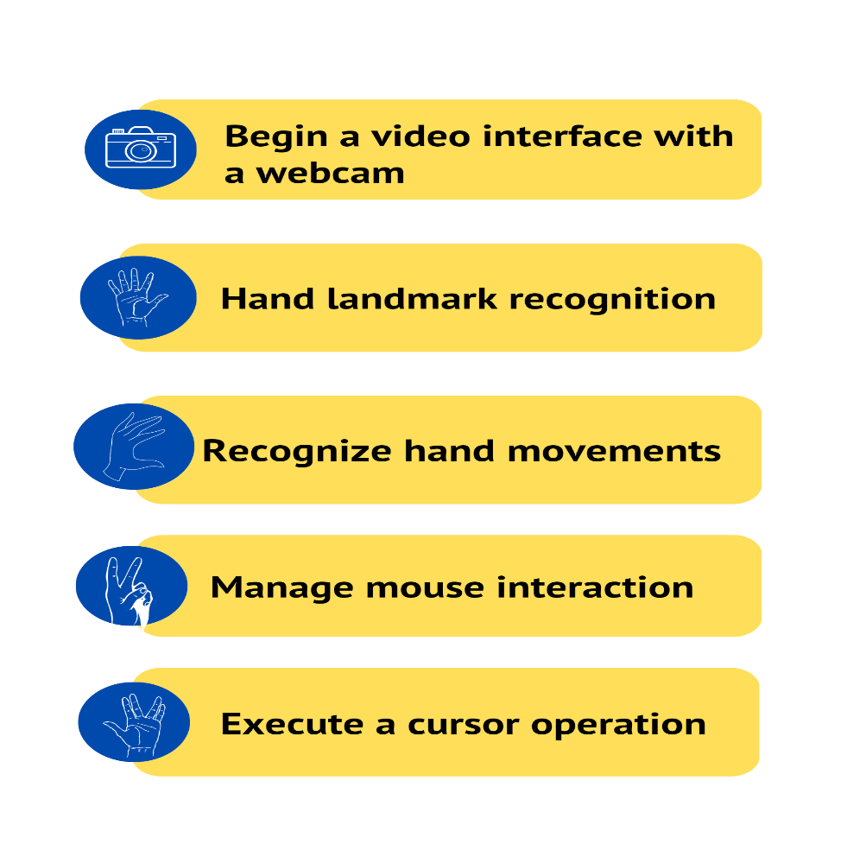

**Methodology:**

**Steps:**

* Initial camera detection is performed by the system, which then starts the video interface.
* After a video interface has been created, the camera can recognise and extract human hand motions.
* The hand tracking capability of the specialist software library MediaPipe allows for precise tracking of the user's hand motion.
* The technology analyses the hand gestures and associates them with various cursor motions and actions.
* To finish the procedure, the cursor moves in accordance with the hand movements that were recognized and reflects them into the appropriate actions.

**Cursor operations:**

1. Hand Landmark detection
2. Left click
3. right click
4. Scrolling
5. Moving document,folder
6. Refreshing page

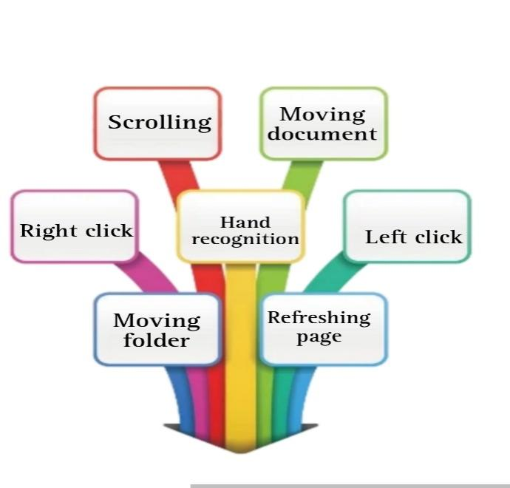

**Implementation:**

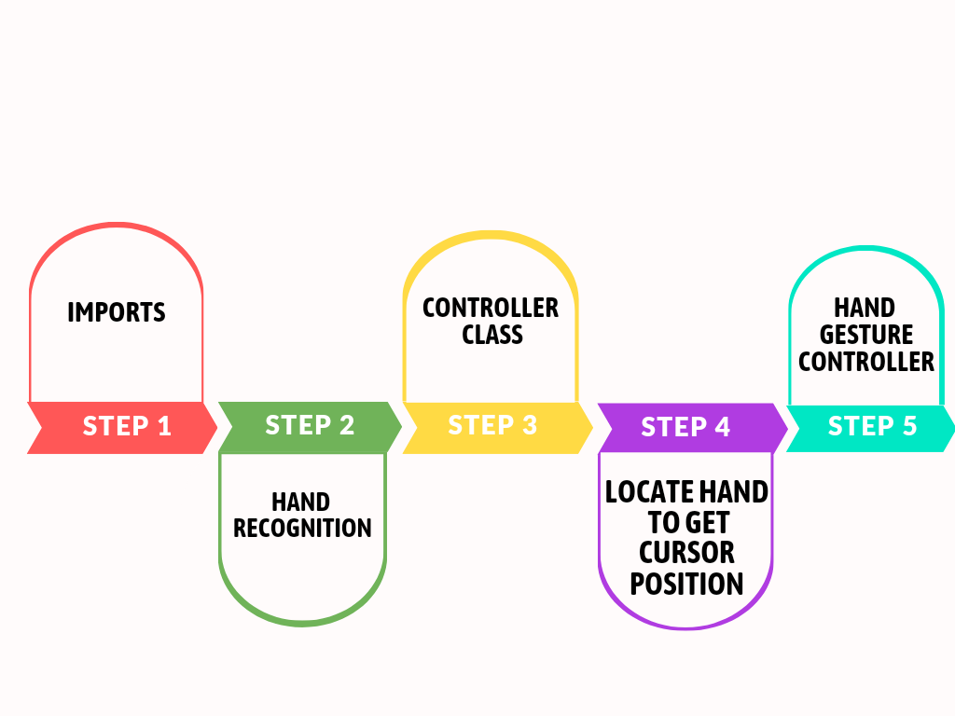

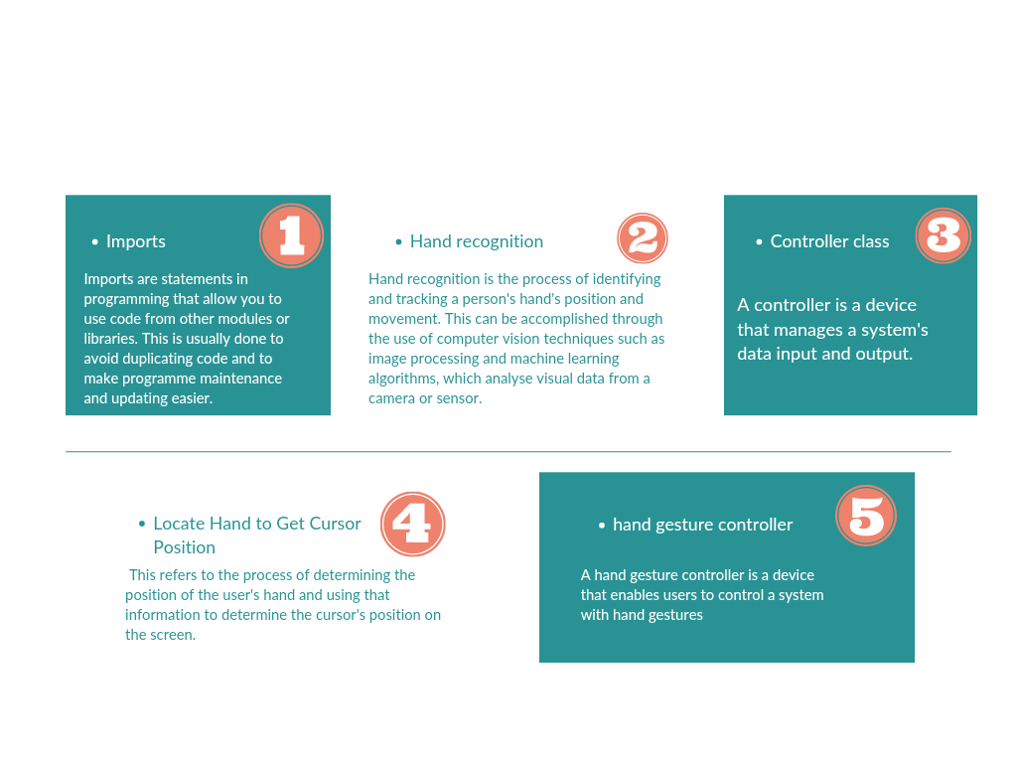

**Result:**

1. Hand Landmark Recognition

The Hand Landmark Recognition is a real-time computer vision technique for detecting and tracking the positions of specific points on a hand. Hand gesture controllers use this technique to allow users to control a virtual mouse with hand gestures.

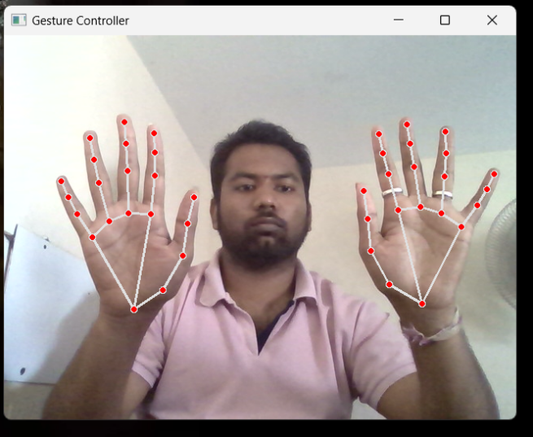 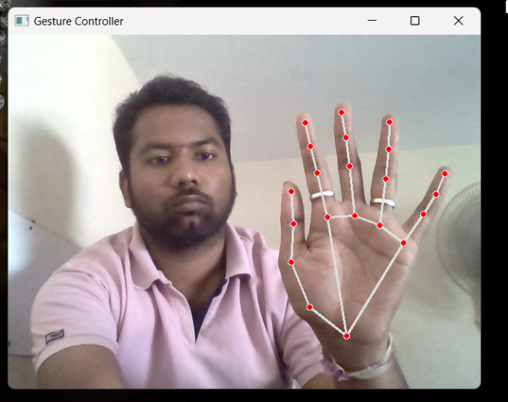

1. Left click

Using a virtual mouse to perform a left-click in a hand gesture controller can be detecting a specific hand gesture, such as a finger tap, and mapping it to a left-click event. As a result, users can interact with a computer system without using their hands.

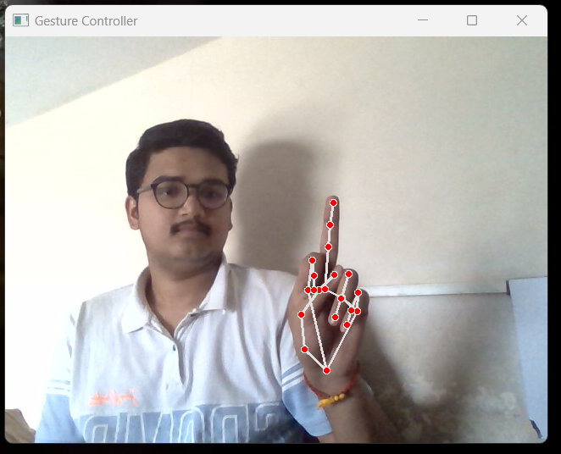

1. Right click

Using a virtual mouse to perform a Right-click in a hand gesture controller can be detecting a specific hand gesture, such as a finger tap and mapping it to a right-click event.

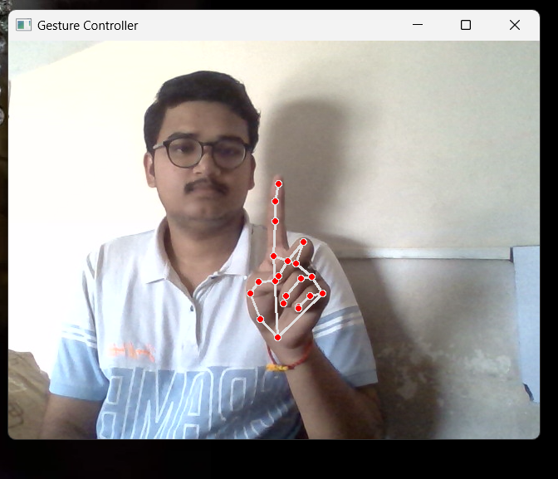

1. Scrolling

Scrolling with hand gesture control enables users to navigate digital content without physically touching a mouse or trackpad.

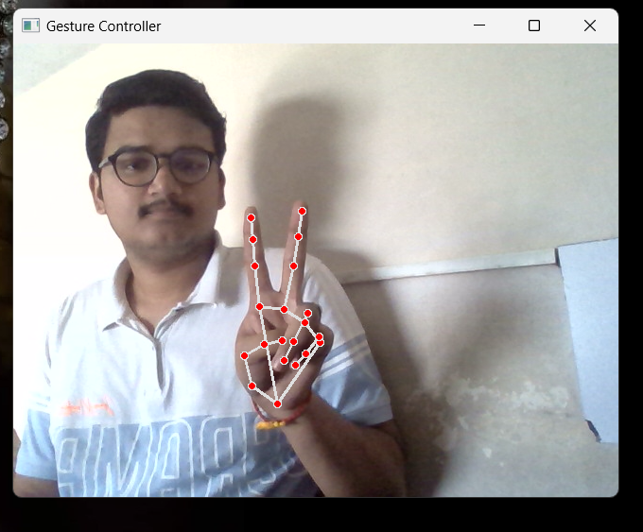

1. Refreshing page

The user can move and drag a document or folder to a new location by using specific hand gestures.

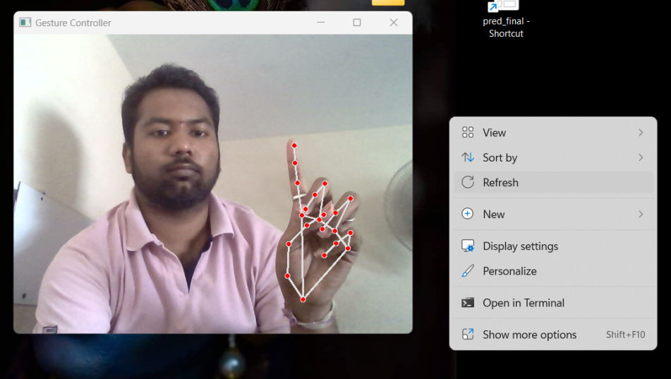

1. Moving document & folder

A specific hand gesture can be used to activate the refreshing page on the virtual mouse.

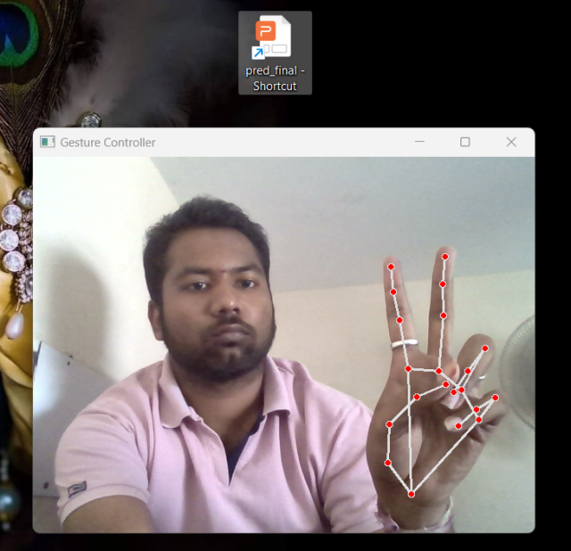 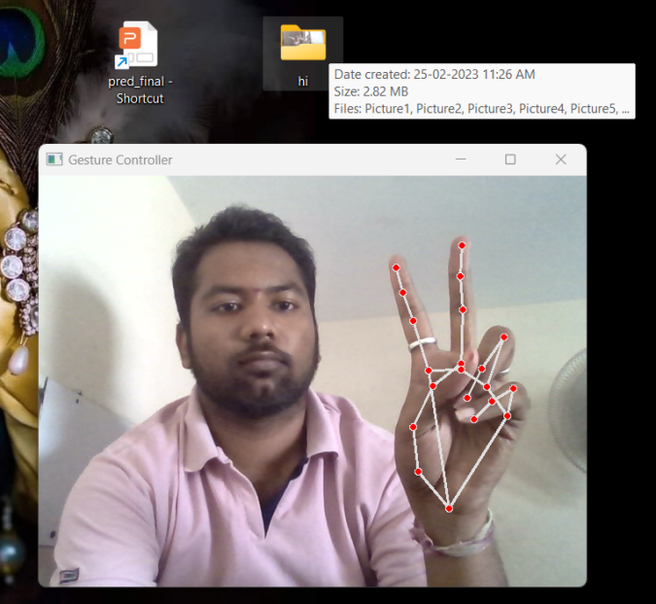

**Conclusion:**

The creation of a virtual mouse controlled by hand gestures is an exciting and promising technology that has the potential to change how we interact with computers and other digital devices. While some issues must be addressed, recent technological advances have enabled the development of more accurate and responsive systems. With future research, this technology could provide a more natural and intuitive way of interacting with digital devices, which could be especially beneficial for people with disabilities or those who struggle to use a traditional mouse. Overall, it's an exciting field with the potential to produce truly innovative and useful developments in the future.

**References:**

<https://www.ijcsmc.com/docs/papers/March2015/V4I3201582.pdf>

<http://www.ijesrt.com/issues%20pdf%20file/Archive-2017/March-2017/34.pdf>

<https://assets.researchsquare.com/files/rs-1616375/v1/5d27011b-ea68-416f-bb6f-f69c00be9b28.pdf?c=1653195556>