SCHOOL OF COMPUTER SCIENCE AND ARTIFICIAL INTELLIGENCE |  |  |  |  | DEPARTMENT OF COMPUTER SCIENCE ENGINEERING
Program Name: B. Tech |  |  |  | Assignment Type: Lab |  |  | Academic Year:2025-2026
Course Coordinator Name |  |  |  | Dr. Rishabh Mittal
Instructor(s) Name |  |  |  | Mr. S Naresh Kumar  Ms. B. Swathi  Dr. Sasanko Shekhar Gantayat  Mr. Md Sallauddin  Dr. Mathivanan  Mr. Y Srikanth  Ms. N Shilpa  Dr. Rishabh Mittal (Coordinator)  Dr. R. Prashant Kumar  Mr. Ankushavali MD  Mr. B Viswanath  Ms. Sujitha Reddy  Ms. A. Anitha  Ms. M.Madhuri  Ms. Katherashala Swetha  Ms. Velpula sumalatha  Mr. Bingi Raju
CourseCode |  |  | 23CS002PC304 | Course Title |  | AI Assisted Coding
Year/Sem |  |  | III/II | Regulation |  | R23
Date and Day  of Assignment |  |  | Week9 – Monday | Time(s) |  | 23CSBTB01 To 23CSBTB52
Holl.NO: |  |  | 2303A54017 | Batche: |  | 48
Assignment Number: 18.1(Present assignment number)/24(Total number of assignments)
 | Q.No. | Question |  |  |  |  |  | Expected Time  to complete
 | 1 | Lab 18 – API Integration: Connecting to External Services with Error Handling  Lab Objectives:  - Learn how to integrate Python programs with external REST APIs.  - Understand API request/response handling using requests or similar libraries.  - Implement proper error handling for failed API calls (timeouts, invalid responses, rate limits).  - Practice extracting and displaying meaningful information from API responses.  Task 1 – Weather API Integration  Connect to a Weather API to fetch current weather details for a given city.  Instructions:  - Prompt AI to generate Python code using the requests library.  - Handle errors: invalid city name, API key errors, and network failures.  - Display temperature, humidity, and weather description in a readable format.  Expected Output:  - A working Python script that fetches and displays weather data with proper error handling.  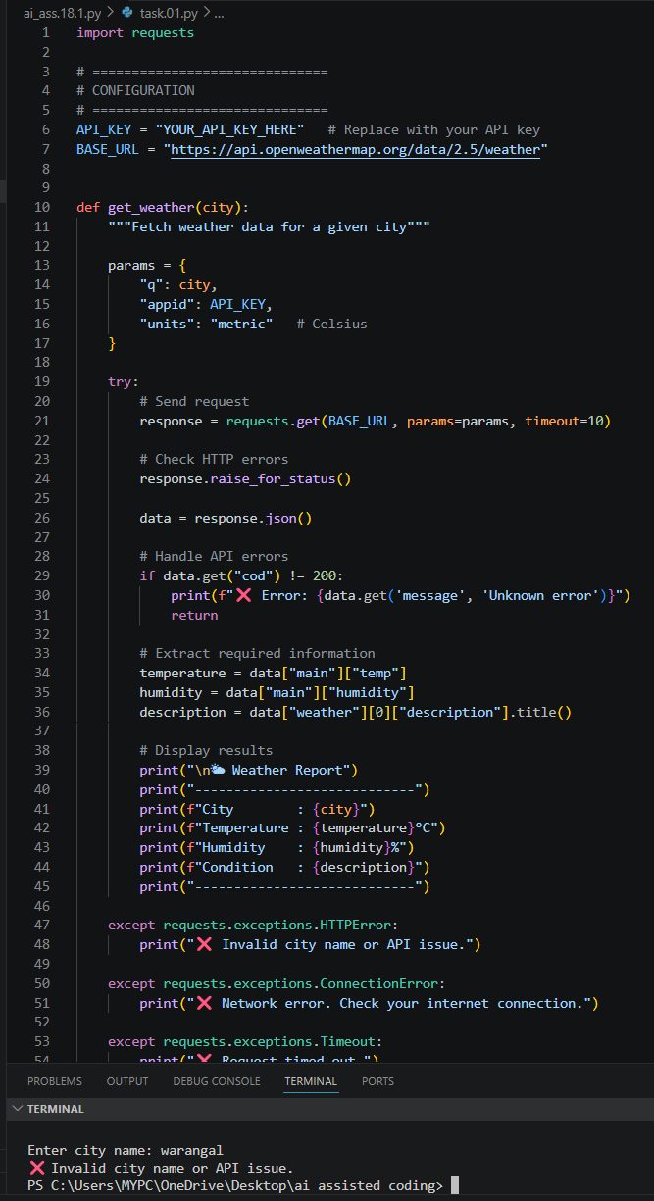  Task 2 – Currency Exchange Rates  Integrate a Currency Exchange API to convert INR to USD, EUR, and GBP.  Instructions:  - Use AI to generate API request code.  - Validate user input for amount and currency codes.  - Implement error handling for invalid responses and API downtime.  - Show conversion results clearly in tabular format.  Expected Output:  - A script that converts INR to multiple currencies with graceful error handling.  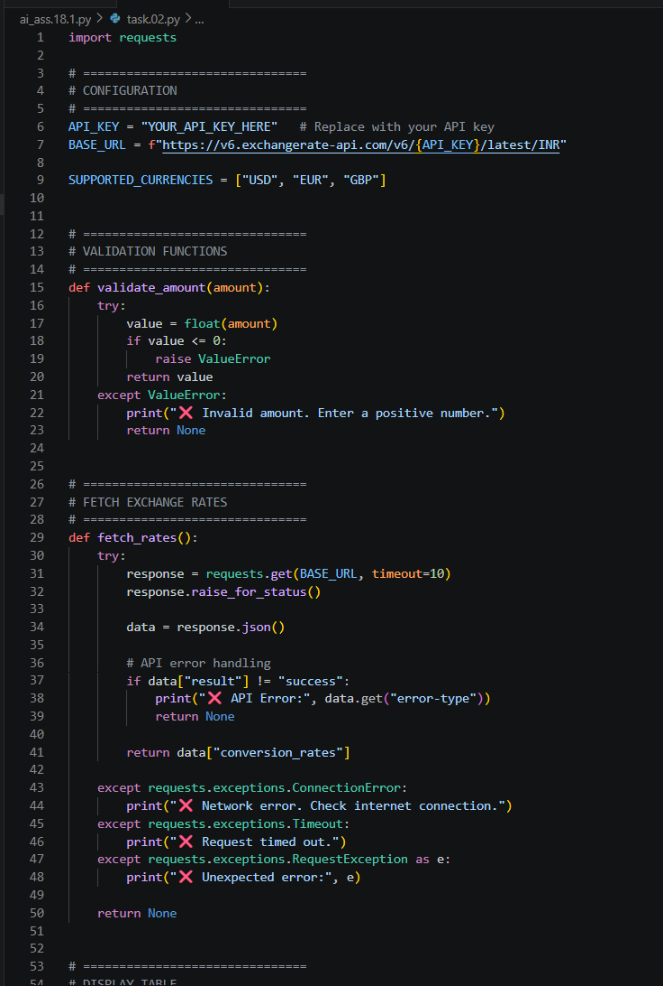  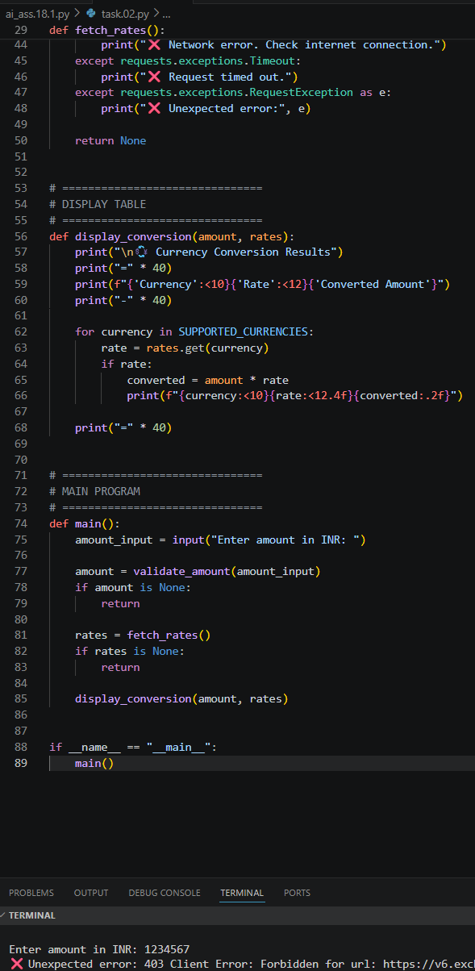  Task 3 – GitHub Repository Info Fetcher  Connect to the GitHub API to fetch details of a repository (e.g., stars, forks, issues).  Instructions:  - Prompt AI to write a Python function to send GET requests to GitHub API.  - Handle rate limit errors, 404 (repo not found), and invalid input.  - Display repository name, description, stars, forks, and open issues.  Expected Output:  - A Python program that retrieves and displays GitHub repository information with robust error handling.  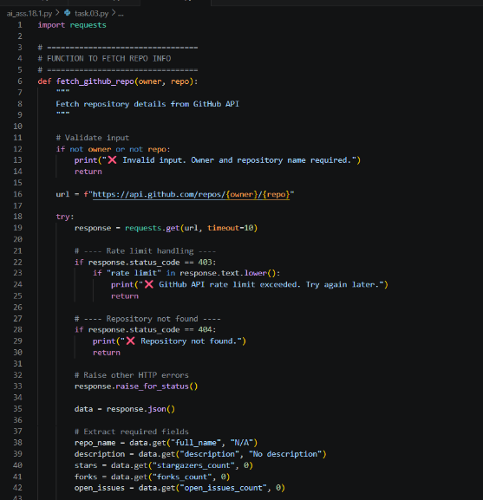  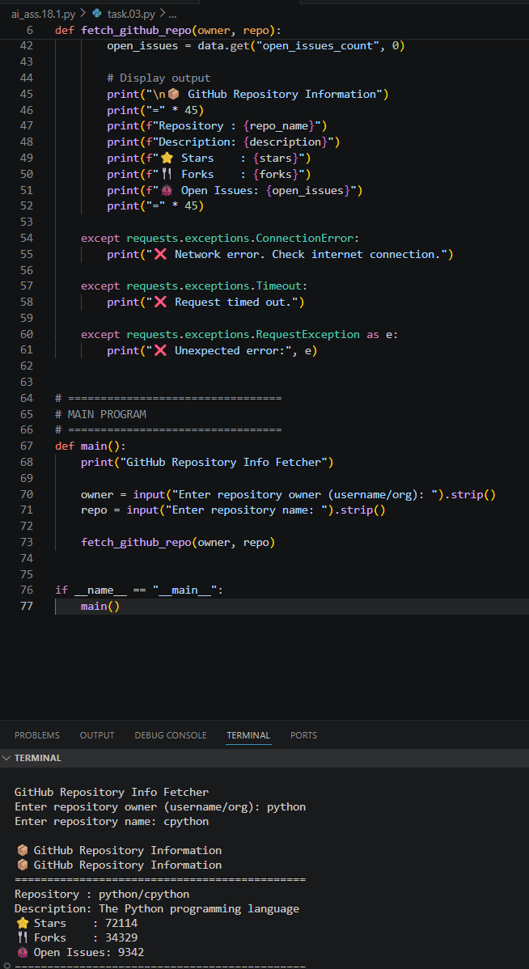  Task 4 – Real-Time Application: News Headlines Aggregator  Scenario: Build a News Aggregator using a free News API.  Requirements:  - Fetch top 5 headlines for a given category (sports, technology, health).  - Handle errors like invalid category, missing API key, and request failures.  - Display headlines in a user-friendly numbered list format.  - Include a retry mechanism if the first request fails.  Expected Output:  - A working Python script that retrieves and displays news headlines with proper error handling  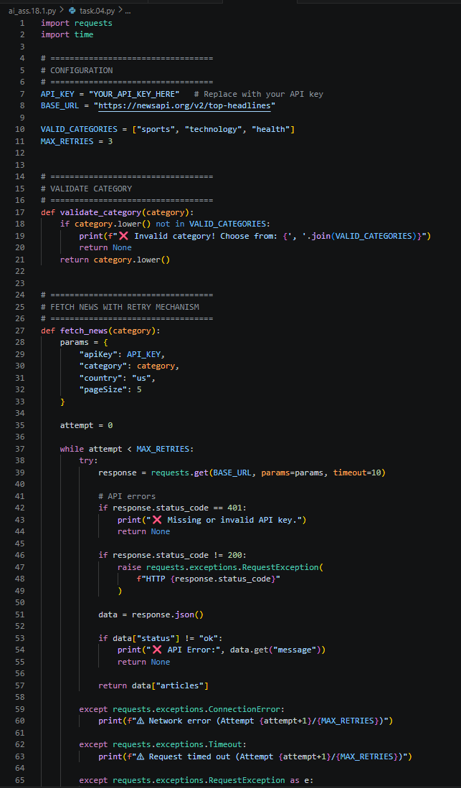  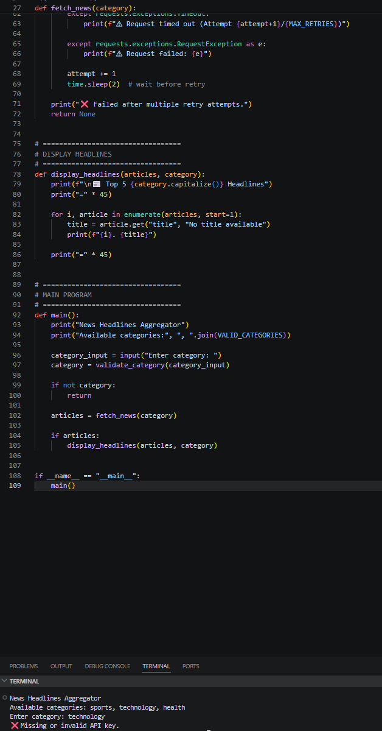 |  |  |  |  |  | Week9 - Monday

