ContentMint: Frontend User Interface Architecture
Dezai Learners Internship Program

1.0 Overview
This document covers the comprehensive frontend setup for the ContentMint application. The primary objective for this phase was to architect, build, and stylize all User Interface (UI) routes prior to establishing database connections via Prisma and external API logic via Groq. The application is built upon Next.js 16 (App Router) and leverages the Turbopack compiler for optimized development performance.

2.0 Design System & Theming
To avoid generic SaaS aesthetics, the application implements a custom "Earthy Botanical" color palette. Because Tailwind CSS v4 utilizes a new CSS-variable-based engine rather than the legacy config file, the theme was established via a custom @theme block in globals.css.
- • Background: #0A0D08 (Very Dark Green)
- • Text/Foreground: #DBCAC0 (Pale Sand)
- • Primary Accents: #6F8055 (Sage Green)
- • Depth Elements: #3E4F32 (Forest Green)
- • Interactive Highlights: #C2A3B3 (Mauve)
These hex codes were directly mapped to the Shadcn UI CSS variables, allowing all installed components to inherit the exact aesthetic without manual CSS overrides.

3.0 Page Architecture & Implementation

3.1 Authentication Flow
The /login, /register, and /forgot-password routes utilize a glass-morphism aesthetic. A critical bug emerged where the Shadcn dropdowns and buttons were nesting <button> tags, triggering DOM hydration mismatch errors due to a recent Radix/Base-UI internal update. This was resolved by removing the 'asChild' props and directly mapping the buttonVariants utility to Next.js <Link> components.
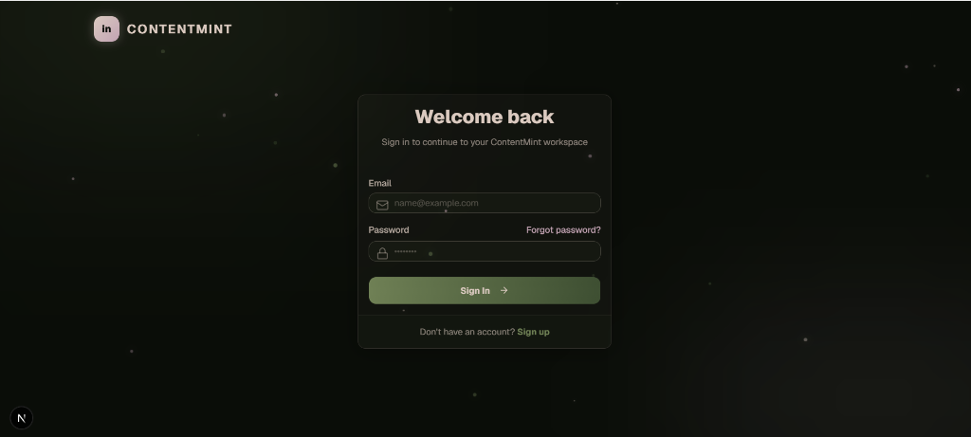

3.2 Dashboard Workspace
The main /dashboard route serves as the primary AI generation interface. The left column contains the prompt Textarea and scheduling inputs. The right column renders a live preview panel featuring a tabbed interface to toggle between Text Post and Carousel Mockup views. A temporary setTimeout function currently simulates the AI loading state.
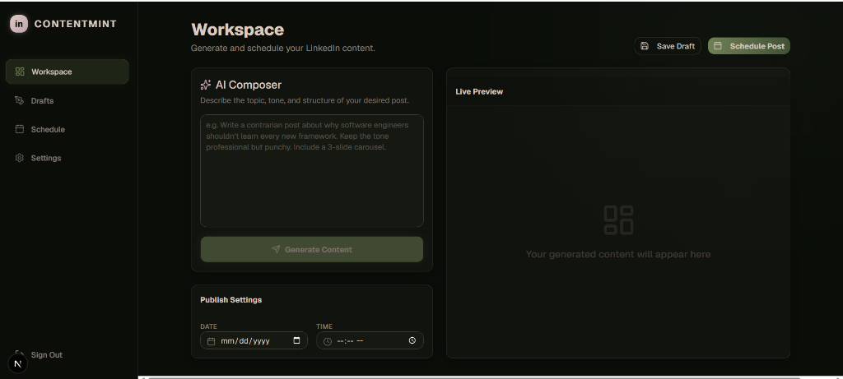

3.3 Drafts Manager
The /dashboard/drafts page utilizes a responsive grid layout displaying saved content. Interactive Shadcn dropdown menus were added to each card to expose quick edit and delete actions.
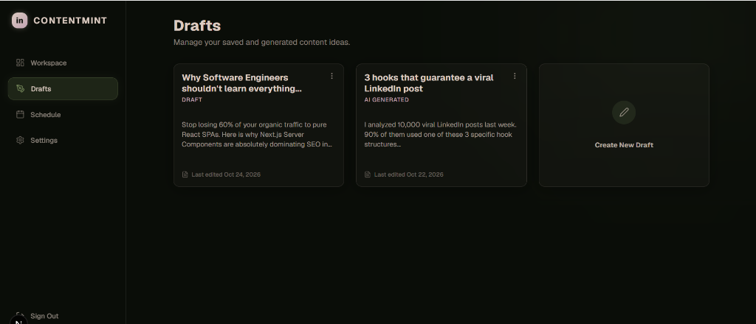

3.4 User Settings & Configuration
The /dashboard/settings page organizes user preferences via a tabbed interface. This includes a secure input block for the user's Groq API Key and a structured mockup of the Pro Subscription billing status.
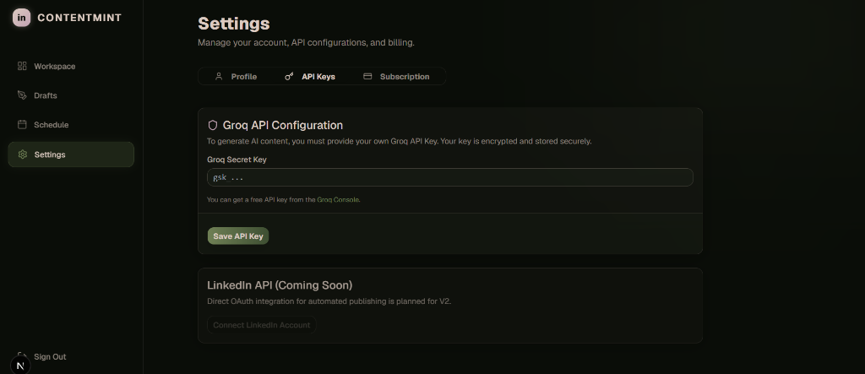

4.0 Next Steps: Backend Integration
With the frontend fully styled and interactive, the architecture is ready for Backend Integration. The upcoming phase will focus on configuring a PostgreSQL database to replace the placeholder data, structuring the Next.js API Routes for JWT session management, and successfully transmitting user prompts to the Groq API.

