Secure Data Hiding: A Comparative Study of Conventional and AI-Based Paradigms
- Princy Aggarwal, Research Scholar, University School of Information, Communication & Technology, Guru Gobind Singh Indraprastha University, Delhi, India, Email ID: princy.aggarwal@gmail.com
- Sartaj Singh Sodhi, Professor, University School of Information, Communication & Technology, Guru Gobind Singh Indraprastha University, Delhi, India, Email ID:
sartaj@ipu.ac.in
Abstract
With the widespread development of digital communication, it has become crucial to secure digital content. Steganography can conceal confidential data within digital media with imperceptibility and robustness. In this paper, we present a survey of data hiding methods from classical spatial domain techniques to recent AI-based techniques. Based on performance measures including payload capacity, PSNR, SSIM, robustness and security, a comparative analysis is carried out. In addition to discussing new developments like transformer-based steganography and hybrid cryptography and steganography systems, the paper emphasizes the benefits and weaknesses of each method. Finally, significant challenges and possible future directions for intelligent and secure data hiding systems are explored.
Keywords: Steganography, Image Data Hiding, Artificial Intelligence, Deep Learning, CNN, GAN, Transform-Domain Techniques, Information Security, Reversible Data Hiding, Digital Watermarking

Introduction
Protecting information transmitted through open digital networks has become a significant issue. Steganography is one of the methods along with encryption and digital watermarking to secure digital information. Unlike cryptography it conceals the data fully inside digital media such that even the presence of some hidden message is not noticed. The issue lies in integrating the data in a way that it becomes so smooth that a person cannot perceive the difference or an algorithm cannot detect it. The spatial and frequency domain methods like LSB, DWT, DCT etc. are computationally inexpensive and easy to implement. They are weak because they have statistical fingerprints that steganalysis classifiers of modern times can detect with high reliability.
Deep learning has made a big difference in the field of steganography. CNNs are trained to compress data in patches of images with natural texture combined with variances. Additionally, GAN-based systems learn directly from a detector by embedding images in a way that makes them statistically identical to the original images. Even the latest methods also fall short of simultaneously satisfying every requirement. Robustness, imperceptibility, and capacity are inherently at odds with one another with each characteristic typically diminishing the other. Finding a workable compromise between all three is still the field's biggest challenge. The fundamental relationship between capacity, imperceptibility, and robustness in steganographic systems is represented in Figure 1.1 In this paper, we examined both the AI-based and classical steganographic techniques on the basis of evaluation metric like capacity, imperceptibility, robustness and cost. The advances in steganalysis and the fields with the strongest research potential are also included.
This survey was conducted after the extensive review of literature published after 2020 in IEEE Xplore, SpringerLink, ScienceDirect, ACM Digital Library and Google Scholar. Steganography, data hiding, deep learning, CNN, GAN, steganalysis, LSB, DCT and DWT were important search terms. Boolean operators were applied to narrow and improve the search as needed. Studies that dealt with image steganography or steganalysis and reported quantifiable results including PSNR, SSIM, BER or payload capacity and were published in a peer-reviewed journal, conference proceedings or reputable preprint repositories were included. Studies confined to non-image media or which were not empirically evaluated were excluded. A total of 43 papers were selected for detailed review of which approximately 60% are from 2023–2026 which reflects the survey’s emphasis on recent developments. Some of the formative works published before 2020 were retained for baseline context. The selected studies were then grouped into classical spatial-domain techniques, transform-domain techniques and approaches based on AI.
The primary contributions of this study include:
- A unified survey spanning spatial-domain, transform-domain, and AI-driven steganographic approaches.
- A comparative evaluation of classical and deep learning methods under shared performance metrics.
- An overview of how modern steganalysis has responded to AI-based embedding advances.
- Identification of open challenges and high-priority future research directions.
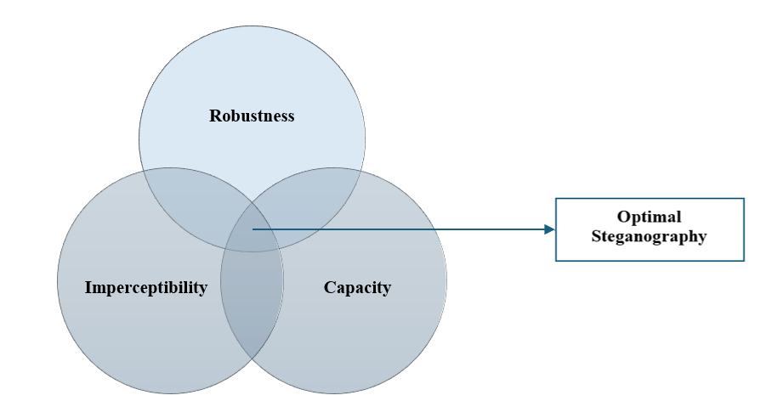
Figure: 1.1 Trade-off relationship among capacity, imperceptibility and robustness
The paper is structured as follows: section 2 covers traditional steganography techniques, section 3 focuses on AI based techniques, section 4 presents recent literature, section 5 covers steganalysis, section 6 compares different steganographic techniques, section 7 focuses on challenges with future scope and section 8 wraps up.

1.2. Traditional Steganographic Techniques
Early steganographic work was largely confined to the spatial domain, where LSB substitution became the method of choice. It is easy to implement and can accommodate a reasonable amount of hidden data without visibly altering the image. The problem, however, is structural. Embedding data directly into pixel values disrupts the statistical fingerprint of the image due to which steganalysis tools can catch spatial-domain methods. Frequency-domain approaches emerged as a more principled response to these vulnerabilities. Figure 1.2 presents different steganographic techniques to emphasize the shift from manual feature engineering to data-driven learned representations.
1.2.1. Spatial-Domain Techniques
Spatial-domain techniques directly manipulate pixel values of the cover image. Their simplicity and low computational cost made them most widely studied approaches. They remain useful where high capacity is prioritised over robustness. Table 1.1 summarises the main techniques under the spatial domain.
Least Significant Bit (LSB)
LSB substitution embeds secret data by changing the least significant bits of pixel intensities. While it offers high embedding capacity, it is highly vulnerable to statistical as well as visual attacks.
Pixel Value Differencing (PVD)
PVD exploits the difference between neighbouring pixels to determine embedding capacity. It improves imperceptibility compared to LSB but remains sensitive to noise and compression.
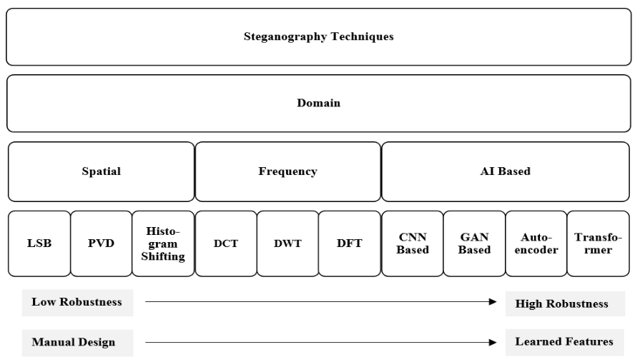
Figure: 1.2 Taxonomy of steganography techniques showing the development from traditional spatial-domain methods to AI-based methods.
Histogram Shifting
Histogram shifting techniques embed data by modifying histogram bins and allow reversible data hiding. It basically involves creating room in the pixel intensity histogram by shifting neighbouring bins and then using that room to encode message bits. However, embedding capacity is limited.
Table 1: Comparison of Classical Spatial-Domain Techniques
Method | Embedding Principle | Capacity | Imperceptibility | Robustness | Complexity
LSB | Bit substitution in pixels | High | Medium | Low | Very Low
PVD | Pixel difference-based | Medium | High | Low | Low
Histogram Shifting | Histogram modification | Low–Medium | High | Medium | Medium

1.2.2. Transform-Domain Techniques
Rather than modifying pixel values, transform-domain techniques operate on mathematical representations of the image. DCT and DWT methods convert the image into frequency components, embed data in coefficients that correspond to regions less sensitive to human visual system, and then transform back. This generally improves imperceptibility and robustness under compression but computational overhead generally increases. Table 1.2 summarises the different transform-domain approaches.
Hybrid Transform Techniques
Hybrid techniques such as DWT-DCT or DWT-SVD take the advantage of multiple transform operations generally outperforming single-transform methods to improve performance in terms of security and robustness.
Table 1.2: Comparison of Transform-Domain Techniques
Method | Transform Used | Capacity | Imperceptibility | Robustness | Typical Media
DCT | Frequency (Cosine) | Medium | High | High | JPEG Images
DWT | Multi-resolution | Medium | High | High | Images & Video
DFT | Frequency Spectrum | Low | Medium | High | Signals
DWT–DCT | Hybrid Transform | Medium | Very High | Very High | Secure Multimedia

1.3. Literature Review
Recent advances in image steganography, steganalysis, and cybersecurity have been extensively explored through diverse computational approaches. Subramanian et al. (2021) [1] and Kumar et al. (2023) [2] provided comprehensive reviews of image steganography, highlighting the evolution from traditional methods to deep learning techniques. Generative methods gained prominence, as demonstrated by Zhang et al. (2020) [3] through cover synthesis with auxiliary semantics, while Hussain et al. (2020) [4] surveyed deep convolutional neural networks for both steganography and steganalysis. Security enhancement strategies were proposed by Shang et al. (2020) [5] using adversarial examples, and Chen et al. (2020) [6] developed high-capacity robust steganography via adversarial networks. Polisetty and Rizvi (2025) [7] introduced GAN-based adaptive image steganography, complementing the historical perspective provided by Sahu and Sahu (2020) [8] on three decades of steganography research. Li et al. (2024) [9] exploited transform domain knowledge with GANs, while Liu et al. (2020) [10] reviewed GAN-based image steganography advancements. Tang et al. (2021) [11] proposed deep reinforcement learning for automatic cost learning, and Kumar et al. (2026) [12] developed secure random pixel distribution techniques, though the latter requires verification due to its future publication date. Eid et al. (2022) [13] surveyed digital image steganalysis methodologies, and Chen et al. (2023) [14] provided a comprehensive survey of covert communications. Lu et al. (2020) [15] focused on secure halftone image steganography, while K and P (2024) [16] reviewed lightweight cryptography and steganography for IoT environments. Foundational work by Fridrich et al. (2003) [17] on breaking the F5 algorithm and by Fridrich and Kodovský (2012) [19] on rich models for steganalysis established critical baselines. Zhang et al. (2025) [18] enhanced generative image steganography using diffusion models, and Xu et al. (2016) [20] along with Ye et al. (2017) [21] advanced CNN architectures for steganalysis. Xiao et al. (2025) [22] proposed transformer-based adversarial networks, while Li et al. (2021) [23] introduced cross feedback mechanisms for GAN-based spatial steganography. Li et al. (2024) [24] developed lightweight GAN-based steganography for IoT forgery prevention, and Sanjalawe et al. (2025) [25] presented a deep learning-driven multi-layered steganographic approach. Chen et al. (2025) [26] proposed ADPGAN for anti-compression steganography, and Alrusaini (2025) [27] evaluated deep learning model robustness for steganalysis. Song et al. (2024) [28] provided a survey on deep learning-based image steganography, while Hu et al. (2018) [29] introduced deep convolutional GANs for steganography. Pevný et al. (2010) [30] demonstrated highly undetectable steganography using high-dimensional image models, and Yang et al. (2024) [31] proposed PRIS for practical robust invertible network steganography. Luo et al. (2010)
1.4.1. Autoencoder-Based Steganography
Steganographic autoencoders encode the cover image and secret payload together into a shared latent representation; the decoder reconstructs the stego image and recovers the message simultaneously. End-to-end training jointly optimises concealment quality and extraction accuracy.
Table 1.3: Comparison of AI-Enabled Data Hiding Methods
Method | Model Type | Capacity | Imperceptibility | Robustness | Security | Limitations
Autoencoder | Encoder–Decoder Neural Network | High | Very High | High | High | Limited robustness to channel noise, fixed capacity
CNN-Based | Deep CNN | High | Very High | Very High | Very High | Content-adaptive but still detectable
GAN-Based | Generator–Discriminator Architecture | Very High | Excellent | Very High | Excellent | High training cost, training instability, robustness failure under compression, resizing, and channel noise
Transformer-Based | Attention-based Deep Learning Model | Very High | Excellent | High | Very High | Very high computational cost, limited real-world deployment

1.5. STEGANALYSIS: DETECTING HIDDEN INFORMATION
Steganalysis encompasses the methods and techniques used to determine whether a digital media file contains concealed information. These approaches work by examining the stego object for statistical deviations or characteristic artifacts that indicate the presence of embedded data.

1.6. PERFORMANCE EVALUATION AND COMPARATIVE ANALYSIS
Steganographic systems are evaluated across image fidelity (PSNR, SSIM, MSE), extraction reliability (BER, NCC), and embedding efficiency (bits per pixel). Table 5 summarizes each metric and what it measures.

Metric | Description | Evaluation Purpose
PSNR (Peak signal-to-noise ratio) | Measures distortion between the cover image and the stego image. | Evaluates imperceptibility
SSIM (Structural Similarity Index) | Measures structural similarity between original and stego images. | Evaluates visual quality
MSE (Mean Square Error) | Computes average squared error between images. | Measures embedding distortion
BER (Bit Error Rate) | Represents error rate in extracted secret data. | Evaluates robustness
NCC (Normalized Cross-Correlation) | Measures correlation between original and extracted data. | Evaluates extraction accuracy
Payload Capacity (bpp) | Number of bits embedded per pixel. | Evaluates embedding efficiency
Table 1.4 lists all of the metrics used in steganography along with their respective measurements.

1.8. CONCLUSION
This paper has reviewed image steganography from classical spatial and frequency-domain methods through to current deep learning systems. Traditional methods like LSB, DCT, DWT, etc. will remain valuable baselines, but these are easily detected by modern detectors. None of the current approaches solve the capacity-imperceptibility-robustness triangle; however, this study shows that deep learning and GAN-based methods in the literature are much superior to traditional ways in terms of imperceptibility, robustness and security. With the continued progress in digital communication, intelligent data hiding system is much more vital than ever to accomplish confidential and robust information exchange. It has been pushed outward but not solved. Deep-learned models are still costly, data-hungry and mainly opaque. Future advances are likely to be in the areas of diffusion-based generation, transformer-based global embedding, cross modality payload distribution and lightweight architectures for edge hardware. Blockchain-based and quantum concealment are worth monitoring. Steganography is maturing at a steady pace and its methods are becoming sophisticated enough to stand alongside, rather than merely supplement the modern cryptographic practice.

References:
- Subramanian, N., Elharrouss, O., Al-Maadeed, S. and Bouridane, A., 2021. Image steganography: A review of the recent advances. IEEE access, 9, pp.23409-23423. DOI: 10.1109/ACCESS.2021.3053998
- Kumar, V., Sharma, S., Kumar, C. and Sahu, A.K., 2023. Latest trends in deep learning techniques for image steganography. International Journal of Digital Crime and Forensics (IJDCF), 15(1), pp.1-14. DOI: 10.4018/IJDCF.318666
- Zhang, Z., Fu, G., Ni, R., Liu, J. and Yang, X., 2020. A generative method for steganography by cover synthesis with auxiliary semantics. Tsinghua Science and Technology, 25(4), pp.516-527. DOI: 10.26599/TST.2019.9010027
- Hussain, I., Zeng, J. and Tan, S., 2020. A Survey on Deep Convolutional Neural Networks for Image Steganography and Steganalysis. KSII Transactions on Internet & Information Systems, 14(3). DOI: 10.3837/tiis.2020.03.017
- Shang, Y., Jiang, S., Ye, D. and Huang, J., 2020. Enhancing the security of deep learning steganography via adversarial examples. Mathematics, 8(9), p.1446. DOI: 10.3390/math8091446
- Chen, B., Wang, J., Chen, Y., Jin, Z., Shim, H.J. and Shi, Y.Q., 2020. High-Capacity Robust Image Steganography via Adversarial Network. KSII Transactions on Internet & Information Systems, 14(1). DOI: 10.3837/tiis.2020.01.020
- Polisetty, D. and Rizvi, S.W.A., 2025. GAN-based Adaptive Image Steganography. International Journal of Computer Applications, 187(6), pp.45-50. DOI: 10.5120/ijca2025924951
- Sahu, A.K. and Sahu, M., 2020. Digital image steganography and steganalysis: A journey of the past three decades. Open Computer Science, 10(1), pp.296-342. DOI: 10.1515/comp-2020-0136
- Li, X., Chen, L., Lai, J., Fu, Z. and Liu, S., 2024. GAN-based image steganography by exploiting transform domain knowledge with deep networks. Multimedia Systems, 30(4), p.224. DOI: 10.1007/s00530-024-01427-4
- Liu, J., Ke, Y., Zhang, Z., Lei, Y., Li, J., Zhang, M. and Yang, X., 2020. Recent advances of image steganography with generative adversarial networks. IEEE access, 8, pp.60575-60597. DOI: 10.1109/ACCESS.2020.2983175

