Database design and a low-level design (LLD)🡪

# Database Design

## Tables

### 1.1.1 **Customer:**

customer_id (PK): INT, Auto Increment

name: VARCHAR(100)

email: VARCHAR(100)

created_at: TIMESTAMP

### *1.1.2* Transaction

transaction_id (PK): INT, Auto Increment

customer_id (FK): INTx`

amount: DECIMAL(10, 2)

transaction_date: DATE

created_at: TIMESTAMP

## RewardPoints

reward_id (PK): INT, Auto Increment

customer_id (FK): INT

month: INT

year: INT

points: INT

created_at: TIMESTAMP

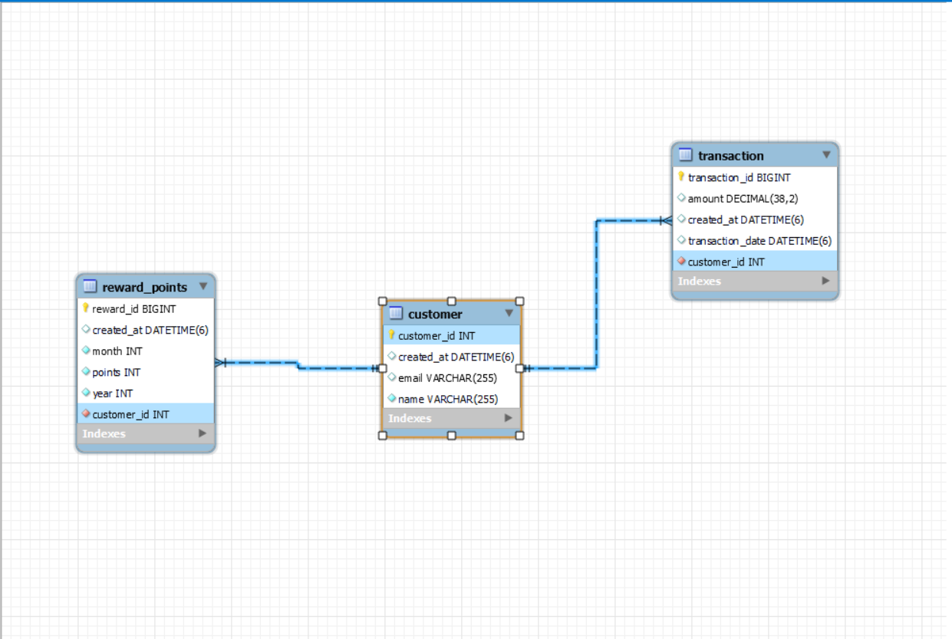

# Low-Level Design (LLD)

## 2.1 Components

### 2.1.1 Models

Customer

Transaction

RewardPoints

### 2.1.2 Repository

CustomerRepository

TransactionRepository

RewardPointsRepository

# 2.1.3 Services

CustomerService

TransactionService

RewardPointsService

# 2.1.4 Controllers

CustomerController

TransactionController

RewardPointsController

# 2.1.5 Utilities

RewardPointsCalculator