# **IT LAB | LAB-1**

K. Sanjay Prabhu

17905528

B.Tech CSE – C

Roll No: 65

Q1.

using System;

namespace l1q1

{

class Program

{

static void Main(string[] args)

{

Console.WriteLine("----L1Q1-------Arithmetic Operations-----");

Console.WriteLine("Enter a:\n");

string a1 = Console.ReadLine();

double a;

double.TryParse(a1, out a);

Console.WriteLine("Enter b:\n");

string b1 = Console.ReadLine();

double b;

double.TryParse(b1, out b);

Console.WriteLine("Press y to continue, n to quit...");

string c = Console.ReadLine();

while (c != "n")

{

Console.WriteLine("1. Add\t 2. Sub\t 3. Mul\t 4. Div\n");

string op = Console.ReadLine();

double res;

switch (op)

{

case "1":

res = a + b;

Console.WriteLine("The result is: {0}", res);

break;

case "2":

res = a - b;

Console.WriteLine("The result is: {0}", res);

break;

case "3":

res = a * b;

Console.WriteLine("The result is: {0}", res);

break;

case "4":

try

{

res = a / b;

Console.WriteLine("The result is: {0}", res);

}

catch (DivideByZeroException e)

{

Console.WriteLine(e.Message);

}

break;

}

Console.WriteLine("Press y to continue, n to quit...");

c = Console.ReadLine();

Console.WriteLine("\n\n");

}

Console.WriteLine("\n------END--------\n");

}

}

}

**INPUT/OUTPUT:**

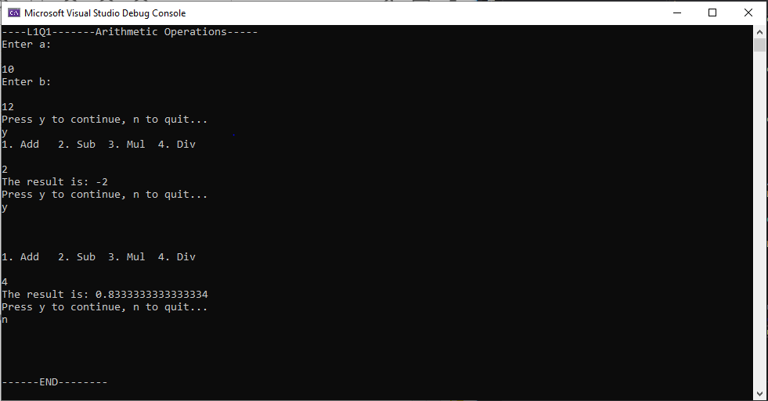

Q2.

using System;

namespace l1q2

{

class Program

{

static void Main(string[] args)

{

Console.WriteLine("\n---L1Q2------DateTime Console Appl-------\n");

Console.WriteLine("Enter a Valid Date as per this format 'DD:MM:YY:hh:mm:ss'");

string date = Console.ReadLine();

Console.WriteLine("\n");

Console.WriteLine("Enter # of ticks [10000000 - 999999999999]");

long t;

string ticks = Console.ReadLine();

long.TryParse(ticks, out t);

while(t<10000000 || t>999999999999)

{

Console.WriteLine("\nPlease enter the ticks within the range of 10000000 - 999999999999!\n");

Console.WriteLine("Enter # of ticks [10000000 - 999999999999]");

ticks = Console.ReadLine();

long.TryParse(ticks, out t);

}

Console.WriteLine("Value of t: {0} \n", t);

//I have used : as a separator hence splitting the string based on :

string[] strsep = date.Split(":");

long dt, mth, yr, hr, min, sec;

long.TryParse(strsep[0], out dt);

long.TryParse(strsep[1], out mth);

long.TryParse(strsep[2], out yr);

long.TryParse(strsep[3], out hr);

long.TryParse(strsep[4], out min);

long.TryParse(strsep[5], out sec);

string str = dt + ":" + mth + ":" + yr + ":" + hr + ":" + min + ":" + sec;

Console.WriteLine("Date and Time before updation: " + str + "\n");

t /= 10000000; /* seconds : To bring it down to Range: 1 - 99999 */

dt += (t / 3600) / 24;

hr += (t / 3600) % 24;

min += (t % 3600) / 60;

sec += (t % 3600) % 60;

str = dt + ":" + mth + ":" + yr + ":" + hr + ":" + min + ":" + sec;

Console.WriteLine("Updated Date and Time: " + str + "\n");

Console.Read();

}

}

}

**INPUT/OUTPUT:**

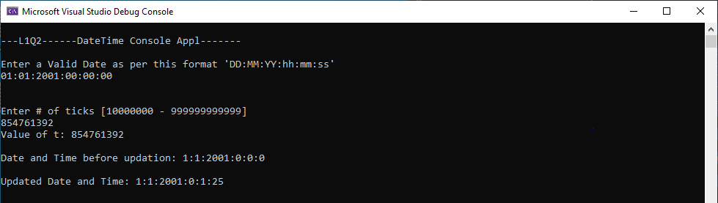

Q3.

**Form1.cs:**

using System;

using System.Collections.Generic;

using System.ComponentModel;

using System.Data;

using System.Drawing;

using System.Linq;

using System.Text;

using System.Threading.Tasks;

using System.Windows.Forms;

namespace l1q3

{

public partial class Form1 : Form

{

public Form1()

{

InitializeComponent();

comboBox1.Items.Add("Level1");

comboBox1.Items.Add("Level2");

comboBox1.Items.Add("Level3");

comboBox1.Items.Add("Level4");

comboBox1.Items.Add("Level5");

comboBox1.Items.Add("Level6");

comboBox1.Items.Add("Level7");

comboBox1.Items.Add("Level8");

comboBox1.Items.Add("Level9");

comboBox1.Items.Add("Level10");

}

private void button1_Click(object sender, EventArgs e)

{

//Submit Button

double salary;

double.TryParse(textBox1.Text,out salary);

string level = comboBox1.Text.ToString();

double bonus=0.0;

if(level=="Level1")

{

bonus = 0.1 * salary;

}

else if(level=="Level2" || level == "Level3" || level == "Level4")

{

bonus = 0.09 * salary;

}

else if(level == "Level5" || level == "Level6" || level == "Level7")

{

bonus = 0.07 * salary;

}

else if(level == "Level8" || level == "Level9" || level == "Level10")

{

bonus = 0.05 * salary;

}

textBox2.Text = bonus.ToString();

}

private void button2_Click(object sender, EventArgs e)

{

textBox1.Text = textBox2.Text = "";

comboBox1.SelectedItem = null;

}

}

}

**Form1.cs [Design]:**

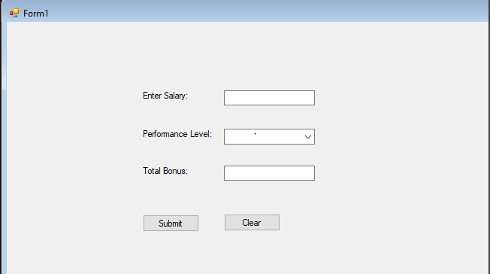

**INPUT/OUTPUT:**

## ComboBox showing 10 levels.

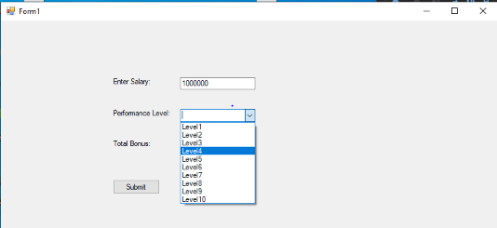

## Submit Button calculates the total bonus as shown.

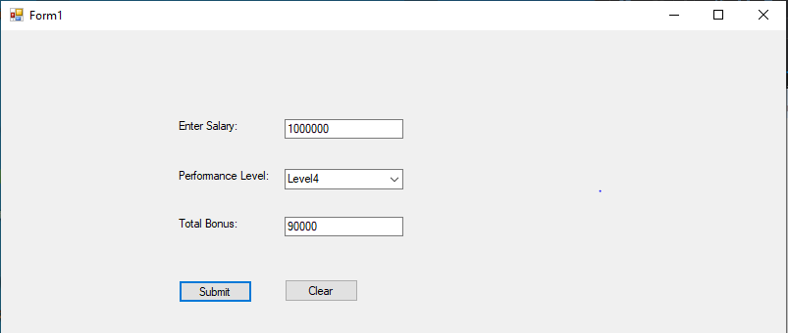

## Clear Button clears everything.

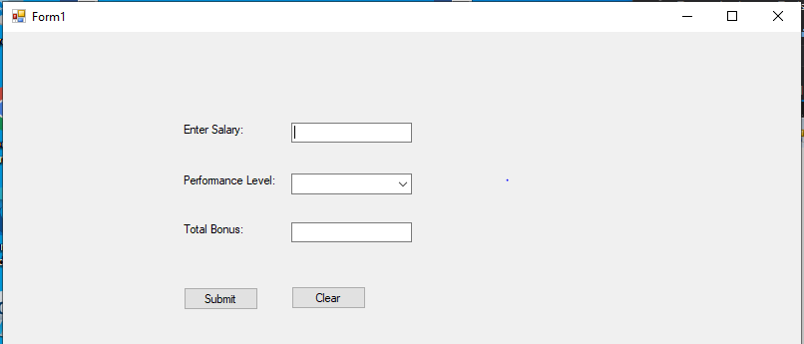

Q4.

**Form1.cs:**

using System;

using System.Collections.Generic;

using System.ComponentModel;

using System.Data;

using System.Drawing;

using System.Linq;

using System.Text;

using System.Threading.Tasks;

using System.Windows.Forms;

namespace l1q4

{

public partial class Form1 : Form

{

public Form1()

{

InitializeComponent();

comboBox1.Items.Add("Lamborghini");

comboBox1.Items.Add("BMW");

comboBox1.Items.Add("Bugatti");

comboBox1.Items.Add("Mercedes");

comboBox2.Items.Add("White");

comboBox2.Items.Add("Black");

comboBox2.Items.Add("Red");

comboBox2.Items.Add("Teal");

comboBox2.Items.Add("Orange");

}

private void button1_Click(object sender, EventArgs e)

{

//Purchase

label5.Text = "Thank you for purchasing!!!";

}

private void button2_Click(object sender, EventArgs e)

{

//Cancel

comboBox1.SelectedItem = comboBox2.SelectedItem = null;

listBox1.SelectedItem = null;

label5.Text = "";

}

private void comboBox1_SelectedIndexChanged(object sender, EventArgs e)

{

//affects the model

//dynamically

string car = comboBox1.Text.ToString();

listBox1.Items.Clear();

textBox1.Text = "";

if(car=="Lamborghini")

{

listBox1.Items.Add("Aventador");

listBox1.Items.Add("Urus");

listBox1.Items.Add("Huracan");

}

else if(car=="BMW")

{

listBox1.Items.Add("507");

listBox1.Items.Add("M535i");

listBox1.Items.Add("M3");

}

else if(car=="Bugatti")

{

listBox1.Items.Add("Veyron");

listBox1.Items.Add("Chiron");

listBox1.Items.Add("Divo");

}

else if(car=="Mercedes")

{

listBox1.Items.Add("S-Class");

listBox1.Items.Add("A-Class");

listBox1.Items.Add("E-Class");

}

}

private void listBox1_SelectedIndexChanged(object sender, EventArgs e)

{

string car = comboBox1.Text.ToString();

int model = listBox1.SelectedIndex;

string price="0.00";

if(model==0)

{

price = "1000000";

}

else if(model==1)

{

price = "800000";

}

else if(model==2)

{

price = "500000";

}

textBox1.Text = price;

}

}

}

**Form1.cs [Design]:**

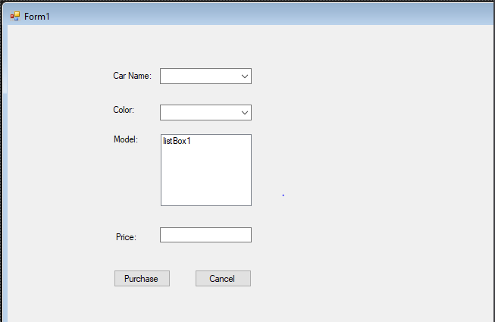

**INPUT/OUTPUT:**

1. Drag and Drop for Car Names:

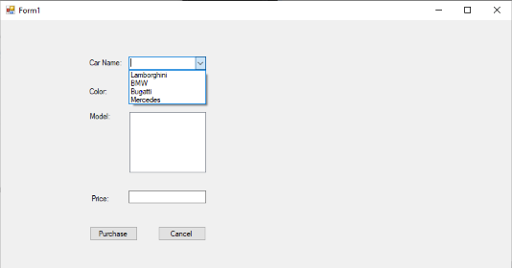

1. Drag and Drop for Car Colors:

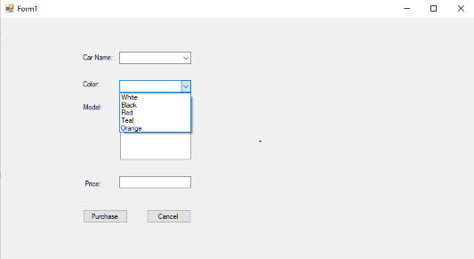

1. ListBox ( dynamically changes for the selected names):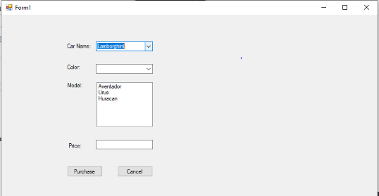

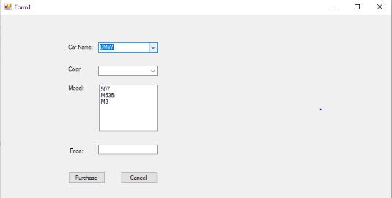

1. Price Is set dynamically according to the model:

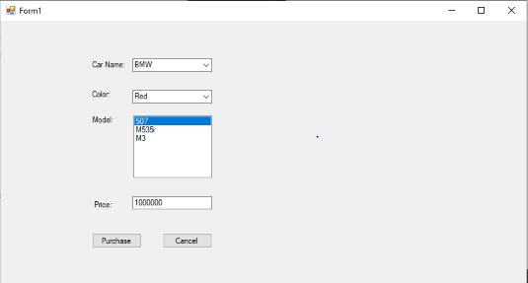

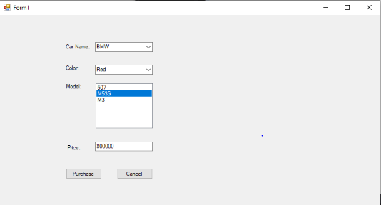

1. Purchase Button:

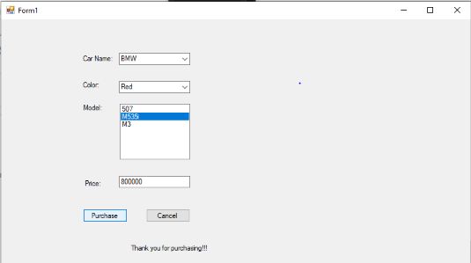

1. Cancel Button:

