# **IT LAB | LAB-2**

K. Sanjay Prabhu

17905528

B.Tech CSE – C

Roll No: 65

Q1.

using System;

namespace l2q1

{

public delegate void PriceChangedEventHandler(double v);

class Item

{

private string name;

public double price;

public event PriceChangedEventHandler PriceChanged;

public double Price

{

get

{

return price;

}

set

{

price = value;

if(PriceChanged!=null)

{

PriceChanged(value);

}

}

}

}

class Program

{

public static void PriceChangeDetected(double value)

{

Console.WriteLine("Price Change Detected! The new price is: " + value);

}

static void Main(string[] args)

{

double price = 10.0;

Item item = new Item();

item.PriceChanged += PriceChangeDetected;

item.Price = 100.0;

item.Price = 1000.0;

}

}

}

**INPUT/OUTPUT:**

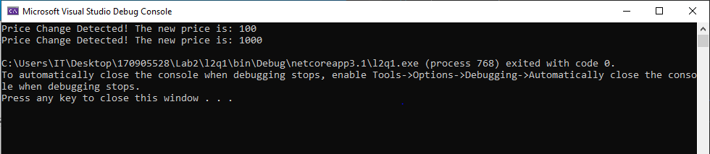

Q2.

using System;

namespace l2q2

{

public delegate void CostEventHandler();

class Item

{

private string name;

public Decimal cost;

public event CostEventHandler CostEvent;

public string Name { get; set; }

public Decimal Cost

{

get

{

return cost;

}

set

{

if(value<0)

{

cost = 0;

if(CostEvent!=null)

{

CostEvent();

}

}

else

{

cost = value;

}

}

}

}

class Program

{

public static void CostNegativeDetected()

{

Console.WriteLine("\nYou have entered negative cost. Reminder: Only Positive values allowed. Negative values will be reset to 0\n");

}

public static Decimal CalcGst(Decimal cost)

{

cost = 8 * cost;

cost = cost / 100;

return cost;

}

static void Main(string[] args)

{

Item item = new Item();

item.Cost = 100;

item.CostEvent += CostNegativeDetected;

Console.WriteLine("Trial1\n");

Console.WriteLine("Cost: " + item.Cost);

Console.WriteLine("\nGST is: " + CalcGst(item.Cost));

Console.WriteLine("--------------------");

Console.WriteLine("\n\nTrial2\n");

item.Cost = -10;

Console.WriteLine("Cost: " + item.Cost);

Console.WriteLine("\nGST is: " + CalcGst(item.Cost));

}

}

}

**INPUT/OUTPUT:**

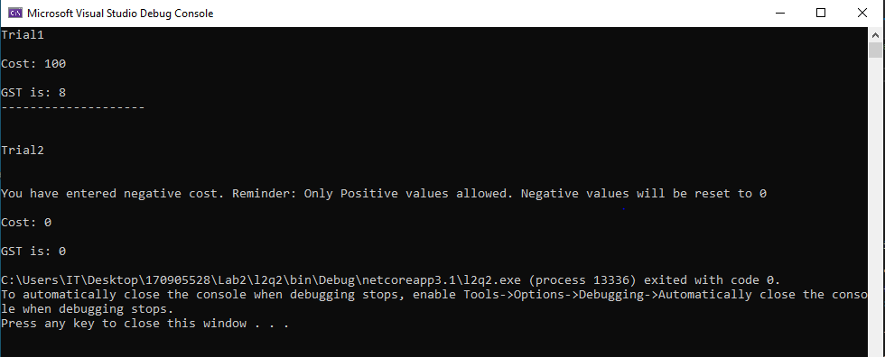

Q3.

using System;

namespace l2q3

{

public delegate void TrafficDel();

class TrafficSignal

{

public void Red()

{

Console.WriteLine("Stop.");

}

public void Yellow()

{

Console.WriteLine("Wait.....");

}

public void Green()

{

Console.WriteLine("GO!!!");

}

}

class Program

{

static void Main(string[] args)

{

TrafficSignal signal = new TrafficSignal();

Console.WriteLine("Using one del....\n");

TrafficDel del = new TrafficDel(signal.Red);

del();

del = new TrafficDel(signal.Yellow);

del();

del = new TrafficDel(signal.Red);

del();

Console.WriteLine("\n\nUsing multiple dels...\n");

TrafficDel red = new TrafficDel(signal.Red);

TrafficDel yel = new TrafficDel(signal.Yellow);

TrafficDel grn = new TrafficDel(signal.Green);

red();

yel();

grn();

}

}

}

**INPUT/OUTPUT:**

