# **IT LAB | LAB-3**

K. Sanjay Prabhu

17905528

B.Tech CSE – C

Roll No: 65

Q1.

**Magazine.aspx:**

<%@ Page Language="C#" AutoEventWireup="true" CodeBehind="Magazine.aspx.cs" Inherits="l3q1.Magazine" %>

<!DOCTYPE html>

<html xmlns="http://www.w3.org/1999/xhtml">

<head runat="server">

<title></title>

</head>

<body>

<form id="form1" runat="server">

<div>

<h1>Create your own front cover!!</h1>

<h3>Fonts</h3>

<asp:Label ID="lblFontFam" runat="server" Width="120px">

Font Family:

</asp:Label>

<asp:DropDownList ID="dpdFontFam" runat="server" OnSelectedIndexChanged="dpdFontFam_SelectedIndexChanged" AutoPostBack="true"></asp:DropDownList>

<br />

<asp:Label ID="lblFontSize" runat="server" Width="120px">

Font Size:

</asp:Label>

<asp:TextBox ID="txtFontSize" runat="server" TextMode="Number"></asp:TextBox>

<br />

<asp:Label ID="lblFontColor" runat="server" Width="120px">

Font Color:

</asp:Label>

<asp:DropDownList ID="dpdFontColor" runat="server" OnSelectedIndexChanged="dpdFontColor_SelectedIndexChanged" AutoPostBack="true"></asp:DropDownList>

<br />

<h3>Themes and Styles</h3>

<asp:Label ID="lblBG" runat="server" Width="120px">

BG Color:

</asp:Label>

<asp:DropDownList ID="dpdBG" runat="server" OnSelectedIndexChanged="dpdBG_SelectedIndexChanged"></asp:DropDownList>

<br />

<asp:Label ID="lblBorder" runat="server" Width="120px">

Border Style:

</asp:Label>

<asp:RadioButtonList ID="rblBorder" runat="server"></asp:RadioButtonList>

<h3>Image</h3>

<asp:Label ID="lblImg" runat="server" Width="120px">

Select an image:

</asp:Label>

<asp:DropDownList ID="dpdImg" runat="server" OnSelectedIndexChanged="dpdImg_SelectedIndexChanged"></asp:DropDownList>

<h3>Write a Title:</h3>

<asp:TextBox ID="txtInput" runat="server" Height="120px" Width="200px"></asp:TextBox>

<br /><br />

<asp:Button ID="btnSubmit" runat="server" Text="Submit" OnClick="btnSubmit_Click" />

<asp:Panel ID="pnl" runat="server" style="left: 450px; position: absolute; top: 100px;" Height="500px" Width="300px" HorizontalAlign="Center">

<asp:Label ID="lblTitle" runat="server" Height="150px" Width="256px"></asp:Label>

<br /><br /><br />

<asp:Image ID="img" runat="server" Height="160px" Width="212px"/>

</asp:Panel>

</div>

</form>

</body>

</html>

**Magazine.aspx.cs:**

using System;

using System.Collections.Generic;

using System.ComponentModel;

using System.Linq;

using System.Data;

using System.Text;

using System.IO;

using System.Web;

using System.Web.UI;

using System.Web.UI.WebControls;

using System.Drawing;

using System.Drawing.Text;

using System.Windows;

using System.Threading.Tasks;

namespace l3q1

{

public partial class Magazine : System.Web.UI.Page

{

private Style primaryStyle = new Style();

protected void Page_Load(object sender, EventArgs e)

{

if(!this.IsPostBack)

{

//Entire collection of fonts

InstalledFontCollection fontCollection = new InstalledFontCollection();

FontFamily[] fonts = fontCollection.Families;

for(int i=0;i<fonts.Length;i++)

{

dpdFontFam.Items.Add(fonts[i].Name);

}

//All colors for font and background

ListItem item = new ListItem();

foreach(KnownColor color in Enum.GetValues(typeof(KnownColor)))

{

item = new ListItem(Enum.GetName(typeof(KnownColor), color), color.ToString());

dpdBG.Items.Add(item);

dpdFontColor.Items.Add(item);

}

//Radio Button List for Border Style

item = new ListItem();

item.Text = BorderStyle.None.ToString();

item.Value = ((int)BorderStyle.None).ToString();

rblBorder.Items.Add(item);

item = new ListItem();

item.Text = BorderStyle.Double.ToString();

item.Value = ((int)BorderStyle.Double).ToString();

rblBorder.Items.Add(item);

item = new ListItem();

item.Text = BorderStyle.Dotted.ToString();

item.Value = ((int)BorderStyle.Dotted).ToString();

rblBorder.Items.Add(item);

item = new ListItem();

item.Text = BorderStyle.Groove.ToString();

item.Value = ((int)BorderStyle.Groove).ToString();

rblBorder.Items.Add(item);

//Selecting Images from imgs directory inside the c# project

DirectoryInfo dir = new DirectoryInfo(Server.MapPath("~/imgs"));

dpdImg.DataSource = dir.GetFiles("*.jpg");

dpdImg.DataBind();

}

}

protected void btnSubmit_Click(object sender, EventArgs e)

{

//Panel background color

pnl.BackColor = Color.FromName(dpdBG.SelectedItem.Text);

pnl.BorderStyle = (BorderStyle)Int32.Parse(rblBorder.SelectedItem.Value);

//Font details on Label title

lblTitle.Font.Name = dpdFontFam.SelectedItem.Text;

lblTitle.Font.Size = FontUnit.Point(Int32.Parse(txtFontSize.Text));

lblTitle.Text = txtInput.Text;

primaryStyle.ForeColor = Color.FromName(dpdFontColor.SelectedItem.Text);

lblTitle.ApplyStyle(primaryStyle);

//Image

img.ImageUrl = "~/imgs/" + dpdImg.SelectedItem.Text;

}

}

}

**INPUT/OUTPUT:**

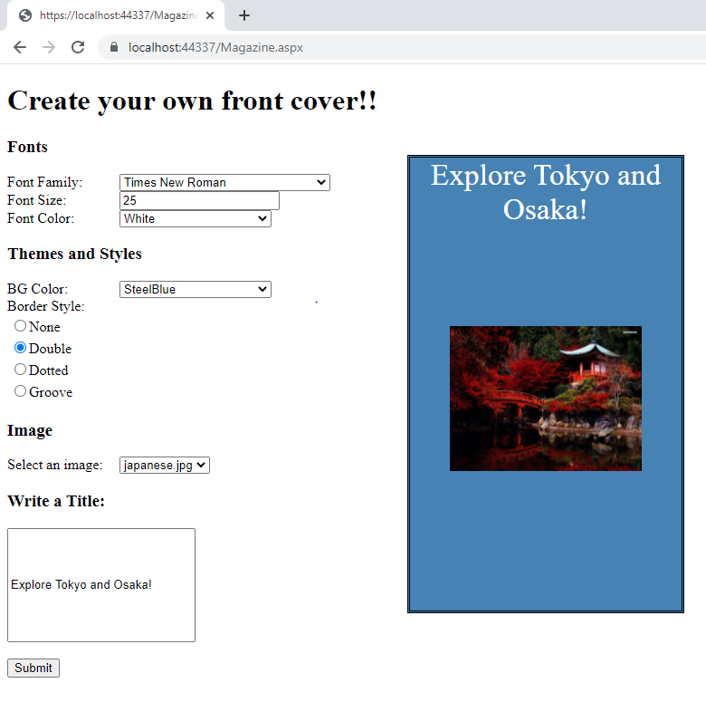

Q2.

**Employee.aspx:**

<%@ Page Language="C#" AutoEventWireup="true" CodeBehind="Employee.aspx.cs" Inherits="l3q2.Employee" %>

<!DOCTYPE html>

<html xmlns="http://www.w3.org/1999/xhtml">

<head runat="server">

<title></title>

</head>

<body>

<form id="form1" runat="server">

<div>

<asp:Label ID="lblID" runat="server" Width="120px">

Employee ID:

</asp:Label>

<asp:DropDownList ID="dpdID" runat="server" OnSelectedIndexChanged="dpdID_SelectedIndexChanged" AutoPostBack="true" AppendDataBoundItems="true">

<asp:ListItem id="liID" runat="server" Value="" Text="Select an ID"></asp:ListItem>

</asp:DropDownList>

<br />

<asp:Label ID="lblName" runat="server" Width="120px">

Employee Name:

</asp:Label>

<asp:TextBox ID="txtName" runat="server"></asp:TextBox>

<br />

<asp:Label ID="lblDOJ" runat="server" Width="120px">

DOJ(dd-mm-yyyy):

</asp:Label>

<asp:TextBox ID="txtDOJ" runat="server"></asp:TextBox>

<br /><br />

<asp:Button ID="btnAIE" runat="server" Text="Am I Eligible?" OnClick="btnAIE_Click"/>

<br />

<asp:Panel ID="pnl" style="LEFT: 350px; POSITION: absolute; TOP: 16px" runat="server"

Height="307px" Width="339px" HorizontalAlign="Center">

<asp:Image id="img" runat="server" Height="500px" Width="400px" />

<br /><br /><br />

<asp:Label ID="lblMsg" runat="server"></asp:Label>

</asp:Panel>

</div>

</form>

</body>

</html>

**Employee.aspx.cs:**

using System;

using System.Collections.Generic;

using System.Linq;

using System.Web;

using System.Web.UI;

using System.Web.UI.WebControls;

using System.IO;

namespace l3q2

{

public partial class Employee : System.Web.UI.Page

{

protected void Page_Load(object sender, EventArgs e)

{

if (!this.IsPostBack)

{

dpdID.Items.Add("170901001");

dpdID.Items.Add("170901002");

dpdID.Items.Add("170901003");

}

}

protected void dpdID_SelectedIndexChanged(object sender, EventArgs e)

{

img.ImageUrl = "~/imgs/" + dpdID.SelectedItem.Text + ".jpg";

}

protected void btnAIE_Click(object sender, EventArgs e)

{

DateTime doj = DateTime.Parse(txtDOJ.Text);

if (DateTime.Now.Subtract(doj).Days > 1825)

{

lblMsg.Text = "Yes";

}

else

{

lblMsg.Text = "No";

}

}

}

}

**INPUT/OUTPUT:**

## <=5 years of experience

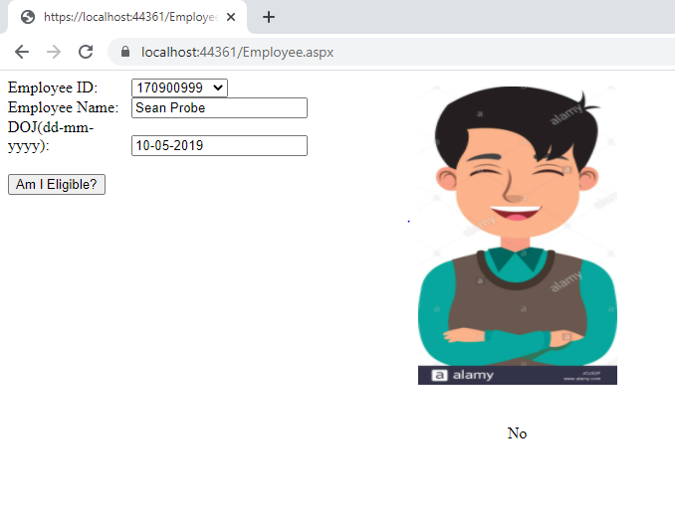

## >5 years of experience

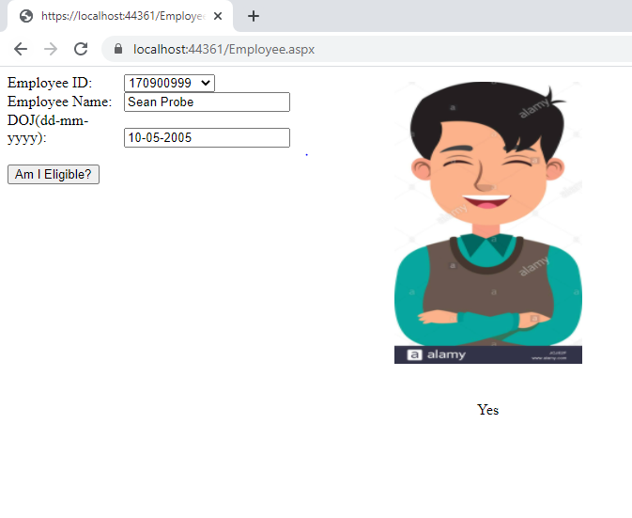

Q3.

**ECardGenerator.aspx:**

<%@ Page Language="C#" AutoEventWireup="true" CodeBehind="ECardGenerator.aspx.cs" Inherits="l3q3.ECardGenerator" %>

<!DOCTYPE html>

<html xmlns="http://www.w3.org/1999/xhtml">

<head runat="server">

<title></title>

<link rel="stylesheet" href="StyleSheet1.css" type="text/css" />

</head>

<body>

<form id="form1" runat="server">

<div>

<div class="div-bg">

<h1>Generate your personal E-Card!</h1>

<h3>Fonts</h3>

<asp:Label ID="lblFontFam" runat="server" Width="120px" Font-Bold="true">

Font:

</asp:Label>

<asp:dropdownlist ID="dpdFontFam" runat="server" Height="22px" Width="194px"></asp:dropdownlist>

<br /><br />

<asp:Label ID="lblFontSize" runat="server" Width="120px" Font-Bold="true">

Font Size:

</asp:Label>

<br />

<asp:textbox ID="txtFontSize" runat="server" TextMode="Number" Width="183px"></asp:textbox>

<br /><br />

<asp:Label ID="lblFontColor" runat="server" Width="120px" Font-Bold="true">

Font Color:

</asp:Label>

<br />

<asp:DropDownList ID="dpdFontColor" runat="server" Height="22px" Width="194px"></asp:DropDownList>

<br /><br />

<h3>Themes and Styles</h3>

<asp:Label ID="lblBG" runat="server" Width="120px" Font-Bold="true">

Background Color:

</asp:Label>

<br />

<asp:dropdownlist ID="dpdBG" runat="server" Height="22px" Width="194px"></asp:dropdownlist>

<br /><br />

<asp:Label ID="lblBorder" runat="server" Width="130px" Font-Bold="true">

Choose a border style:

</asp:Label>

<br />

<asp:radiobuttonlist ID="rblBorder" runat="server" Height="59px" Width="177px" Font-Size="X-Small"></asp:radiobuttonlist>

<asp:checkbox ID="chkPicture" runat="server" Text="Add the Default Picture" Font-Bold="true"></asp:checkbox>

<br /><br />

<asp:Label ID="lblGreet" runat="server" Width="180px" Font-Bold="true">

Enter the greeting text below:

</asp:Label>

<br />

<asp:textbox ID="txtGreeting" runat="server" Height="85px" Width="240px" TextMode="MultiLine"></asp:textbox>

<br /><br />

<asp:button ID="cmdUpdate" runat="server" Height="24px" Width="71px" Text="Update" onclick="cmdUpdate_Click"></asp:button>

</div>

<asp:panel ID="pnlCard" CssClass="pnl-bg" runat="server" Height="507px" Width="339px" HorizontalAlign="Center">

<br />&nbsp;

<asp:Label ID="lblGreeting" runat="server" Height="150px" Width="256px"></asp:Label>

<br /><br /><br />

<asp:Image ID="imgDefault" runat="server" Height="160px" Width="212px" Visible="False"></asp:Image>

</asp:panel>

</div>

</form>

</body>

</html>

**ECardGenerator.aspx.cs:**

using System;

using System.Collections;

using System.ComponentModel;

using System.Data;

using System.Drawing;

using System.Drawing.Text;

using System.Web;

using System.Web.SessionState;

using System.Web.UI;

using System.Web.UI.WebControls;

using System.Web.UI.HtmlControls;

namespace l3q3

{

public partial class ECardGenerator : System.Web.UI.Page

{

private Style primaryStyle = new Style();

protected void Page_Load(object sender, EventArgs e)

{

if (this.IsPostBack == false)

{

//Entire collection of fonts

InstalledFontCollection fontCollection = new InstalledFontCollection();

FontFamily[] fonts = fontCollection.Families;

for (int i = 0; i < fonts.Length; i++)

{

dpdFontFam.Items.Add(fonts[i].Name);

}

//All colors for font and background

ListItem item = new ListItem();

foreach (KnownColor color in Enum.GetValues(typeof(KnownColor)))

{

item = new ListItem(Enum.GetName(typeof(KnownColor), color), color.ToString());

dpdBG.Items.Add(item);

dpdFontColor.Items.Add(item);

}

//Radio Button List for Border Style

item = new ListItem();

item.Text = BorderStyle.None.ToString();

item.Value = ((int)BorderStyle.None).ToString();

rblBorder.Items.Add(item);

item = new ListItem();

item.Text = BorderStyle.Double.ToString();

item.Value = ((int)BorderStyle.Double).ToString();

rblBorder.Items.Add(item);

item = new ListItem();

item.Text = BorderStyle.Dotted.ToString();

item.Value = ((int)BorderStyle.Dotted).ToString();

rblBorder.Items.Add(item);

item = new ListItem();

item.Text = BorderStyle.Groove.ToString();

item.Value = ((int)BorderStyle.Groove).ToString();

rblBorder.Items.Add(item);

// Select the first border option.

rblBorder.SelectedIndex = 0;

// Set the picture.

imgDefault.ImageUrl = "defaultpic.png";

}

}

protected void cmdUpdate_Click(object sender, System.EventArgs e)

{

// Update the color.

pnlCard.BackColor = Color.FromName(dpdBG.SelectedItem.Text);

// Update the font.

lblGreeting.Font.Name = dpdFontFam.SelectedItem.Text;

lblGreeting.Font.Size = FontUnit.Point(Int32.Parse(txtFontSize.Text));

primaryStyle.ForeColor = Color.FromName(dpdFontColor.SelectedItem.Text);

lblGreeting.ApplyStyle(primaryStyle);

// Update the border style.

pnlCard.BorderStyle = (BorderStyle)Int32.Parse(rblBorder.SelectedItem.Value);

// Update the picture.

if(chkPicture.Checked == true)

{

imgDefault.Visible = true;

}

else

{

imgDefault.Visible = false;

}

// Set the text.

lblGreeting.Text = txtGreeting.Text;

}

}

}

**INPUT/OUTPUT:**

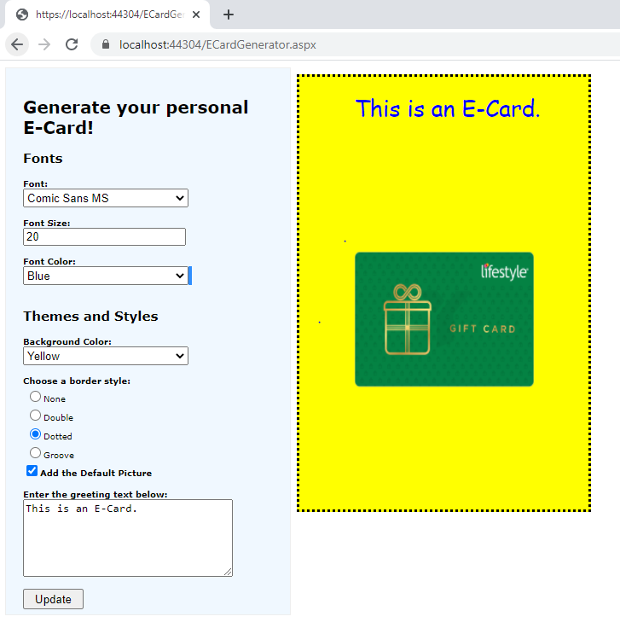

Q4.

**Captcha.aspx:**

<%@ Page Language="C#" AutoEventWireup="true" CodeBehind="Captcha.aspx.cs" Inherits="l3q4.Captcha" %>

<!DOCTYPE html>

<html xmlns="http://www.w3.org/1999/xhtml">

<head runat="server">

<title></title>

</head>

<body>

<form id="form1" runat="server">

<div>

<h2>Test the Captcha!</h2>

<asp:Image ID="imgCaptcha" runat="server" />

<br />

<asp:TextBox ID="txt2" runat="server"></asp:TextBox>

<br /><br />

<asp:Button ID="btn1" runat="server" Text="Check" OnClick="btn1_Click" EnableViewState="true"/>

<br /><br />

<asp:Label ID="lbl1" runat="server"></asp:Label>

</div>

</form>

</body>

</html>

**Captcha.aspx.cs:**

using System;

using System.Collections.Generic;

using System.Linq;

using System.Web;

using System.Web.UI;

using System.Web.UI.WebControls;

namespace l3q4

{

public partial class Captcha : System.Web.UI.Page

{

private int count;

protected void Page_Load(object sender, EventArgs e)

{

if(!this.IsPostBack)

{

count = 0;

ViewState["count"] = count;

lbl1.Text = "You have 3 attempts remaining.";

imgCaptcha.ImageUrl = "captcha.jfif";

}

}

protected void btn1_Click(object sender, EventArgs e)

{

if(txt2.Text != "83tsU")

{

count = (int)ViewState["count"];

count += 1;

ViewState["count"] = count;

lbl1.Text = "You have " + (3 - count) + " attempts remaining.";

}

else

{

count = 0;

ViewState["count"] = count;

lbl1.Text = "Successful!";

}

if (count == 3)

{

txt2.Enabled = false;

lbl1.Text = "You have crossed the maximum attempts (3) !!! ;_;";

}

}

}

}

**INPUT/OUTPUT:**

## Successfull

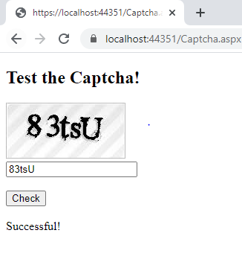

## Unsuccessfull attempt 1

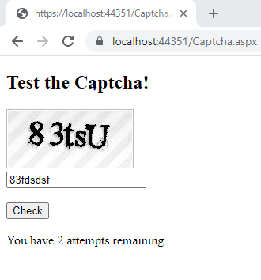

## Text Box disabled after 3 failed attempts

