# **IT LAB | LAB-4**

K. Sanjay Prabhu

17905528

B.Tech CSE – C

Roll No: 65

Q1.

**FirstPage.aspx:**

<%@ Page Language="C#" AutoEventWireup="true" CodeBehind="FirstPage.aspx.cs" Inherits="l4q1.QueryString" %>

<!DOCTYPE html>

<html xmlns="http://www.w3.org/1999/xhtml">

<head runat="server">

<title></title>

</head>

<body>

<form id="form1" runat="server">

<div>

<asp:Label ID="lblMan" runat="server" Width="210px">

Select a Car Manufacturer:

</asp:Label>

<asp:DropDownList ID="dpdManu" runat="server" OnSelectedIndexChanged="dpdManu_SelectedIndexChanged" AutoPostBack="true"></asp:DropDownList>

<br /><br />

<asp:TextBox ID="txtModel" runat="server"></asp:TextBox>

</div>

</form>

</body>

</html>

**FirstPage.aspx.cs:**

using System;

using System.Collections.Generic;

using System.Linq;

using System.Web;

using System.Web.UI;

using System.Web.UI.WebControls;

namespace l4q1

{

public partial class QueryString : System.Web.UI.Page

{

protected void Page_Load(object sender, EventArgs e)

{

if(!this.IsPostBack)

{

dpdManu.Items.Add("");

dpdManu.Items.Add("Tesla");

dpdManu.Items.Add("Mercedes");

dpdManu.Items.Add("BMW");

}

}

protected void dpdManu_SelectedIndexChanged(object sender, EventArgs e)

{

string manu = dpdManu.SelectedItem.ToString();

if(manu=="Tesla")

{

txtModel.Text = "Model S";

}

else if(manu=="Mercedes")

{

txtModel.Text = "S-Class";

}

else if(manu=="BMW")

{

txtModel.Text = "Model X1";

}

Console.WriteLine("Here");

Response.Redirect("SecondPage.aspx?Manu=" + dpdManu.SelectedItem.ToString() + "&Model=" + txtModel.Text);

}

}

}

**SecondPage.aspx:**

<%@ Page Language="C#" AutoEventWireup="true" CodeBehind="SecondPage.aspx.cs" Inherits="l4q1.SecondPage" %>

<!DOCTYPE html>

<html xmlns="http://www.w3.org/1999/xhtml">

<head runat="server">

<title></title>

</head>

<body>

<form id="form1" runat="server">

<div>

<asp:Label ID="lblManu" runat="server"></asp:Label>

</div>

</form>

</body>

</html>

**SecondPage.aspx.cs:**

using System;

using System.Collections.Generic;

using System.Linq;

using System.Web;

using System.Web.UI;

using System.Web.UI.WebControls;

namespace l4q1

{

public partial class SecondPage : System.Web.UI.Page

{

protected void Page_Load(object sender, EventArgs e)

{

lblManu.Text = "The manufacturer is: " + Request.QueryString["Manu"] + " and the model is: " + Request.QueryString["Model"];

}

}

}

**INPUT/OUTPUT:**

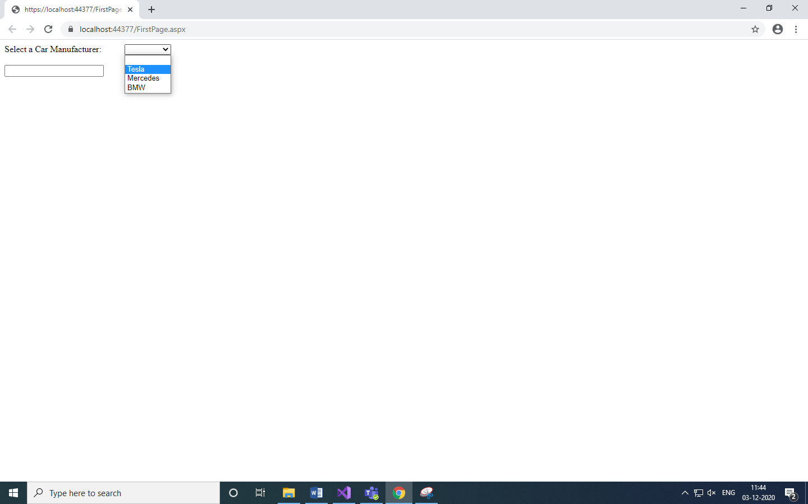

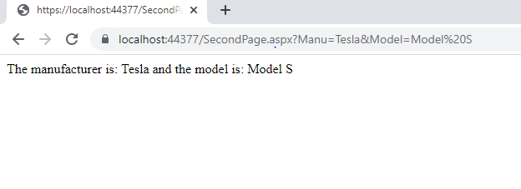

Q2.

**FirstPage.aspx:**

<%@ Page Language="C#" AutoEventWireup="true" CodeBehind="FirstPage.aspx.cs" Inherits="l4q2.FirstPage" %>

<!DOCTYPE html>

<html xmlns="http://www.w3.org/1999/xhtml">

<head runat="server">

<title></title>

</head>

<body>

<form id="form1" runat="server">

<div>

<asp:Label ID="lblName" runat="server" Width="120px">

Name:

</asp:Label>

<asp:TextBox ID="txtName" runat="server"></asp:TextBox>

<br />

<asp:Label ID="lblRNO" runat="server" Width="120px">

RNO:

</asp:Label>

<asp:TextBox ID="txtRNO" runat="server"></asp:TextBox>

<br />

<asp:Label ID="lblSub" runat="server" Width="120px">

Subjects:

</asp:Label>

<asp:DropDownList ID="dpdSub" runat="server" OnSelectedIndexChanged="dpdSub_SelectedIndexChanged"></asp:DropDownList>

<br /><br />

<asp:Button ID="btnPage1" runat="server" Text="Submit" OnClick="btnPage1_Click"/>

</div>

</form>

</body>

</html>

**FirstPage.aspx.cs:**

using System;

using System.Collections.Generic;

using System.Linq;

using System.Web;

using System.Web.UI;

using System.Web.UI.WebControls;

namespace l4q2

{

public partial class FirstPage : System.Web.UI.Page

{

protected void Page_Load(object sender, EventArgs e)

{

if (!this.IsPostBack)

{

dpdSub.Items.Add("Maths");

dpdSub.Items.Add("Physics");

dpdSub.Items.Add("Chem");

dpdSub.Items.Add("Bio");

dpdSub.Items.Add("English");

dpdSub.Items.Add("Computers");

}

}

protected void dpdSub_SelectedIndexChanged(object sender, EventArgs e)

{

}

protected void btnPage1_Click(object sender, EventArgs e)

{

Session["Name"] = txtName.Text;

Session["Roll"] = txtRNO.Text;

Session["Subject"] = dpdSub.SelectedItem.ToString();

Response.Redirect("SecondPage.aspx");

}

}

}

**SecondPage.aspx:**

page<%@ Page Language="C#" AutoEventWireup="true" CodeBehind="SecondPage.aspx.cs" Inherits="l4q2.Second" %>

<!DOCTYPE html>

<html xmlns="http://www.w3.org/1999/xhtml">

<head runat="server">

<title></title>

</head>

<body>

<form id="form1" runat="server">

<div>

<asp:Label ID="lblFirst" runat="server"></asp:Label>

<br />

<asp:Button ID="btnSecond" runat="server" Text="+1 Counter" OnClick="btnSecond_Click"/>

<br /><br />

<asp:Label ID="lblCounter" runat="server"></asp:Label>

</div>

</form>

</body>

</html>

**SecondPAge.aspx.cs:**

using System;

using System.Collections.Generic;

using System.Linq;

using System.Web;

using System.Web.UI;

using System.Web.UI.WebControls;

namespace l4q2

{

public partial class Second : System.Web.UI.Page

{

protected void Page_Load(object sender, EventArgs e)

{

lblFirst.Text = "Name: " + Session["Name"] + "\n";

lblFirst.Text += "\nRoll: " + Session["Roll"] + "\n";

lblFirst.Text += "\nSubject: " + Session["Subject"] + "\n";

HttpCookie cookie = new HttpCookie("CookieTest");

cookie["counter"] = "0";

//cookie["test"] = "1";

lblCounter.Text = "0";

Response.Cookies.Add(cookie);

}

protected void btnSecond_Click(object sender, EventArgs e)

{

HttpCookie cookie = Request.Cookies["CookieTest"];

if (cookie != null)

{

int counter = int.Parse(cookie["counter"]);

counter += 1;

cookie["counter"] = counter.ToString();

Response.Cookies.Add(cookie);

lblCounter.Text = cookie["counter"];

}

}

}

}

**INPUT/OUTPUT:**

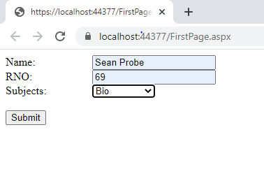

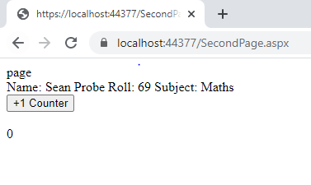

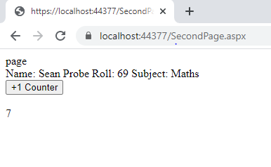

Q3.

**Shopping.aspx:**

<%@ Page Language="C#" AutoEventWireup="true" CodeBehind="Shopping.aspx.cs" Inherits="l4q3.Shopping" %>

<!DOCTYPE html>

<html xmlns="http://www.w3.org/1999/xhtml">

<head runat="server">

<title></title>

</head>

<body>

<form id="form1" runat="server">

<div>

<asp:Label ID="lblName" runat="server" Width="120px">

Name:

</asp:Label>

<asp:TextBox ID="txtName" runat="server"></asp:TextBox>

<br />

<asp:Label ID="lblProds" runat="server" Width="120px">

Select:

</asp:Label>

<asp:DropDownList ID="dpdProds" runat="server"></asp:DropDownList>

<br />

<asp:Label ID="lblQuant" runat="server" Width="120px">

Qunatity:

</asp:Label>

<asp:TextBox ID="txtQuant" runat="server" TextMode="Number"></asp:TextBox>

<br />

<asp:Button ID="btnSubmit" runat="server" Text="Continue Shopping" OnClick="btnSubmit_Click"/>

<br />

<asp:Label ID="lblCart" runat="server"></asp:Label>

</div>

</form>

</body>

</html>

**Shopping.aspx.cs:**

using System;

using System.Collections.Generic;

using System.Linq;

using System.Web;

using System.Web.UI;

using System.Web.UI.WebControls;

namespace l4q3

{

public partial class Shopping : System.Web.UI.Page

{

protected void Page_Load(object sender, EventArgs e)

{

HttpCookie cookie;

if (!this.IsPostBack)

{

dpdProds.Items.Add("Mobile");

dpdProds.Items.Add("Laptop");

dpdProds.Items.Add("Pendrive");

if (Request.Cookies["Cart"] == null)

{

cookie = new HttpCookie("Cart");

cookie["Name"] = "-";

cookie["mobile"] = "0";

cookie["laptop"] = "0";

cookie["pendrive"] = "0";

cookie.Expires = DateTime.Now.AddYears(2);

Response.Cookies.Add(cookie);

}

else

{

cookie = Request.Cookies["Cart"];

lblCart.Text = "Welcome back " + cookie["Name"] + "\n";

lblCart.Text += "Your shopping cart is as follows: \n";

lblCart.Text += "Mobiles: " + cookie["mobile"];

lblCart.Text += "\nLaptops: " + cookie["laptop"];

lblCart.Text += "\nPendrives: " + cookie["pendrive"];

}

}

else

{

cookie = Request.Cookies["Cart"];

lblCart.Text = "Welcome back " + cookie["Name"] + "\n";

lblCart.Text += "Your shopping cart is as follows: \n";

lblCart.Text += "Mobiles: " + cookie["mobile"];

lblCart.Text += "\nLaptops: " + cookie["laptop"];

lblCart.Text += "\nPendrives: " + cookie["pendrive"];

}

}

protected void btnSubmit_Click(object sender, EventArgs e)

{

HttpCookie cookie = Request.Cookies["Cart"];

string name = txtName.Text;

cookie["Name"] = name;

if (dpdProds.SelectedItem.ToString().Equals("Mobile"))

{

cookie["mobile"] = (int.Parse(cookie["mobile"]) + int.Parse(txtQuant.Text)).ToString();

}

else if (dpdProds.SelectedItem.ToString().Equals("Laptop"))

{

cookie["laptop"] = (int.Parse(cookie["laptop"]) + int.Parse(txtQuant.Text)).ToString(); ;

}

else if (dpdProds.SelectedItem.ToString().Equals("Pendrive"))

{

cookie["pendrive"] = (int.Parse(cookie["pendrive"]) + int.Parse(txtQuant.Text)).ToString(); ;

}

cookie.Expires = DateTime.Now.AddYears(2);

Response.Cookies.Add(cookie);

lblCart.Text = "Welcome back " + cookie["Name"] + "\n";

lblCart.Text += "Your shopping cart is as follows: \n";

lblCart.Text += "Mobiles: " + cookie["mobile"];

lblCart.Text += "\nLaptops: " + cookie["laptop"];

lblCart.Text += "\nPendrives: " + cookie["pendrive"];

}

}

}

**INPUT/OUTPUT:**

## Cookie was acitivated hence last activity was stored

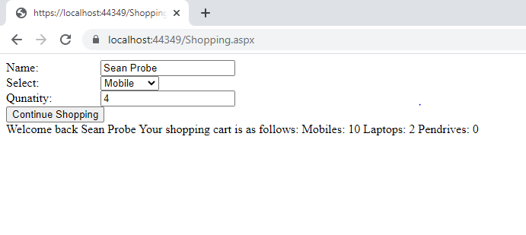

Q4.

**Login.aspx:**

<%@ Page Language="C#" AutoEventWireup="true" CodeBehind="LoginPage.aspx.cs" Inherits="l4q4.LoginPage" %>

<!DOCTYPE html>

<html xmlns="http://www.w3.org/1999/xhtml">

<head runat="server">

<title></title>

</head>

<body>

<form id="form1" runat="server">

<div>

<h1>Login Page</h1>

<asp:Label ID="lblUName" runat="server" Width="120px">

Username:

</asp:Label>

<asp:TextBox ID="txtUName" runat="server"></asp:TextBox>

<br />

<asp:Label ID="lblPswd" runat="server" Width="120px">

Password:

</asp:Label>

<asp:TextBox ID="txtPswd" runat="server" TextMode="Password"></asp:TextBox>

<br /><br />

<asp:Button ID="btnLogin" runat="server" Text="Login" OnClick="btnLogin_Click" />

<br /><br />

<asp:Label ID="lblLoginCnt" runat="server" Width="200px"></asp:Label>

</div>

</form>

</body>

</html>

**Login.aspx.cs:**

using System;

using System.Collections.Generic;

using System.Linq;

using System.Web;

using System.Web.UI;

using System.Web.UI.WebControls;

namespace l4q4

{

public partial class LoginPage : System.Web.UI.Page

{

private int count;

protected void Page_Load(object sender, EventArgs e)

{

if(!this.IsPostBack)

{

Session["login_success"] = 0;

Application["login_fail"] = 0;

}

}

protected void btnLogin_Click(object sender, EventArgs e)

{

string uname = txtUName.Text;

string pswd = txtPswd.Text;

if(uname.Equals("seanprobe@hotmail.com") && pswd.Equals("1729DamDasCrazy"))

{

count = (int)Session["login_success"];

count+=1;

Session["login_success"] = count;

Application["login_fail"] = 0;

lblLoginCnt.Text = "You have logged in successfully! Login count: " + count.ToString();

lblLoginCnt.ForeColor = System.Drawing.Color.Green;

}

else

{

count = (int)Application["login_fail"];

count++;

lblLoginCnt.Text = "Username and password mismatch! You have: " +(3-count).ToString()+" attempts left!";

lblLoginCnt.ForeColor = System.Drawing.Color.Red;

Application["login_fail"] = count;

if(count == 3)

{

txtUName.Enabled = false;

txtPswd.Enabled = false;

}

}

}

}

}

**INPUT/OUTPUT:**

## Successfull login along with count

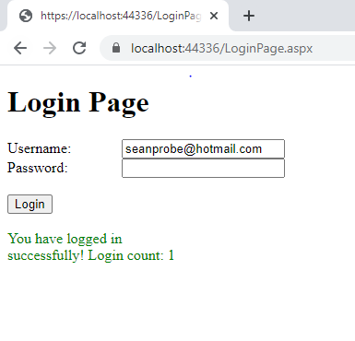

## Unsuccessfull attempt 1

## TextBox disabled after 3 unsuccessful attempts