# **IT LAB | LAB-5**

K. Sanjay Prabhu

17905528

B.Tech CSE – C

Roll No: 65

Q1.

**StudentElection.aspx:**

<%@ Page Language="C#" AutoEventWireup="true" CodeBehind="StudentElection.aspx.cs" Inherits="l5q1.StudentElection" %>

<!DOCTYPE html>

<html xmlns="http://www.w3.org/1999/xhtml">

<head runat="server">

<title></title>

</head>

<body>

<form id="form1" runat="server">

<div>

<asp:Label ID="lblCandidate" runat="server" Width="120px">

Candidate:

</asp:Label>

<asp:DropDownList ID="dpdCandidate" runat="server"></asp:DropDownList>

<asp:RequiredFieldValidator ID="validCandidate" runat="server" ErrorMessage="Choose Candidate!" ControlToValidate="dpdCandidate" InitialValue="Choose Candidate" ForeColor="Red"></asp:RequiredFieldValidator>

<br />

<asp:Label ID="lblHouse" runat="server" Width="120px">

House:

</asp:Label>

<asp:RadioButtonList ID="rblHouse" runat="server"></asp:RadioButtonList>

<asp:RequiredFieldValidator ID="validHouse" runat="server" ErrorMessage="Choose House!" ControlToValidate="rblHouse" ForeColor="Red"></asp:RequiredFieldValidator>

<br /><br />

<asp:Label ID="lblClass" runat="server" Width="120px">

Class:

</asp:Label>

<asp:TextBox ID="txtClass" runat="server"></asp:TextBox>

<asp:RangeValidator ID="rangeClass" runat="server" ErrorMessage="Out of Range! Enter Between 6 - 12" Type="Integer" MinimumValue="6" MaximumValue="12" ControlToValidate="txtClass" ForeColor="Red"></asp:RangeValidator>

<asp:RequiredFieldValidator ID="validClass" runat="server" ErrorMessage="Enter Class!" ControlToValidate="txtClass" ForeColor="Red"></asp:RequiredFieldValidator><br />

<br />

<asp:Label ID="lblEmail" runat="server" Width="120px">

Email:

</asp:Label>

<asp:TextBox ID="txtEmail" runat="server"></asp:TextBox>

<asp:RegularExpressionValidator ID="regxEmail" runat="server" ErrorMessage="Invalid Email!" ControlToValidate="txtEmail" ValidationExpression=".+@.+" ForeColor="Red"></asp:RegularExpressionValidator>

<asp:RequiredFieldValidator ID="validEmail" runat="server" ErrorMessage="Enter Email!" ControlToValidate="txtEmail" ForeColor="Red"></asp:RequiredFieldValidator>

<br />

<asp:Label ID="lblContact" runat="server" Width="120px">

Contact No:

</asp:Label>

<asp:TextBox ID="txtContact" runat="server"></asp:TextBox>

<asp:CustomValidator ID="cvContact" runat="server" ErrorMessage="Invalid Contact Number!" ValidateEmptyText="false" ControlToValidate="txtContact" OnServerValidate="cvContact_ServerValidate" ClientValidationFunction="cvContact_ServerValidation" ForeColor="Red"></asp:CustomValidator>

<asp:RequiredFieldValidator ID="validContact" runat="server" ErrorMessage="Enter Contact!" ControlToValidate="txtContact" ForeColor="Red"></asp:RequiredFieldValidator>

<br /><br />

<asp:Button ID="btnSubmit" runat="server" Text="Submit" OnClick="btnSubmit_Click"/>

<br />

<asp:Label ID="lblSuccess" runat="server" Width="120px"></asp:Label>

<br />

<asp:ValidationSummary ID="ValidationSummary1" runat="server" ShowMessageBox="true"/>

</div>

</form>

</body>

</html>

**StudentElection.aspx.cs:**

using System;

using System.Collections.Generic;

using System.Linq;

using System.Web;

using System.Web.UI;

using System.Web.UI.WebControls;

using System.Drawing;

using System.Drawing.Text;

namespace l5q1

{

public partial class StudentElection : System.Web.UI.Page

{

protected void Page_Load(object sender, EventArgs e)

{

if (!IsPostBack)

{

dpdCandidate.Items.Clear();

dpdCandidate.Items.Add("");

dpdCandidate.Items.Add("Zoro");

dpdCandidate.Items.Add("Zuko");

dpdCandidate.Items.Add("Kakashi H.");

dpdCandidate.Items.Add("Levi A.");

dpdCandidate.Items.Add("Shoto T.");

rblHouse.ClearSelection();

rblHouse.Items.Add("Hokage");

rblHouse.Items.Add("Raikage");

rblHouse.Items.Add("Tsuchikage");

rblHouse.Items.Add("Kazekage");

rblHouse.Items.Add("Mizukage");

}

}

protected void cvContact_ServerValidate(object source, ServerValidateEventArgs args)

{

try

{

if(txtContact.Text.Length != 10)

args.IsValid = false;

else

args.IsValid = true;

}

catch

{

args.IsValid = false;

}

}

protected void btnSubmit_Click(object sender, EventArgs e)

{

if (Page.IsValid)

{

lblSuccess.Text = "Success";

lblSuccess.ForeColor = System.Drawing.Color.Green;

}

}

}

}

**Input/Output:**

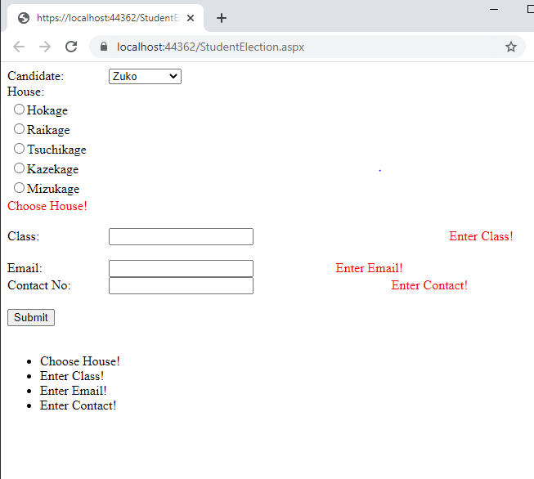

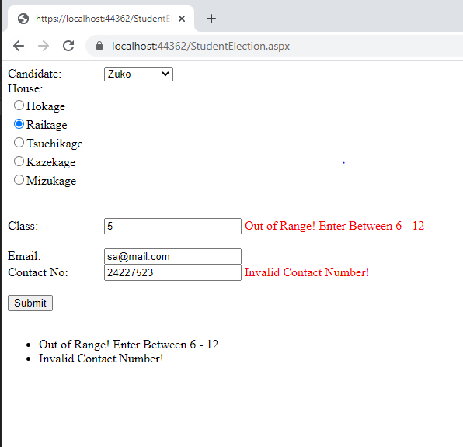

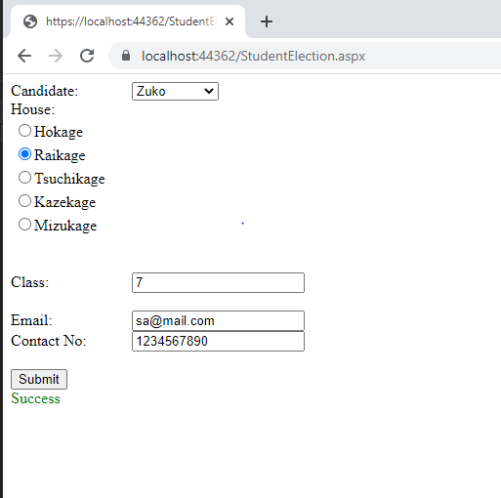

**Q2.**

**MasterPage.Master**

<%@ Master Language="C#" AutoEventWireup="true" CodeBehind="MasterPage.master.cs" Inherits="l5q2.MasterPage" %>

<!DOCTYPE html>

<html>

<head runat="server">

<title></title>

<asp:ContentPlaceHolder ID="head" runat="server">

</asp:ContentPlaceHolder>

</head>

<body>

<form id="form1" runat="server">

<div>

<h1>Hello! Welcome to Metro!</h1>

<br /><br />

<asp:Image ID="img" runat="server" ImageUrl="/metro.jpg" Height="300px" Width="500px"/>

<br />

<h2>Select a Page to visit below...</h2>

<div>

<a href="Electronics.aspx">Electronics</a><br />

<a href="Baggages.aspx">Baggages</a><br />

<a href="Offers.aspx">Offers</a><br />

</div>

<br />

<br />

<asp:ContentPlaceHolder ID="ContentPlaceHolder1" runat="server">

</asp:ContentPlaceHolder>

<br /><br />

<asp:Label ID="lblContact" runat="server" Text="Contact us: 0820 2415 785"></asp:Label>

<br />

<asp:Label ID="lblEmail" runat="server" Text="Email us: metro@manipal.edu.in"></asp:Label>

</div>

</form>

</body>

</html>

**Electronics.aspx**

<%@ Page Title="" Language="C#" MasterPageFile="~/MasterPage.Master" AutoEventWireup="true" CodeBehind="Electronics.aspx.cs" Inherits="l5q2.Electronics" %>

<asp:Content ID="Content1" ContentPlaceHolderID="head" runat="server">

Electronics

</asp:Content>

<asp:Content ID="Content2" ContentPlaceHolderID="ContentPlaceHolder1" runat="server">

<asp:Label ID="lblMobiles" runat="server" Text="Mobiles" />

<asp:DropDownList ID="dpdMobiles" runat="server">

<asp:ListItem Text="Samsung" Value="1"></asp:ListItem>

<asp:ListItem Text="Apple" Value="2"></asp:ListItem>

<asp:ListItem Text="Asus" Value="3"></asp:ListItem>

</asp:DropDownList>

<br />

<asp:Label ID="lblLaptops" runat="server" Text="Laptop" />

<asp:DropDownList ID="dpdLaptops" runat="server">

<asp:ListItem Text="Predator" Value="1"></asp:ListItem>

<asp:ListItem Text="Alien" Value="2"></asp:ListItem>

<asp:ListItem Text="Mac" Value="3"></asp:ListItem>

</asp:DropDownList>

<br />

<asp:Label ID="lblPrinters" runat="server" Text="Printers" />

<asp:DropDownList ID="dpdPrinters" runat="server">

<asp:ListItem Text="HP" Value="1"></asp:ListItem>

<asp:ListItem Text="Inkjet" Value="2"></asp:ListItem>

</asp:DropDownList>

</asp:Content>

**Baggages.aspx**

<%@ Page Title="" Language="C#" MasterPageFile="~/MasterPage.Master" AutoEventWireup="true" CodeBehind="Baggages.aspx.cs" Inherits="l5q2.Baggages" %>

<asp:Content ID="Content1" ContentPlaceHolderID="head" runat="server">

Baggages

</asp:Content>

<asp:Content ID="Content2" ContentPlaceHolderID="ContentPlaceHolder1" runat="server">

<asp:Image ID="img1" runat="server" ImageUrl="~/hilfiger.jpg"/>

<asp:Image ID="img2" runat="server" ImageUrl="~/wildcraft.jpg" />

<asp:Image ID="img3" runat="server" ImageUrl="~/safari.jpg"/>

</asp:Content>

**Offers.aspx**

<%@ Page Title="" Language="C#" MasterPageFile="~/MasterPage.Master" AutoEventWireup="true" CodeBehind="Offers.aspx.cs" Inherits="l5q2.Offers" %>

<asp:Content ID="Content1" ContentPlaceHolderID="head" runat="server">

Offers

</asp:Content>

<asp:Content ID="Content2" ContentPlaceHolderID="ContentPlaceHolder1" runat="server">

<asp:Image ID="img1" runat="server" ImageUrl="~/christmas.jpg"/>

<asp:Image ID="img2" runat="server" ImageUrl="~/diwali.jpg"/>

<asp:Image id="img3" runat="server" ImageUrl="~/bday.jpg"/>

</asp:Content>

**Input/Output:**

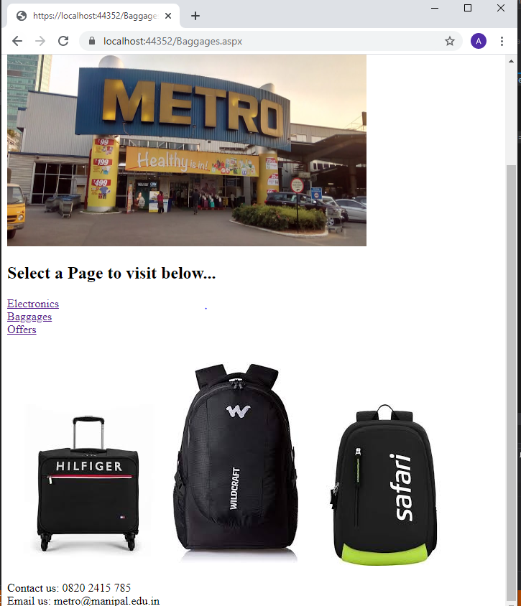

**Q3.**

**Season.aspx**

<%@ Page Language="C#" AutoEventWireup="true" CodeBehind="Season.aspx.cs" Inherits="l5q3.Season" %>

<!DOCTYPE html>

<html xmlns="http://www.w3.org/1999/xhtml">

<head runat="server">

<title></title>

</head>

<body>

<form id="form1" runat="server">

<div>

<h1>Welcome to virtual season simulator!</h1>

<div>

<asp:DropDownList runat="server" ID="theme" AutoPostBack="true" OnSelectedIndexChanged="theme_SelectedIndexChanged">

<asp:ListItem Text="Select a theme" Value="NA"></asp:ListItem>

<asp:ListItem Text="Summer theme" Value="Summer"></asp:ListItem>

<asp:ListItem Text="Monsoon theme" Value="Monsoon"></asp:ListItem>

</asp:DropDownList>

<br />

<asp:Label runat="server">Here is some sample text.</asp:Label>

</div>

</div>

</form>

</body>

</html>

**Season.aspx.cs:**

using System;

using System.Collections.Generic;

using System.Linq;

using System.Web;

using System.Web.UI;

using System.Web.UI.WebControls;

namespace l5q3

{

public partial class Season : System.Web.UI.Page

{

protected void Page_Load(object sender, EventArgs e)

{

}

protected void theme_SelectedIndexChanged(object sender, EventArgs e)

{

Session["chosenTheme"] = theme.SelectedValue;

Response.Redirect(Request.RawUrl);

}

protected void Page_PreInit(object sender, EventArgs e)

{

if (Session["chosenTheme"] != null && (string)Session["chosenTheme"] != "NA")

{

Page.Theme = Session["chosenTheme"].ToString();

}

}

}

}

Input/Output:

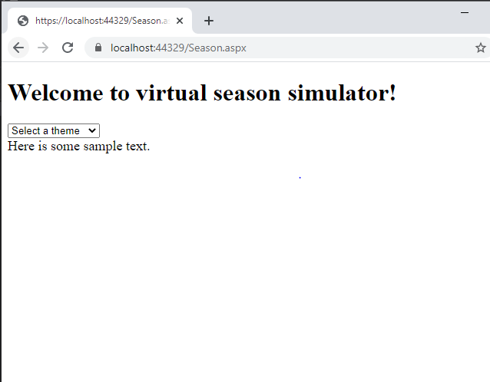

Q4.

MasterPages:

<%@ Master Language="C#" AutoEventWireup="true" CodeBehind="MasterPage1.master.cs" Inherits="l5q4.MasterPage1" %>

<!DOCTYPE html>

<html>

<head runat="server">

<title></title>

<asp:ContentPlaceHolder ID="head" runat="server">

</asp:ContentPlaceHolder>

</head>

<body>

<form id="form1" runat="server">

<div>

<asp:ContentPlaceHolder ID="page1" runat="server">

</asp:ContentPlaceHolder>

<asp:ContentPlaceHolder ID="page2" runat="server">

</asp:ContentPlaceHolder>

</div>

</form>

</body>

</html>

WebForm1.aspx:

<%@ Page Title="" Language="C#" MasterPageFile="~/MasterPage1.Master" AutoEventWireup="true" CodeBehind="WebForm1.aspx.cs" Inherits="l5q4.WebForm1" %>

<asp:Content ID="Content1" ContentPlaceHolderID="head" runat="server">

First-Page

</asp:Content>

<asp:Content ID="Content2" ContentPlaceHolderID="page1" runat="server">

<asp:Label ID="lbl" runat="server" Text=""></asp:Label>

<asp:DropDownList ID="dpdMobile" runat="server" AutoPostBack="true" OnSelectedIndexChanged="dpdMobile_SelectedIndexChanged"></asp:DropDownList>

<asp:Button ID="btn" runat="server" Text="->Page 2" OnClick="btn_Click"/>

</asp:Content>

WebForm2.aspx:

<%@ Page Title="" Language="C#" MasterPageFile="~/MasterPage1.Master" AutoEventWireup="true" CodeBehind="WebForm2.aspx.cs" Inherits="l5q4.WebForm2" %>

<asp:Content ID="Content1" ContentPlaceHolderID="head" runat="server">

Second-Page

</asp:Content>

<asp:Content ID="Content2" ContentPlaceHolderID="page2" runat="server">

<asp:Label ID="lbl" runat="server" Text=""></asp:Label>

<asp:Button ID="btn" runat="server" Text="Go back" OnClick="btn_Click"/>

</asp:Content>

WebFrom1.aspx.cs

using System;

using System.Collections.Generic;

using System.Linq;

using System.Web;

using System.Web.UI;

using System.Web.UI.WebControls;

namespace l5q4

{

public partial class WebForm1 : System.Web.UI.Page

{

protected void Page_Load(object sender, EventArgs e)

{

if(!this.IsPostBack)

{

dpdMobile.Items.Add("Apple");

dpdMobile.Items.Add("Samsung");

dpdMobile.Items.Add("Pixel");

lbl.Text = dpdMobile.Text;

}

}

protected void dpdMobile_SelectedIndexChanged(object sender, EventArgs e)

{

lbl.Text = dpdMobile.Text;

}

protected void btn_Click(object sender, EventArgs e)

{

string url = "WebForm2.aspx?Mobile=" + Server.UrlEncode(dpdMobile.Text);

Response.Redirect(url);

}

}

}

WebFrom2.aspx.cs:

using System;

using System.Collections.Generic;

using System.Linq;

using System.Web;

using System.Web.UI;

using System.Web.UI.WebControls;

namespace l5q4

{

public partial class WebForm2 : System.Web.UI.Page

{

protected void Page_Load(object sender, EventArgs e)

{

if(!this.IsPostBack)

{

string mobile = Request.QueryString["Mobile"];

switch(mobile)

{

case "Apple":

lbl.Text = "Screen:800x640, Memory: 64GB, Camera: 1080p, Battery: 5000MHa";

break;

case "Samsung":

lbl.Text = "Screen:900x640, Memory: 32GB, Camera: 1440p, Battery: 530MHa";

break;

case "Pixel":

lbl.Text = "Screen:800x540, Memory: 64GB, Camera: 720p, Battery: 4400MHa";

break;

default: break;

}

}

}

protected void btn_Click(object sender, EventArgs e)

{

Response.Redirect("WebForm1.aspx");

}

}

}

InputOutput:

