# **IT LAB | LAB-6**

K. Sanjay Prabhu

17905528

B.Tech CSE – C

Roll No: 65

Q1.

**Webform1.aspx:**

<%@ Page Language="C#" AutoEventWireup="true" CodeBehind="WebForm1.aspx.cs" Inherits="l6q1.WebForm1" %>

<!DOCTYPE html>

<html xmlns="http://www.w3.org/1999/xhtml">

<head runat="server">

<title></title>

</head>

<body>

<form id="form1" runat="server">

<div style="height: 452px">

<asp:Label ID="Label1" runat="server" Text="Staff ID"></asp:Label>

<br />

<br />

<asp:DropDownList ID="DropDownList1" runat="server" AutoPostBack="true" OnSelectedIndexChanged="DropDownList1_SelectedIndexChanged">

</asp:DropDownList>

<br />

<br />

<asp:Label ID="Label2" runat="server" Text="Staff Details:"></asp:Label>

<br />

<br />

<asp:ListBox ID="ListBox1" runat="server"></asp:ListBox>

<br />

<br />

<asp:Button ID="Button1" runat="server" Text="Update" OnClick="Button1_Click" />

<br />

<br />

<asp:Label ID="Label3" runat="server"></asp:Label>

</div>

</form>

</body>

</html>

**Webform1.aspx.cs:**

using System;

using System.Collections.Generic;

using System.Linq;

using System.Web;

using System.Web.UI;

using System.Web.UI.WebControls;

using System.Data;

using System.Data.Sql;

using System.Data.SqlClient;

namespace l6q1

{

public partial class WebForm1 : System.Web.UI.Page

{

protected void Page_Load(object sender, EventArgs e)

{

if (!this.IsPostBack)

{

ListBox1.Items.Add("Hyderabad");

ListBox1.Items.Add("Banglore");

ListBox1.Items.Add("Delhi");

dpdID();

}

}

private void dpdID()

{

string connection_string = @"Data Source=(localdb)\MSSQLLocalDB;Initial Catalog=HouseKeeping;Integrated Security=True;Pooling=False";

string select = "SELECT StaffID from Staff";

SqlConnection con = new SqlConnection(connection_string);

SqlCommand cmd = new SqlCommand(select, con);

SqlDataAdapter adapter = new SqlDataAdapter(cmd);

DataSet ds = new DataSet();

try

{

con.Open();

adapter.Fill(ds, "Staff");

}

catch (Exception err)

{

}

finally

{

con.Close();

}

foreach (DataRow row in ds.Tables["Staff"].Rows)

{

DropDownList1.Items.Add(row["StaffID"].ToString());

}

}

protected void DropDownList1_SelectedIndexChanged(object sender, EventArgs e)

{

int id = Int32.Parse(DropDownList1.SelectedValue);

string connection_string = @"Data Source=(localdb)\MSSQLLocalDB;Initial Catalog=HouseKeeping; Integrated Security=SSPI";

string select = "SELECT FirstName,LastName,DNo,Street,City,State,ZipCode FROM Staff where StaffID=" + id;

SqlConnection con = new SqlConnection(connection_string);

SqlCommand cmd = new SqlCommand(select, con);

SqlDataAdapter adapter = new SqlDataAdapter(cmd);

DataSet ds = new DataSet();

try

{

con.Open();

adapter.Fill(ds, "Staff");

}

catch (Exception err)

{

}

finally

{

con.Close();

}

DataRow row = ds.Tables["Staff"].Rows[0];

string f_name = (string)row["FirstName"];

string l_name = (string)row["LastName"];

int d_no = (int)row["DNo"];

string street = (string)row["Street"];

string city = (string)row["City"];

string state = (string)row["State"];

decimal zip = (decimal)row["ZipCode"];

Label2.Text = f_name + "<br>" + l_name + "<br>" + d_no.ToString() + "<br>" + street + "<br>" + city + "<br>" + state + "<br>" + zip.ToString();

}

protected void Button1_Click(object sender, EventArgs e)

{

int id = Int32.Parse(DropDownList1.SelectedValue);

string city = ListBox1.SelectedValue;

string connection_string = "Data Source=(localdb)\\MSSQLLocalDB;Initial Catalog=HouseKeeping; Integrated Security=SSPI";

string update = "UPDATE Staff SET City=@city" + " WHERE StaffID=@id";

SqlConnection con = new SqlConnection(connection_string);

SqlCommand cmd = new SqlCommand(update, con);

cmd.Parameters.AddWithValue("@city", city);

cmd.Parameters.AddWithValue("@id", id);

int updated = 0;

try

{

con.Open();

updated = cmd.ExecuteNonQuery();

}

catch (Exception err)

{

}

finally

{

con.Close();

}

if (updated > 0)

{

Label3.Text = "Record has been updated successfully!";

Label3.ForeColor = System.Drawing.Color.Green;

}

else

{

Label3.Text = "Record updation unsuccessful!";

Label3.ForeColor = System.Drawing.Color.Red;

}

}

}

}

**INPUT/OUTPUT:**

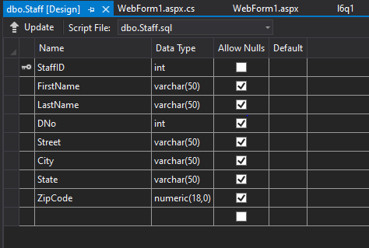

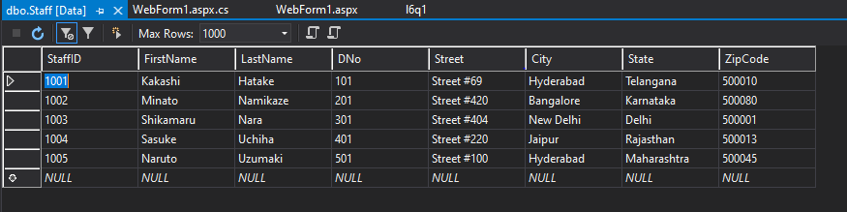

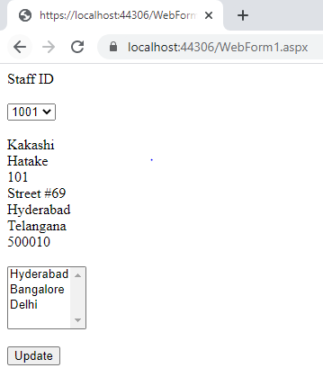

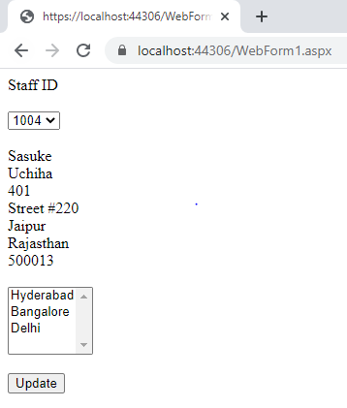

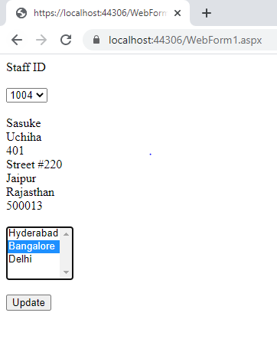

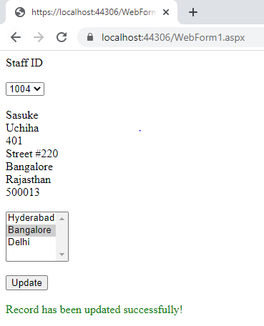

Q2.

**Webform1.aspx:**

<%@ Page Language="C#" AutoEventWireup="true" CodeBehind="WebForm1.aspx.cs" Inherits="l6q2.WebForm1" %>

<!DOCTYPE html>

<html xmlns="http://www.w3.org/1999/xhtml">

<head runat="server">

<title></title>

</head>

<body>

<form id="form1" runat="server">

<div style="height: 312px">

<br />

<br />

&nbsp;&nbsp;&nbsp;

<asp:Label ID="Label1" runat="server" Text="Choose the genre:"></asp:Label>

&nbsp;&nbsp;&nbsp;

<asp:DropDownList ID="DropDownList1" runat="server" OnSelectedIndexChanged="DropDownList1_SelectedIndexChanged" AutoPostBack="true">

</asp:DropDownList>

<br />

<br />

&nbsp;&nbsp;&nbsp;

<asp:ListBox ID="ListBox1" runat="server" OnSelectedIndexChanged="ListBox1_SelectedIndexChanged" AutoPostBack="true"></asp:ListBox>

<br />

<br />

&nbsp;&nbsp;&nbsp;

<asp:TextBox ID="TextBox1" runat="server" TextMode="MultiLine" ></asp:TextBox>

<br />

<br />

</div>

</form>

</body>

</html>

**WebForm1.aspx.cs:**

using System;

using System.Collections.Generic;

using System.Linq;

using System.Web;

using System.Web.UI;

using System.Web.UI.WebControls;

using System.Data;

using System.Data.Sql;

using System.Data.SqlClient;

namespace l6q2

{

public partial class WebForm1 : System.Web.UI.Page

{

protected void Page_Load(object sender, EventArgs e)

{

if (!this.IsPostBack)

{

DropDownList1.Items.Add("");

DropDownList1.Items.Add("comedy");

DropDownList1.Items.Add("romance");

DropDownList1.Items.Add("animated");

}

}

protected void DropDownList1_SelectedIndexChanged(object sender, EventArgs e)

{

string category = DropDownList1.SelectedValue;

string connection_string = @"Data Source=(localdb)\MSSQLLocalDB;Initial Catalog=Test;Integrated Security=SSPI";

string query = "SELECT name,age from Legends WHERE category='" + category + "'";

SqlConnection con = new SqlConnection(connection_string);

SqlCommand cmd = new SqlCommand(query, con);

try

{

con.Open();

ListBox1.DataSource = cmd.ExecuteReader();

ListBox1.DataTextField = "name";

ListBox1.DataValueField = "age";

ListBox1.DataBind();

}

catch (Exception err)

{

}

finally

{

con.Close();

}

//ListBox1.SelectedIndex = -1;

}

protected void ListBox1_SelectedIndexChanged(object sender, EventArgs e)

{

string name = ListBox1.SelectedItem.Text;

string age = ListBox1.SelectedValue;

TextBox1.Text = "Name:" + name.ToString() + "\n" + "Age:" + age.ToString();

}

}

}

**INPUT/OUTPUT:**

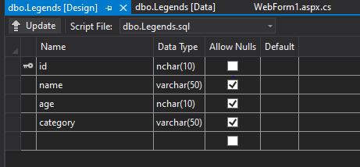

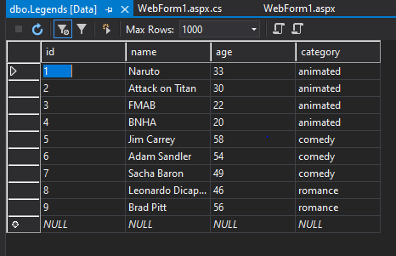

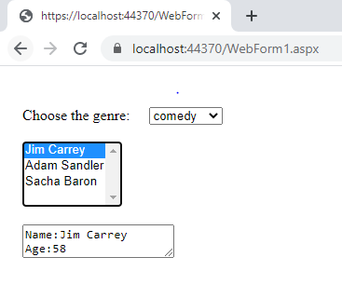

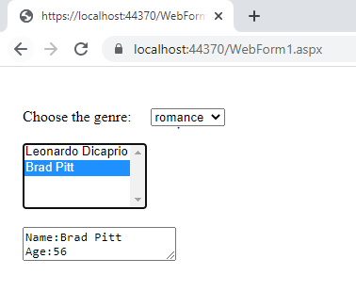

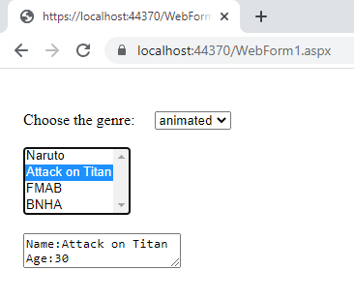

Q3.

**Webform1.aspx:**

<%@ Page Language="C#" AutoEventWireup="true" CodeBehind="WebForm1.aspx.cs" Inherits="l6q3.WebForm1" %>

<!DOCTYPE html>

<html xmlns="http://www.w3.org/1999/xhtml">

<head runat="server">

<title></title>

</head>

<body>

<form id="form1" runat="server">

<div style="height: 300px">

<br />

<br />

&nbsp;&nbsp;&nbsp;

<asp:Label ID="Label1" runat="server" Text="Enter price"></asp:Label>

&nbsp;&nbsp;&nbsp;

<asp:TextBox ID="TextBox1" runat="server"></asp:TextBox>

<br />

<br />

&nbsp;&nbsp;&nbsp;

<asp:Button ID="Button1" runat="server" OnClick="Button1_Click" Text="Modify" />

</div>

</form>

</body>

</html>

**WebForm1.aspx.cs:**

using System;

using System.Collections.Generic;

using System.Linq;

using System.Web;

using System.Web.UI;

using System.Web.UI.WebControls;

using System.Data;

using System.Data.Sql;

using System.Data.SqlClient;

namespace l6q3

{

public partial class WebForm1 : System.Web.UI.Page

{

protected void Page_Load(object sender, EventArgs e)

{

}

protected void Button1_Click(object sender, EventArgs e)

{

int price = Int32.Parse(TextBox1.Text);

string connection_string = @"Data Source=(localdb)\MSSQLLocalDB;Initial Catalog=Products;Integrated Security=SSPI";

string query = "UPDATE Items SET price=@price WHERE flavor='vanilla'";

SqlConnection con = new SqlConnection(connection_string);

SqlCommand cmd = new SqlCommand(query, con);

cmd.Parameters.AddWithValue("@price", price);

try

{

con.Open();

cmd.ExecuteNonQuery();

}

catch (Exception err)

{

}

finally

{

con.Close();

}

}

}

}

**INPUT/OUTPUT:**

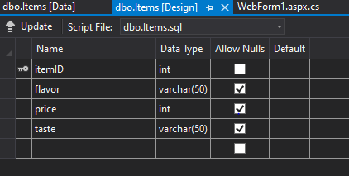

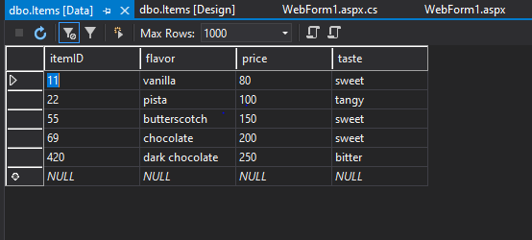

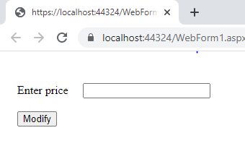

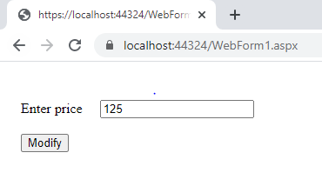

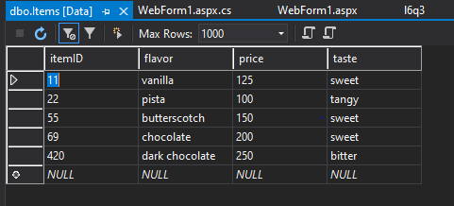

Q4.

**Webform1.aspx:**

<%@ Page Language="C#" AutoEventWireup="true" CodeBehind="WebForm1.aspx.cs" Inherits="l6q4.WebForm1" %>

<!DOCTYPE html>

<html xmlns="http://www.w3.org/1999/xhtml">

<head runat="server">

<title></title>

</head>

<body>

<form id="form1" runat="server">

<div style="height: 400px">

<br />

&nbsp;&nbsp;&nbsp;

<asp:Label ID="Label1" runat="server" Text="Name" Width="120px"></asp:Label>

&nbsp;&nbsp;&nbsp;

<asp:TextBox ID="TextBox1" runat="server"></asp:TextBox>

<br />

<br />

&nbsp;&nbsp;&nbsp;

<asp:Label ID="Label2" runat="server" Text="Company" Width="120px"></asp:Label>

&nbsp;&nbsp;&nbsp;

<asp:TextBox ID="TextBox2" runat="server"></asp:TextBox>

<br />

<br />

&nbsp;&nbsp;&nbsp;

<asp:Label ID="Label3" runat="server" Text="Salary" Width="120px"></asp:Label>

&nbsp;&nbsp;&nbsp;

<asp:TextBox ID="TextBox3" runat="server"></asp:TextBox>

<br />

<br />

&nbsp;&nbsp;&nbsp;

<asp:Button ID="Button1" runat="server" OnClick="Button1_Click" Text="Add to Works table" />

<br />

<br />

&nbsp;&nbsp;&nbsp;

<asp:Label ID="Label4" runat="server"></asp:Label>

<br />

<br />

&nbsp;&nbsp;&nbsp;

<asp:Label ID="Label5" runat="server" Text="Search employees by company"></asp:Label>

&nbsp;&nbsp;&nbsp;

<asp:TextBox ID="TextBox4" runat="server"></asp:TextBox>

&nbsp;&nbsp;&nbsp;

<asp:Button ID="Button2" runat="server" OnClick="Button2_Click" Text="Search" />

<br />

<br />

&nbsp;&nbsp;&nbsp;

<asp:ListBox ID="ListBox1" runat="server"></asp:ListBox>

<br />

</div>

</form>

</body>

</html>

**Webform1.aspx.cs:**

using System;

using System.Collections.Generic;

using System.Linq;

using System.Web;

using System.Web.UI;

using System.Web.UI.WebControls;

using System.Data;

using System.Data.Sql;

using System.Data.SqlClient;

namespace l6q4

{

public partial class WebForm1 : System.Web.UI.Page

{

protected void Page_Load(object sender, EventArgs e)

{

}

protected void Button1_Click(object sender, EventArgs e)

{

string name = TextBox1.Text;

string company = TextBox2.Text;

string salary = TextBox3.Text;

string connection_string = @"Data Source=(localdb)\MSSQLLocalDB;Initial Catalog=Q4;Integrated Security=SSPI";

SqlConnection con = new SqlConnection(connection_string);

string query = "INSERT INTO Works (person_name,company,salary) VALUES ('" + name + "','" + company + "','" + salary + "')";

SqlCommand cmd = new SqlCommand(query, con);

int added = 0;

try

{

con.Open();

added = cmd.ExecuteNonQuery();

}

catch (Exception err)

{

}

finally

{

con.Close();

}

if (added > 0)

{

Label4.Text = "Successful!";

Label4.ForeColor = System.Drawing.Color.Green;

}

else

{

Label4.Text = "Unsuccessfull!";

Label4.ForeColor = System.Drawing.Color.Red;

}

}

protected void Button2_Click(object sender, EventArgs e)

{

ListBox1.Items.Clear();

string company = TextBox4.Text;

string connection_string = @"Data Source=(localdb)\MSSQLLocalDB;Initial Catalog=Q4;Integrated Security=SSPI";

string query = "SELECT Lives.person_name name,Lives.city city FROM Works,Lives where company='" + company + "' AND Works.person_name=Lives.person_name";

SqlConnection con = new SqlConnection(connection_string);

SqlCommand cmd = new SqlCommand(query, con);

SqlDataReader reader;

try

{

con.Open();

reader = cmd.ExecuteReader();

while (reader.Read())

{

string name = (string)reader["person_name"];

string city = (string)reader["city"];

ListBox1.Items.Add(name + " " + city);

}

}

catch (Exception err)

{

}

finally

{

con.Close();

}

}

}

}

**INPUT/OUTPUT:**

