# **IT LAB | LAB-7**

K. Sanjay Prabhu

17905528

B.Tech CSE – C

Roll No: 65

Q1.

**Webform1.aspx:**

<%@ Page Language="C#" AutoEventWireup="true" CodeBehind="WebForm1.aspx.cs" Inherits="l7q1.WebForm1" %>

<!DOCTYPE html>

<html xmlns="http://www.w3.org/1999/xhtml">

<head runat="server">

<title></title>

</head>

<body>

<form id="form1" runat="server">

<div style="height: 442px">

<br />

<h1>Welcome to Tony's Juice Center!</h1>

&nbsp;&nbsp;&nbsp;

<asp:Label ID="Label1" runat="server" Text="Pick your Fruit(s):"></asp:Label>

<br />

&nbsp;&nbsp;

&nbsp;

<asp:CheckBoxList ID="CheckBoxList1" runat="server">

</asp:CheckBoxList>

<br />

&nbsp;&nbsp;&nbsp;

<asp:Label ID="Label2" runat="server" Text="Select any Ice cream:"></asp:Label>

<br />

&nbsp;&nbsp;&nbsp;

<asp:RadioButtonList ID="RadioButtonList1" runat="server">

</asp:RadioButtonList>

<br />

&nbsp;&nbsp;&nbsp;

<asp:Button ID="Button1" runat="server" OnClick="Button1_Click" Text="Make milkshake" />

<br />

<br />

&nbsp;&nbsp;&nbsp;

<asp:Label ID="Label3" runat="server" Text="Fruits:"></asp:Label>

&nbsp;&nbsp;&nbsp;

<br />

<br />

&nbsp;&nbsp;&nbsp;

<asp:Label ID="Label4" runat="server" Text="Ice cream:"></asp:Label>

<br />

<br />

&nbsp;&nbsp;&nbsp;

<asp:Label ID="Label5" runat="server" Text="Cost:"></asp:Label>

<br />

<p style="margin-left: 40px">

<br />

<br />

&nbsp;&nbsp;&nbsp;

</p>

</div>

</form>

</body>

</html>

**Webform1.aspx.cs:**

using System;

using System.Collections.Generic;

using System.Linq;

using System.Web;

using System.Web.UI;

using System.Web.UI.WebControls;

namespace l7q1

{

public partial class WebForm1 : System.Web.UI.Page

{

protected void Page_Load(object sender, EventArgs e)

{

if (!this.IsPostBack)

{

List<String> fruits = new List<String>();

fruits.Add("Mango");

fruits.Add("Orange");

fruits.Add("Apple");

fruits.Add("Banana");

List<String> ice_cream = new List<String>();

ice_cream.Add("Vanilla");

ice_cream.Add("Strawberry");

ice_cream.Add("Pista");

ice_cream.Add("Chocolate");

CheckBoxList1.DataSource = fruits;

RadioButtonList1.DataSource = ice_cream;

this.DataBind();

}

Label3.Text = "Fruits:";

Label4.Text = "Ice cream:";

Label5.Text = "Cost:";

}

protected void Button1_Click(object sender, EventArgs e)

{

foreach (ListItem item in CheckBoxList1.Items)

{

if (item.Selected == true)

{

Label3.Text += item.Text + " ";

}

}

Label4.Text += RadioButtonList1.SelectedValue;

Random r = new Random();

Label5.Text += r.Next(100, 200).ToString();

}

}

}

**INPUT/OUTPUT:**

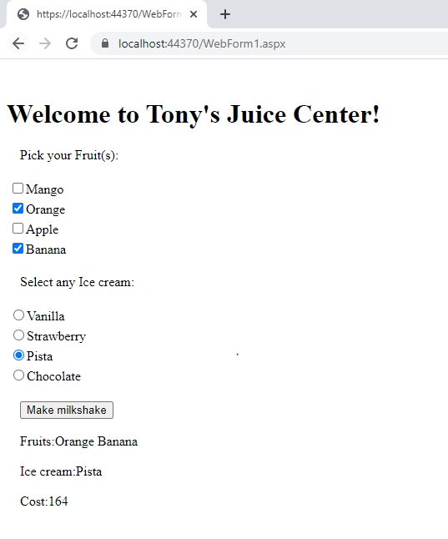

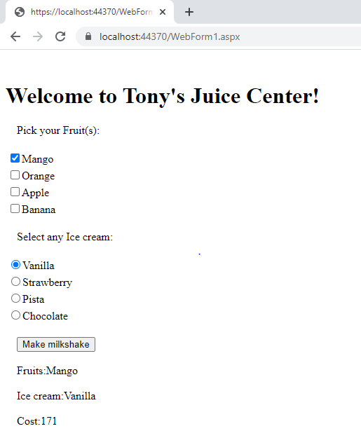

Q2.

**Webform1.aspx:**

<%@ Page Language="C#" AutoEventWireup="true" CodeBehind="WebForm1.aspx.cs" Inherits="l7q2.WebForm1" %>

<!DOCTYPE html>

<html xmlns="http://www.w3.org/1999/xhtml">

<head runat="server">

<title></title>

</head>

<body>

<form id="form1" runat="server">

<div style="height: 239px">

&nbsp;&nbsp;&nbsp;&nbsp;

<br />

<br />

&nbsp;&nbsp;&nbsp;

<h1>Tony Gunka's Travel & Tour packages:</h1>

<br />

<br />

&nbsp;&nbsp;&nbsp;

<asp:ListBox ID="ListBox1" runat="server" DataSourceID="SqlDataSource1" DataTextField="place" AutoPostBack="true"></asp:ListBox>

<asp:SqlDataSource ID="SqlDataSource1" runat="server" ConnectionString="Data Source=(localdb)\MSSQLLocalDB;Initial Catalog=Data;Integrated Security=SSPI" SelectCommand="SELECT place FROM TourPackages" ></asp:SqlDataSource>

<br />

<br />

&nbsp;&nbsp;&nbsp;

<asp:Button ID="Button1" runat="server" OnClick="Button1_Click" Text="Get Details" />

</div>

</form>

</body>

</html>

**Webform1.aspx.cs:**

using System;

using System.Collections.Generic;

using System.Linq;

using System.Web;

using System.Web.UI;

using System.Web.UI.WebControls;

namespace l7q2

{

public partial class WebForm1 : System.Web.UI.Page

{

protected void Page_Load(object sender, EventArgs e)

{

}

protected void Button1_Click(object sender, EventArgs e)

{

string place = ListBox1.SelectedValue;

string url = "WebForm2.aspx?place=" + Server.UrlEncode(place);

Response.Redirect(url);

}

}

}

**Webform2.aspx:**

<%@ Page Language="C#" AutoEventWireup="true" CodeBehind="WebForm2.aspx.cs" Inherits="l7q2.WebForm2" %>

<!DOCTYPE html>

<html xmlns="http://www.w3.org/1999/xhtml">

<head runat="server">

<title></title>

</head>

<body>

<form id="form1" runat="server">

<div style="height: 238px">

<asp:GridView ID="GridView1" runat="server" DataSourceID="SqlDataSource1">

</asp:GridView>

<asp:SqlDataSource ID="SqlDataSource1" runat="server" ConnectionString="Data Source=(localdb)\MSSQLLocalDB;Initial Catalog=Data;Integrated Security=SSPI" SelectCommand="SELECT * FROM TourPackages WHERE place=@place">

<SelectParameters>

<asp:QueryStringParameter Name="place" QueryStringField="place"/>

</SelectParameters>

</asp:SqlDataSource>

</div>

</form>

</body>

</html>

**WebForm2.aspx.cs:**

using System;

using System.Collections.Generic;

using System.Linq;

using System.Web;

using System.Web.UI;

using System.Web.UI.WebControls;

namespace l7q2

{

public partial class WebForm2 : System.Web.UI.Page

{

protected void Page_Load(object sender, EventArgs e)

{

}

}

}

**INPUT/OUTPUT:**

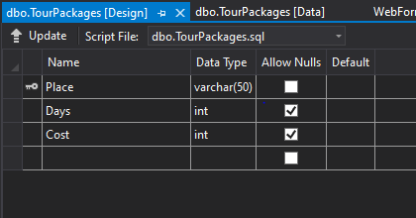

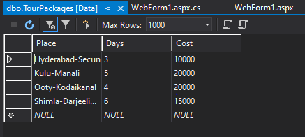

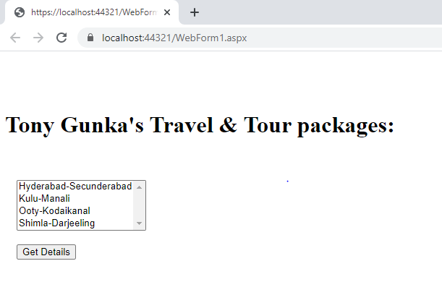

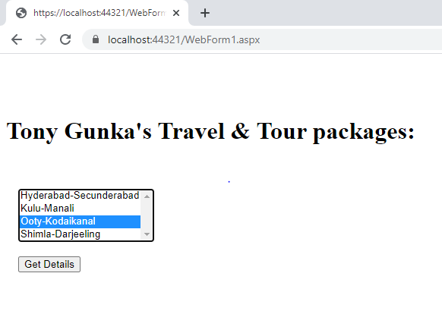

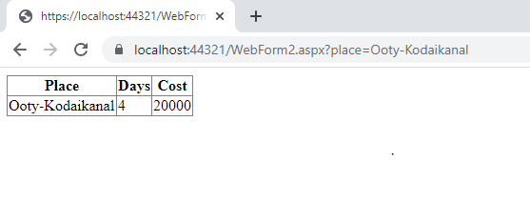

Q3.

**Webform1.aspx:**

<%@ Page Language="C#" AutoEventWireup="true" CodeBehind="WebForm1.aspx.cs" Inherits="l7q3.WebForm1" %>

<!DOCTYPE html>

<html xmlns="http://www.w3.org/1999/xhtml">

<head runat="server">

<title></title>

</head>

<body>

<form id="form1" runat="server">

<div style="height: 304px">

&nbsp;&nbsp;&nbsp;&nbsp;&nbsp;

<h1>Select a state and view the cities</h1>

<br />

<br />

&nbsp;&nbsp;&nbsp;

<asp:Label ID="Label1" runat="server" Text="States:"></asp:Label>

<br />

<br />

&nbsp;&nbsp;&nbsp;

<asp:DropDownList ID="DropDownList1" runat="server" OnSelectedIndexChanged="DropDownList1_SelectedIndexChanged" AutoPostBack="true">

</asp:DropDownList>

<br />

<br />

&nbsp;&nbsp;&nbsp;

<asp:Label ID="Label2" runat="server" Text="Cities:"></asp:Label>

<br />

<br />

&nbsp;&nbsp;&nbsp;

<asp:DropDownList ID="DropDownList2" runat="server" DataSourceID="SqlDataSource1" DataTextField="CityName">

</asp:DropDownList>

<asp:SqlDataSource ID="SqlDataSource1" runat="server" ConnectionString="Data Source=(localdb)\MSSQLLocalDB;Initial Catalog=Q3;Integrated Security=True;Pooling=False" SelectCommand="SELECT CityName FROM City WHERE StateID=@StateID">

<SelectParameters>

<asp:ControlParameter ControlID="DropDownList1" Name="StateID" PropertyName="SelectedValue"/>

</SelectParameters>

</asp:SqlDataSource>

</div>

</form>

</body>

</html>

**Webform1.aspx.cs:**

using System;

using System.Collections.Generic;

using System.Linq;

using System.Web;

using System.Web.UI;

using System.Web.UI.WebControls;

namespace l7q3

{

public partial class WebForm1 : System.Web.UI.Page

{

protected void Page_Load(object sender, EventArgs e)

{

if (!this.IsPostBack)

{

Dictionary<int, string> state = new Dictionary<int, string>();

state.Add(1, "Telangana");

state.Add(2, "Karnataka");

state.Add(3, "Maharashtra");

state.Add(4, "Gujarat");

state.Add(5, "U.P");

DropDownList1.DataSource = state;

DropDownList1.DataTextField = "Value";

DropDownList1.DataValueField = "Key";

this.DataBind();

}

}

protected void DropDownList1_SelectedIndexChanged(object sender, EventArgs e)

{

}

}

}

**INPUT/OUTPUT:**

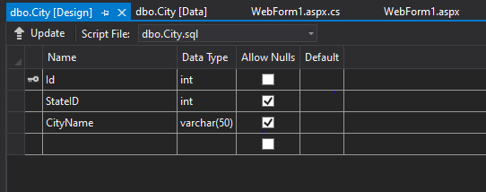

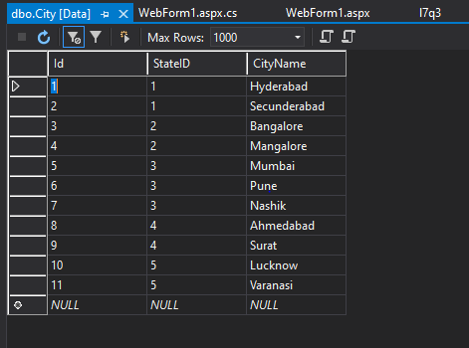

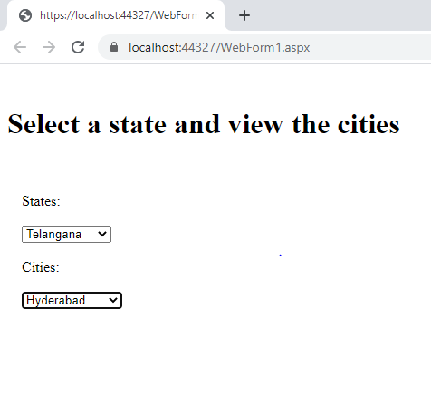

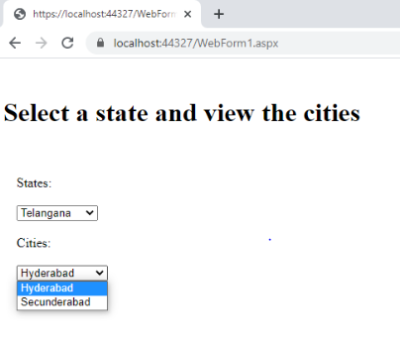

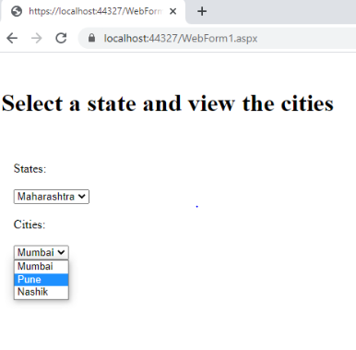

Q4.

**Webform1.aspx:**

<%@ Page Language="C#" AutoEventWireup="true" CodeBehind="WebForm1.aspx.cs" Inherits="l7q4.WebForm1" %>

<!DOCTYPE html>

<html xmlns="http://www.w3.org/1999/xhtml">

<head runat="server">

<title></title>

</head>

<body>

<form id="form1" runat="server">

<div style="height: 519px">

<h1>Netflix lite</h1>

&nbsp;&nbsp;&nbsp;

<br />

<br />

&nbsp;&nbsp;&nbsp;

<asp:Label ID="Label1" runat="server" Text="Categories:"></asp:Label>

<br />

&nbsp;&nbsp;&nbsp;

<br />

&nbsp;&nbsp;&nbsp;

<asp:DropDownList ID="DropDownList1" runat="server" AutoPostBack="true">

</asp:DropDownList>

<br />

<br />

&nbsp;&nbsp;&nbsp;

<asp:Label ID="Label2" runat="server" Text="Actors:"></asp:Label>

<br />

<br />

&nbsp;&nbsp;&nbsp;

<asp:ListBox ID="ListBox1" runat="server" DataSourceID="SqlDataSource1" DataTextField="name" AutoPostBack="true"></asp:ListBox>

<br />

<br />

&nbsp;&nbsp;&nbsp;

<asp:Label ID="Label3" runat="server" Text="Actor details:"></asp:Label>

<br />

<br />

&nbsp;&nbsp;&nbsp;

<asp:GridView ID="GridView1" runat="server" DataSourceID="SqlDataSource2">

</asp:GridView>

<br />

<br />

<asp:SqlDataSource ID="SqlDataSource1" runat="server" ConnectionString="Data Source=(localdb)\MSSQLLocalDB;Initial Catalog=L7Q4;Integrated Security=True;Pooling=False" SelectCommand="SELECT name FROM Actors WHERE category=@category">

<SelectParameters>

<asp:ControlParameter ControlID="DropDownList1" Name="category" PropertyName="SelectedValue"/>

</SelectParameters>

</asp:SqlDataSource>

<asp:SqlDataSource ID="SqlDataSource2" runat="server" ConnectionString="Data Source=(localdb)\MSSQLLocalDB;Initial Catalog=L7Q4;Integrated Security=True;Pooling=False" SelectCommand="SELECT name,age FROM Actors WHERE name=@name">

<SelectParameters>

<asp:ControlParameter ControlID="ListBox1" Name="name" PropertyName="SelectedValue"/>

</SelectParameters>

</asp:SqlDataSource>

&nbsp;&nbsp;&nbsp;

</div>

</form>

</body>

</html>

**Webform1.aspx.cs:**

using System;

using System.Collections.Generic;

using System.Linq;

using System.Web;

using System.Web.UI;

using System.Web.UI.WebControls;

namespace l7q4

{

public partial class WebForm1 : System.Web.UI.Page

{

protected void Page_Load(object sender, EventArgs e)

{

if (!this.IsPostBack)

{

List<String> category = new List<String>();

category.Add("action");

category.Add("comedy");

category.Add("animated");

category.Add("romance");

DropDownList1.DataSource = category;

this.DataBind();

}

}

}

}

**INPUT/OUTPUT:**

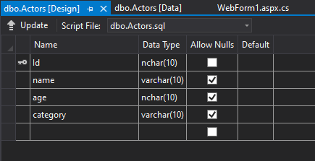

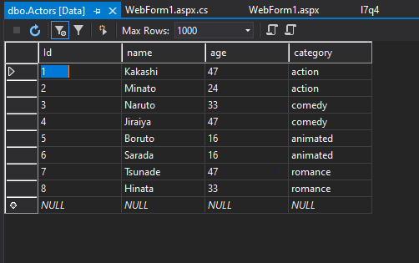

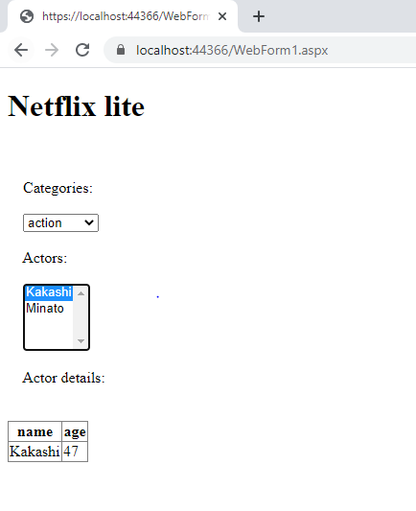

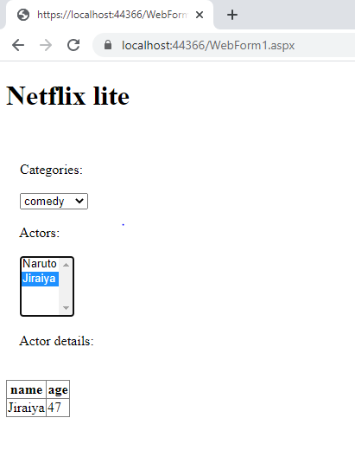

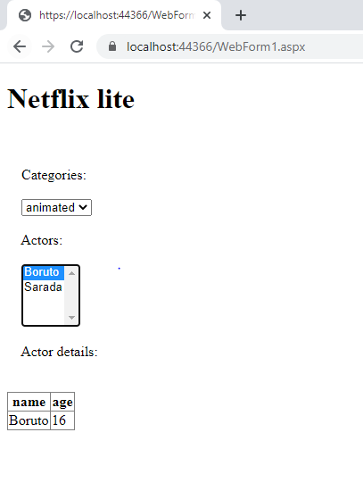

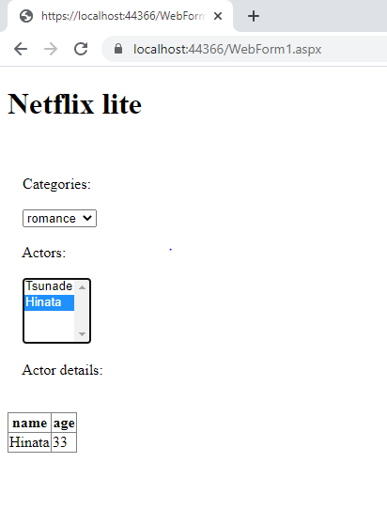

------------------------------End-------------------------------------------------