# **IT LAB | LAB-8**

K. Sanjay Prabhu

17905528

B.Tech CSE – C

Roll No: 65

Q1.

**Webform1.aspx:**

<%@ Page Language="C#" AutoEventWireup="true" CodeBehind="WebForm1.aspx.cs" Inherits="l8q1.WebForm1" %>

<!DOCTYPE html>

<html xmlns="http://www.w3.org/1999/xhtml">

<head runat="server">

<title></title>

</head>

<body>

<form id="form1" runat="server">

<div style="height: 250px">

<asp:GridView ID="GridView1" runat="server" DataSourceID="SqlDataSource1" AutoGenerateColumns="false" AllowSorting="true" OnRowDataBound="GridView1_RowDataBound">

<Columns>

<asp:TemplateField HeaderText="Staff Details" SortExpression="name">

<ItemTemplate>

<b>Name:</b> <%# Eval("name") %>

<br />

<b>Age:</b> <%# Eval("age") %>

</ItemTemplate>

</asp:TemplateField>

<asp:BoundField DataField="designation" HeaderText="Designation"/>

<asp:BoundField DataField="salary" HeaderText="Salary"/>

</Columns>

</asp:GridView>

</div>

<asp:SqlDataSource ID="SqlDataSource1" runat="server" ConnectionString="Data Source=(localdb)\MSSQLLocalDB;Initial Catalog=L8Q1;Integrated Security=True;Pooling=False" SelectCommand="SELECT name,age,designation,salary FROM Staff"></asp:SqlDataSource>

</form>

</body>

</html>

**WebForm1.aspx.cs:**

using System;

using System.Collections.Generic;

using System.Linq;

using System.Web;

using System.Web.UI;

using System.Web.UI.WebControls;

namespace l8q1

{

public partial class WebForm1 : System.Web.UI.Page

{

protected void Page_Load(object sender, EventArgs e)

{

}

protected void GridView1_RowDataBound(object sender, GridViewRowEventArgs e)

{

if (e.Row.RowType == DataControlRowType.DataRow)

{

int age = (int)DataBinder.Eval(e.Row.DataItem, "age");

if (age > 35)

{

e.Row.BackColor = System.Drawing.Color.DarkBlue;

e.Row.ForeColor = System.Drawing.Color.White;

}

}

}

}

}

**INPUT/OUTPUT:**

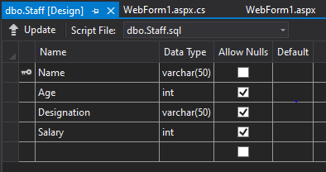

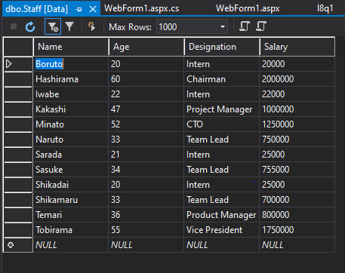

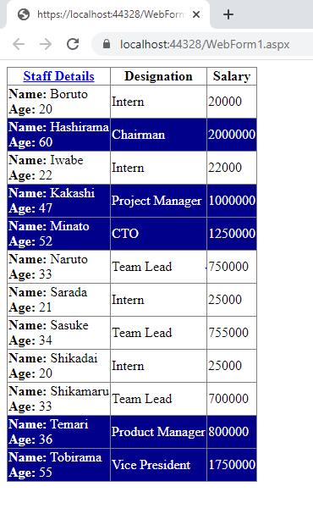

Q2.

**Webform1.aspx:**

<%@ Page Language="C#" AutoEventWireup="true" CodeBehind="WebForm1.aspx.cs" Inherits="l8q2.WebForm1" %>

<!DOCTYPE html>

<html xmlns="http://www.w3.org/1999/xhtml">

<head runat="server">

<title></title>

</head>

<body>

<form id="form1" runat="server">

<div style="height: 350px">

<asp:GridView ID="GridView1" runat="server" DataSourceID="SqlDataSource1" AutoGenerateColumns="false" AllowPaging="true" PageSize="3" DataKeyNames="id">

<HeaderStyle BackColor="Green" ForeColor="Red" Font-Bold="true"/>

<Columns>

<asp:CommandField ShowEditButton="true"/>

<asp:BoundField DataField="id" HeaderText="Id" ReadOnly="true"/>

<asp:TemplateField HeaderText="Name">

<ItemTemplate>

<b>First Name:</b> <%# Eval("FirstName") %>

<br />

<b>Last Name:</b> <%# Eval("LastName") %>

</ItemTemplate>

<EditItemTemplate>

<b>First Name:</b> <asp:TextBox runat="server" ID="TextBox1" Text='<%# Bind("FirstName") %>'></asp:TextBox>

<br />

<b>Last Name:</b> <%# Eval("LastName") %>

</EditItemTemplate>

</asp:TemplateField>

<asp:BoundField DataField="BookTitle" HeaderText="Book Title" ReadOnly="true"/>

<asp:BoundField DataField="Genre" HeaderText="Genre" ReadOnly="true"/>

<asp:BoundField DataField="CopiesSold" HeaderText="Copies Sold"/>

</Columns>

</asp:GridView>

</div>

<asp:SqlDataSource ID="SqlDataSource1" runat="server" ConnectionString="Data Source=(localdb)\MSSQLLocalDB;Initial Catalog=L8Q2;Integrated Security=True;Pooling=False" SelectCommand="select * FROM Authors" UpdateCommand="UPDATE Authors SET CopiesSold=@CopiesSold,FirstName=@FirstName WHERE id=@id">

</asp:SqlDataSource>

</form>

</body>

</html>

**WebForm1.aspx.cs:**

using System;

using System.Collections.Generic;

using System.Linq;

using System.Web;

using System.Web.UI;

using System.Web.UI.WebControls;

using System.Data;

using System.Data.Sql;

using System.Data.SqlClient;

namespace l8q2

{

public partial class WebForm1 : System.Web.UI.Page

{

protected void Page_Load(object sender, EventArgs e)

{

}

}

}

**INPUT/OUTPUT:**

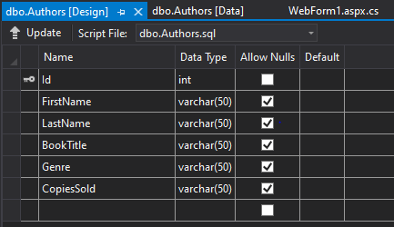

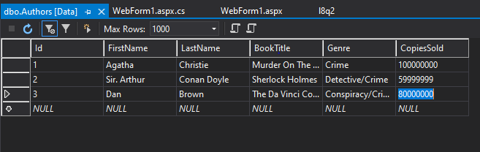

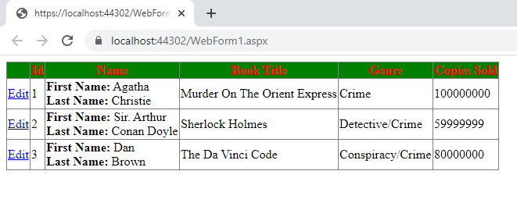

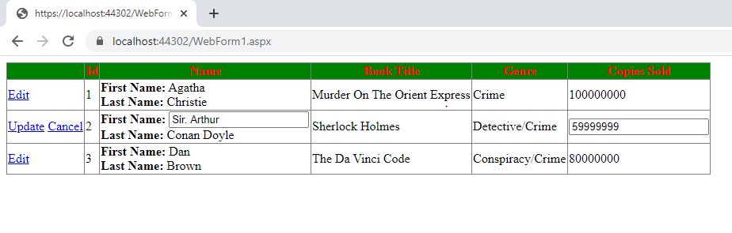

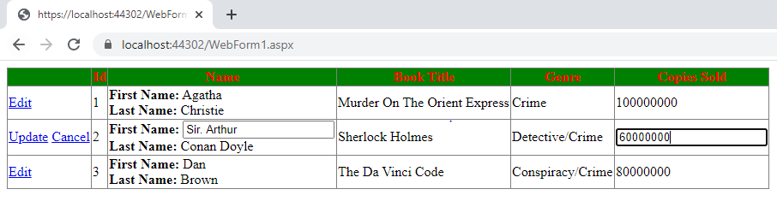

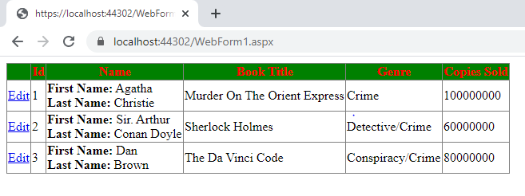

**changes reflected in the database dynamically**

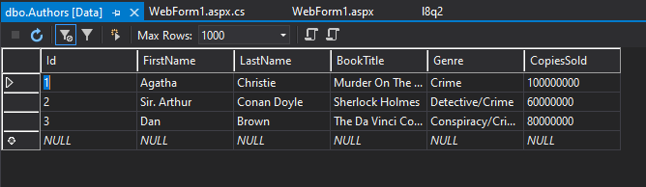

Q3.

**Webform1.aspx:**

<%@ Page Language="C#" AutoEventWireup="true" CodeBehind="WebForm1.aspx.cs" Inherits="l8q3.WebForm1" %>

<!DOCTYPE html>

<html xmlns="http://www.w3.org/1999/xhtml">

<head runat="server">

<title></title>

</head>

<body>

<form id="form1" runat="server">

<div>

</div>

</form>

</body>

</html>

**Webform1.aspx.cs:**

using System;

using System.Collections.Generic;

using System.Linq;

using System.Web;

using System.Web.UI;

using System.Web.UI.WebControls;

using System.IO;

using System.Xml.Linq;

namespace l8q3

{

public partial class WebForm1 : System.Web.UI.Page

{

protected void Page_Load(object sender, EventArgs e)

{

if (!this.IsPostBack)

{

string file = Path.Combine(Request.PhysicalApplicationPath, @"App_Data\Cars.xml");

XDocument doc = new XDocument(

new XDeclaration("1.0", null, "yes"),

new XElement("Cars",

new XElement("Detail", new XElement("Name", "I20"), new XElement("Make", "Hyundai"), new XElement("Price", "700000")),

new XElement("Detail", new XElement("Name", "I10"), new XElement("Make", "Hyundai"), new XElement("Price", "600000"))));

doc.Save(file);

}

}

}

}

**INPUT/OUTPUT:**

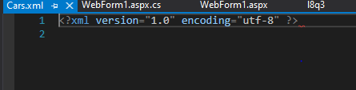

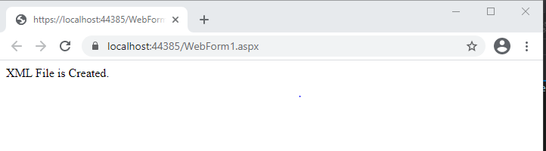

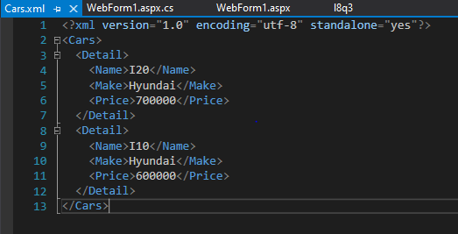

Q4. ( Additional 1 )

**Webform1.aspx:**

<%@ Page Language="C#" AutoEventWireup="true" CodeBehind="WebForm1.aspx.cs" Inherits="L8Add1.WebForm1" %>

<!DOCTYPE html>

<html xmlns="http://www.w3.org/1999/xhtml">

<head runat="server">

<title></title>

</head>

<body>

<form id="form1" runat="server">

<div style="height: 319px">

<asp:GridView ID="GridView1" runat="server" DataSourceID="SqlDataSource1" AutoGenerateColumns="false" AllowSorting="true" DataKeyNames="id">

<Columns>

<asp:BoundField DataField="id" HeaderText="Id" ReadOnly="true" SortExpression="id"/>

<asp:TemplateField HeaderText="Name" SortExpression="name">

<ItemTemplate>

<b>Name:</b> <%# Eval("name") %>

</ItemTemplate>

<EditItemTemplate>

<b>Name:</b> <asp:TextBox ID="TextBox2" runat="server" Text='<%# Bind("name") %>'></asp:TextBox>

<asp:RequiredFieldValidator ID="RequiredFieldValidator1" runat="server" ErrorMessage="Name is required" EnableClientScript="false" ControlToValidate="TextBox2" ForeColor="Red"></asp:RequiredFieldValidator>

</EditItemTemplate>

</asp:TemplateField>

<asp:TemplateField HeaderText="Details">

<ItemTemplate>

<b>Price:</b> <%# Eval("price") %>

<br />

<br />

<b>Quantity:</b> <%# Eval("quantity") %>

</ItemTemplate>

<EditItemTemplate>

<b>Price:</b> <%# Eval("price") %>

<br />

<br />

<b>Quantity</b> <asp:TextBox ID="TextBox1" runat="server" Text='<%# Bind("quantity") %>'></asp:TextBox>

<asp:RangeValidator ID="RangeValidator1" runat="server" ErrorMessage="Quantity should be between 1 and 20" ControlToValidate="TextBox1" EnableClientScript="false" Type="Integer" MinimumValue="1" MaximumValue="20" ForeColor="Red"></asp:RangeValidator>

</EditItemTemplate>

</asp:TemplateField>

<asp:CommandField ShowEditButton="true"/>

</Columns>

</asp:GridView>

<asp:SqlDataSource ID="SqlDataSource1" runat="server" ConnectionString="Data Source=(localdb)\MSSQLLocalDB;Initial Catalog=L8Add1;Integrated Security=True;Pooling=False" SelectCommand="SELECT * FROM Product" UpdateCommand="UPDATE Product SET Quantity=@Quantity,Name=@Name WHERE id=@id"></asp:SqlDataSource>

</div>

</form>

</body>

</html>

**Webform1.aspx.cs:**

using System;

using System.Collections.Generic;

using System.Linq;

using System.Web;

using System.Web.UI;

using System.Web.UI.WebControls;

namespace L8Add1

{

public partial class WebForm1 : System.Web.UI.Page

{

protected void Page_Load(object sender, EventArgs e)

{

}

}

}

**INPUT/OUTPUT:**

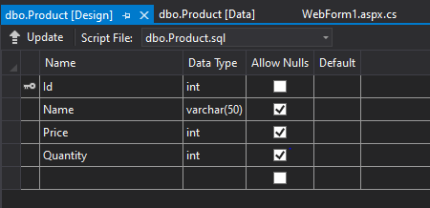

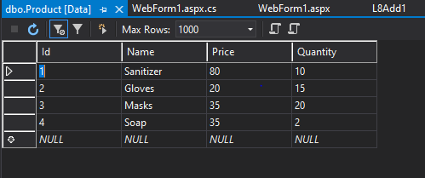

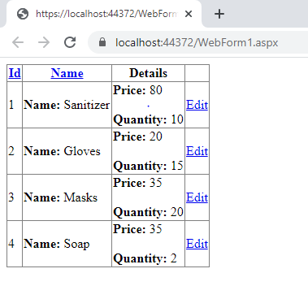

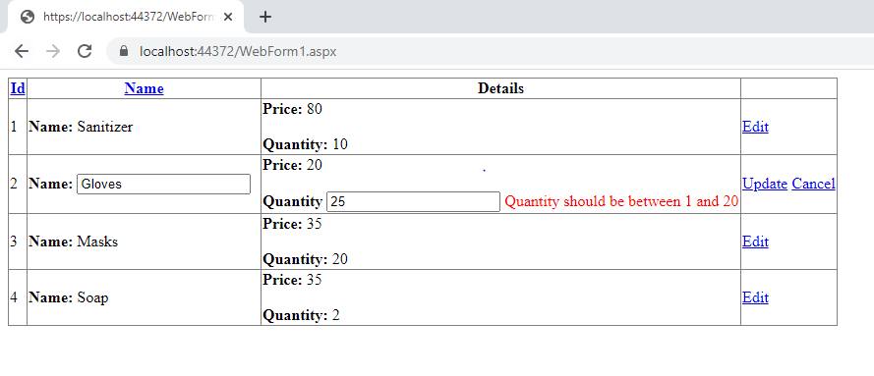

**Changed the “Gloves” Qty from 15 to 20. Update button clicked. O/P on the next page.**

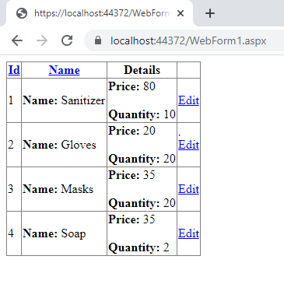

**changes reflected in the database dynamically**

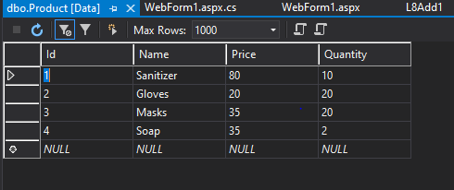

-------------------------------------------------END------------------------------------------------------------------------