**Protractor Automation using Jasmine**

1. Download Node.js <https://nodejs.org/en/download/>

Verify NodeJS is installed

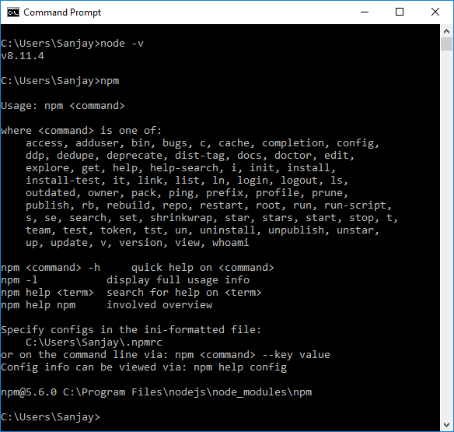

1. Install Protractor - <https://www.protractortest.org/#/tutorial>

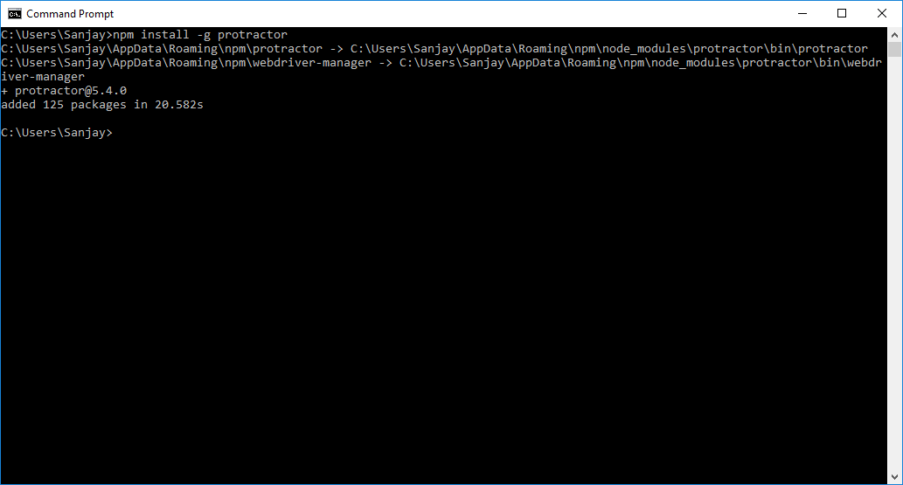

Update WebDriver

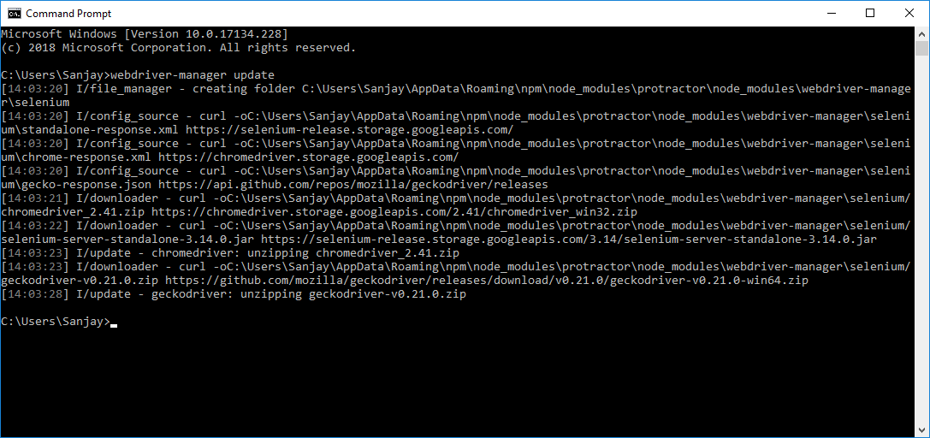

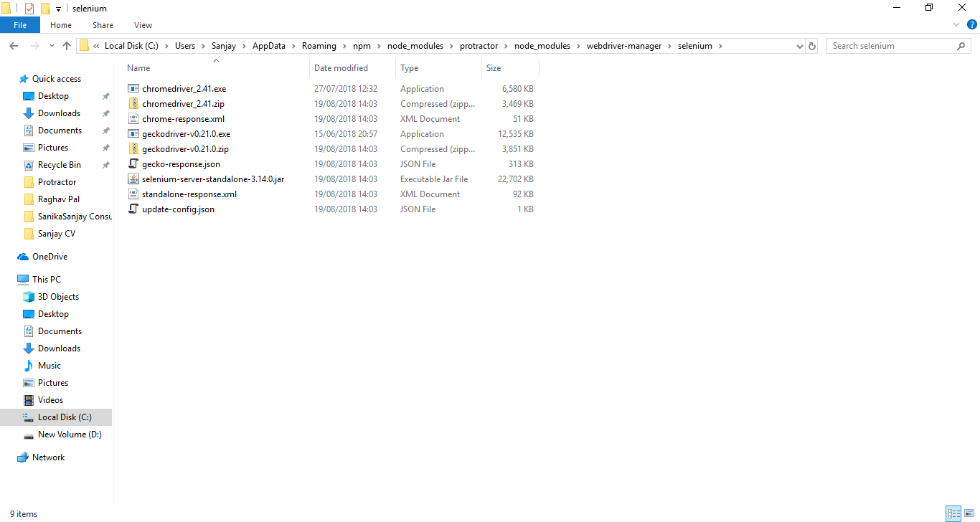

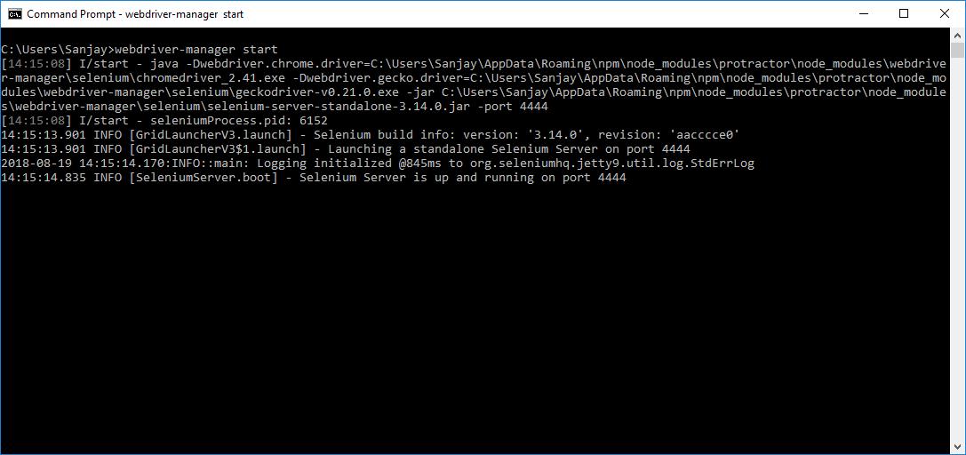

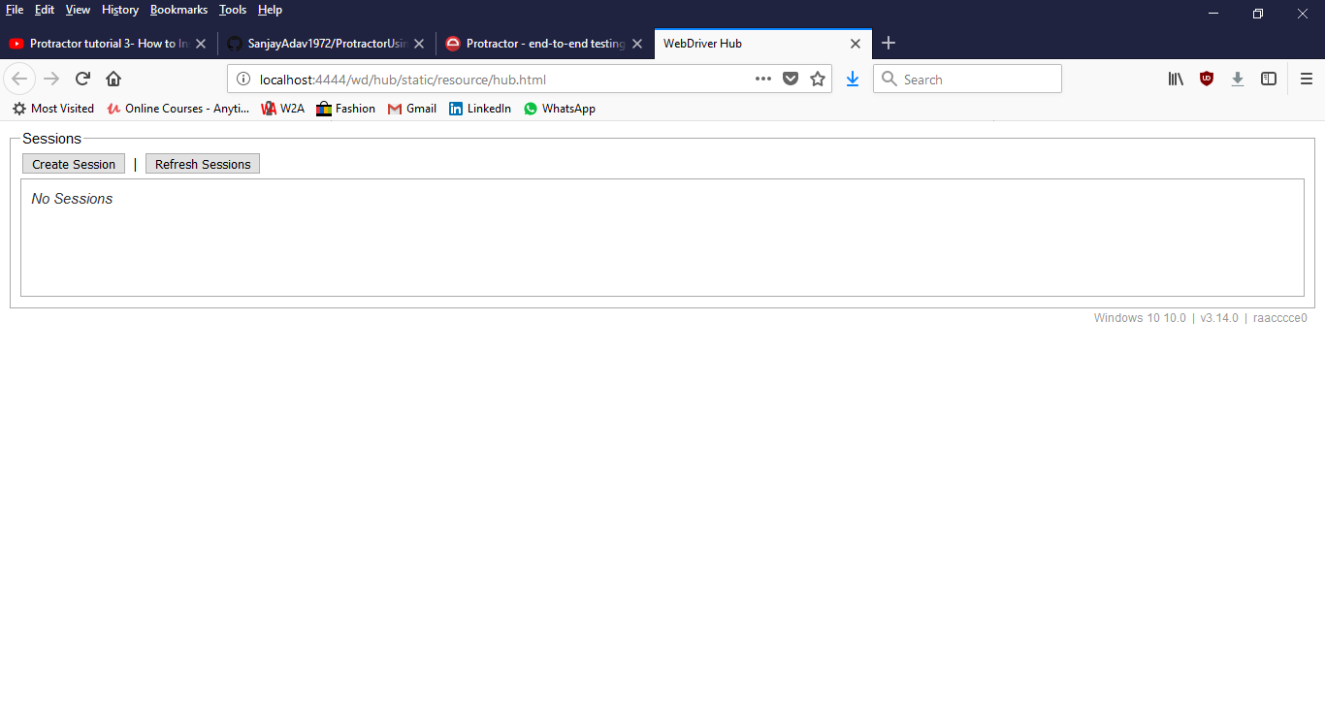

1. Install tern plugin using Eclipse

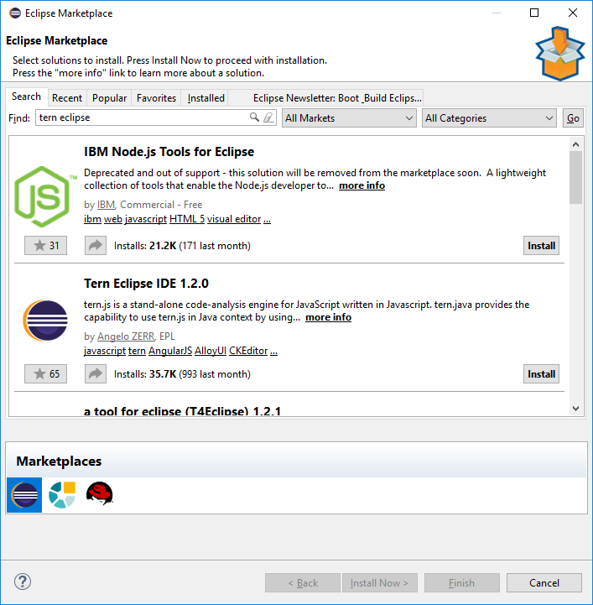

1. Install Protractor Beautiful Reporter

