|  |  |
| --- | --- |
| **Ex. No: 1** | **A python program to implement Univariate Regression, Bivariate Regression and Multivariate Regression** |
| **Date:24/01/25** |

# AIM:

To implement a python program using univariate, bivariate and multivariate regression features for a given iris dataset.

# ALGORITHM:

**STEP 1:** Start the program

**STEP 2:** Import the necessary libraries: pandas for data manipulation, numpy for numerical operations, matplotlib.pyplot for plotting, and LinearRegression from sklearn.linear_model.

**STEP 3:** Read the dataset using pandas.read_csv() and store it in a variable such as data.

**STEP 4:** Prepare the data by extracting the independent variable(s) X and the dependent variable y, and reshape them into 2D arrays if required.

**STEP 5:** Perform univariate, bivariate, and multivariate linear regression using either numpy.polyfit or sklearn's LinearRegression, then make predictions and calculate the R-squared value to assess model accuracy.

**STEP 6:** Visualize the results using 2D/3D scatter plots and regression lines or planes, and display the coefficients, intercepts, and R-squared values for each model.

**STEP 7:** Stop

# PROGRAM:

import pandas as pd import seaborn as sns

import matplotlib.pyplot as plt import numpy as np

df=pd.read_csv(r'C:\Users\221801049\Iris.csv') df.head(150)

df.shape

# OUTPUT:

**UNIVARIATE FOR SEPAL WIDTH**

df_Setosa = df[df['Species'] == 'Iris-setosa'] df_Virginica = df[df['Species'] == 'Iris-virginica'] df_Versicolor = df[df['Species'] == 'Iris-versicolor'] plt.figure(figsize=(10, 6))

plt.scatter(df_Setosa['SepalWidthCm'], np.zeros_like(df_Setosa['SepalWidthCm']), label='Setosa',

alpha=0.6) plt.scatter(df_Versicolor['SepalWidthCm'], np.zeros_like(df_Versicolor['SepalWidthCm']),

label='Versicolor', alpha=0.6)

plt.scatter(df_Virginica['SepalWidthCm'], np.zeros_like(df_Virginica['SepalWidthCm']),

label='Virginica', alpha=0.6)

plt.xlabel('Sepal Width')

plt.title('Sepal Width Distribution by Iris Variety') plt.legend()

plt.show()

# OUTPUT:

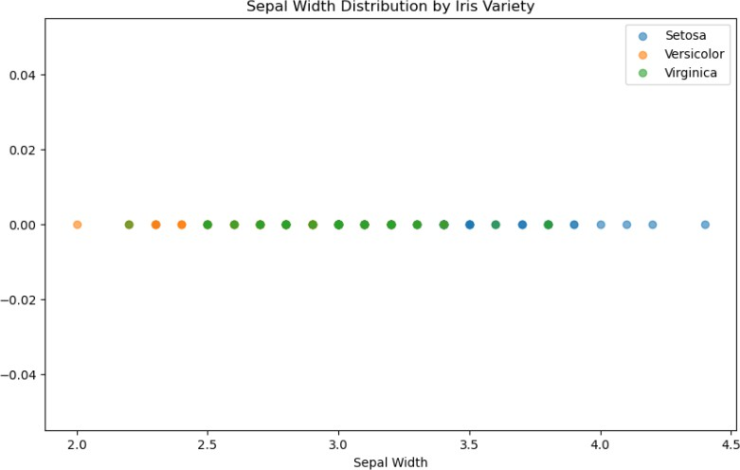

**UNIVARIATE FOR SEPAL LENGTH**

plt.figure(figsize=(10, 6))

plt.scatter(df_Setosa['SepalLengthCm'], np.zeros_like(df_Setosa['SepalLengthCm']),

label='Setosa',alpha=0.6) plt.scatter(df_Versicolor['SepalLengthCm'], np.zeros_like(df_Versicolor['SepalLengthCm']),

label='Versicolor', alpha=0.6)

plt.scatter(df_Virginica['SepalLengthCm'], np.zeros_like(df_Virginica['SepalLengthCm']),

label='Virginica', alpha=0.6)

plt.xlabel('Sepal Length')

plt.title('Sepal Length Distribution by Iris Variety') plt.legend()

plt.show()

# OUTPUT:

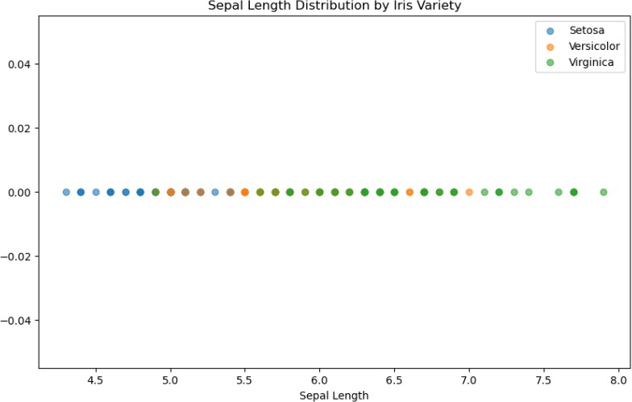

**UNIVARIATE FOR PETAL WIDTH**

plt.figure(figsize=(12, 6))

plt.scatter(df_Setosa['PetalWidthCm'], np.zeros_like(df_Setosa['PetalWidthCm']), label='Setosa', alpha=0.6) plt.scatter(df_Versicolor['PetalWidthCm'], np.zeros_like(df_Versicolor['PetalWidthCm']), label='Versicolor', alpha=0.6)

plt.scatter(df_Virginica['PetalWidthCm'], np.zeros_like(df_Virginica['PetalWidthCm']), label='Virginica', alpha=0.6)

plt.xlabel('Petal Width (cm)')

plt.title('Petal Width Distribution by Iris Variety') plt.legend()

plt.show()

# OUTPUT:

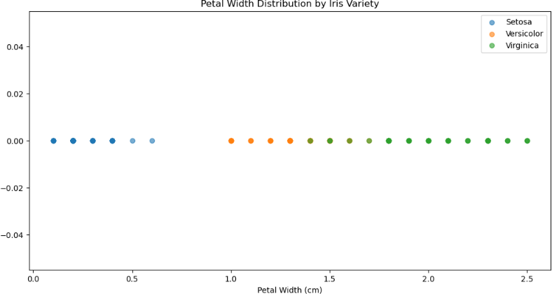

**UNIVARIATE FOR PETAL LENGTH**

plt.figure(figsize=(12, 6))

plt.scatter(df_Setosa['PetalLengthCm'], np.zeros_like(df_Setosa['PetalLengthCm']), label='Setosa', alpha=0.6) plt.scatter(df_Versicolor['PetalLengthCm'], np.zeros_like(df_Versicolor['PetalLengthCm']), label='Versicolor',

alpha=0.6)

plt.scatter(df_Virginica['PetalLengthCm'], np.zeros_like(df_Virginica['PetalLengthCm']), label='Virginica',

alpha=0.6)

plt.xlabel('Petal Length (cm)')

plt.title('Petal Length Distribution by Iris Variety') plt.legend()

plt.show()

# OUTPUT:

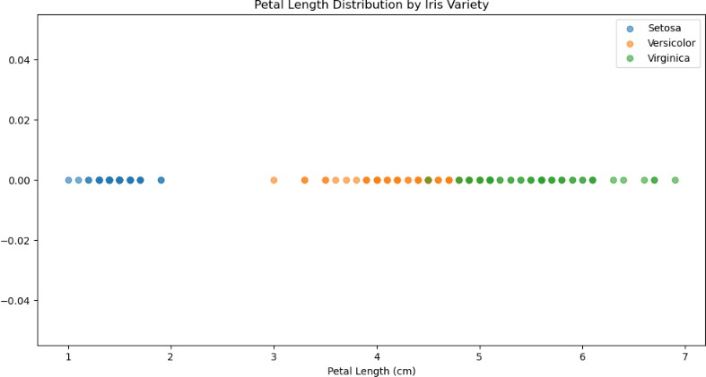

**BIVARIATE SEPAL.WIDTH VS PETAL.WIDTH**

g = sns.FacetGrid(df, hue='Species', height=5) g.map(plt.scatter, 'SepalWidthCm', 'PetalWidthCm', alpha=0.6) g.add_legend()

plt.show()

# OUTPUT:

**BIVARIATE SEPAL.LENGTH VS PETAL.LENGTH**

g = sns.FacetGrid(df, hue='Species', height=5)

g.map(plt.scatter, 'SepalLengthCm', 'PetalLengthCm', alpha=0.6) g.add_legend()

plt.show()

# OUTPUT:

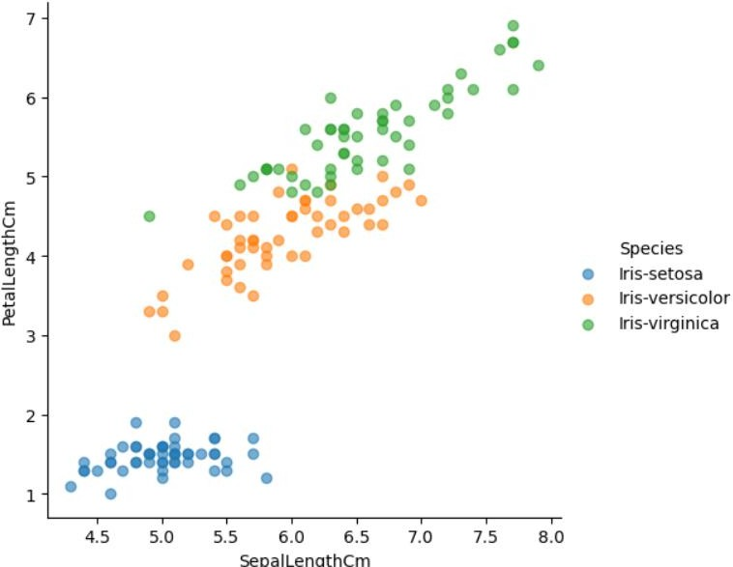

**MULTIVARIATE ALL THE FEATURES**

g=sns.pairplot(df,hue='Species',height=2) plt.show()

# OUTPUT:

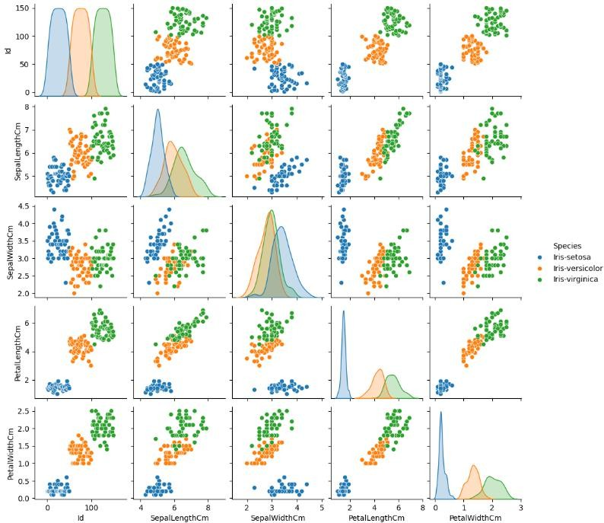

**RESULT:**

Thus, the python program to implement univariate, bivariate and multivariate regression features for the given iris dataset is analyzed and the features are plotted using scatter plot.

|  |  |
| --- | --- |
| **Ex. No: 2** | **A python program to implement Simple linear regression using Least Square Method** |
| **Date:31/01/25** |

# AIM:

To implement a python program for constructing a simple linear regression using least square method.

# ALGORITHM:

**STEP 1:** Start the program

**STEP 2:** Import pandas for data handling and matplotlib.pyplot for plotting. Read the dataset using pandas.read_csv() and store it in a variable like data.

**STEP 3:** Extract the independent variable X and dependent variable y, and reshape them into 2D arrays if necessary.

**STEP 4:** Calculate the mean of X and y, then compute the slope (m) and intercept (b) using the formulas for simple linear regression.

**STEP 5:** Use the slope and intercept to make predictions for each X value. Calculate the Total Sum of Squares (TSS), Residual Sum of Squares (RSS), and the R-squared value to assess model accuracy.

**STEP 6:** Plot the original data points as a scatter plot and the regression line using the predicted values.

**STEP 7:** Print the calculated slope, intercept, and R-squared value to complete the program.

**STEP 8:** Stop

# PROGRAM:

import numpy as np

import matplotlib.pyplot as plt # Sample data

x = np.array([1, 2, 3, 4, 5], dtype=float)

y = np.array([2, 4, 5, 4, 5], dtype=float) # Calculate means

x_mean = np.mean(x) y_mean = np.mean(y) # Calculate coefficients

numerator = np.sum((x - x_mean) * (y - y_mean)) denominator = np.sum((x - x_mean)**2)

slope = numerator / denominator intercept = y_mean - slope * x_mean # Prediction function

def predict(x_val):

return slope * x_val + intercept # Predict y values

y_pred = predict(x) # Print results

print(f"Slope (m): {slope}") print(f"Intercept (b): {intercept}")

print("Regression Line Equation: y = {:.2f}x + {:.2f}".format(slope, intercept)) # Plotting

plt.scatter(x, y, color='blue', label='Actual data') plt.plot(x, y_pred, color='red', label='Regression line') plt.xlabel('x')

plt.ylabel('y')

plt.title('Simple Linear Regression using Least Squares Method') plt.legend()

plt.grid(True) plt.show()

# OUTPUT:

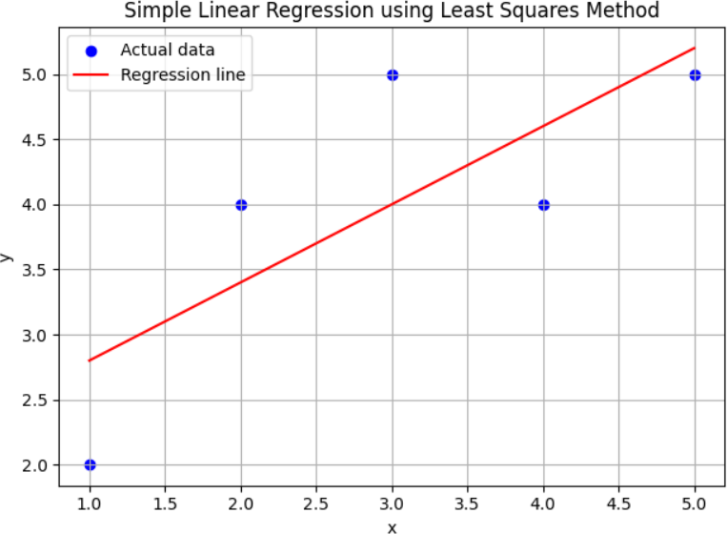

**RESULT:**

Thus, the python program for constructing a simple linear regression using least square method has been implemented and executed successfully.

|  |  |
| --- | --- |
| **Ex. No: 3** | **A python program to implement Logistic Model** |
| **Date:07/02/25** |

# AIM:

To implement python program for the logistic model using DigitalAd dataset.

# ALGORITHM:

**STEP 1:** Start the program

**STEP 2:** Load the dataset

**STEP 3:** Display the shape and first 5 rows of the dataset to understand its structure

**STEP 4:** Separate features (X) and target (Y) and split the data into training and testing sets

**STEP 5:** Train a Logistic Regression model and Make predictions on the test set

**STEP 6:** Evaluate the model using confusion matrix and Print the accuracy of the model

**STEP 7:** Predict for a new customer and Output the prediction result

**STEP 8:** Stop the program

# PROGRAM:

import pandas as pd import numpy as np

data = pd.read_csv("DigitalAd_dataset.csv") print(data.shape)

print(data.head(5))

X = data.iloc[:, :-1].values # All columns except the last one (features)

Y = data.iloc[:, -1].values # Last column as target

from sklearn.model_selection import train_test_split

X_train, X_test, y_train, y_test = train_test_split(X, Y, test_size=0.25, random_state=0)

from sklearn.preprocessing import StandardScaler # Feature scaling (standardizing the features) sc = StandardScaler()

X_train = sc.fit_transform(X_train) X_test = sc.transform(X_test)

from sklearn.linear_model import LogisticRegression # Train a Logistic Regression model model = LogisticRegression(random_state=0)

model.fit(X_train, y_train)

y_pred = model.predict(X_test) # Make predictions on the test set from sklearn.metrics import confusion_matrix, accuracy_score

cm = confusion_matrix(y_test, y_pred) # Evaluate the model using confusion matrix print("Confusion Matrix: ")

print(cm)

print("Accuracy of the Model: {0}%".format(accuracy_score(y_test, y_pred) * 100)) age = int(input("Enter New Customer Age: ")) # Predict for a new customer sal = int(input("Enter New Customer Salary: "))

newCust = [[age, sal]]

result = model.predict(sc.transform(newCust)) # Output the prediction result print(result)

if result == 1: print("Customer will Buy")

else:

print("Customer won't Buy")

# OUTPUT:

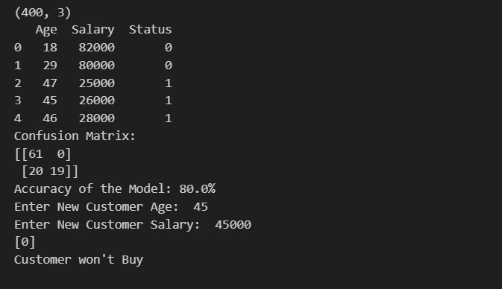

**RESULT:**

Thus, the python program to implement logistic regression for the given dataset is analyzed and the performance of the developed model is measured successfully.

|  |  |
| --- | --- |
| **Ex. No: 4** | **A python program to implement Single Layer Perceptron** |
| **Date:14/02/25** |

# AIM:

To implement python program for the single layer perceptron.

**STEP 1:** Start the program.

**STEP 2:** Import the necessary packages: numpy and matplotlib.

**STEP 3:** Prepare or read a simple dataset (input features X and labels Y).

**STEP 4:** Initialize the perceptron parameters: weights and bias.

**STEP 5:** Define the activation function (step function).

**STEP 6:** Train the perceptron. For each epoch (iteration),Calculate the output.

**STEP 7:** After training, display the final weights and bias. **STEP 8:** Visualize the decision boundary using matplotlib. **STEP 9:** Stop the program.

# PROGRAM:

import numpy as np

import matplotlib.pyplot as plt X = np.array([

[0, 0],

[0, 1],

[1, 0],

[1, 1]])

Y = np.array([0, 1, 1, 1]) # OR gate outputs weights = np.zeros(X.shape[1])

bias = 0

learning_rate = 0.1

epochs = 10

def activation_fn(x): return 1 if x >= 0 else 0

for epoch in range(epochs): print(f"\nEpoch {epoch+1}") for i in range(len(X)):

linear_output = np.dot(X[i], weights) + bias y_predicted = activation_fn(linear_output) error = Y[i] - y_predicted

weights += learning_rate * error * X[i] bias += learning_rate * error

print(f"Input: {X[i]}, Predicted: {y_predicted}, Error: {error}, Updated Weights: {weights}, Updated Bias: {bias}")

print("\nFinal Weights:", weights) print("Final Bias:", bias)

for i in range(len(X)): if Y[i] == 0:

plt.scatter(X[i][0], X[i][1], color='red', marker='o') else:

plt.scatter(X[i][0], X[i][1], color='blue', marker='x')

x_values = [np.min(X[:, 0] - 1), np.max(X[:, 0] + 1)]

y_values = -(weights[0] * np.array(x_values) + bias) / weights[1] plt.plot(x_values, y_values, label='Decision Boundary') plt.xlabel('X1')

plt.ylabel('X2')

plt.title('Single Layer Perceptron Decision Boundary') plt.legend()

plt.grid(True) plt.show() **OUTPUT**

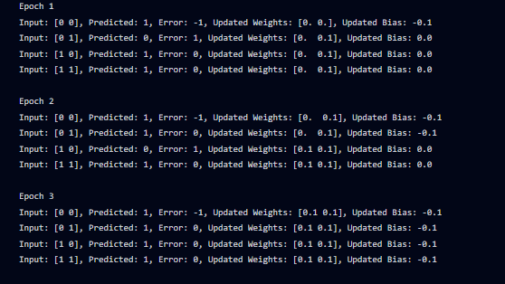

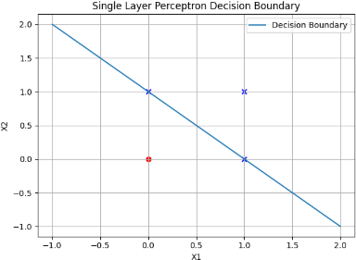

# RESULT:

Thus, the python program Single Layer Perceptron was successfully implemented using Python.

|  |  |
| --- | --- |
| **Ex. No: 5** | **A python program to implement Multilayer Perceptron with Back Propagation** |
| **Date:21/02/25** |

**AIM:**

To implement multilayer perceptron with back propagation using python.

**PROCEDURE:**

**STEP 1:** Start the program

**STEP 2:** Create a class MLP with an init method that initializes weights and biases for the input-to- hidden and hidden-to-output layers.

**STEP 3:** Include activation functions like sigmoid and its derivative and Implement the train() method which performs forward propagation to calculate predictions, backward propagation to compute gradients, and updates weights and biases using gradient descent over a number of epochs.

**STEP 4:** Set up an XOR dataset with 2 inputs and 1 output. Instantiate the MLP with 2 input nodes, 4 hidden nodes, and 1 output node. Train the model using the XOR data for 10,000 epochs.

**STEP 5:** After training, pass the input data through the network again using the learned weights to generate predictions.

**STEP 6:** print the outputs to observe how well the model learned the XOR logic.

**STEP 7:** Stop the program

**PROGRAM:**

import numpy as np class MLP:

def init (self, input_size, hidden_size, output_size): self.input_size = input_size

self.hidden_size = hidden_size self.output_size = output_size

# initialize weights matrix and biases

self.W_input_hidden = np.random.rand(self.input_size, self.hidden_size) self.b_input_hidden = np.zeros((1, self.hidden_size)) self.W_hidden_output = np.random.rand(self.hidden_size, self.output_size) self.b_hidden_output = np.zeros((1, self.output_size))

def sigmoid(self, x):

return 1 / (1 + np.exp(-x)) def d_sigmoid(self, x):

return x * (1 - x)

def train(self, input_data, target, epochs=1000, lr=0.2): for epoch in range(epochs):

# Forward propagation

hidden_layer_input = np.dot(input_data, self.W_input_hidden) + self.b_input_hidden hidden_layer_output = self.sigmoid(hidden_layer_input)

output_layer_input = np.dot(hidden_layer_output, self.W_hidden_output) +

self.b_hidden_output

output = self.sigmoid(output_layer_input)

# Backward propagation output_error = target - output

output_grad = output_error * self.d_sigmoid(output) hidden_error = np.dot(output_grad, self.W_hidden_output.T)

hidden_grad = hidden_error * self.d_sigmoid(hidden_layer_output)

# Update weights and biases using gradient descent

self.W_hidden_output += np.dot(hidden_layer_output.T, output_grad) * lr self.b_hidden_output += np.sum(output_grad, axis=0, keepdims=True) * lr self.W_input_hidden += np.dot(input_data.T, hidden_grad) * lr self.b_input_hidden += np.sum(hidden_grad, axis=0, keepdims=True) * lr

# Optionally, print error every 1000 epochs if epoch % 1000 == 0:

error = np.mean(np.square(target - output)) # Mean Squared Error print(f'Epoch {epoch}, Error: {error}')

# Example usage:

if name == " main ":

# XOR problem: 4 samples, 2 input features, 1 output X = np.array([[0, 0], [0, 1], [1, 0], [1, 1]])

y = np.array([[0], [1], [1], [0]])

# Create MLP with 2 input nodes, 4 hidden nodes, and 1 output node mlp = MLP(input_size=2, hidden_size=4, output_size=1)

mlp.train(X, y, epochs=10000) # Train the model # Test the model after training

print("Predictions after training:")

hidden_layer_input = np.dot(X, mlp.W_input_hidden) + mlp.b_input_hidden hidden_layer_output = mlp.sigmoid(hidden_layer_input)

output_layer_input = np.dot(hidden_layer_output, mlp.W_hidden_output) + mlp.b_hidden_output predictions = mlp.sigmoid(output_layer_input)

print(predictions)

# OUTPUT:

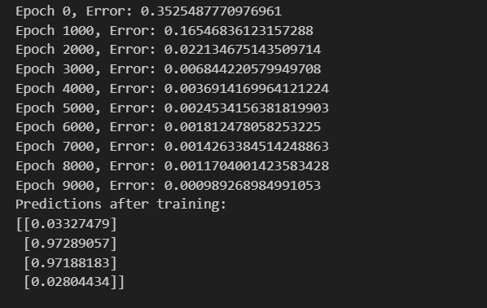

**RESULT:**

Thus, the Python program to implement a simple multi-layer perceptron (MLP) for the XOR problem is analyzed, and the model successfully predicts the output after training by learning the non-linear relationships in the data.

|  |  |
| --- | --- |
| **Ex. No: 6** | **A python program to do face recognition using SVM classifier** |
| **Date: 28/02/25** |

**AIM:**

To implement a SVM classifier model using python and determine its accuracy.

**PROCEDURE:**

**STEP 1:** Start the program.

**STEP 2:** Import the necessary libraries and Load the dataset.

**STEP 3:** Flatten the images and apply PCA

**STEP 4:** Split the dataset into train & test sets and train SVM model

**STEP 5:** Make prediction and evaluate the accuracy.

**STEP 6: P**rint the model accuracy and visualize some test images with predictions.

**STEP 7:** Stop the program.

**PROGRAM:**

import cv2

import numpy as np

import matplotlib.pyplot as plt from sklearn.svm import SVC

from sklearn.datasets import fetch_lfw_people

from sklearn.model_selection import train_test_split from sklearn.decomposition import PCA

from sklearn.metrics import accuracy_score

lfw = fetch_lfw_people(min_faces_per_person=100, resize=0.4, download_if_missing=True) X, y = lfw.images, lfw.target # Images and labels

X_flat = X.reshape(X.shape[0], -1) # Convert images to 1D array

pca = PCA(n_components=100).fit(X_flat) # Reduce dimensions to 100 principal components X_pca = pca.transform(X_flat)

X_train, X_test, y_train, y_test = train_test_split(X_pca, y, test_size=0.2, random_state=42) svm = SVC(kernel='linear')

svm.fit(X_train, y_train) y_pred = svm.predict(X_test)

accuracy = accuracy_score(y_test, y_pred) print(f"Model Accuracy: {accuracy * 100:.2f}%")

fig, axes = plt.subplots(2, 5, figsize=(10, 5)) # Create a grid of 2 rows, 5 columns for i, ax in enumerate(axes.ravel()):

ax.imshow(X[i], cmap='gray') # Show actual face image ax.set_title(f"Pred: {lfw.target_names[y_pred[i]]}") # Predicted name ax.axis('off')

plt.show()

**OUTPUT:**

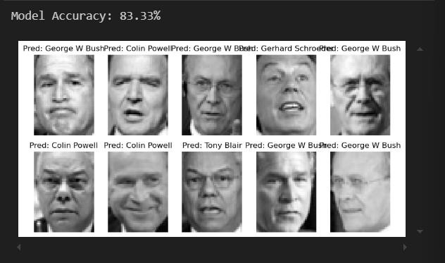

# RESULT:

Thus the python program to implement SVM classifier model has been executed successfully and the classified output has been analyzed for the given dataset.\\

|  |  |
| --- | --- |
| **Ex. No: 7** | **A python program to implement Decision Tree** |
| **Date:07/03/2025** |

# AIM:

To build, train, and visualize a Decision Tree Classifier using the Iris dataset in Python, and to evaluate the model's performance based on its accuracy on the test data.

# ALGORITHM:

**STEP 1:** Start the program.

**STEP 2:** Import necessary modules: datasets, train_test_split, DecisionTreeClassifier, accuracy_score, and matplotlib.pyplot.

**STEP 3:** Load the Iris dataset and separate it into features (X) and target labels (y).

**STEP 4:** Split the dataset into training and testing sets using train_test_split().

**STEP 5:** Create an instance of DecisionTreeClassifier, train (fit) it using the training data (X_train, y_train).

**STEP 6:** Predict the target labels for the test set using the trained classifier.

**STEP 7:** Calculate and print the model’s accuracy using accuracy_score().

**STEP 8:** Visualize the trained Decision Tree using plot_tree() and display it with plt.show().

**STEP 9:** Stop the program.

# PROGRAM:

from sklearn import datasets

from sklearn.model_selection import train_test_split

from sklearn.tree import DecisionTreeClassifier, plot_tree from sklearn.metrics import accuracy_score

import matplotlib.pyplot as plt iris = datasets.load_iris()

X, y = iris.data, iris.target

X_train, X_test, y_train, y_test = train_test_split(X, y, test_size=0.2, random_state=42) clf = DecisionTreeClassifier()

clf.fit(X_train, y_train) y_pred = clf.predict(X_test)

print(f"Accuracy: {accuracy_score(y_test, y_pred) * 100:.2f}%") plt.figure(figsize=(12, 10))

plot_tree(clf, filled=True, feature_names=iris.feature_names, class_names=iris.target_names) plt.show()

# OUTPUT:

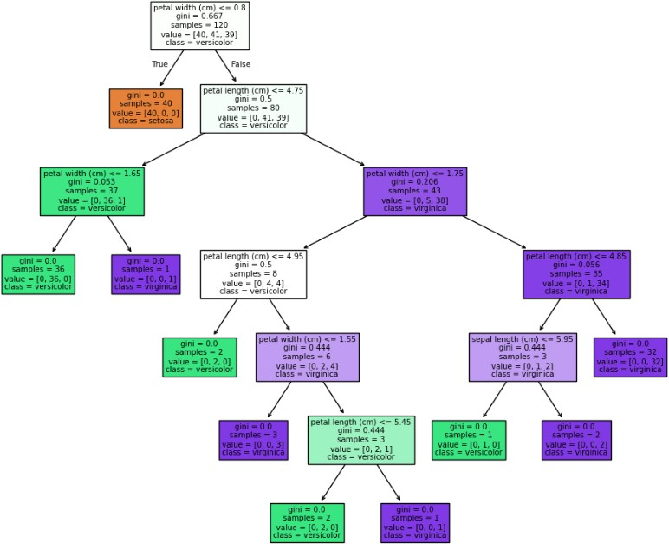

**RESULT:**

Thus, the Python program to build, train, and visualize a Decision Tree Classifier on the Iris dataset was successfully implemented.

|  |  |
| --- | --- |
| **Ex. No: 8** | **A python program to implement Boosting** |
| **Date:28/03/25** |

# AIM:

To build and evaluate a python program to implement boosting.

# ALGORITHM:

**STEP 1:** Start the program.

**STEP 2**: Import required libraries: sklearn, numpy, and matplotlib.

**STEP 3**: Generate a synthetic binary classification dataset using make_classification().

**STEP 4:** Split the dataset into training and testing sets using train_test_split().

**STEP 5:** Initialize the AdaBoostClassifier with a base estimator (DecisionTreeClassifier) and train it on the training data.

**STEP 6:** Use the trained model to make predictions on the test set.

**STEP 7:** Calculate and print the accuracy of the model using accuracy_score().

**STEP 8:** Visualize the decision boundaries by predicting over a meshgrid and plotting the results.

**STEP 9:** Stop the program.

# PROGRAM:

from sklearn.ensemble import AdaBoostClassifier from sklearn.tree import DecisionTreeClassifier from sklearn.datasets import make_classification from sklearn.model_selection import train_test_split from sklearn.metrics import accuracy_score

import matplotlib.pyplot as plt import numpy as np

X, y = make_classification(n_samples=1000, n_features=2, n_informative=2, n_redundant=0, random_state=42)

X_train, X_test, y_train, y_test = train_test_split(X, y, test_size=0.2, random_state=42) boost = AdaBoostClassifier(DecisionTreeClassifier(max_depth=1), n_estimators=50,

random_state=42)

boost.fit(X_train, y_train)

y_pred = boost.predict(X_test) # Predict and evaluate model performance accuracy = accuracy_score(y_test, y_pred)

print(f"Accuracy: {accuracy * 100:.2f}%")

x_min, x_max = X[:, 0].min() - 1, X[:, 0].max() + 1 # Visualization - Decision Boundaries y_min, y_max = X[:, 1].min() - 1, X[:, 1].max() + 1

xx, yy = np.meshgrid(np.linspace(x_min, x_max, 100), np.linspace(y_min, y_max, 100)) Z = boost.predict(np.c_[xx.ravel(), yy.ravel()])

Z = Z.reshape(xx.shape)

plt.figure(figsize=(8, 6)) plt.contourf(xx, yy, Z, alpha=0.3)

plt.scatter(X[:, 0], X[:, 1], c=y, edgecolors="k", cmap=plt.cm.Paired) plt.title("AdaBoost Decision Boundaries")

plt.xlabel("Feature 1")

plt.ylabel("Feature 2") plt.show()

# OUTPUT:

**RESULT:**

Thus, the Python program for Boosting using AdaBoostClassifier was successfully executed.

|  |  |
| --- | --- |
| **Ex. No: 9** | **A python program to implement KNN and K-Means** |
| **Date:04/04/25** |

# AIM:

To implement the K-Nearest Neighbors (KNN) and K Means algorithm on the Iris dataset for classification and evaluate its accuracy.

# ALGORITHM:

**STEP 1:** Start the program.

**STEP 2:** Import necessary libraries such as sklearn.datasets, train_test_split, KNeighborsClassifier, and accuracy_score.

**STEP 3:** Load the Iris dataset and extract the features (X) and target labels (y).

**STEP 4:** Split the dataset into training and testing sets.

**STEP 5:** Create a KNeighborsClassifier model with a defined value of k (e.g., k = 3).

**STEP 6:** Train the model using the training data.

**STEP 7:** Predict the labels for the test data.

**STEP 8:** Evaluate the model by calculating the accuracy score.

**STEP 9:** Display the results.

**STEP 10:** Stop the program.

**STEP 11:** Import necessary libraries such as sklearn.datasets, KMeans, matplotlib.pyplot, and PCA from sklearn.decomposition.

**STEP 12:** Load the Iris dataset and extract the feature matrix (X).

**STEP 13:** Choose the number of clusters (k = 3 for Iris)

**STEP 14:** Create a KMeans object.

**STEP 15:** Fit the KMeans model on the dataset to form clusters.

**STEP 16:** Retrieve and store the cluster labels.

**STEP 17:** Reduce dimensionality using PCA for visualization (2 components). **STEP 18:** Plot the clustered data on a 2D scatter plot using the PCA-reduced values. **STEP 19:** Display the visualization.

**STEP 20:** Stop the program.

# PROGRAM:

from sklearn.datasets import load_iris

from sklearn.model_selection import train_test_split from sklearn.neighbors import KNeighborsClassifier from sklearn.metrics import accuracy_score

# Load dataset iris = load_iris()

X, y = iris.data, iris.target

X_train, X_test, y_train, y_test = train_test_split(X, y, test_size=0.2, random_state=42) knn = KNeighborsClassifier(n_neighbors=3)

knn.fit(X_train, y_train) y_pred = knn.predict(X_test)

accuracy = accuracy_score(y_test, y_pred) print(f"KNN Accuracy: {accuracy * 100:.2f}%") from sklearn.datasets import load_iris

from sklearn.model_selection import train_test_split from sklearn.neighbors import KNeighborsClassifier from sklearn.metrics import accuracy_score

iris = load_iris()

X, y = iris.data, iris.target

X_train, X_test, y_train, y_test = train_test_split(X, y, test_size=0.2, random_state=42) knn = KNeighborsClassifier(n_neighbors=3)

knn.fit(X_train, y_train) y_pred = knn.predict(X_test)

accuracy = accuracy_score(y_test, y_pred) print(f"KNN Accuracy: {accuracy * 100:.2f}%")

# OUTPUT:

**RESULT:**

Thus the python program for building classification model using KNN algorithm is executed and verified successfully.

|  |  |
| --- | --- |
| **Ex. No: 10** | **A python program to implement Dimensionality Reduction – PCA** |
| **Date:11/04/25** |

# AIM:

To develop a Python program to implement Principal Component Analysis (PCA) for dimensionality reduction using the Digits dataset.

# ALGORITHM:

**STEP 1:** Start the program.

**STEP 2:** Import the required libraries: numpy, matplotlib.pyplot, sklearn.decomposition.PCA, and sklearn.datasets.load_digits.

**STEP 3:** Load the Digits dataset using load_digits() and store the data in variable X.

**STEP 4:** Apply PCA with n_components=2 using the PCA() class and fit-transform the dataset.

**STEP 5**: Store the result of PCA in X_pca and visualize the 2D projection of the data using a scatter plot. **STEP 6:** Color the points in the plot based on their digit labels using a color map for better interpretation. **STEP 7:** Add labels, a colorbar, and a title to the plot for clarity.

**STEP 8:** Stop the program.

# PROGRAM:

import numpy as np

import matplotlib.pyplot as plt

from sklearn.decomposition import PCA from sklearn.datasets import load_digits # Load dataset

digits = load_digits()

X = digits.data y = digits.target # Apply PCA

pca = PCA(n_components=2) X_pca = pca.fit_transform(X) # Plot PCA results

plt.scatter(X_pca[:, 0], X_pca[:, 1], c=y, cmap='viridis', alpha=0.5) plt.colorbar()

plt.title("PCA - Digit Dataset") plt.xlabel("Principal Component 1")

plt.ylabel("Principal Component 2") plt.show()

# OUTPUT:

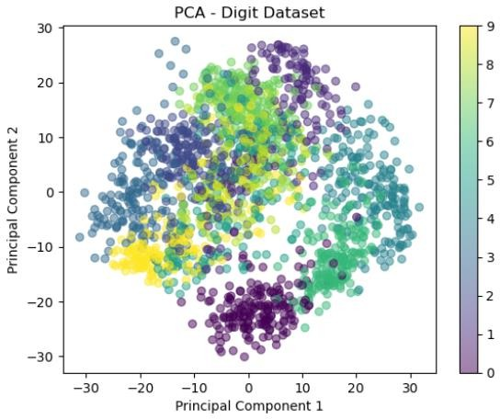

**RESULT:**

Thus, the Python program to perform dimensionality reduction using PCA was successfully executed and visualized using the Digits dataset.

|  |  |
| --- | --- |
| **Ex. No: 11** | **Mini project – Develop a simple application using TensorFlow / Keras** |
| **Date:11/04/25** |

# AIM:

To develop a Removing Noise from Images Using the TensorFlow.

# ALGORITHM:

**STEP 1:** Start the program.

**STEP 2:** Add random Gaussian noise to the images and clip values to stay between 0 and 1.

**STEP 3:** Load the MNIST dataset and split it into training and testing sets..

**STEP 4:** Build a Convolutional autoencoder model:

* Use Conv2D and Maxpooling layers for encoding.
* Use Con2D Transpose and Conv2D Layers for Decoding.

**STEP 5:** Compile the model using the adam optimizer and binary crossentropy loss.

**STEP 6:** Train the model with noisy images as input and original images as the output

**STEP 7:** Predict and Display the denoised images alongside their noisy versions

**STEP 8:** Stop the program.

# PROGRAM:

import tensorflow as tf, matplotlib.pyplot as plt

(x,*), (xt,*) = tf.keras.datasets.mnist.load_data()

x = xt[..., None] / 255.

xn = tf.clip_by_value(x + .5*tf.random.normal(tf.shape(x)), 0, 1)

m = tf.keras.Sequential([

tf.keras.layers.Input((28,28,1)),

tf.keras.layers.Conv2D(16, 3, padding='same', activation='relu'),

tf.keras.layers.MaxPool2D(),

tf.keras.layers.Conv2DTranspose(16, 3, strides=2, padding='same', activation='relu'),

tf.keras.layers.Conv2D(1, 3, padding='same', activation='sigmoid')

])

m.compile('adam', 'binary_crossentropy')

m.fit(xn, x, epochs=3, batch_size=128, verbose=0)

for i in range(5):

noisy_img = xn[i].numpy().squeeze()

denoised_img = m.predict(xn[i:i+1], verbose=0).squeeze()

plt.subplot(1,2,1)

plt.imshow(noisy_img, cmap='gray')

plt.axis('off')

plt.title('Noisy')

plt.subplot(1,2,2)

plt.imshow(denoised_img, cmap='gray')

plt.axis('off')

plt.title('Denoised')

plt.show()

# OUTPUT:

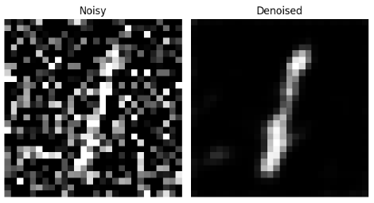

**RESULT:**

Thus, the TensorFlow based application for Removing Noise from Images Using the TensorFlow is developed, executed successfully, and the model’s performance is visualized and verified.