**LightCents - IOT - Final Project Idea**

***COMP216 – Networking For Software Developers***

**Team Members:**

Sanjay Mahabir

Gequilan, Kassie Lyn

Fatima, Husna

Bharti, Neeraj

Abolghasem, Azadeh

**Overview**

This project was inspired by the assigned final project and is thus very similar. The only difference is that instead of generating random values to simulate a sensor, real sensor values are generated with an actual light dependent resistor (LDR) /photoresistor. At the heart of this project is the **Node MicroController Unit MCU ESP8266** which is running MicroPython and has built-in Wi-Fi connectivity. The MicroController uses MQTT to publish/broadcast its light readings to a local MQTT broker that transmits these values to connected subscriber clients. These values are plotted on a line graph in realtime using a GUI created with the Tkinter library.

**Details**

The project setup requires the following:

1. A laptop with the Eclipse MQTT broker installed, configured and running
2. This Laptop must have its mobile hotspot turned on for other devices/clients to access the MQTT broker that is running locally on this machine. (An online test broker could also be used)
3. The NodeMCU is flashed with MicroPython and the MQTT libraries and custom programs are loaded
4. The required circuits on the NodeMCU with the photoresistor are wired up.
5. The NodeMCU can then connect to this laptop’s hotspot and publish its light readings using MQTT.
6. The same or other laptops/devices can then run the subscriber python program to read those values and plot them on a line graph in realtime using a Tkinter GUI interface.

The figures below show the actual NodeMCU used in the project and the real output achieved by shining a light and covering the light sensor.

**Figure 1.** The NodeMCU with its light Sensor and two optional LEDs hooked up. The LEDs illuminate to indicate when high or low light levels are reached, respectively.

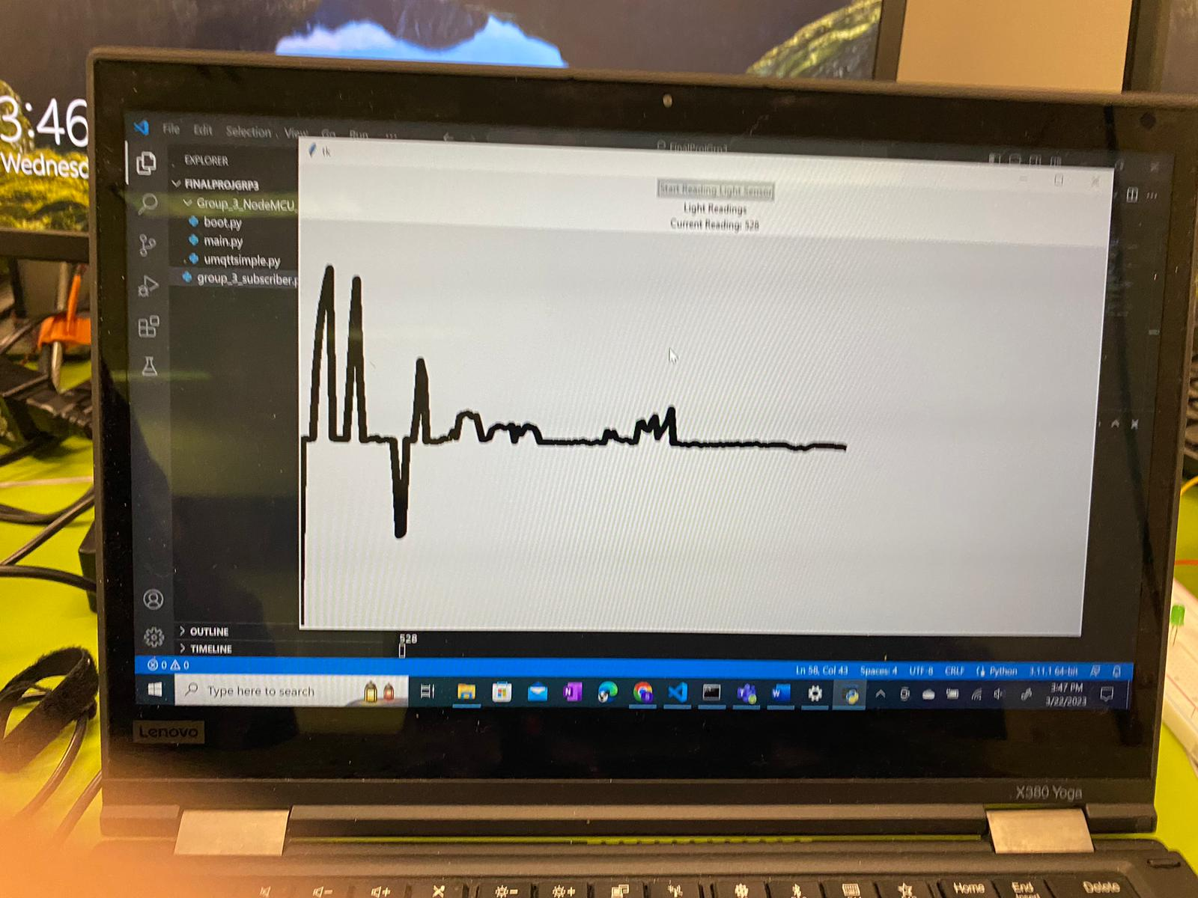

**Figure 2.** Example output from the connected Subscriber Client executing the Tkinter GUI

**Conclusion**

This project was initially an experimental project and it was uncertain whether the team could get this work. However, because one of the members had a microcontroller kit they never used, this was an opportunity for the team to have fun with this kit. Through past experience and research, the team was able to connect all the components together to create a successful project. The usefulness of IOT, especially MQTT has definitely been realized as a result of this undertaking.