CAPSTONE SOFTWARE ENGINEERING PROJECT REPORT
PROCUREFLOW
Regional B2B Procurement and Quotation Management Platform for MSMEs
――――――――――――――――――――――――――――――――――――――――――――――――――――――――
Project Overview & Domain Scope
EXECUTIVE PROJECT SUMMARY: ProcureFlow is a full-stack, state-driven B2B procurement workflow platform engineered for Micro, Small, and Medium Enterprises (MSMEs). Rather than operating as an open-ended lead-generation directory, ProcureFlow digitizes and strictly governs the end-to-end purchasing lifecycle: requirement drafting, regional vendor discovery, dynamic tiered pricing evaluation with floating-point epsilon precision, side-by-side bid comparison, direct vendor selection, and database-enforced immutable purchase order generation.

Project Metadata & Institutional Submission Details
Candidate Name | [Student Name]
Registration / Roll Number | [Registration / Roll Number]
Degree & Branch | Bachelor of Engineering in Computer Science & Engineering
Department | Department of Computer Science and Engineering
Academic Institution | [Institution / University Name]
Project Supervisor / Guide | [Project Guide Name, Designation & Department]
Academic Year & Session | 2025 – 2026
Project Source Repository | https://github.com/SanjayDurai16/ProcureFlow

Submitted in partial fulfillment of the requirements for the Degree of Bachelor of Engineering
October 2026

1. Executive Abstract
Context & Problem Space: Micro, Small, and Medium Enterprises (MSMEs) constitute the industrial backbone of manufacturing and regional commerce. Despite their economic significance, internal procurement operations across small industrial units frequently rely on disconnected communication channels, including unstructured email exchanges, informal messaging, phone calls, and manual spreadsheets. This fragmented approach leads to quotation loss, inconsistent commercial baselines, complete lack of volume pricing visibility, delayed supplier selections, and unstandardized purchase commitments.
Proposed Solution: ProcureFlow is an end-to-end, state-driven B2B procurement and quotation management web application designed to replace ad-hoc purchasing workflows with rigorous digital governance. The system models the complete procurement lifecycle across two distinct user roles: Buyers (industrial purchasers) and Vendors (regional suppliers). The core engine enforces a deterministic Finite State Machine (FSM), algorithmic dynamic tiered pricing evaluation, objective tabular quotation comparison, direct vendor selection, and database-enforced immutable Purchase Order (PO) issuance.
Technical Architecture & Verification: The application is architected as a modular monolith utilizing React 19, TypeScript, and Vite on the presentation tier, and Node.js, Express 5, and MongoDB with Mongoose on the server tier. Security and validation are guaranteed through salted bcrypt password hashing, stateless JSON Web Tokens (JWT), Zod runtime schema validation, and multi-tenant authorization guards. Automated testing with Vitest and Supertest verifies 20 unit and integration tests (100% pass rate) covering pricing edge cases, state machine transitions, and cross-tenant data isolation.
2. Background and Industry Motivation
In industrial manufacturing clusters—such as the automotive corridors of Chennai, machine tooling hubs of Coimbatore, and precision engineering clusters of Bangalore—small enterprises must procure raw materials and specialized components under stringent operating margins and compressed delivery windows. Unlike multinational corporations equipped with enterprise resource planning (ERP) suites like SAP or Oracle, MSMEs operate with lean administrative teams and cannot justify the licensing costs, lengthy deployment cycles, and operational complexity of enterprise procurement software. Consequently, MSMEs remain tethered to manual purchasing methods that impair operational efficiency and supply chain resilience.
3. The Operational Pitfalls of Fragmented Procurement
- Communication Breakdowns: Unstructured email threads and messaging chats lead to misplaced specifications, missed bid deadlines, and communication silos.
- Opaque Quotation Comparison: Vendors submit quotations across heterogeneous spreadsheets with differing units, delivery terms, and tax components, making fair comparison labor-intensive and error-prone.
- Absence of Volume Tier Mechanics: Suppliers offer quantity-based discounts, but buyers lack automated computational engines to dynamically evaluate volume tiers against their exact batch quantities.
- Unstandardized Purchase Commitments: Informal agreements result in verbal purchasing commitments without auditable purchase documentation containing fixed line items, agreed terms, and delivery milestones.
4. Specific Problem Addressed by ProcureFlow
ProcureFlow directly resolves this operational deficit by establishing a lightweight, structured digital workflow that bridges the gap between unstructured consumer messaging and over-engineered enterprise ERPs. It enforces algorithmic pricing transparency, regional vendor discovery, role-based tenant isolation, deterministic state transitions, and verifiable commercial auditability for industrial MSMEs.

1. Project Objectives
Primary Objective: To architect, implement, and empirically verify a full-stack, state-driven B2B procurement platform specifically designed to govern the purchasing lifecycle for MSMEs with commercial transparency and technical rigor.
- 1. Lifecycle Governance: Enforce a deterministic backend Finite State Machine (FSM) governing RFQ transitions (DRAFT -> OPEN -> UNDER_REVIEW -> APPROVED -> PO_ISSUED), blocking unauthorized or illegal status leaps with HTTP 422.
- 2. Dynamic Pricing Engine: Develop an algorithmic tiered pricing engine that dynamically evaluates vendor volume slabs against requested batch quantities, incorporating Number.EPSILON floating-point rounding precision.
- 3. Quotation Comparison: Provide a normalized side-by-side quotation comparison matrix that objectively identifies lowest price and fastest lead times while gracefully handling multi-quote ties.
- 4. Tenant Security & RBAC: Enforce strict Role-Based Access Control (RBAC) and multi-tenant data isolation, ensuring Buyers cannot tamper with competing organizations' RFQs and Vendors cannot view unreleased drafts.
- 5. Purchase Order Integrity: Generate immutable Purchase Orders with database-enforced uniqueness (unique: true index on rfq_id) to eliminate duplicate commitments under concurrent requests.
- 6. Milestone Audit Trail: Implement a lightweight, append-only chronological audit timeline recording all significant lifecycle events for operational accountability.
2. Project Scope and Boundaries
In-Scope Modules (Implemented & Verified) | Out-of-Scope System Boundaries (Deliberate Limits)
RFQ lifecycle management (Draft, Publish, Review, Select, Issue PO) | Multi-line Bill of Materials (BOM) per single RFQ
Regional industrial hub tagging (Chennai, Coimbatore, Bangalore) | Real-time payment gateway / bank escrow fund disbursement
Volume-based slab pricing validation & mathematical resolution | Automated third-party freight / GPS logistics integration
Immutable PO issuance with fulfillment FSM & chronological audit timeline | External SMTP mail servers & SMS notification gateways
3. System Requirements Specification
- Functional: FR-1: Secure authentication with encrypted passwords (bcryptjs) and stateless JWT role claims.
- Functional: FR-2: RFQ creation, specification drafting, regional hub tagging, and publication.
- Functional: FR-3: Vendor quotation submission with multi-tiered volume pricing slabs and lead times.
- Functional: FR-4: Automated unit price and total spend evaluation based on buyer requested quantity.
- Functional: FR-5: Standardized comparison matrix highlighting lowest spend and fastest delivery with tie handling.
- Functional: FR-6: Direct quotation selection, competitive bid rejection, and approval state transition.
- Functional: FR-7: Idempotent Purchase Order generation with unique PO serial numbers (PO-YYYY-XXXX).
- Functional: FR-8: Chronological audit event persistence and retrieval via REST API timeline endpoint.
- Non-Functional: NFR-1 (Performance): API response latencies <100ms for pricing evaluation and quote comparisons.
- Non-Functional: NFR-2 (Security): Multi-tenant ownership verification rejecting unauthorized cross-organization access with 403.
- Non-Functional: NFR-3 (Integrity): Database uniqueness constraint preventing duplicate PO generation under race conditions.

1. Three-Tier Modular Monolith Architecture
ProcureFlow is engineered as a three-tier modular monolith, prioritizing domain separation, high cohesion, and low coupling without the operational overhead of microservices. The architecture cleanly decouples client presentation, HTTP transport/middleware, domain business logic, and data persistence.
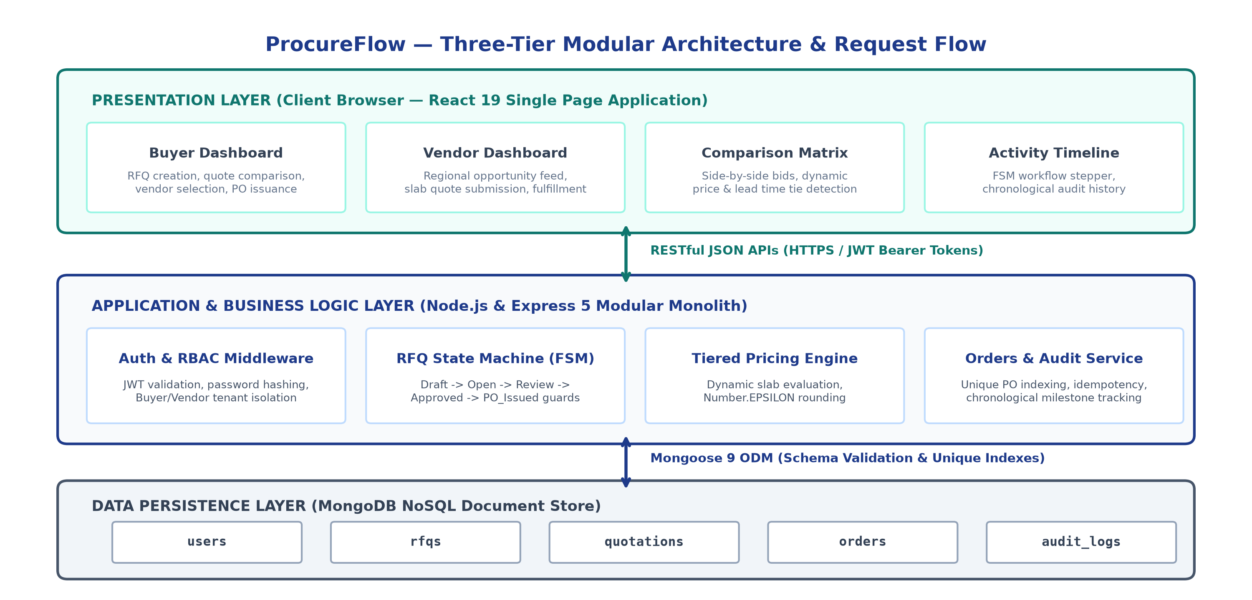
Figure 4.1: ProcureFlow Three-Tier Modular Architecture and Inter-Layer Communication
2. Deterministic Workflow & Finite State Machine (FSM)
State Machine Invariants: A central architectural contribution of ProcureFlow is the elimination of arbitrary database mutations through a centralized Finite State Machine. The procurement lifecycle advances through strictly validated state transitions:
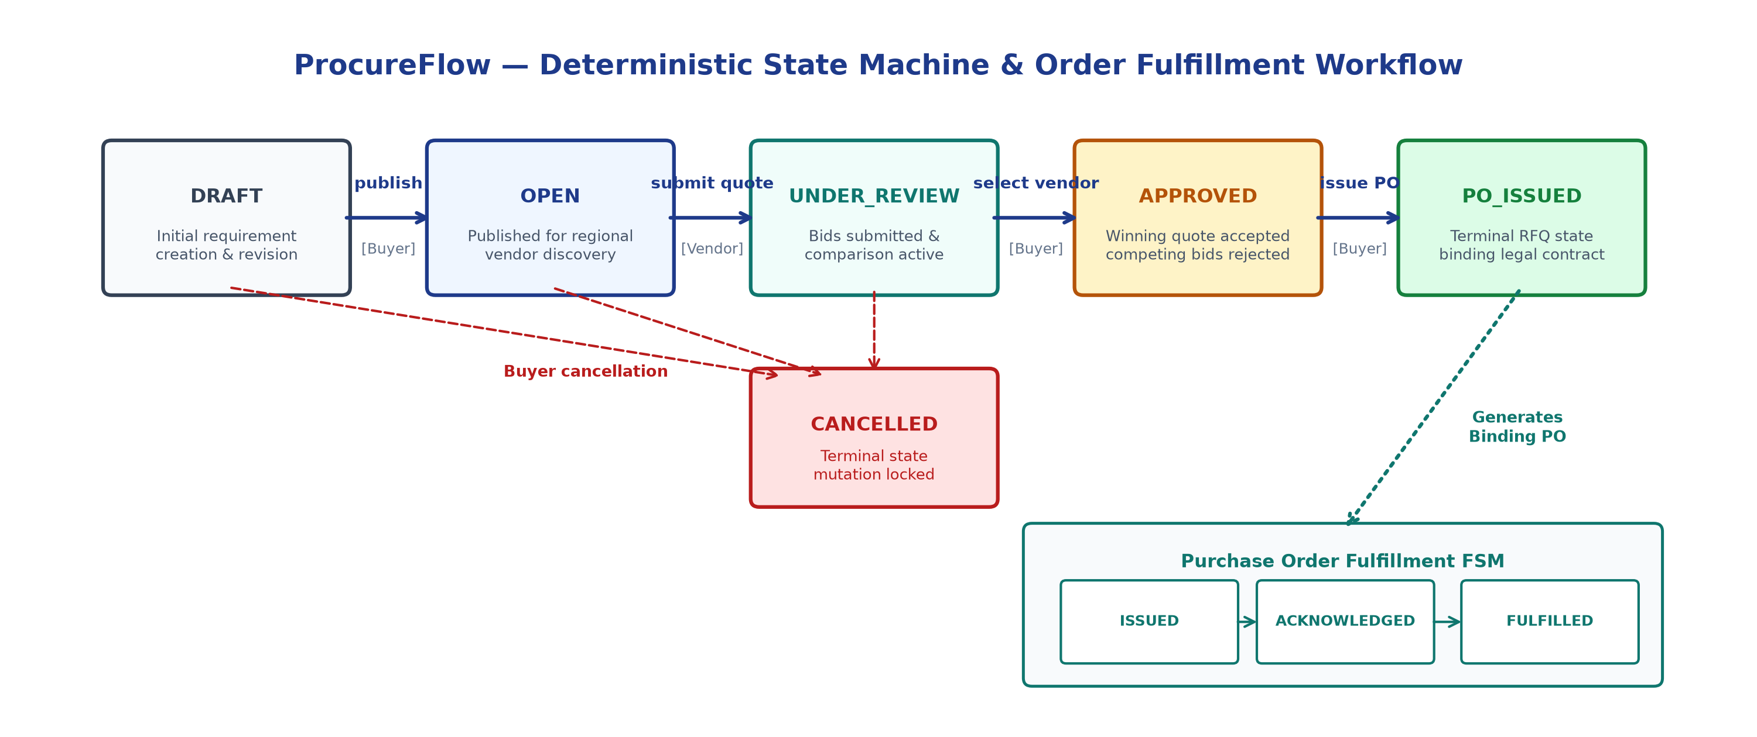
Figure 4.2: Deterministic RFQ Finite State Machine and Order Fulfillment Transitions
Lifecycle Progression Rules: 1. DRAFT -> OPEN: Triggered by Buyer publication; validates required fields and broadcasts RFQ to regional suppliers. 2. OPEN -> UNDER_REVIEW: Initiated upon receipt of eligible vendor quotations. 3. UNDER_REVIEW -> APPROVED: Buyer confirms winning quotation; competing bids are marked REJECTED. 4. APPROVED -> PO_ISSUED: Buyer generates formal PO; RFQ reaches terminal state. 5. CANCELLED: Can be invoked from DRAFT, OPEN, or UNDER_REVIEW, immediately freezing all bidding.

1. Authentication and RBAC Module (modules/auth)
The authentication module manages user identity, organization mapping, and regional hub assignments. Passwords are encrypted using bcryptjs with 10 salt rounds. Upon verification, the server issues a signed JSON Web Token (JWT) containing the user ID, email, role (BUYER or VENDOR), organization, and regional hub. Middleware functions (authenticateToken and requireRole) guard protected API endpoints.
2. RFQ Management and FSM Module (modules/rfqs)
Governs procurement requirements. Validates payloads against Zod schemas and enforces multi-tenant ownership: buyers can only update or cancel their own RFQs. To protect buyer confidentiality, vendors attempting to query DRAFT RFQs or draft quotations receive an immediate HTTP 403 Forbidden error.
3. Dynamic Tiered Pricing Engine (modules/quotations)
Algorithmic Formulation: Vendors submit volume-based pricing slabs defining minimum quantities, maximum quantities (or null for open-ended top tiers), and unit prices. The pricing engine enforces strict economic and mathematical invariants:
- Validation Invariant 1: Boundary and Gap Validation: Validates that slab n+1 starts exactly at min_{n+1} = max_n + 1. Slabs with gaps or overlaps are rejected with 400 Bad Request.
- Validation Invariant 2: Non-Inverted Economics: Enforces price monotonicity (unit_price_{n+1} <= unit_price_n) to ensure higher volumes do not incur higher per-unit rates.
- Validation Invariant 3: Decimal Precision & Epsilon Rounding: Evaluated totals use Math.round((val + Number.EPSILON) * 100) / 100, preventing IEEE 754 precision drift (e.g. 17 * 12.35 = 209.94999999999999 rounds to 209.95).
4. Quotation Comparison Matrix & Fair Tie Handling
When evaluating competing bids, the backend evaluates all quotes against requested quantity Q and compiles a normalized comparison matrix. To avoid unfair algorithmic bias, the system tracks multiple lowest price IDs (lowestPriceQuoteIds) and fastest lead time IDs (fastestDeliveryQuoteIds). All tied quotations are highlighted equally in the UI.
5. Purchase Order Issuance & Fulfillment (modules/orders)
Upon quotation approval, the buyer generates an official Purchase Order. Idempotency is enforced: if a PO already exists for the given rfq_id, the existing document is returned safely without duplicate writes. A database-level unique index on rfq_id prevents concurrent generation race conditions. Post-issuance fulfillment follows an explicit state machine: ISSUED -> ACKNOWLEDGED -> FULFILLED, rejecting backward mutations.
6. Append-Only Audit Trail & Activity Timeline (modules/audit)
Provides commercial auditability by recording milestone events: CREATE_DRAFT, PUBLISH, CANCEL, SUBMIT_QUOTE, SELECT_VENDOR, GENERATE_PO, ACKNOWLEDGE_PO, and FULFILL_PO. Records capture entity type, entity ID, from_state, to_state, actor user ID, timestamp, and notes. The GET /api/rfqs/:id/timeline endpoint populates a visual activity log in the frontend.

1. Evaluated Technology Stack
Layer | Technology | Version | Technical Role & Justification
Frontend UI | React 19 | v19.0.0 | Component-based SPA, predictable state rendering and fast updates
Type Safety | TypeScript | v5.6.3 | Compile-time type verification, interfaces for API contracts and domain models
Build Tooling | Vite | v8.3.0 | Ultra-fast ES module bundling and optimized production client distribution
Server Runtime | Node.js (ESM) | v22.x | Asynchronous, event-driven backend runtime utilizing native ES modules
API Framework | Express | v5.2.1 | Robust middleware routing pipeline and clean modular monolith controllers
Database & ODM | MongoDB / Mongoose | v9.10.2 | Document store for flexible pricing slabs with schema validation & unique indexes
Validation & Auth | Zod & JWT / bcryptjs | v4 / v9 / v3 | Runtime schema validation, salted password hashing, and stateless bearer auth
2. Data Model & Relational Schema Architecture
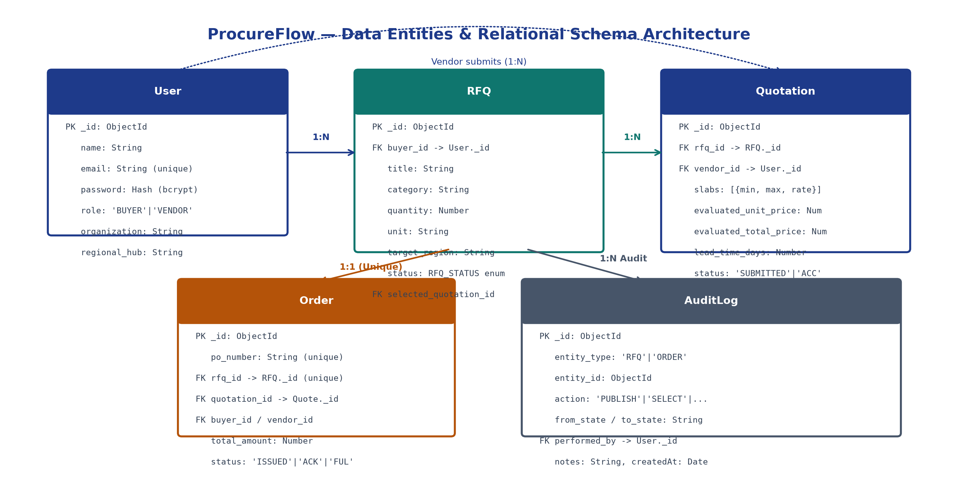
Figure 6.1: ProcureFlow Entity-Relationship Schema Architecture & Indexed References
3. Application Security Implementation & Boundaries
- Cryptographic Protection: User passwords salted and hashed with bcryptjs (10 rounds); raw passwords never stored.
- Stateless Token Security: JWT bearer tokens cryptographically signed with HS256 secret; bearer token verified on all private routes.
- Runtime Input Sanitization: All write endpoints validate incoming JSON against strict Zod schemas before service execution.
- Multi-Tenant Isolation: Buyers can only inspect and manage RFQs belonging to their account; cross-tenant tampering triggers 403.
- Security Limitations: Known Boundaries: Current system operates in single-cluster deployment without distributed refresh token rotators, CSRF tokens (session cookies not used), or external WAF/rate-limiting proxies (identified for future production scaling).

1. Testing Strategy and Test Architecture
Software reliability and mathematical accuracy are verified via automated testing using Vitest 5 and Supertest 7. The test suite isolates business logic units (pricing engine and finite state machine) and executes full-flow HTTP integration tests against an active MongoDB test instance.
2. Verified Test Execution Summary (20/20 Tests Passing)
Test Suite File | Scope / Target Module | Tests | Result | Duration
pricing-engine.test.js | Tiered pricing, boundary checks, gaps, epsilon rounding | 11 | 11 Passed (100%) | 27 ms
state-machine.test.js | RFQ lifecycle FSM, illegal transitions, terminal locks | 5 | 5 Passed (100%) | 16 ms
rfq-workflow.test.js | HTTP API integration, RBAC, tenant isolation, PO idempotency | 4 | 4 Passed (100%) | 937 ms
3. Deep-Dive Analysis of Verified Critical Scenarios
- Exact Boundary Resolution: Verifies calculations at exact slab boundaries (e.g., quantities 100, 499, 500) and open-ended max_qty: null.
- Out-of-Bounds Rejection: Rejects quantities below minimum tier or above bounded maximum with 400 Bad Request.
- Slab Gap & Overlap Detection: Identifies and rejects non-continuous slabs (e.g. 1–100 followed by 150–500) and overlapping brackets.
- Monotonicity & Inverted Pricing: Rejects inverted economics where larger purchase quantities cost more per unit than lower tiers.
- Epsilon Floating-Point Precision: Verifies Math.round((val + Number.EPSILON) * 100) / 100 correctly rounds boundary floating-point values without IEEE 754 drift.
- FSM Illegal Transition Blocking: Asserts attempts to jump from DRAFT directly to PO_ISSUED throw HTTP 422 Unprocessable Entity.
- Terminal State Lock: Asserts mutations on terminal PO_ISSUED or CANCELLED records are blocked.
- Cross-Tenant Security Isolation: Asserts Buyer B attempting to fetch or modify Buyer A's RFQs receives HTTP 403 Forbidden.
- PO Generation Idempotency: Asserts duplicate PO generation requests return existing PO without duplicate database writes.
4. Current Technical Limitations & Known Gaps
While the 20 automated tests demonstrate high architectural dependability, current testing is focused on backend services and API routes. End-to-end browser automation (e.g., Playwright or Cypress) is not yet integrated into CI. Performance benchmarks under high concurrent write loads (>10,000 req/sec) have not been conducted.

1. Project Conclusion
ProcureFlow successfully demonstrates the design, full-stack implementation, and automated verification of a state-driven B2B procurement platform engineered specifically for the operational needs of MSMEs. By enforcing a deterministic Finite State Machine, automated tiered pricing evaluation with epsilon precision, objective quotation comparison with tie-handling, database-enforced PO uniqueness, and append-only audit tracking, the application replaces fragmented manual procurement with a transparent, reliable, and auditable commercial workflow.
2. Key Technical Learning Outcomes
- State Machine Architecture: Designing centralized state machines to protect transactional integrity across complex business lifecycles.
- Financial Numerical Precision: Understanding IEEE 754 binary floating-point representation and implementing epsilon rounding in commercial software.
- Multi-Tenant Security: Implementing defense-in-depth authorization with JWT claims and multi-tenant resource ownership guards.
- Test-Driven Dependability: Developing comprehensive unit and integration test suites using Vitest and Supertest to eliminate regressions.
3. Proposed Future Scope & Production Roadmap
- 1. Multi-Item RFQ / BOM Support: Expanding RFQ schemas to support multi-item Bill of Materials (BOM) with item-specific delivery milestones.
- 2. Multi-Tier Financial Approvals: Introducing configurable managerial threshold approval workflows for orders exceeding configured capital limits.
- 3. Real-Time WebSocket Alerts: Integrating WebSocket connections to provide instant notification of new quotations and order acknowledgments.
- 4. B2B Escrow Payment Gateways: Connecting escrow-based milestone payment gateways to automate fund disbursement upon PO fulfillment.
- 5. Document Export Services: Providing native server-side PDF generation for formal offline RFQ summaries and printable tax invoices.
- 6. Containerized Orchestration: Packaging services into multi-stage Docker containers with automated GitHub Actions CI/CD pipelines.
4. Technical References and Official Documentation
- React Documentation (React 19) — https://react.dev (Official documentation on concurrent features & hooks).
- Node.js Documentation (Node.js v22 LTS) — https://nodejs.org/docs (ES module architecture and runtime APIs).
- Express Application Framework — https://expressjs.com (Routing pipelines and RESTful middleware design).
- MongoDB & Mongoose ODM — https://mongoosejs.com/docs (Schema modeling, indexing, and validation hooks).
- Zod Validation Library — https://zod.dev (TypeScript-first schema declaration and runtime payload validation).
- Vitest Testing Framework — https://vitest.dev (Blazing-fast unit and integration testing runner).
- RFC 7519 JSON Web Token (JWT) — https://datatracker.ietf.org/doc/html/rfc7519 (Stateless security specification).

Candidate Signature | Project Supervisor | Department HOD / Examiner
_____________________  [Student Name] | _____________________  [Guide Name, Designation] | _____________________  Head of Department

