Lab 1: Applied data science

1. ***Which variables have the most explanatory power? Which have the least?***

The next method is to use pearson test to compare both variables:

df **=** pd**.**read_csv**(**"trafficking_data.csv"**)**

**print** pearsonr**(**df**[**"persons prosecuted"**],**df**[**"Adult victims"**])**

……and so on

person prosecuted VS adult victim:

(-0.048430976740660318, 0.54565160155960302)

child victim VS adult victim:

(-0.035024116929785513, 0.66219496601816152)

gdp VS adult victim:

(0.028646394597412601, 0.72087188051004913)

life expectancy VS adult victim:

(0.049826116824534659, 0.53412741414372966)

Female primary education VS adult victim:

(-0.10034340943285375, 0.20967825172658733)

policy index VS adult victim:

(0.063669987031620329, 0.42674651732545388)

where the return value is (Pearson's correlation coefficient, 2-tailed p-value). Here we understand that almost no correlation between two of them (pearson coefficient varies from -1 to 1, close to zero implies no correlation). P-value roughly indicates the probability of an uncorrelated system producing datasets that have a Pearson correlation at least as extreme as the one computed from these datasets. In addition, policy index seems to be dominant factor in predicting Adult victims.

Then we start implementing linear prediction model to try predicting each expected Y values by fixed x variables and compare the R squared value.

OLS Regression Results

==============================================================================

Dep. Variable: Adult_victims R-squared: 0.106

Model: OLS Adj. R-squared: 0.089

Method: Least Squares F-statistic: 6.142

Date: Wed, 08 Oct 2014 Prob (F-statistic): 0.000567

Time: 18:24:05 Log-Likelihood: -1280.2

No. Observations: 158 AIC: 2566.

Df Residuals: 155 BIC: 2576.

Df Model: 3

=====================================================================================

coef std err t P>|t| [95.0% Conf. Int.]

-------------------------------------------------------------------------------------

gdp -3.425e-12 3.06e-11 -0.112 0.911 -6.38e-11 5.7e-11

policy_index 19.3717 31.154 0.622 0.535 -42.169 80.913

life_expectancy 4.5127 8.912 0.506 0.613 -13.092 22.117

females_education -4.4773 11.804 -0.379 0.705 -27.795 18.840

==============================================================================

Omnibus: 198.128 Durbin-Watson: 0.777

Prob(Omnibus): 0.000 Jarque-Bera (JB): 5932.011

Skew: 5.132 Prob(JB): 0.00

Kurtosis: 31.208 Cond. No. 1.20e+12

==============================================================================

Warnings:

[1] The condition number is large, 1.2e+12. This might indicate that there are

strong multicollinearity or other numerical problems.

Parameters: gdp -3.425145e-12

policy_index 1.937171e+01

life_expectancy 4.512711e+00

females_education -4.477272e+00

dtype: float64

Warnings:

[1] The condition number is large, 1.2e+12. This might indicate that there are

strong multicollinearity or other numerical problems.

Parameters: gdp -2.586435e-12

policy_index 5.257530e+00

life_expectancy -1.838591e+00

females_education 2.201553e+00

dtype: float64

OLS Regression Results

==============================================================================

Dep. Variable: persons_prosecuted R-squared: 0.034

Model: OLS Adj. R-squared: 0.015

Method: Least Squares F-statistic: 1.828

Date: Wed, 08 Oct 2014 Prob (F-statistic): 0.144

Time: 18:24:05 Log-Likelihood: -1510.8

No. Observations: 158 AIC: 3028.

Df Residuals: 155 BIC: 3037.

Df Model: 3

=====================================================================================

coef std err t P>|t| [95.0% Conf. Int.]

-------------------------------------------------------------------------------------

gdp 5.426e-12 1.32e-10 0.041 0.967 -2.55e-10 2.65e-10

policy_index 101.7509 134.108 0.759 0.449 -163.163 366.665

life_expectancy -32.9970 38.363 -0.860 0.391 -108.779 42.785

females_education 36.2056 50.813 0.713 0.477 -64.169 136.581

==============================================================================

Omnibus: 224.600 Durbin-Watson: 0.538

Prob(Omnibus): 0.000 Jarque-Bera (JB): 10002.180

Skew: 6.162 Prob(JB): 0.00

Kurtosis: 39.979 Cond. No. 1.20e+12

==============================================================================

Warnings:

[1] The condition number is large, 1.2e+12. This might indicate that there are

strong multicollinearity or other numerical problems.

Parameters: gdp 5.425977e-12

policy_index 1.017509e+02

life_expectancy -3.299698e+01

females_education 3.620564e+01

dtype: float64

R^2 of results_victims 0.106242258731

R^2 of results_prosecuted 0.0341707197668

From the result above we could see that R squared for adult victim is larger than results prosecuted. Therefore, we will use Adult victims as the value to predict in this assignment.

1. ***Remove some the outlier countries, how does this effect your model?*** -----

To get a better image on how removing outlier countries, we can observe the distribution of influential plot (H leverage VS studentized residuals). Here we remove Brazil who has unevenly distributed residual value, bigger than the standardized value of 3:

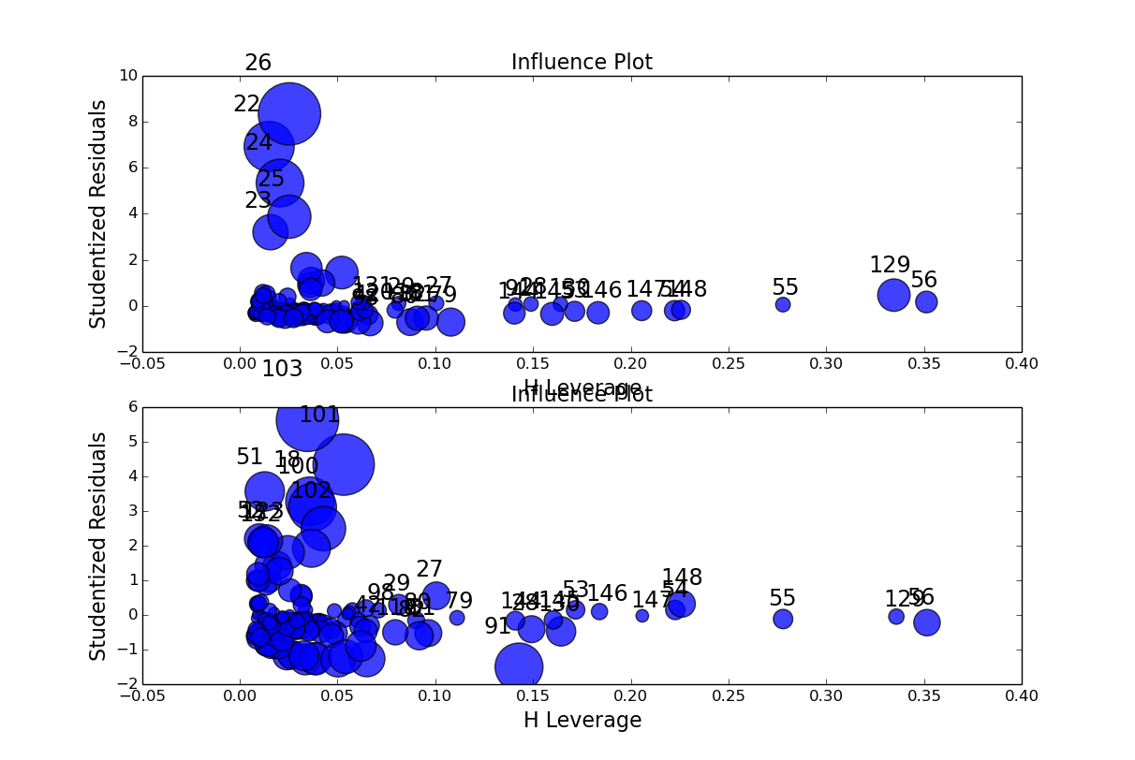

More detail summary of the coefficient can be seen here:

OLS Regression Results

==============================================================================

Dep. Variable: Adult_victims R-squared: 0.024

Model: OLS Adj. R-squared: -0.002

Method: Least Squares F-statistic: 0.9258

Date: Wed, 08 Oct 2014 Prob (F-statistic): 0.451

Time: 18:24:12 Log-Likelihood: -1278.7

No. Observations: 158 AIC: 2567.

Df Residuals: 153 BIC: 2583.

Df Model: 4

======================================================================================

coef std err t P>|t| [95.0% Conf. Int.]

--------------------------------------------------------------------------------------

const 6367.3284 4201.836 1.515 0.132 -1933.778 1.47e+04

gdp 4.989e-12 3.12e-11 0.160 0.873 -5.66e-11 6.65e-11

policy_index 16.6306 31.606 0.526 0.600 -45.810 79.071

females_education -130.7897 84.940 -1.540 0.126 -298.596 37.017

life_expectancy 1.3003 9.139 0.142 0.887 -16.755 19.356

persons_prosecuted -0.0182 0.019 -0.948 0.344 -0.056 0.020

child_victims -0.6412 0.768 -0.835 0.405 -2.159 0.876

==============================================================================

Omnibus: 191.304 Durbin-Watson: 0.794

Prob(Omnibus): 0.000 Jarque-Bera (JB): 5184.289

Skew: 4.886 Prob(JB): 0.00

Kurtosis: 29.306 Cond. No. 1.61e+14

==============================================================================

Warnings:

[1] The condition number is large, 1.61e+14. This might indicate that there are

strong multicollinearity or other numerical problems.

Outlier: [22, 23, 24, 25, 26]

country year persons_prosecuted Adult_victims child_victims \

22 Brazil 2003 52 5223 0

23 Brazil 2004 130 2887 0

24 Brazil 2005 128 4348 0

25 Brazil 2006 117 3417 0

26 Brazil 2007 200 5975 0

gdp policy_index females_education life_expectancy

22 5.524693e+11 10 47.71990 71

23 6.637603e+11 11 47.70676 71

24 8.821857e+11 12 47.59256 71

25 1.088917e+12 11 47.20861 71

26 1.366824e+12 11 47.20861 71

OLS Regression Results

==============================================================================

Dep. Variable: Adult_victims R-squared: 0.153

Model: OLS Adj. R-squared: 0.130

Method: Least Squares F-statistic: 6.683

Date: Wed, 08 Oct 2014 Prob (F-statistic): 5.68e-05

Time: 18:24:13 Log-Likelihood: -1037.2

No. Observations: 153 AIC: 2084.

Df Residuals: 148 BIC: 2100.

Df Model: 4

======================================================================================

coef std err t P>|t| [95.0% Conf. Int.]

--------------------------------------------------------------------------------------

const -3407.2866 1153.837 -2.953 0.004 -5687.410 -1127.163

gdp 8.754e-12 8.38e-12 1.044 0.298 -7.81e-12 2.53e-11

policy_index -0.3600 8.523 -0.042 0.966 -17.203 16.483

females_education 82.6792 23.400 3.533 0.001 36.438 128.920

life_expectancy -7.1481 2.466 -2.899 0.004 -12.021 -2.275

persons_prosecuted -0.0029 0.005 -0.555 0.580 -0.013 0.007

child_victims 0.3980 0.208 1.913 0.058 -0.013 0.809

==============================================================================

Omnibus: 91.217 Durbin-Watson: 0.738

Prob(Omnibus): 0.000 Jarque-Bera (JB): 417.753

Skew: 2.289 Prob(JB): 1.93e-91

Kurtosis: 9.676 Cond. No. 1.64e+14

==============================================================================

Warnings:

[1] The condition number is large, 1.64e+14. This might indicate that there are

strong multicollinearity or other numerical problems.

From the summary above we could see that R squared increased from 0.024 to 0.153, showing that the model works better without outliers.

1. ***Log-scale each of the variables, how does this change your model? Does it improve the models predictive power? How can you tell?***

After scales were changed to logarithmic, we could observer that R squared increased significantly:

OLS Regression Results

==============================================================================

Dep. Variable: Adult_victims R-squared: 0.153

Model: OLS Adj. R-squared: 0.130

Method: Least Squares F-statistic: 6.683

Date: Wed, 08 Oct 2014 Prob (F-statistic): 5.68e-05

Time: 19:50:51 Log-Likelihood: -1037.2

No. Observations: 153 AIC: 2084.

Df Residuals: 148 BIC: 2100.

Df Model: 4

======================================================================================

coef std err t P>|t| [95.0% Conf. Int.]

--------------------------------------------------------------------------------------

Intercept -3407.2866 1153.837 -2.953 0.004 -5687.410 -1127.163

persons_prosecuted -0.0029 0.005 -0.555 0.580 -0.013 0.007

child_victims 0.3980 0.208 1.913 0.058 -0.013 0.809

gdp 8.754e-12 8.38e-12 1.044 0.298 -7.81e-12 2.53e-11

policy_index -0.3600 8.523 -0.042 0.966 -17.203 16.483

females_education 82.6792 23.400 3.533 0.001 36.438 128.920

life_expectancy -7.1481 2.466 -2.899 0.004 -12.021 -2.275

==============================================================================

Omnibus: 91.217 Durbin-Watson: 0.738

Prob(Omnibus): 0.000 Jarque-Bera (JB): 417.753

Skew: 2.289 Prob(JB): 1.93e-91

Kurtosis: 9.676 Cond. No. nan

==============================================================================

Warnings:

[1] The smallest eigenvalue is -6.49e+08. This might indicate that there are

strong multicollinearity problems or that the design matrix is singular.

OLS Regression Results

==============================================================================

Dep. Variable: Adult_victims R-squared: 0.454

Model: OLS Adj. R-squared: 0.432

Method: Least Squares F-statistic: 20.27

Date: Wed, 08 Oct 2014 Prob (F-statistic): 3.63e-17

Time: 19:50:51 Log-Likelihood: -1003.6

No. Observations: 153 AIC: 2021.

Df Residuals: 146 BIC: 2042.

Df Model: 6

================================================================================================

coef std err t P>|t| [95.0% Conf. Int.]

------------------------------------------------------------------------------------------------

Intercept -1.001e+04 3555.325 -2.815 0.006 -1.7e+04 -2981.212

np.log1p(persons_prosecuted) 29.3962 7.357 3.995 0.000 14.855 43.937

np.log1p(child_victims) 24.5572 7.602 3.231 0.002 9.534 39.581

np.log1p(gdp) -32.4480 3.509 -9.246 0.000 -39.384 -25.512

np.log1p(policy_index) 82.4559 53.638 1.537 0.126 -23.552 188.464

np.log1p(females_education) 2615.0982 911.383 2.869 0.005 813.891 4416.306

np.log1p(life_expectancy) 97.1963 137.693 0.706 0.481 -174.932 369.325

==============================================================================

Omnibus: 68.088 Durbin-Watson: 1.049

Prob(Omnibus): 0.000 Jarque-Bera (JB): 198.134

Skew: 1.820 Prob(JB): 9.46e-44

Kurtosis: 7.222 Cond. No. 6.52e+03

==============================================================================

Warnings:

[1] The condition number is large, 6.52e+03. This might indicate that there are

strong multicollinearity or other numerical problems.

Therefore, we may conclude logarithmic conversion did improve the predictive power of this particular regression model.

1. ***Can you think of any other modeling techniques (from class) that could be used instead of linear regression? Try using one of these and explain your results, with diagrams and if possible, a visualization as well as descriptive statistics.***

One of the other model that was discussed in the class (not lab) were polinomial. In this assignment linear, 2nd order and 3rd order of polynomial regressions were tested. It can be done by implementing formula in statsmodels OLS feature:

# 3-rd order polynomial

poly_3 **=** smf**.**ols**(**formula**=**'Adult_victims~ 1 + persons_prosecuted + child_victims+ gdp+ policy_index+ females_education + life_expectancy+I(persons_prosecuted ** 2.0) + I(child_victims ** 2.0)+ I(gdp ** 2.0) + I(policy_index ** 2.0)+I(females_education ** 2.0) + I(life_expectancy ** 2.0)+I(persons_prosecuted ** 3.0) + I(child_victims ** 3.0)+ I(gdp ** 3.0) + I(policy_index ** 3.0)+I(females_education ** 3.0) + I(life_expectancy ** 3.0)'**,** data**=**df**).**fit**()**

**print** poly_3**.**summary**()**

plt**.**plot**(**x**,** poly_3**.**predict**(**X**),** 'go'**,** label**=**'Poly n=3 $R^2$=%.2f' **%** poly_3**.**rsquared**,**

alpha**=**0.9**)**

The statistic summary:

OLS Regression Results

==============================================================================

Dep. Variable: Adult_victims R-squared: 0.454

Model: OLS Adj. R-squared: 0.432

Method: Least Squares F-statistic: 20.27

Date: Wed, 08 Oct 2014 Prob (F-statistic): 3.63e-17

Time: 22:03:28 Log-Likelihood: -1003.6

No. Observations: 153 AIC: 2021.

Df Residuals: 146 BIC: 2042.

Df Model: 6

======================================================================================

coef std err t P>|t| [95.0% Conf. Int.]

--------------------------------------------------------------------------------------

const -1.001e+04 3555.325 -2.815 0.006 -1.7e+04 -2981.212

gdp -32.4480 3.509 -9.246 0.000 -39.384 -25.512

policy_index 82.4559 53.638 1.537 0.126 -23.552 188.464

females_education 2615.0982 911.383 2.869 0.005 813.891 4416.306

life_expectancy 97.1963 137.693 0.706 0.481 -174.932 369.325

persons_prosecuted 29.3962 7.357 3.995 0.000 14.855 43.937

child_victims 24.5572 7.602 3.231 0.002 9.534 39.581

==============================================================================

Omnibus: 68.088 Durbin-Watson: 1.049

Prob(Omnibus): 0.000 Jarque-Bera (JB): 198.134

Skew: 1.820 Prob(JB): 9.46e-44

Kurtosis: 7.222 Cond. No. 6.52e+03

==============================================================================

Warnings:

[1] The condition number is large, 6.52e+03. This might indicate that there are

strong multicollinearity or other numerical problems.

OLS Regression Results

==============================================================================

Dep. Variable: Adult_victims R-squared: 0.673

Model: OLS Adj. R-squared: 0.629

Method: Least Squares F-statistic: 15.29

Date: Wed, 08 Oct 2014 Prob (F-statistic): 2.45e-24

Time: 22:03:28 Log-Likelihood: -964.53

No. Observations: 153 AIC: 1967.

Df Residuals: 134 BIC: 2025.

Df Model: 18

================================================================================================

coef std err t P>|t| [95.0% Conf. Int.]

------------------------------------------------------------------------------------------------

Intercept -5.723e+07 1.04e+08 -0.551 0.582 -2.62e+08 1.48e+08

persons_prosecuted -133.4874 33.380 -3.999 0.000 -199.508 -67.467

child_victims -15.8600 59.138 -0.268 0.789 -132.825 101.105

gdp -107.1898 47.483 -2.257 0.026 -201.103 -13.276

policy_index -637.5839 504.583 -1.264 0.209 -1635.560 360.393

females_education 4.34e+07 8e+07 0.542 0.588 -1.15e+08 2.02e+08

life_expectancy 4.193e+05 3.9e+05 1.075 0.284 -3.52e+05 1.19e+06

I(persons_prosecuted ** 2.0) 50.3547 10.252 4.912 0.000 30.079 70.631

I(child_victims ** 2.0) 8.6766 27.626 0.314 0.754 -45.962 63.315

I(gdp ** 2.0) 3.8014 3.751 1.013 0.313 -3.618 11.221

I(policy_index ** 2.0) 601.7357 406.774 1.479 0.141 -202.792 1406.263

I(females_education ** 2.0) -1.108e+07 2.06e+07 -0.538 0.591 -5.18e+07 2.97e+07

I(life_expectancy ** 2.0) -9.996e+04 9.4e+04 -1.064 0.289 -2.86e+05 8.59e+04

I(persons_prosecuted ** 3.0) -3.8735 0.737 -5.257 0.000 -5.331 -2.416

I(child_victims ** 3.0) -0.1597 3.171 -0.050 0.960 -6.431 6.112

I(gdp ** 3.0) -0.0361 0.075 -0.480 0.632 -0.185 0.113

I(policy_index ** 3.0) -131.4920 86.698 -1.517 0.132 -302.965 39.981

I(females_education ** 3.0) 9.435e+05 1.77e+06 0.534 0.594 -2.55e+06 4.44e+06

I(life_expectancy ** 3.0) 7933.6415 7540.870 1.052 0.295 -6980.886 2.28e+04

==============================================================================

Omnibus: 69.548 Durbin-Watson: 1.413

Prob(Omnibus): 0.000 Jarque-Bera (JB): 283.826

Skew: 1.678 Prob(JB): 2.33e-62

Kurtosis: 8.766 Cond. No. 8.61e+10

==============================================================================

Warnings:

[1] The smallest eigenvalue is 4.91e-12. This might indicate that there are

strong multicollinearity problems or that the design matrix is singular.

Therefore, we may conclude the best regression model is the one with highest R squared value, which is 3rd order of polynomial. In the following graphs, red is the 2nd order, green dots are the 3rd order polynomial, and plus sign shows regular linear regression.

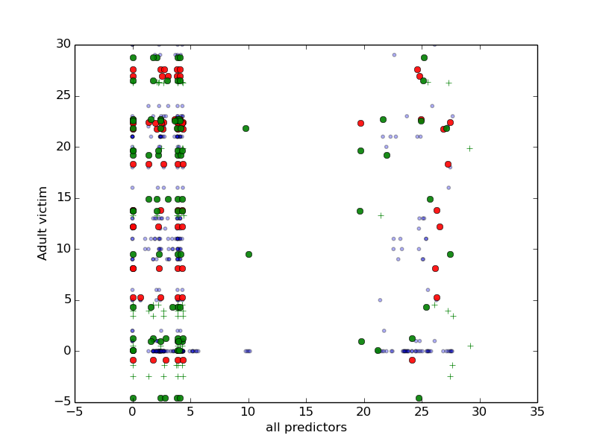

1. ***Think about how this model might be improved by adding more data. Then add this data to the model and test your hypothesis. What did you find. Provide descriptive statistics and visualizations as well as a few paragraphs explaining how you chose what data you did and why.***

Testing model achieved from the test training datasets and apply the same model to new unemployment rate data sets:

OLS Regression Results

==============================================================================

Dep. Variable: Adult_victims R-squared: 0.673

Model: OLS Adj. R-squared: 0.629

Method: Least Squares F-statistic: 15.29

Date: Wed, 08 Oct 2014 Prob (F-statistic): 2.45e-24

Time: 22:31:41 Log-Likelihood: -964.53

No. Observations: 153 AIC: 1967.

Df Residuals: 134 BIC: 2025.

Df Model: 18

================================================================================================

coef std err t P>|t| [95.0% Conf. Int.]

------------------------------------------------------------------------------------------------

Intercept -5.723e+07 1.04e+08 -0.551 0.582 -2.62e+08 1.48e+08

persons_prosecuted -133.4874 33.380 -3.999 0.000 -199.508 -67.467

child_victims -15.8600 59.138 -0.268 0.789 -132.825 101.105

gdp -107.1898 47.483 -2.257 0.026 -201.103 -13.276

policy_index -637.5839 504.583 -1.264 0.209 -1635.560 360.393

females_education 4.34e+07 8e+07 0.542 0.588 -1.15e+08 2.02e+08

life_expectancy 4.193e+05 3.9e+05 1.075 0.284 -3.52e+05 1.19e+06

I(persons_prosecuted ** 2.0) 50.3547 10.252 4.912 0.000 30.079 70.631

I(child_victims ** 2.0) 8.6766 27.626 0.314 0.754 -45.962 63.315

I(gdp ** 2.0) 3.8014 3.751 1.013 0.313 -3.618 11.221

I(policy_index ** 2.0) 601.7357 406.774 1.479 0.141 -202.792 1406.263

I(females_education ** 2.0) -1.108e+07 2.06e+07 -0.538 0.591 -5.18e+07 2.97e+07

I(life_expectancy ** 2.0) -9.996e+04 9.4e+04 -1.064 0.289 -2.86e+05 8.59e+04

I(persons_prosecuted ** 3.0) -3.8735 0.737 -5.257 0.000 -5.331 -2.416

I(child_victims ** 3.0) -0.1597 3.171 -0.050 0.960 -6.431 6.112

I(gdp ** 3.0) -0.0361 0.075 -0.480 0.632 -0.185 0.113

I(policy_index ** 3.0) -131.4920 86.698 -1.517 0.132 -302.965 39.981

I(females_education ** 3.0) 9.435e+05 1.77e+06 0.534 0.594 -2.55e+06 4.44e+06

I(life_expectancy ** 3.0) 7933.6417 7540.870 1.052 0.295 -6980.886 2.28e+04

==============================================================================

Omnibus: 69.548 Durbin-Watson: 1.413

Prob(Omnibus): 0.000 Jarque-Bera (JB): 283.826

Skew: 1.678 Prob(JB): 2.33e-62

Kurtosis: 8.766 Cond. No. nan

==============================================================================

Warnings:

[1] The smallest eigenvalue is -5.15e-12. This might indicate that there are

strong multicollinearity problems or that the design matrix is singular.

OLS Regression Results

==============================================================================

Dep. Variable: Adult_victims R-squared: 0.673

Model: OLS Adj. R-squared: 0.621

Method: Least Squares F-statistic: 12.85

Date: Wed, 08 Oct 2014 Prob (F-statistic): 1.26e-22

Time: 22:31:42 Log-Likelihood: -964.38

No. Observations: 153 AIC: 1973.

Df Residuals: 131 BIC: 2039.

Df Model: 21

================================================================================================

coef std err t P>|t| [95.0% Conf. Int.]

------------------------------------------------------------------------------------------------

Intercept -5.783e+07 1.05e+08 -0.550 0.583 -2.66e+08 1.5e+08

persons_prosecuted -132.5277 33.867 -3.913 0.000 -199.525 -65.530

child_victims -14.3127 59.915 -0.239 0.812 -132.839 104.214

gdp -108.7413 48.593 -2.238 0.027 -204.870 -12.612

policy_index -651.9263 511.092 -1.276 0.204 -1662.988 359.135

females_education 4.389e+07 8.11e+07 0.541 0.589 -1.16e+08 2.04e+08

life_expectancy 4.045e+05 3.95e+05 1.023 0.308 -3.78e+05 1.19e+06

new_data -0.1280 19.341 -0.007 0.995 -38.389 38.133

I(persons_prosecuted ** 2.0) 50.3116 10.404 4.836 0.000 29.729 70.894

I(child_victims ** 2.0) 7.8654 28.000 0.281 0.779 -47.524 63.255

I(gdp ** 2.0) 3.9073 3.825 1.021 0.309 -3.660 11.474

I(policy_index ** 2.0) 611.7667 411.725 1.486 0.140 -202.724 1426.257

I(females_education ** 2.0) -1.121e+07 2.09e+07 -0.537 0.592 -5.25e+07 3.01e+07

I(life_expectancy ** 2.0) -9.637e+04 9.52e+04 -1.012 0.313 -2.85e+05 9.2e+04

I(new_data ** 2.0) -5.8822 12.764 -0.461 0.646 -31.132 19.368

I(persons_prosecuted ** 3.0) -3.8810 0.748 -5.189 0.000 -5.361 -2.401

I(child_victims ** 3.0) -0.0741 3.213 -0.023 0.982 -6.430 6.282

I(gdp ** 3.0) -0.0383 0.077 -0.500 0.618 -0.190 0.113

I(policy_index ** 3.0) -133.3417 87.717 -1.520 0.131 -306.866 40.183

I(females_education ** 3.0) 9.544e+05 1.79e+06 0.533 0.595 -2.59e+06 4.5e+06

I(life_expectancy ** 3.0) 7644.0742 7642.478 1.000 0.319 -7474.570 2.28e+04

I(new_data ** 3.0) 1.0261 6.075 0.169 0.866 -10.991 13.044

==============================================================================

Omnibus: 68.626 Durbin-Watson: 1.420

Prob(Omnibus): 0.000 Jarque-Bera (JB): 281.148

Skew: 1.650 Prob(JB): 8.90e-62

Kurtosis: 8.763 Cond. No. nan

==============================================================================

Warnings:

[1] The smallest eigenvalue is -1.37e-11. This might indicate that there are

strong multicollinearity problems or that the design matrix is singular.

For initial testing random numbers was used to test whether the model consistently maintain the R squared given the polynomial effect. We could conclude that adding random variables to this model does not significantly change the R squared.

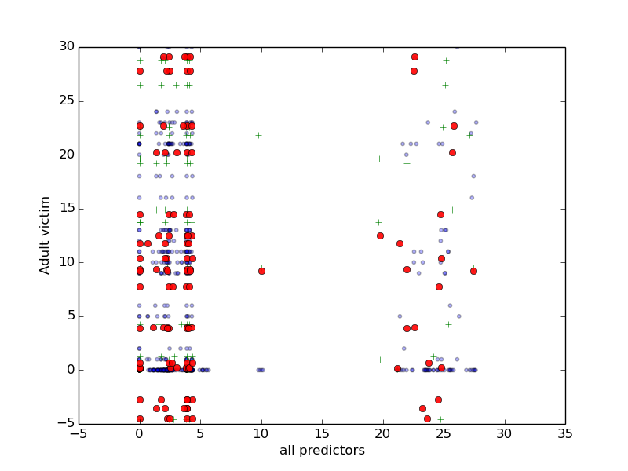

1. ***Using the model and data discussed in class predict how many cases a set of "new countries" would have (data to be provided in a separate csv file) Provide visualizations and a few paragraphs explaining your results.***

Note that new.csv does not have Adult victim, child victim and people prosecution value, and to get the expected value, we recalculate the model using the same number of x variables (fields) as the new sets. Note that the model predictive power decreased dramatically because it is used against different set of x values (this time all other expected values such as persons prosecuted):

OLS Regression Results

==============================================================================

Dep. Variable: Adult_victims R-squared: -0.315

Model: OLS Adj. R-squared: -0.315

Method: Least Squares F-statistic: -inf

Date: Thu, 09 Oct 2014 Prob (F-statistic): nan

Time: 00:17:07 Log-Likelihood: -1070.9

No. Observations: 153 AIC: 2144.

Df Residuals: 152 BIC: 2147.

Df Model: 0

===============================================================================================

coef std err t P>|t| [95.0% Conf. Int.]

-----------------------------------------------------------------------------------------------

Intercept 7.208e-48 1.28e-47 0.563 0.574 -1.81e-47 3.25e-47

gdp -3.066e-37 5.44e-37 -0.563 0.574 -1.38e-36 7.69e-37

policy_index -2.808e-74 6.99e-74 -0.402 0.688 -1.66e-73 1.1e-73

females_education 3.482e-46 6.18e-46 0.563 0.574 -8.73e-46 1.57e-45

life_expectancy 4.694e-46 8.34e-46 0.563 0.574 -1.18e-45 2.12e-45

I(gdp ** 2.0) 3.778e-24 6.71e-24 0.563 0.574 -9.48e-24 1.7e-23

I(policy_index ** 2.0) 6.994e-46 1.24e-45 0.563 0.574 -1.75e-45 3.15e-45

I(females_education ** 2.0) 1.683e-44 2.99e-44 0.563 0.574 -4.22e-44 7.59e-44

I(life_expectancy ** 2.0) 3.1e-44 5.51e-44 0.563 0.574 -7.78e-44 1.4e-43

I(gdp ** 3.0) -2.197e-37 5.47e-37 -0.402 0.688 -1.3e-36 8.61e-37

I(policy_index ** 3.0) 7.37e-45 1.31e-44 0.563 0.574 -1.85e-44 3.32e-44

I(females_education ** 3.0) 8.132e-43 1.44e-42 0.563 0.574 -2.04e-42 3.67e-42

I(life_expectancy ** 3.0) 2.075e-42 3.69e-42 0.563 0.574 -5.21e-42 9.36e-42

==============================================================================

Omnibus: 110.367 Durbin-Watson: 0.569

Prob(Omnibus): 0.000 Jarque-Bera (JB): 656.897

Skew: 2.782 Prob(JB): 2.27e-143

Kurtosis: 11.490 Cond. No. nan

==============================================================================

Warnings:

[1] The smallest eigenvalue is -0.028. This might indicate that there are

strong multicollinearity problems or that the design matrix is singular.

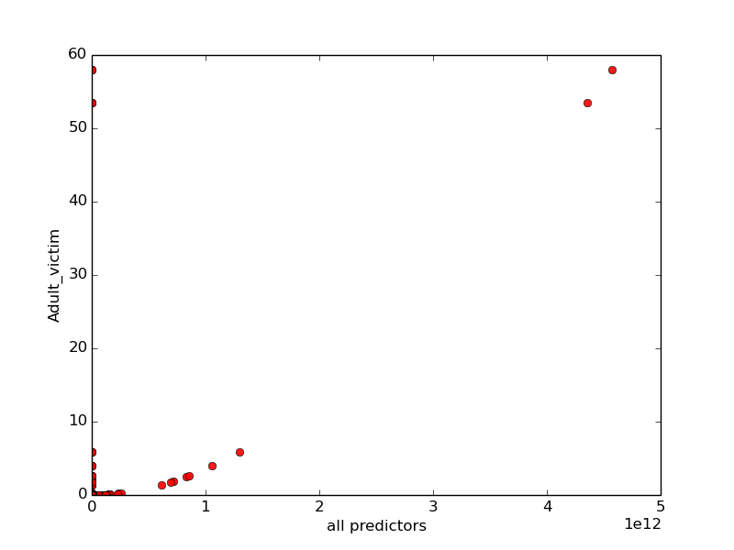

1. ***Try other models discussed from class. What do these models predict and how do they differ from the linear regression model?***

In this problem I used weighted least squares, to get the statistic summary as follows:

WLS Regression Results

==============================================================================

Dep. Variable: Adult_victims R-squared: 0.128

Model: WLS Adj. R-squared: 0.116

Method: Least Squares F-statistic: 11.02

Date: Thu, 09 Oct 2014 Prob (F-statistic): 3.44e-05

Time: 01:13:24 Log-Likelihood: -654.63

No. Observations: 153 AIC: 1315.

Df Residuals: 150 BIC: 1324.

Df Model: 2

=====================================================================================

coef std err t P>|t| [95.0% Conf. Int.]

-------------------------------------------------------------------------------------

const -2951.2832 1089.960 -2.708 0.008 -5104.940 -797.626

gdp 8.351e-12 8.44e-12 0.989 0.324 -8.33e-12 2.5e-11

policy_index 0.9748 8.546 0.114 0.909 -15.912 17.861

females_education 74.1763 22.284 3.329 0.001 30.146 118.207

life_expectancy -7.8345 2.436 -3.217 0.002 -12.647 -3.022

==============================================================================

Omnibus: 88.244 Durbin-Watson: 0.797

Prob(Omnibus): 0.000 Jarque-Bera (JB): 379.683

Skew: 2.229 Prob(JB): 3.57e-83

Kurtosis: 9.299 Cond. No. 1.54e+14

==============================================================================

Warnings:

[1] The condition number is large, 1.54e+14. This might indicate that there are

strong multicollinearity or other numerical problems.

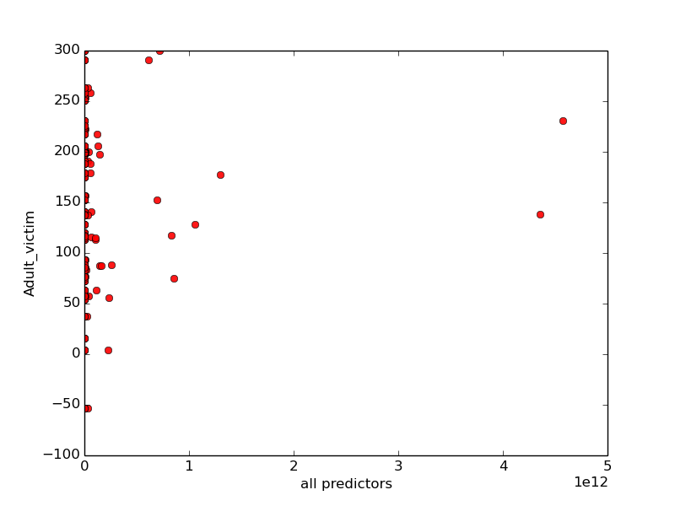

This prediction

The WLS is capable of resulting higher R squared value compared to the previous 3rd order polynomial model, but not as good as the original linier model.

1. ***Now remove the variables with the least explanatory power. Does your linear regression improve compared to the other models? Does it do worse? Why? Please provide visuals and a few paragraphs of explanation***

From the summary we could see that gdb has the least explanatory power since it has smallest coefficient:

WLS Regression Results

==============================================================================

Dep. Variable: Adult_victims R-squared: 0.122

Model: WLS Adj. R-squared: 0.105

Method: Least Squares F-statistic: 6.925

Date: Thu, 09 Oct 2014 Prob (F-statistic): 0.000214

Time: 01:22:09 Log-Likelihood: -655.12

No. Observations: 153 AIC: 1318.

Df Residuals: 149 BIC: 1330.

Df Model: 3

=====================================================================================

coef std err t P>|t| [95.0% Conf. Int.]

-------------------------------------------------------------------------------------

const -3161.9193 1076.032 -2.939 0.004 -5288.172 -1035.667

policy_index 4.1584 7.969 0.522 0.603 -11.589 19.906

females_education 77.4102 22.188 3.489 0.001 33.566 121.255

life_expectancy -7.3936 2.410 -3.067 0.003 -12.157 -2.631

==============================================================================

Omnibus: 87.565 Durbin-Watson: 0.798

Prob(Omnibus): 0.000 Jarque-Bera (JB): 373.048

Skew: 2.213 Prob(JB): 9.85e-82

Kurtosis: 9.239 Cond. No. 4.99e+03

==============================================================================

Warnings:

[1] The condition number is large, 4.99e+03. This might indicate that there are

strong multicollinearity or other numerical problems.

From here we know that WLS gives relatively equal predictive power compared to last result since we only omitted the variable that does not have significant effect to the whole model.

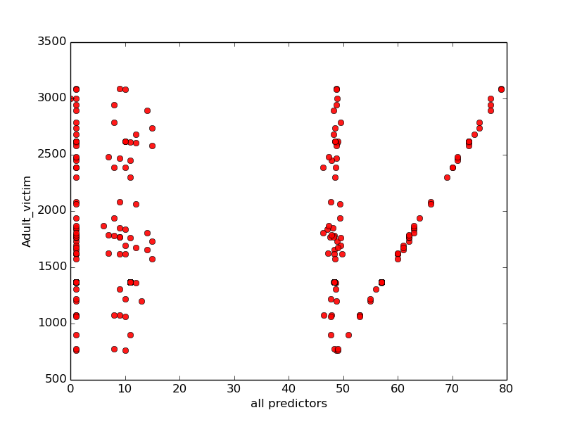

1. ***Now add in the extra data you found. Does your linear regression improved compared to the other models? Does it do worse? Why? Please provide visuals and a few paragraphs of explanation***

By adding unemployment variable it could be seen that the R squared and adjusted Rsquared does add up the value of R squared from 0.122 to 0.124.

WLS Regression Results

==============================================================================

Dep. Variable: Adult_victims R-squared: 0.124

Model: WLS Adj. R-squared: 0.101

Method: Least Squares F-statistic: 5.254

Date: Thu, 09 Oct 2014 Prob (F-statistic): 0.000551

Time: 11:24:36 Log-Likelihood: -654.95

No. Observations: 153 AIC: 1320.

Df Residuals: 148 BIC: 1335.

Df Model: 4

=====================================================================================

coef std err t P>|t| [95.0% Conf. Int.]

-------------------------------------------------------------------------------------

const -1.324e+04 4281.373 -3.092 0.002 -2.17e+04 -4777.917

policy_index 59.0554 64.946 0.909 0.365 -69.286 187.397

females_education 3918.4535 1097.999 3.569 0.000 1748.673 6088.234

life_expectancy -473.9677 153.584 -3.086 0.002 -777.469 -170.466

unemployment -27.6415 31.278 -0.884 0.378 -89.450 34.167

==============================================================================

Omnibus: 87.335 Durbin-Watson: 0.798

Prob(Omnibus): 0.000 Jarque-Bera (JB): 370.310

Skew: 2.208 Prob(JB): 3.88e-81

Kurtosis: 9.212 Cond. No. 1.63e+03

==============================================================================

Warnings:

[1] The condition number is large, 1.63e+03. This might indicate that there are

strong multicollinearity or other numerical problems.

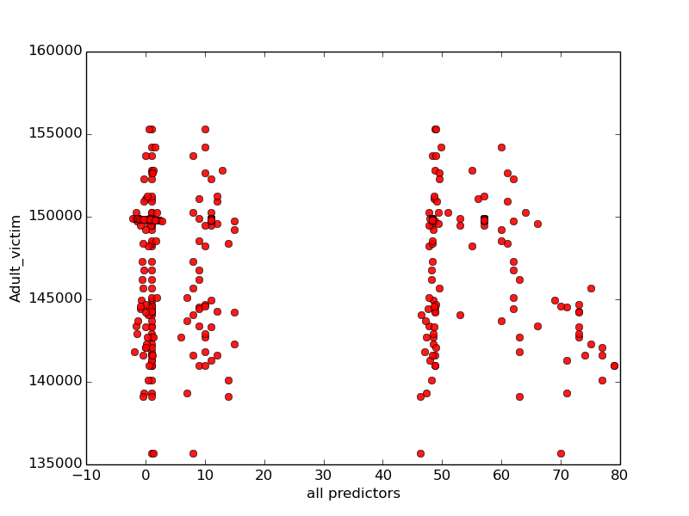

<http://www.internetworldstats.com/>

<http://data.worldbank.org/indicator/IT.NET.USER.P2/countries>

--sources of internet usage

<http://www.internetlivestats.com/internet-users/>

--number of connected devices

1. ***download (or scrape) data from the above websites.***

Downloaded from the website into CSV then run scripts to add to adding into main csv.

1. ***How much explanatory power does the model gain by adding the amount of internet penetration in a given country? How much does adding the total number of connected devices add?***

We would like to know how much the know the explanatory power the model gain, so we run a multivariate linear regression:

OLS Regression Results

==============================================================================

Dep. Variable: Adult_victims R-squared: 0.153

Model: OLS Adj. R-squared: 0.130

Method: Least Squares F-statistic: 6.683

Date: Thu, 09 Oct 2014 Prob (F-statistic): 5.68e-05

Time: 09:51:59 Log-Likelihood: -1037.2

No. Observations: 153 AIC: 2084.

Df Residuals: 148 BIC: 2100.

Df Model: 4

======================================================================================

coef std err t P>|t| [95.0% Conf. Int.]

--------------------------------------------------------------------------------------

const -3407.2646 1153.837 -2.953 0.004 -5687.387 -1127.142

gdp 8.744e-12 8.37e-12 1.044 0.298 -7.8e-12 2.53e-11

policy_index -0.3599 8.523 -0.042 0.966 -17.203 16.483

females_education 82.6786 23.400 3.533 0.001 36.437 128.920

life_expectancy -7.1480 2.466 -2.899 0.004 -12.021 -2.275

persons_prosecuted -0.0029 0.005 -0.555 0.580 -0.013 0.007

child_victims 0.3980 0.208 1.913 0.058 -0.013 0.809

==============================================================================

Omnibus: 91.217 Durbin-Watson: 0.738

Prob(Omnibus): 0.000 Jarque-Bera (JB): 417.756

Skew: 2.289 Prob(JB): 1.93e-91

Kurtosis: 9.676 Cond. No. 1.64e+14

==============================================================================

Warnings:

[1] The condition number is large, 1.64e+14. This might indicate that there are

strong multicollinearity or other numerical problems.

OLS Regression Results

==============================================================================

Dep. Variable: Adult_victims R-squared: 0.164

Model: OLS Adj. R-squared: 0.135

Method: Least Squares F-statistic: 5.760

Date: Thu, 09 Oct 2014 Prob (F-statistic): 6.94e-05

Time: 09:51:59 Log-Likelihood: -1036.3

No. Observations: 153 AIC: 2085.

Df Residuals: 147 BIC: 2103.

Df Model: 5

======================================================================================

coef std err t P>|t| [95.0% Conf. Int.]

--------------------------------------------------------------------------------------

const -3437.2616 1150.537 -2.988 0.003 -5710.992 -1163.532

gdp 1.536e-11 9.63e-12 1.595 0.113 -3.67e-12 3.44e-11

policy_index -0.3827 8.497 -0.045 0.964 -17.175 16.410

females_education 80.6406 23.376 3.450 0.001 34.445 126.836

life_expectancy -4.7612 3.006 -1.584 0.115 -10.702 1.180

persons_prosecuted -0.0039 0.005 -0.746 0.457 -0.014 0.006

child_victims 0.3724 0.208 1.788 0.076 -0.039 0.784

internet_penet -1.8272 1.324 -1.380 0.170 -4.445 0.790

==============================================================================

Omnibus: 90.949 Durbin-Watson: 0.747

Prob(Omnibus): 0.000 Jarque-Bera (JB): 417.275

Skew: 2.279 Prob(JB): 2.45e-91

Kurtosis: 9.684 Cond. No. 1.64e+14

==============================================================================

Warnings:

[1] The condition number is large, 1.64e+14. This might indicate that there are

strong multicollinearity or other numerical problems.

OLS Regression Results

==============================================================================

Dep. Variable: Adult_victims R-squared: 0.156

Model: OLS Adj. R-squared: 0.127

Method: Least Squares F-statistic: 5.435

Date: Thu, 09 Oct 2014 Prob (F-statistic): 0.000128

Time: 09:51:59 Log-Likelihood: -1037.0

No. Observations: 153 AIC: 2086.

Df Residuals: 147 BIC: 2104.

Df Model: 5

======================================================================================

coef std err t P>|t| [95.0% Conf. Int.]

--------------------------------------------------------------------------------------

const -3556.1615 1173.716 -3.030 0.003 -5875.698 -1236.625

gdp -9.496e-12 2.65e-11 -0.359 0.720 -6.18e-11 4.28e-11

policy_index -1.1579 8.607 -0.135 0.893 -18.168 15.852

females_education 85.7290 23.811 3.600 0.000 38.674 132.784

life_expectancy -7.1508 2.470 -2.895 0.004 -12.032 -2.269

persons_prosecuted -0.0114 0.013 -0.888 0.376 -0.037 0.014

child_victims 0.4081 0.209 1.954 0.053 -0.005 0.821

connected_dev 8.891e-07 1.22e-06 0.726 0.469 -1.53e-06 3.31e-06

==============================================================================

Omnibus: 92.312 Durbin-Watson: 0.741

Prob(Omnibus): 0.000 Jarque-Bera (JB): 433.177

Skew: 2.310 Prob(JB): 8.65e-95

Kurtosis: 9.826 Cond. No. 1.67e+14

==============================================================================

Warnings:

[1] The condition number is large, 1.67e+14. This might indicate that there are

strong multicollinearity or other numerical problems.

Similarly, this shows that internet penetration was the only additional variable that has positive correlation to adult victim. We could observe that by adding internet penetration variable to the model from 0.153 to 0.164.

1. ***Can you give an explanation of why or why not this does not add to the model's explanatory power? Is there another variable you might take away that is related to these variables?***

The pearson test was conducted and resulted in the following:

Internet penetration VS adult victim:

(-0.17378602791144523, 0.03168508364587453)

Connected device VS adult victim:

(-0.023572270737661622, 0.77241153794652262)

As Pearson correlation coefficient varies from -1 to 1, close to zero implies no correlation). This explained that the number of internet penetration have higher correlation to the object that we are interested in observing, Adult value.