Assignment 5: Applied data science

**ANSWERS:**

1. Consider the AR(1) DGP presented in class: y_t=ρy_(t-1)+ϵ_t.
2. For this exercise, set ρ=0.5. Generate this DGP using 1,000 Gaussian white-noise draws from N(0,1) by letting y1=ϵ1. Plot this DGP. Run a linear regression to get the least-squares estimate of ρ. (You should include a constant in the regression.) Does your 95% confidence interval include 0.5?

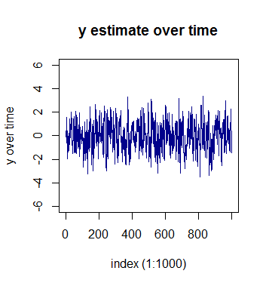

Call:

lm(formula = y[2:1000] ~ y[1:999])

Residuals:

Min 1Q Median 3Q Max

-2.9222 -0.6388 0.0093 0.6259 3.1465

Coefficients:

Estimate Std. Error t value Pr(>|t|)

(Intercept) -0.01994 0.03167 -0.63 0.529

y[1:999] 0.54421 0.02658 20.47 <2e-16 ***

---

Signif. codes: 0 ・**・0.001 ・*・0.01 ・・0.05 ・・0.1 ・・1

Residual standard error: 1 on 997 degrees of freedom

Multiple R-squared: 0.296, Adjusted R-squared: 0.2953

F-statistic: 419.1 on 1 and 997 DF, p-value: < 2.2e-16

> stargazer(model_linear, title="Linear regression results", type="text", ci.level=0.95, ci=TRUE)

Linear regression results

===============================================

Dependent variable:

---------------------------

y[2:1000]

-----------------------------------------------

y[1:999] 0.544***

(0.492, 0.596)

Constant -0.020

(-0.082, 0.042)

-----------------------------------------------

Observations 999

R2 0.296

Adjusted R2 0.295

Residual Std. Error 1.000 (df = 997)

F Statistic 419.139*** (df = 1; 997)

===============================================

Note: *p<0.1; **p<0.05; ***p<0.01

We can see that 95% confidence interval include 0.5 (ranges between 0.492 and 0.596).

1. Repeat a. assuming ρ=-0.5.

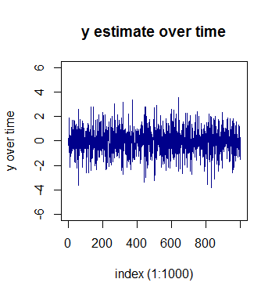

1. Call:
2. lm(formula = y[2:1000] ~ y[1:999])
3. Residuals:
4. Min 1Q Median 3Q Max
5. -2.9783 -0.6297 0.0019 0.6240 3.1791
6. Coefficients:
7. Estimate Std. Error t value Pr(>|t|)
8. (Intercept) -0.02123 0.03167 -0.67 0.503
9. y[1:999] -0.46266 0.02808 -16.48 <2e-16 ***
10. ---
11. Signif. codes: 0 ・**・0.001 ・*・0.01 ・・0.05 ・・0.1 ・・1
12. Residual standard error: 1.001 on 997 degrees of freedom
13. Multiple R-squared: 0.214, Adjusted R-squared: 0.2133
14. F-statistic: 271.5 on 1 and 997 DF, p-value: < 2.2e-16
15. > stargazer(model_linear, title="Linear regression results", type="text", ci.level=0.95, ci=TRUE)
16. Linear regression results
17. ===============================================
18. Dependent variable:
19. ---------------------------
20. y[2:1000]
21. -----------------------------------------------
22. y[1:999] -0.463***
23. (-0.518, -0.408)
25. Constant -0.021
26. (-0.083, 0.041)
28. -----------------------------------------------
29. Observations 999
30. R2 0.214
31. Adjusted R2 0.213
32. Residual Std. Error 1.001 (df = 997)
33. F Statistic 271.522*** (df = 1; 997)
34. ===============================================
35. Note: *p<0.1; **p<0.05; ***p<0.01

We can see that 95% confidence interval includes -0.5 (ranges between -0.408 and -0.518).

1. Repeat a. assuming ρ=1. (This is called a random walk or unit root.)

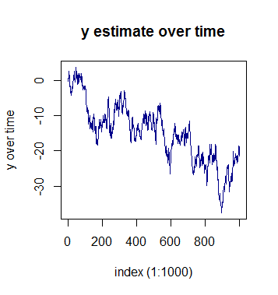

1. Call:
2. lm(formula = y[2:1000] ~ y[1:999])
3. Residuals:
4. Min 1Q Median 3Q Max
5. -3.03277 -0.62796 0.01084 0.61970 3.15372
6. Coefficients:
7. Estimate Std. Error t value Pr(>|t|)
8. (Intercept) -0.151911 0.065431 -2.322 0.0204 *
9. y[1:999] 0.991329 0.003816 259.765 <2e-16 ***
10. ---
11. Signif. codes: 0 ・**・0.001 ・*・0.01 ・・0.05 ・・0.1 ・・1
12. Residual standard error: 0.9992 on 997 degrees of freedom
13. Multiple R-squared: 0.9854, Adjusted R-squared: 0.9854
14. F-statistic: 6.748e+04 on 1 and 997 DF, p-value: < 2.2e-16
15. > stargazer(model_linear, title="Linear regression results", type="text", ci.level=0.95, ci=TRUE)
16. Linear regression results
17. ===============================================
18. Dependent variable:
19. ---------------------------
20. y[2:1000]
21. -----------------------------------------------
22. y[1:999] 0.991***
23. (0.984, 0.999)
25. Constant -0.152**
26. (-0.280, -0.024)
28. -----------------------------------------------
29. Observations 999
30. R2 0.985
31. Adjusted R2 0.985
32. Residual Std. Error 0.999 (df = 997)
33. F Statistic 67,478.100*** (df = 1; 997)
34. ===============================================

Note: *p<0.1; **p<0.05; ***p<0.01

Now the result shows interesting point. We can see that 95% confidence interval does not include 1 (ranges between 0.984 and 0.999). It shows that having ρ equal to 1 means that y[t] in respect to y[t-1] can be completely random (also shown in the graph above.)

1. Consider the AR(1) DGP presented in class: y_t=ρy_(t-1)+ϵ_t.
   1. Following 1c. above, generate two independent random walks of 1,000 observations, calling them Walk1 and Walk2. Fit the bivariate linear model that relates Walk1 to Walk2 and report your regression results.

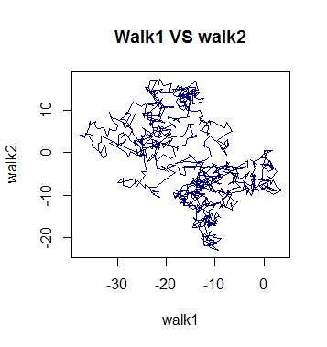

Call:

lm(formula = walk2 ~ walk1)

Residuals:

Min 1Q Median 3Q Max

-18.6905 -5.5889 -0.2076 5.8936 19.0279

Coefficients:

Estimate Std. Error t value Pr(>|t|)

(Intercept) -9.18099 0.54254 -16.92 <2e-16 ***

walk1 -0.49803 0.03163 -15.74 <2e-16 ***

---

Signif. codes: 0 ・**・0.001 ・*・0.01 ・・0.05 ・・0.1 ・・1

Residual standard error: 8.286 on 998 degrees of freedom

Multiple R-squared: 0.1989, Adjusted R-squared: 0.1981

F-statistic: 247.9 on 1 and 998 DF, p-value: < 2.2e-16

> stargazer(model_linear, title="Linear regression results", type="text", ci.level=0.95, ci=TRUE)

Linear regression results

===============================================

Dependent variable:

---------------------------

walk2

-----------------------------------------------

walk1 -0.498***

(-0.560, -0.436)

Constant -9.181***

(-10.244, -8.118)

-----------------------------------------------

Observations 1,000

R2 0.199

Adjusted R2 0.198

Residual Std. Error 8.286 (df = 998)

F Statistic 247.852*** (df = 1; 998)

===============================================

Note: *p<0.1; **p<0.05; ***p<0.01

* 1. Recall the Monte Carlo simulation exercise in HW 4, Question 3c. Using a similar approach, repeat a. above 1,000 times, each time recording the estimated value of the slope coefficient of the bivariate regression. Generate a histogram of your 1,000 replications. How do these results compare to those you found in HW 4, Question 3c?

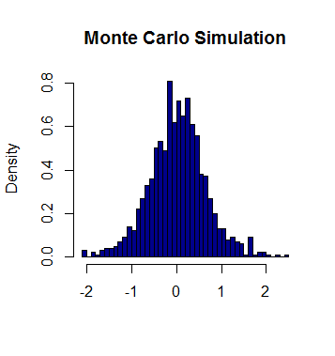

1. > mean(betas)
2. [1] 0.02731522
3. > sd(betas)
4. [1] 0.6327763

We could see from the histogram above that the distribution of beta (linear regression) of each random walk iteration forms another normal distribution at 0 as its center (mean = 0.027 and standard deviation = 0.632).

1. Consider your results in 2b as well as the dispersion in your histogram. Is there something about independent unit roots that may lead one to find correlation when there is none?

We could see that both histograms are centered to 0, meaning it shows that the beta is 0 which means that although in single iteration it might show that it is related, the monte carlo simulation confirmed that the it is not related.

In the case of equation used in this assignment, I think independent unit roots being introduced cannot add more correlations as long as it is constant value. However the value could introduce correlation if Ro is dependent to time element. It is also possible to have “drifts” in addition to random noise, and trends which might not be independent to time element, for instance:

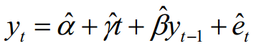

In this case, y might have some correlation to y(t-1).