**CDAC Feb 2015**

D latch

Name: Bhrigu Bhargava

**D latch**

# Design Approach:

# This D-latch is obtained from SR by connecting both the inputs. This is also known as Toggle latch as output is toggled if T=1. The truth table is show in table 1.

# Circuit Diagram:

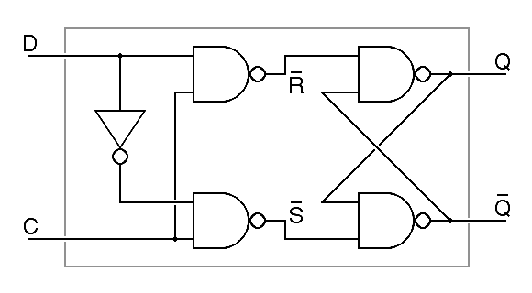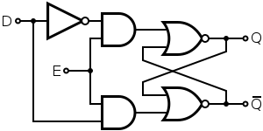

**Fig 1:- Circuit Diagram of D latch**

**Truth Table:**

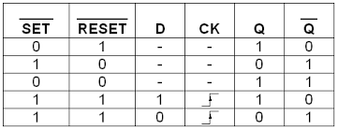

**Source Code:**

module dl (nq,q,en,ip);

output nq,q;

input ip,en;

wire t1,t2;

nand n0 (t1,en,ip);

nand n1 (t2,en,~ip);

nand n2 (q,t1,nq);

nand n3 (nq,t2,q);

endmodule

**Synthesis:**

1. RTL Schematic

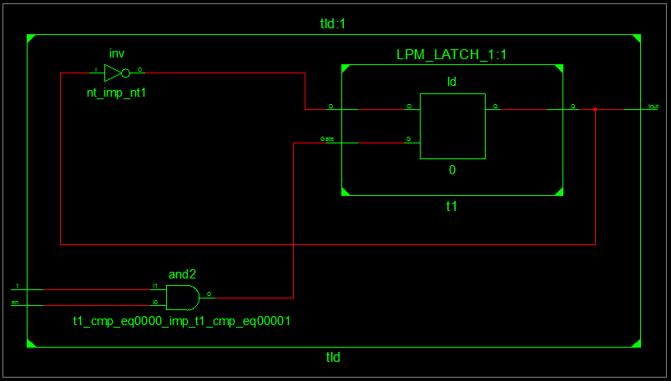

1. Block Diagram

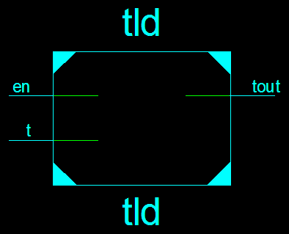

1. Tech Schematic

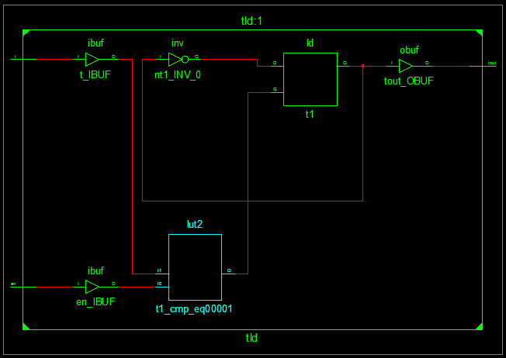

1. Simulation Waveform Result

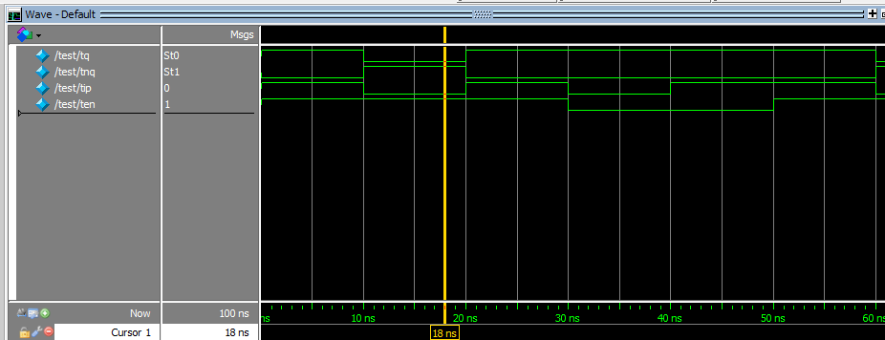

**Error:**

None.

**Verified by:**

Dharamveer Chundawat (150240133007)