DAA – LAB 4
1) QUICK SORT
#include <stdio.h>

void swap(int *a, int *b) {
int temp = *a;
*a = *b;
*b = temp;
}

int partition(int arr[], int low, int high) {

int pivot = arr[high];
int i = low - 1;

for (int j = low; j < high; j++) {
if (arr[j] <= pivot) {
i++;
swap(&arr[i], &arr[j]);
}
}

swap(&arr[i + 1], &arr[high]);
return i + 1;
}

void quickSort(int arr[], int low, int high) {

if (low < high) {
int pi = partition(arr, low, high);

quickSort(arr, low, pi - 1);
quickSort(arr, pi + 1, high);
}
}

int main() {

int n, i, arr[20];

printf("Name: Sanjay\n");
printf("Roll No: CH.SC.U4CSE24246\n");

printf("Enter number of elements: ");
scanf("%d", &n);

printf("Enter elements:\n");

for(i = 0; i < n; i++)
scanf("%d", &arr[i]);

quickSort(arr, 0, n - 1);

printf("Sorted array:\n");

for(i = 0; i < n; i++)
printf("%d ", arr[i]);

return 0;
}

OUTPUT :
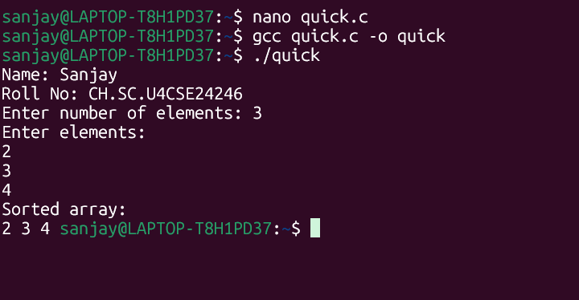
2) MERGE SORT
#include <stdio.h>

void merge(int arr[], int low, int mid, int high) {

int i = low, j = mid + 1, k = 0;
int temp[50];

while (i <= mid && j <= high) {

if (arr[i] <= arr[j])
temp[k++] = arr[i++];
else
temp[k++] = arr[j++];
}

while (i <= mid)
temp[k++] = arr[i++];

while (j <= high)
temp[k++] = arr[j++];

for (i = low, k = 0; i <= high; i++, k++)
arr[i] = temp[k];
}

void mergeSort(int arr[], int low, int high) {

if (low < high) {

int mid = (low + high) / 2;

mergeSort(arr, low, mid);
mergeSort(arr, mid + 1, high);

merge(arr, low, mid, high);
}
}

int main() {

int n, i, arr[50];

printf("Name: Sanjay\n");
printf("Roll No: CH.SC.U4CSE24246\n");

printf("Enter number of elements: ");
scanf("%d", &n);

printf("Enter elements:\n");

for (i = 0; i < n; i++)
scanf("%d", &arr[i]);

mergeSort(arr, 0, n - 1);

printf("Sorted array:\n");

for (i = 0; i < n; i++)
printf("%d ", arr[i]);

return 0;
}

OUTPUT : 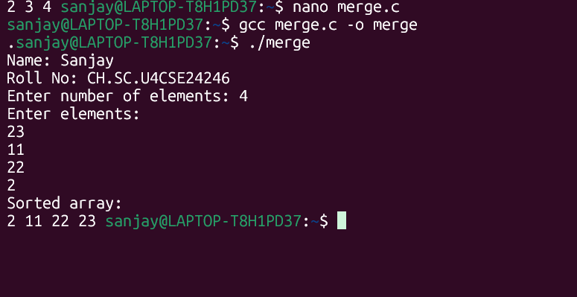

3) Binary Search Tree :

Code : #include <stdio.h>
#include <stdlib.h>

struct Node {
int data;
struct Node *left, *right;
};

struct Node* createNode(int value) {

struct Node* newNode = (struct Node*)malloc(sizeof(struct Node));

newNode->data = value;
newNode->left = NULL;
newNode->right = NULL;

return newNode;
}

struct Node* insert(struct Node* root, int value) {

if (root == NULL)
return createNode(value);

if (value < root->data)
root->left = insert(root->left, value);

else
root->right = insert(root->right, value);

return root;
}

void inorder(struct Node* root) {

if (root != NULL) {

inorder(root->left);
printf("%d ", root->data);
inorder(root->right);
}
}

int main() {

struct Node* root = NULL;
int n, i, value;

printf("Name: Sanjay\n");
printf("Roll No: CH.SC.U4CSE24246\n");

printf("Enter number of nodes: ");
scanf("%d", &n);

printf("Enter values:\n");

for(i = 0; i < n; i++) {
scanf("%d", &value);
root = insert(root, value);
}

printf("Inorder traversal:\n");
inorder(root);

return 0;
}

Output :
