S P SANJAY IYER
CH.SC.U4CSE24246
DAA ASSIGNMENT -2

- BUBBLE SORT

Code :

#include <stdio.h>

int main() {
int a[20], n, i, j, temp;

printf("Enter number of elements: ");
scanf("%d", &n);

printf("Enter elements:\n");
for(i = 0; i < n; i++)
scanf("%d", &a[i]);

for(i = 0; i < n - 1; i++) {
for(j = 0; j < n - i - 1; j++) {
if(a[j] > a[j + 1]) {
temp = a[j];
a[j] = a[j + 1];
a[j + 1] = temp;
}
}
}

printf("Sorted array:\n");
for(i = 0; i < n; i++)
printf("%d ", a[i]);

return 0;
}

OUTPUT :
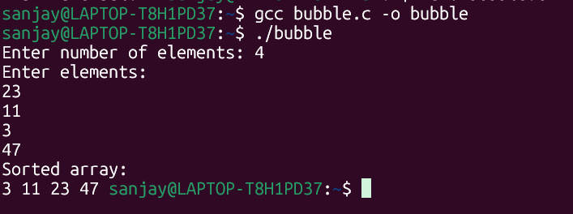

- SELECTION SORT
CODE :

#include <stdio.h>

int main() {
int a[20], n, i, j, min, temp;

printf("Enter number of elements: ");
scanf("%d", &n);

printf("Enter elements:\n");
for(i = 0; i < n; i++)
scanf("%d", &a[i]);

for(i = 0; i < n - 1; i++) {
min = i;
for(j = i + 1; j < n; j++) {
if(a[j] < a[min])
min = j;
}
temp = a[i];
a[i] = a[min];
a[min] = temp;
}

printf("Sorted array:\n");
for(i = 0; i < n; i++)
printf("%d ", a[i]);

return 0;
}
OUTPUT :
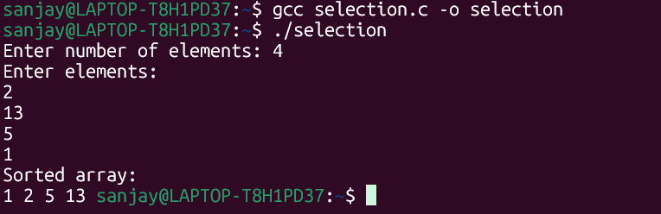
3)INSERTION SORT
CODE :
#include <stdio.h>

int main() {
int a[20], n, i, j, key;

printf("Enter number of elements: ");
scanf("%d", &n);

printf("Enter elements:\n");
for(i = 0; i < n; i++)
scanf("%d", &a[i]);

for(i = 1; i < n; i++) {
key = a[i];
j = i - 1;

while(j >= 0 && a[j] > key) {
a[j + 1] = a[j];
j--;
}
a[j + 1] = key;
}

printf("Sorted array:\n");
for(i = 0; i < n; i++)
printf("%d ", a[i]);

return 0;
}
OUTPUT :
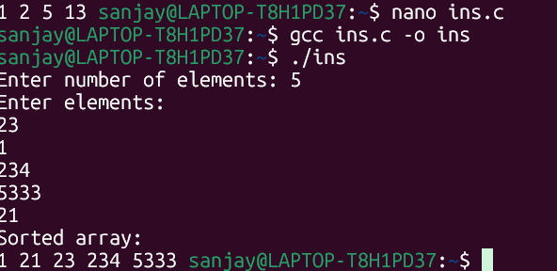
4) BUCKET SORT
CODE :
#include <stdio.h>

int main() {
int a[20], bucket[10] = {0}, n, i, j, k = 0;

printf("Enter number of elements: ");
scanf("%d", &n);

printf("Enter elements (0 to 9 only):\n");
for(i = 0; i < n; i++) {
scanf("%d", &a[i]);
bucket[a[i]]++;
}

for(i = 0; i < 10; i++) {
for(j = 0; j < bucket[i]; j++) {
a[k++] = i;
}
}

printf("Sorted array:\n");
for(i = 0; i < n; i++)
printf("%d ", a[i]);

return 0;
}
OUTPUT:
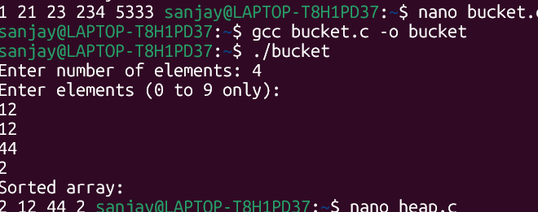
5) HEAP SORT
CODE:
#include <stdio.h>

void heapify(int a[], int n, int i) {
int largest = i;
int l = 2*i + 1;
int r = 2*i + 2;
int temp;

if(l < n && a[l] > a[largest])
largest = l;

if(r < n && a[r] > a[largest])
largest = r;

if(largest != i) {
temp = a[i];
a[i] = a[largest];
a[largest] = temp;
heapify(a, n, largest);
}
}

int main() {
int a[20], n, i, temp;

printf("Enter number of elements: ");
scanf("%d", &n);

printf("Enter elements:\n");
for(i = 0; i < n; i++)
scanf("%d", &a[i]);

for(i = n/2 - 1; i >= 0; i--)
heapify(a, n, i);

for(i = n - 1; i > 0; i--) {
temp = a[0];
a[0] = a[i];
a[i] = temp;
heapify(a, i, 0);
}

printf("Sorted array:\n");
for(i = 0; i < n; i++)
printf("%d ", a[i]);

return 0;
}
OUTPUT:
