S P SANJAY IYER
CH.SC.U4CSE24246
DAA ASSIGNMENT - 3

- BFS CODE :
#include <stdio.h>

int queue[20], front = -1, rear = -1;
int visited[20], adj[20][20], n;

void bfs(int start) {
int i;
printf("BFS Traversal: ");
queue[++rear] = start;
visited[start] = 1;

while (front != rear) {
start = queue[++front];
printf("%d ", start);

for (i = 0; i < n; i++) {
if (adj[start][i] == 1 && visited[i] == 0) {
queue[++rear] = i;
visited[i] = 1;
}
}
}
}

int main() {
int i, j, start;

printf("Name: S P SANJAY IYER\n");
printf("Roll No: CH.SC.U4CSE24246\n\n");

printf("Enter number of vertices: ");
scanf("%d", &n);

printf("Enter adjacency matrix:\n");
for (i = 0; i < n; i++)
for (j = 0; j < n; j++)
scanf("%d", &adj[i][j]);

for (i = 0; i < n; i++)
visited[i] = 0;

printf("Enter starting vertex: ");
scanf("%d", &start);

bfs(start);
return 0;
}
OUTPUT :
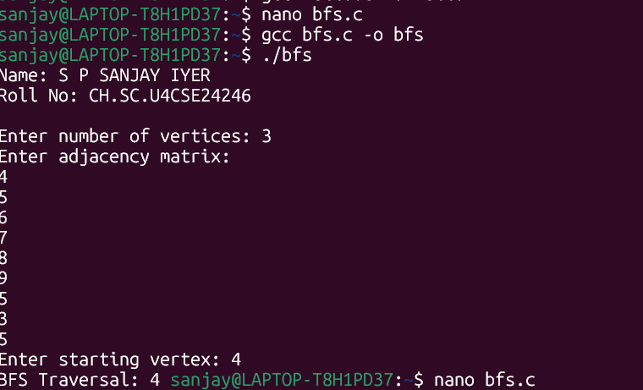

2) DFS CODE

#include <stdio.h>

int visited[20], adj[20][20], n;

void dfs(int start) {
int i;
printf("%d ", start);
visited[start] = 1;

for (i = 0; i < n; i++) {
if (adj[start][i] == 1 && visited[i] == 0) {
dfs(i);
}
}
}

int main() {
int i, j, start;

printf("Name: S P SANJAY IYER\n");
printf("Roll No: CH.SC.U4CSE24246\n\n");

printf("Enter number of vertices: ");
scanf("%d", &n);

printf("Enter adjacency matrix:\n");
for (i = 0; i < n; i++)
for (j = 0; j < n; j++)
scanf("%d", &adj[i][j]);

for (i = 0; i < n; i++)
visited[i] = 0;

printf("Enter starting vertex: ");
scanf("%d", &start);

printf("DFS Traversal: ");
dfs(start);
return 0;
}

OUTPUT :
