DAA LAB 5 : SANJAY – CH.SC.U4CSE24246
1) krushkal
code : #include <stdio.h>
#include <stdlib.h>

#define MAX 20

struct Edge {
int u, v, weight;
};

struct Graph {
int V, E;
struct Edge edges[MAX];
};

int find(int parent[], int i) {
if (parent[i] == i)
return i;
return find(parent, parent[i]);
}

void unionSet(int parent[], int x, int y) {
int xroot = find(parent, x);
int yroot = find(parent, y);
parent[yroot] = xroot;
}

void sortEdges(struct Graph *g) {

int i, j;
struct Edge temp;

for (i = 0; i < g->E - 1; i++) {
for (j = 0; j < g->E - i - 1; j++) {

if (g->edges[j].weight > g->edges[j + 1].weight) {

temp = g->edges[j];
g->edges[j] = g->edges[j + 1];
g->edges[j + 1] = temp;
}
}
}
}

void kruskal(struct Graph *g) {

int parent[MAX];
int i, count = 0;
int minCost = 0;

for (i = 0; i < g->V; i++)
parent[i] = i;

sortEdges(g);

printf("Edges in Minimum Spanning Tree:\n");

for (i = 0; i < g->E && count < g->V - 1; i++) {

int u = g->edges[i].u;
int v = g->edges[i].v;
int w = g->edges[i].weight;

int setU = find(parent, u);
int setV = find(parent, v);

if (setU != setV) {

printf("%d -- %d == %d\n", u, v, w);
minCost += w;
unionSet(parent, setU, setV);
count++;
}
}

printf("Minimum Cost = %d\n", minCost);
}

int main() {

struct Graph g;
int i;

printf("Name: Sanjay\n");
printf("Roll No: CH.SC.U4CSE24246\n");

printf("Enter number of vertices: ");
scanf("%d", &g.V);

printf("Enter number of edges: ");
scanf("%d", &g.E);

printf("Enter edges (u v weight):\n");

for (i = 0; i < g.E; i++) {

scanf("%d %d %d",
&g.edges[i].u,
&g.edges[i].v,
&g.edges[i].weight);
}

kruskal(&g);

return 0;
}

Output : 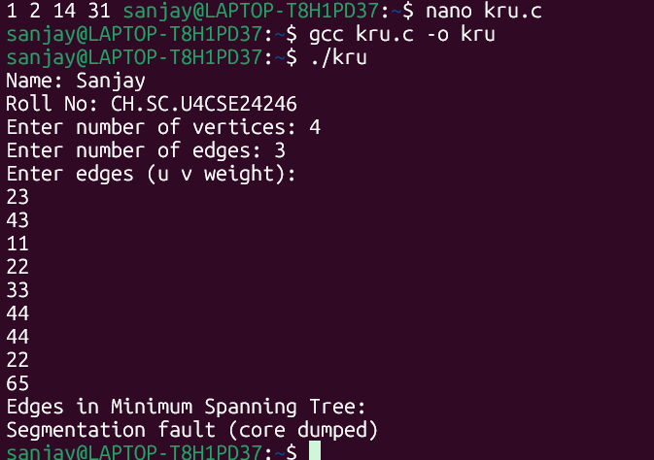

2) Prims :
code :
#include <stdio.h>

#define INF 999

int main() {

int n, i, j;
int cost[10][10];
int visited[10] = {0};

int minCost = 0;
int edgeCount = 0;

printf("Name: Sanjay\n");
printf("Roll No: CH.SC.U4CSE24246\n");

printf("Enter number of vertices: ");
scanf("%d", &n);

printf("Enter cost adjacency matrix:\n");

for (i = 0; i < n; i++) {
for (j = 0; j < n; j++) {

scanf("%d", &cost[i][j]);

if (cost[i][j] == 0)
cost[i][j] = INF;
}
}

visited[0] = 1;

printf("Edges in Minimum Spanning Tree:\n");

while (edgeCount < n - 1) {

int min = INF, u = -1, v = -1;

for (i = 0; i < n; i++) {

if (visited[i]) {

for (j = 0; j < n; j++) {

if (!visited[j] && cost[i][j] < min) {

min = cost[i][j];
u = i;
v = j;
}
}
}
}

if (u != -1 && v != -1) {

printf("%d -- %d == %d\n", u, v, min);

minCost += min;
visited[v] = 1;
edgeCount++;
}
}

printf("Minimum Cost = %d\n", minCost);

return 0;
}
Output: 