Assignment 8

1. Refer the below given dataset.

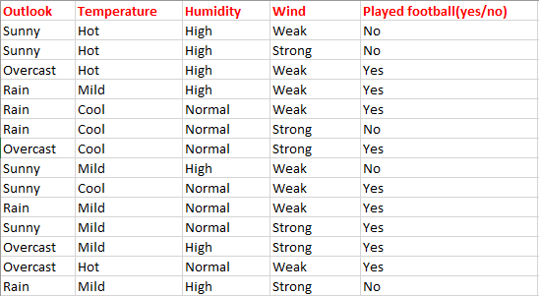

Create a decision tree from scratch using the above dataset using ID3 algorithm.

Given a new set of features, predict whether game will be played.

|  |  |  |  |  |
| --- | --- | --- | --- | --- |
| Outlook | Temperature | Humidity | Wind | Play |
| Rain | Hot | Normal | Weak | ? |

1. For the same above problem create a decision tree using scikit learn API. Predict for the new set of features given as in the question 1.