1. **C# Program to Copy a Section of One Array to Another.**

using System;

namespace ArrayCopy

{

class Program

{

static void Main(string[] args)

{

int[] src = { 15, 67, 89, 90, 180, 270 };

int[] dest = new int[3];

Array.Copy(src, dest, 3);

Console.Write("Source_Array= ");

foreach (int e in src)

Console.Write(e + " ");

Console.Write("\nDest_Array= ");

foreach (int e in dest)

Console.Write(e + " ");

Console.ReadLine();

}

}

}

**Output:**

Source_Array= 15 67 89 90 180 270

Dest_Array= 15 67 89

**2. Write a c# program in console application to illustrate command line arguments.**

**i) cmdLineArg.cs**

**using System;**

**namespace Lab**

**{**

**class cmdLineArg**

**{**

**public static void Main(string[] args)**

**{**

**Console.WriteLine("cmdLineArg.Length="+args.Length+"\nArgument List:");**

**for(int i=0;i<args.Length;i++)**

**Console.WriteLine(args[i]);**

**Console.ReadLine();**

**}**

**}**

**}**

**Output:**

**C:\Users\Sanjay-PC\Desktop>csc cmdLineArg.cs**

**Microsoft (R) Visual C# Compiler version 4.8.3752.0**

**for C# 5**

**Copyright (C) Microsoft Corporation. All rights reserved.**

**This compiler is provided as part of the Microsoft (R) .NET Framework, but only supports language versions up to C# 5, which is no longer the latest version. For compilers that support newer versions of the C# programming language, see** [**http://go.microsoft.com/fwlink/?LinkID=533240**](http://go.microsoft.com/fwlink/?LinkID=533240)

**C:\Users\Sanjay-PC\Desktop>cmdLineArg Name phno 54**

**cmdLineArg.Length=3**

**Argument List:**

**Name**

**phno**

**54**

**ii) Fact.cs**

using System;

namespace Lab

{

class Fact

{

public static void Main(string[] args)

{

int n,fact=1;

if(int.TryParse(args[0],out n))

{

for(int i=1;i<=n;i++)

fact=fact*i;

Console.WriteLine("fact of {0} is {1}",args[0],fact);

Console.ReadLine();

}

}

}

}

**Output:**

**C:\Users\Sanjay-PC\source\repos>csc Fact.cs**

**Microsoft (R) Visual C# Compiler version 4.8.3752.0**

**for C# 5**

**Copyright (C) Microsoft Corporation. All rights reserved.**

**This compiler is provided as part of the Microsoft (R) .NET Framework, but only supports language versions up to C# 5, which is no longer the latest version. For compilers that support newer versions of the C# programming language, see** [**http://go.microsoft.com/fwlink/?LinkID=533240**](http://go.microsoft.com/fwlink/?LinkID=533240)

**C:\Users\Sanjay-PC\source\repos>Fact 5**

**fact of 5 is 120**

**C:\Users\Sanjay-PC\source\repos>Fact 0**

**fact of 0 is 1**

1. **C# Program to Convert Infix to Postfix & (Prefix).**

using System;

using System.Collections.Generic;

using System.Linq;

namespace InfixTo_Prefix_Postfix

{

class Program

{

public static void Main(string[] args)

{

Console.Write("Enter Infix Expression: ");

string exp = Console.ReadLine();

Console.Write("Postfix_Exp= {0}\nPrefix_exp={1} ", infixToPostfix(exp),

infixToPrefix(exp));

Console.ReadLine();

}

public static string infixToPostfix(string exp)

{

string result = "";

Stack<char> stack = new Stack<char>();

for (int i = 0; i < exp.Length; ++i)

{

char c = exp[i];

if (char.IsLetterOrDigit(c))

result += c;

else if (c == '(')

stack.Push(c);

else if (c == ')')

{

while (stack.Count > 0 && stack.Peek() != '(')

result += stack.Pop();

if (stack.Count > 0 && stack.Peek() != '(')

return "Invalid Expression";

else

stack.Pop();

}

else

{

while (stack.Count > 0 && Prec(c) <= Prec(stack.Peek()))

{

result += stack.Pop();

}

stack.Push(c);

}

}

while (stack.Count > 0)

result += stack.Pop();

// stack.Clear();

return result;

}

public static string infixToPrefix(string exp)

{

string rev_exp="";

char[] chars = exp.ToCharArray();

for(int j=chars.Length-1;j>=0;j--)

{

if (chars[j] == '(')

rev_exp += ')';

else if (chars[j] == ')')

rev_exp += '(';

else

rev_exp += chars[j];

}

var postfix = infixToPostfix(rev_exp);

var result = new string(postfix.ToCharArray().Reverse().ToArray());

return result;

}

internal static int Prec(char ch)

{

switch (ch)

{

case '+':

case '-':

return 1;

case '*':

case '/':

return 2;

case '^':

return 3;

}

return -1;

}

}

}

**Output:**

**Enter Infix Expression: (X+Y)/(N+M)**

**Postfix_Exp= XY+NM+/**

**Prefix_exp=/+XY+NM**

1. **C# program to check whether the entered year is a Leap year or not.**

using System;

namespace Leap_Year

{

class Program

{

static void Main(string[] args)

{

Console.Write("Enter a Year:");

int y = int.Parse(Console.ReadLine());

if ((y % 4 == 0 && y % 100 != 0) || (y % 400 == 0))

Console.WriteLine("{0} is a Leap Year", y);

else

Console.WriteLine("{0} is not a Leap Year", y);

Console.Read();

}

}

}

**Output:**

Enter a Year:2015

2015 is not a Leap Year

Enter a Year:2016

1. is a Leap Year
2. **C# program to reverse a String with Predefined functions.**

using System;

namespace Reverse_String

{

class Program

{

static void Main(string[] args)

{

Console.Write("Enter a string: ");

string mystr = Console.ReadLine();

Console.WriteLine("Reverse_string: {0}", ReverseString(mystr));

Console.Read();

}

public static string ReverseString(string mystr)

{

char[] charArray = mystr.ToCharArray();

Array.Reverse(charArray);

return new string(charArray);

}

}

}

**Output:**

Enter a string: Excuse Me

Reverse_string: eM esucxE

1. **C# Program to Use Delegate to Call 2 Methods within which First method Prints to Console and Second Method Prints to File.**

using System;

using System.IO;

namespace DelegateFile

{

class Program

{

static FileStream fs;

static StreamWriter sw;

public delegate void printString(string s);

public static void screen(string str)

{

Console.WriteLine("The string is:\n{0}", str);

}

public static void File(string s)

{

fs = new FileStream("C:\\Users\\Sanjay-PC\\source\\repos\\Sanjay_C#_Lab

\\Delegate File\\Delegate File\\Msg.txt", FileMode.Append, FileAccess.Write);

sw = new StreamWriter(fs);

sw.WriteLine(s);

sw.Flush();

sw.Close();

fs.Close();

}

public static void sendString(printString ps)

{

ps("C# Program to \nuse Delegates");

}

static void Main(string[] args)

{

printString ps1 = new printString(screen);

printString ps2 = new printString(File);

sendString(ps1);

sendString(ps2);

Console.Read();

}

}

}

**Output:**

The string is:

C# Program to

use Delegates

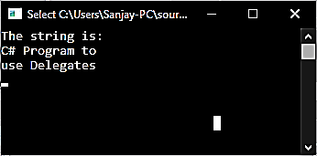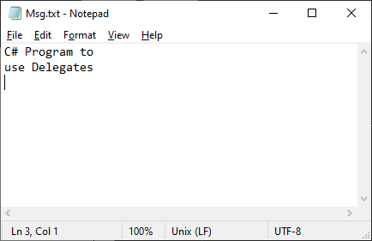

1. **C# program to process the results of a particular course you are familiar with using interfaces and properties.**

using System;

namespace Result_Process

{

class Program

{

class Result

{

string course_name="N.A";

int no_of_papers=0,marks=0;

//Property

public string Course_Name{ get; set; }

public int No_Of_Papers{ get; set; }

public int Marks{ get; set; }

}

static void Main(string[] args)

{

int avg=0;

Result r = new Result();

Console.Write("Result Page(Enter student details)\nCourse Name:");

r.Course_Name = Console.ReadLine();

Console.Write("No.of Papers:");

r.No_Of_Papers = int.Parse(Console.ReadLine());

for(int i=1;i<=r.No_Of_Papers;i++)

{

Result p=new Result();

Console.Write("Paper"+i+" Marks=");

p.Marks = int.Parse(Console.ReadLine());

avg+= p.Marks;

}

Console.WriteLine("\nResult: " + (avg) / r.No_Of_Papers + "% in " + r.Course_Name);

Console.Read();

}

}

}

**Output:**

**Result Page(Enter student details)**

**Course Name:Msc Cs**

**No.of Papers:4**

**Paper1 Marks=77**

**Paper2 Marks=88**

**Paper3 Marks=66**

**Paper4 Marks=98**

**Result: 82% in Msc Cs**

1. **C# Program to Illustrate Methods of FileInfo Class.**

using System;

using System.IO;

namespace FileInfo_Methods

{

class Program

{

static void Main(string[] args)

{

//creates reference to a file

FileInfo fi=new FileInfo("test.txt");

FileStream fs = fi.Open(FileMode.OpenOrCreate, FileAccess.ReadWrite,

FileShare.ReadWrite);

StreamReader sr = new StreamReader(fs);

StreamWriter sw = new StreamWriter(fs);

Console.Write("\nContent: " + sr.ReadToEnd());

sw.Write("\nIm the content\nexcuse"+ fi.GetHashCode());

fi.Encrypt();

Console.Write("\nContent: " + sr.ReadToEnd());//doesn't prints content

sw.Close();

sr.Close();

fs.Close();

Console.WriteLine("\nProperties:\nDirectoryName : " + fi.DirectoryName +

"\nFullName: " + fi.FullName +

"\nExtension: " + fi.Extension+

"\nSize(Length):"+fi.Length+

"\nName:"+fi.Name+

"\nIsReadOnly:"+fi.IsReadOnly+

"\nLastWriteTime:"+fi.LastWriteTime+

"\nLastAccessTime: "+fi.LastAccessTime+

"\nExists: "+ fi.Exists);

Console.Read();

}

}

}

**Output:**

Content: Im previous content

Content:

Properties:

DirectoryName:C:\Users\SanjayPC\source\repos\Sanjay_C#_Lab\FileInfo_Methods\FileInfo_Methods\bin\Debug\netcoreapp3.1

FullName:C:\Users\SanjayPC\source\repos\Sanjay_C#_Lab\FileInfo_Methods\FileInfo_Methods\bin\Debug\netcoreapp3.1\test.txt

Extension: .txt

Size(Length):49

Name:test.txt

IsReadOnly:False

LastWriteTime:01-04-2021 23:13:33

LastAccessTime: 01-04-2021 23:13:33

Exists: True

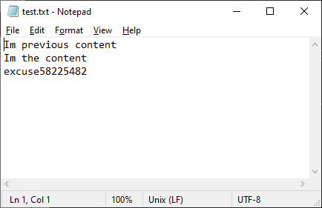

1. **C# Program to Illustrate Pascal Triangle**

using System;

namespace Pascal

{

class Program

{

static void Main(string[] args)

{

int val = 1, blank, i, j;

Console.Write("Enter no.of rows: ");

int rows = int.Parse(Console.ReadLine());

Console.WriteLine("Pascal Triangle");

for (i = 0; i < rows; i++)

{

for (blank = 1; blank <= rows - i; blank++)

Console.Write(" ");

for (j = 0; j <= i; j++)

{

if (j == 0 || i == 0)

val = 1;

else

val = val * (i - j + 1) / j;

Console.Write(val + " ");

}

Console.WriteLine();

}

Console.Read();

}

}

}

**Output:**

Enter no.of rows: 5

Pascal Triangle

1

1 1

1 2 1

1 3 3 1

1 4 6 4 1

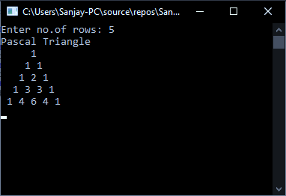

1. **C# Program to Calculate the Series sin(x)=x-x^3/3!+x^5/5!-x^7/7!+……**

using System;

namespace sinx

{

public class Program

{

public static void Main()

{

Console.Write("Enter Angle(in degree)= ");

int x = int.Parse(Console.ReadLine()), sign = 1, n = 1;

decimal res = 0;

double rad = x * (Math.PI / 180.0); //convert Degree To Radian

for (long po = 1; n <= 10; po += 2)

{

res += (decimal)(sign * (Math.Pow(rad, po)) / fact(po));

n += 1;

sign *= -1;

}

Console.Write("sin({0})= {1}", x, res);

Console.Read();

}

static long fact(long p)

{

if (p >= 1)

return (p * fact(p - 1));

return 1;

}

}

}

**Output:**

Enter Angle(in degree)= 90

sin(90)= 1.0000000000000033316944870526

Enter Angle(in degree)= 120

sin(120)= 0.8660254037843388681946638

Enter Angle(in degree)= 180

sin(180)= -0.0000000005289272179189

1. **C# Program to Display Upper Triangular and Lower Triangular Matrix.**

using System;

namespace Upper_Lower

{

public class Program

{

static void Upper(int[,] Matrix, int rows, int cols)

{

Console.WriteLine("\nUpper Triangular Matrix=");

for (int i = 0; i < rows; i++)

{

for (int j = 0; j < cols; j++)

{

if (i > j)

Console.Write("0 ");

else

Console.Write(Matrix[i, j] + " ");

}

Console.WriteLine();

}

}

static void Lower(int[,] Matrix, int rows, int cols)

{

Console.WriteLine("\nLower Triangular Matrix = ");

for (int i = 0; i < rows; i++)

{

for (int j = 0; j < cols; j++)

{

if (i < j)

Console.Write("0 ");

else

Console.Write(Matrix[i, j] + " ");

}

Console.WriteLine();

}

}

public static void Main()

{

Console.Write("Rows= ");

int rows = int.Parse(Console.ReadLine());

Console.Write("Cols= ");

int cols = int.Parse(Console.ReadLine());

int[,] Matrix = new int[rows, cols];

for (int i = 0; i < rows; i++)

{

for (int j = 0; j < cols; j++)

{

Console.Write("Matrix[{0}][{1}]=", i, j);

Matrix[i, j] = int.Parse(Console.ReadLine());

}

}

Console.WriteLine("Matrix:");

for (int i = 0; i < rows; i++)

{

for (int j = 0; j < cols; j++)

{

Console.Write(Matrix[i, j] + " ");

}

Console.WriteLine();

}

Upper(Matrix, rows, cols);

Lower(Matrix, rows, cols);

Console.Read();

}

}

}

**/Output:**

Rows= 3

Cols= 3

Matrix[0][0]=5

Matrix[0][1]=6

Matrix[0][2]=7

Matrix[1][0]=3

Matrix[1][1]=2

Matrix[1][2]=7

Matrix[2][0]=8

Matrix[2][1]=9

Matrix[2][2]=7

Matrix:

5 6 7

3 2 7

8 9 7

Upper Triangular Matrix=

5 6 7

0 2 7

0 0 7

Lower Triangular Matrix =

5 0 0

3 2 0

8 9 7

1. **C# Program to Display the IP Address of the Machine.**

using System;

using System.Net;

namespace IPAddress

{

class Program

{

static void Main(string[] args)

{

var host = Dns.GetHostName();

Console.WriteLine("Host: "+host);

foreach (var ip in Dns.GetHostEntry(host).AddressList)

Console.WriteLine(ip.AddressFamily+" : "+ip);

Console.Read();

}

}

}

**Output:**

Host: DESKTOP-LEUH97F

InterNetworkV6 : fe80::f1bf:9701:1fb9:f380%24

InterNetworkV6 : 2405:204:5789:b456:4969:83e1:2987:cdbd

InterNetworkV6 : 2405:204:5789:b456:f1bf:9701:1fb9:f380\

InterNetwork : 192.168.43.36

**Windows Application**

1. **Program to Get 2 Arrays as Input and Produce a 3rd Array by appending one to other.**

using System;

using System.Linq;

using System.Text.RegularExpressions;

using System.Windows.Forms;

namespace Array_Append_Easy

{

public partial class Form1 : Form

{

string[] arr1, arr2, arr3;

public Form1()

{

InitializeComponent();

Array3.Visible = false;

}

private void Append_Btn_Click(object sender, EventArgs e)

{

if (Array1.Text != "" && Array2.Text != "")

{

Array1.Text = Regex.Replace(Array1.Text.Trim(), " +", " ");

Array2.Text = Regex.Replace(Array2.Text.Trim(), " +", " ");

arr1 = Array1.Text.Split(' ');

arr2 = Array2.Text.Split(' ');

arr3 = arr1.Concat(arr2).ToArray();

Array3.Text = "Array3 =[" + string.Join(", ", arr3) + "]";

Array3.Visible = true;

}

else

{

MessageBox.Show("Please Enter Elements", "Array_Append_GUI",

MessageBoxButtons.OK);

}

}

private void clear_Click(object sender, EventArgs e)

{

Array3.Visible = false;

Array1.Clear();

Array2.Clear();

}

}

}

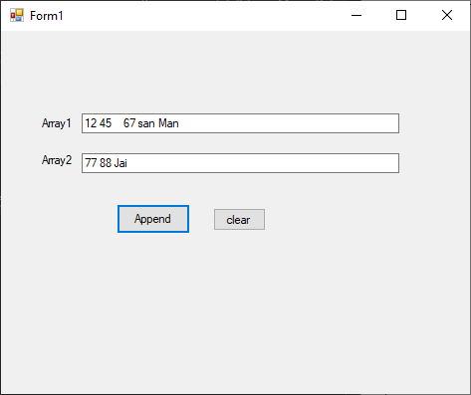

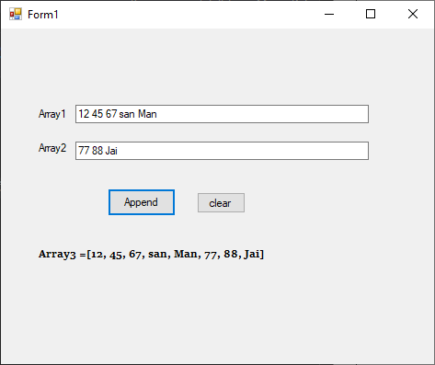

1. **Program to Produce a Filtered Sequence of Elements that Contain only One Property of Each Student.**
2. **Program to Read Data from Stream and Cast Data to Chars.**

using System;

using System.IO;

using System.Windows.Forms;

namespace StreamToCharFormApp

{

public partial class Form1 : Form

{

public Form1()

{

InitializeComponent();

}

private void Select_Click(object sender, EventArgs e)

{

OpenFileDialog File_Selector_Dialog = new OpenFileDialog();

File_Selector_Dialog.InitialDirectory = "C:\\Users\\Sanjay-PC\\Desktop\\";

File_Selector_Dialog.Filter = "Access files(*.txt)|*.txt";

DialogResult result = File_Selector_Dialog.ShowDialog();

string path = File_Selector_Dialog.FileName;

File_stream.Text = path;

if (path != "")

{

string text = File.ReadAllText(path);//Reading Data Stream

ReadData_lb.Text += text;

using (Stream s = new FileStream(path, FileMode.Open))

{

int read;

while ((read = s.ReadByte()) != -1)

{

Display_lb.Text += (char)read + " ";//Casting in Char Data Type

}

}

}

}

}

}

**Output:**

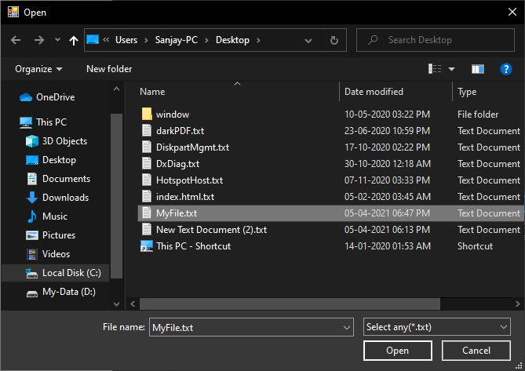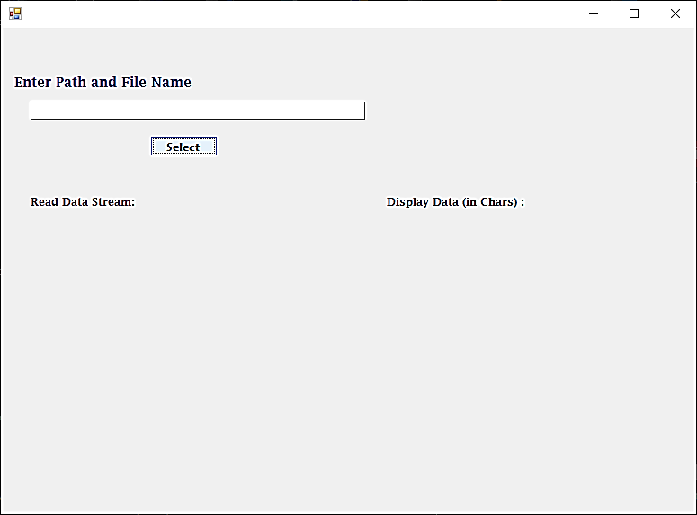

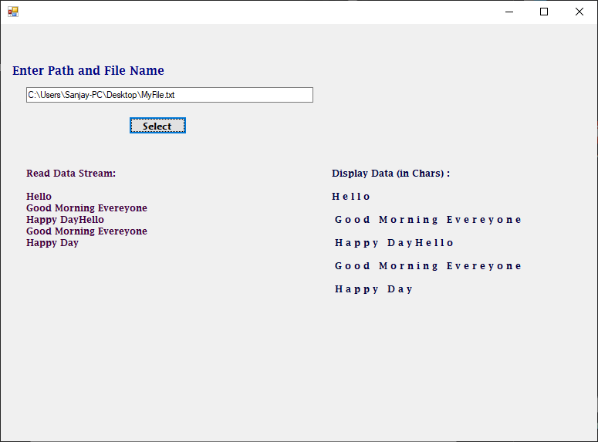

**ii)cmd**

using System;

using System.IO;

namespace StreamToCharApp

{

class Program

{

static void Main(string[] args)

{

Console.Write("Enter full path of file(.txt): ");

string path = Console.ReadLine();

if (File.Exists(path))

{

Console.Write("Content(stream):\n"+File.ReadAllText(path));

Console.WriteLine("\n(in chars):");

using (Stream s = new FileStream(path, FileMode.Open))

{

int read;

while((read=s.ReadByte())!=-1)

{

Console.Write(" {0}", (char)read);

}

}

}

else

Console.WriteLine("File Not Exists");

Console.Read();

}

}

}

**Output:**

**Enter full path of file(.txt): C:\Users\Sanjay-PC\Desktop\myfile.txt**

**Content(stream):**

**Hello**

**Good Morning Everyone**

**Happy Day**

**(in chars):**

**H e l l o**

**G o o d M o r n i n g E v e r y o n e**

**H a p p y D a y**

1. **Program to Display the Abbreviation of a Text.**

using System;

using System.Windows.Forms;

namespace Abbrevation_Form

{

public partial class Form1 : Form

{

public Form1()

{

InitializeComponent();

}

private void abbrevate_Click(object sender, EventArgs e)

{

int j = 0;

string str = TextBox1.Text;

str = str.ToUpper();

char[] result = new char[str.Length];

result[j++] = str[0];

result[j++] = '.';

for (int i = 0; i < str.Length - 1; i++)

{

if (str[i] == ' ' && str[i + 1] != ' ')

{

result[j++] = str[i + 1];

result[j++] = '.';

}

}

Result.Text = "Abbrevation= " + new string(result);

Result.Visible = true;

}

private void TextBox1_KeyUp(object sender, KeyEventArgs ke)

{

Console.WriteLine(ke.ToString());

if(ke.KeyValue==13)

{

abbrevate_Click(sender, ke);

}

}

}

}

**Output:**

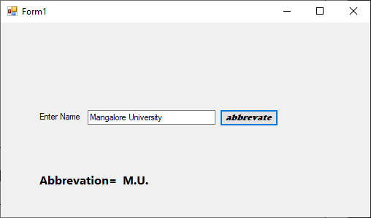

1. **Program to Demonstrate Transactions using Interface.**

**Design Window:**

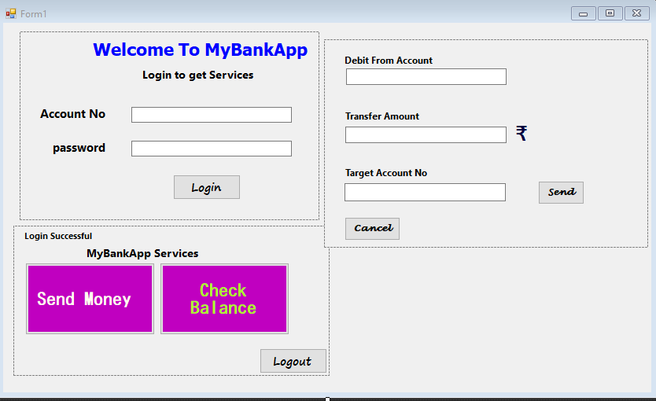

**Code:**

using System;

using System.Data.SqlClient;

using System.Windows.Forms;

namespace Bank_Transaction

{

public partial class Form1 : Form

{

static string con_str = "Data

Source=(LocalDB)\\MSSQLLocalDB;AttachDbFilename=C:\\Users\\Sanjay-PC\\source\\repos\\Sanjay_C#_Lab\\Bank Transaction\\Bank Transaction\\LocalBankDB.mdf;Integrated Security=True";

SqlConnection conn=new SqlConnection(con_str);

SqlCommand cmd;

string sql, login_acc_no="";

float Bal = 0;

public Form1()

{

InitializeComponent();

Home_Panel.Visible = false;

Transaction_Panel.Visible = false;

conn.Open();

}

private void Login_Btn_Click(object sender, EventArgs e)

{

SqlDataReader dreader1;

if (acc_no.Text != "" && pswd.Text != "")

{

sql = "Select * from dbo.LocalBank where (Acc_No=" + acc_no.Text + " AND

Password=\'" + pswd.Text + "\')";

cmd = new SqlCommand(sql, conn);

using (dreader1 = cmd.ExecuteReader())

{

if (dreader1.Read())

{

Home_Panel.Location = Login_Panel.Location;

Login_Panel.Visible = false;

Home_Panel.Visible = true;

login_acc_no = acc_no.Text;

dreader1.Close();

}

else

MessageBox.Show("Invlid Account No / Password", "Login Failed");

}

}

else

MessageBox.Show("Please Enter Account No* and Password*", "Login Failed");

Bal_Btn.Enabled = true;

}

private void Bal_Btn_Click(object sender, EventArgs e)

{

SqlDataReader dreader2;

sql = "select Balance from dbo.LocalBank where Acc_No=" + acc_no.Text;

cmd = new SqlCommand(sql, conn);

dreader2 = cmd.ExecuteReader();

if (dreader2.Read())

Bal_lb.Text = "Balance: " + dreader2.GetValue(0)+" Rs";

dreader2.Close();

Bal_Btn.Enabled = false;

}

private void logout_Btn_Click(object sender, EventArgs e)

{

conn.Dispose();

conn.Close();

Application.Restart();

}

private void send_Btn_Click(object sender, EventArgs e)

{

deb_acc_no.Text = login_acc_no;

deb_acc_no.Enabled = false;

Bal_lb.Text = "";

Transaction_Panel.Location = Login_Panel.Location;

Home_Panel.Visible = false;

Transaction_Panel.Visible =true ;

}

private void send_cnf_Btn_Click(object sender, EventArgs e)

{

SqlDataReader dreader3;

SqlDataReader readBal;

sql = "select Balance from dbo.LocalBank where Acc_No=" + deb_acc_no.Text;

cmd = new SqlCommand(sql, conn);

readBal = cmd.ExecuteReader();

if(readBal.Read())

{

Bal=(float)readBal.GetDouble(0);

readBal.Close();

}

SqlTransaction trans = conn.BeginTransaction();

//Existance of Target Acct

sql = "select * from dbo.LocalBank where Acc_No=" + Target_Account_No.Text;

cmd = new SqlCommand(sql, conn,trans);

dreader3 = cmd.ExecuteReader();

if (dreader3.Read())//if exists

{

if (Transfer_Amount.Text != "")

{

float Transfer_amt = float.Parse(Transfer_Amount.Text);

if (Transfer_amt > 0 && Transfer_amt < Bal)

{

//Update

sql = @"Update dbo.LocalBank SET Balance=Balance-" + Transfer_amt + "

where Acc_No=" + deb_acc_no.Text + ";" +

"Update dbo.LocalBank SET Balance = Balance+" + Transfer_amt + "

where Acc_No = " + Target_Account_No.Text + ";";

cmd = new SqlCommand(sql, conn);

dreader3.Close();

cmd.Transaction = trans;

int ret = cmd.ExecuteNonQuery();

Console.WriteLine(ret);

trans.Commit();

MessageBox.Show("Rs." + Transfer_amt + "Sent To " +

Target_Account_No.Text, " Transaction Successful!");

Transaction_Panel.Visible = false;

Home_Panel.Visible = true;

}

else

MessageBox.Show("No Sufficient Balance or Invalid Amount", "Alert!");

}

else

MessageBox.Show("Enter valid Amount", "Alert!");

}

else

MessageBox.Show("Target Account Not Exist", "Transaction Failed!");

Bal_Btn.Enabled = true;

}

private void cancel_Btn_Click(object sender, EventArgs e)

{

Transaction_Panel.Visible = false;

Home_Panel.Visible = true;

}

private void Form1_KeyDown(object sender,KeyEventArgs ke)

{

if(ke.Alt && ke.KeyCode==Keys.F4)

{

conn.Dispose();

conn.Close();

}

}

}

}

**Output:**

Database:

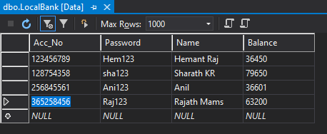

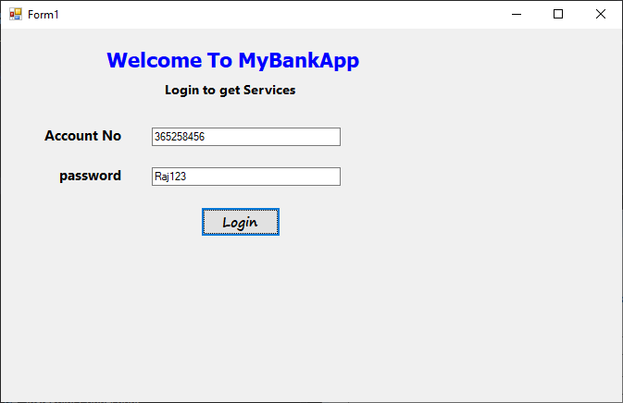

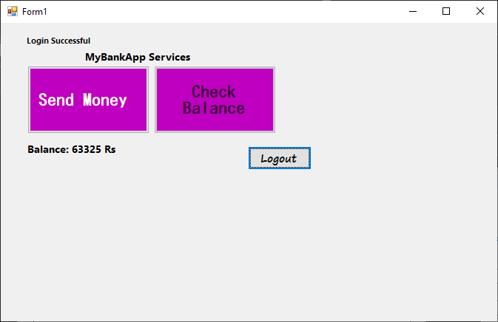

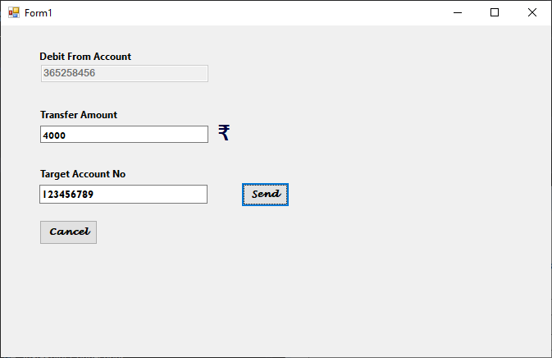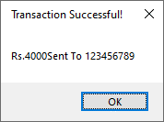

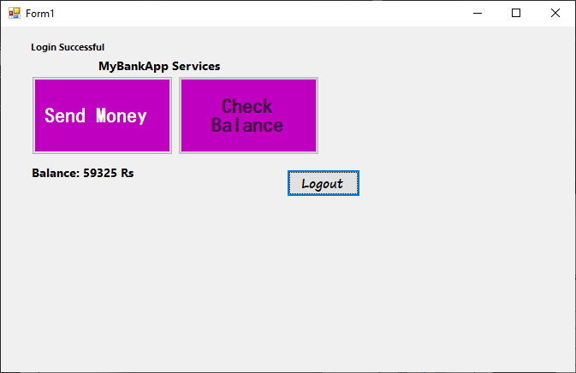

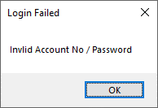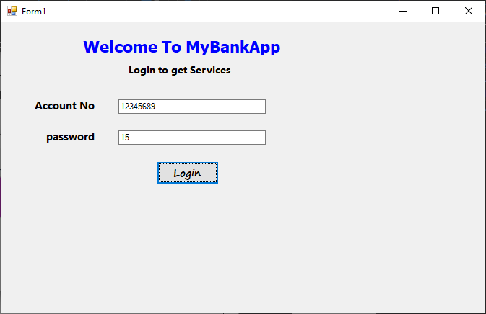

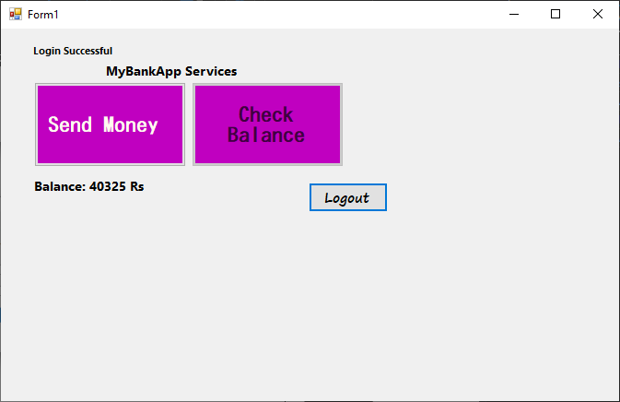

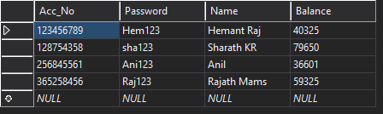

**Database After**

**Transaction:**20. **Design a C# Windows Application program to implement keyboard event and mouse event**.

using System;

using System.Collections.Generic;

using System.ComponentModel;

using System.Data;

using System.Drawing;

using System.Linq;

using System.Text;

using System.Threading.Tasks;

using System.Windows.Forms;

namespace Mouse_KeyBoard_Events

{

public partial class Form1 : Form

{

public Form1()

{

InitializeComponent();

}

private void textBox1_MouseClick(object sender, MouseEventArgs e)

{

if (e.Button == MouseButtons.Left)

Mouse_Message_lb.Text +="Mouse Clicked (Left)\n";

else

Mouse_Message_lb.Text += "Mouse Clicked (Right)\n";

}

private void textBox1_MouseDoubleClick(object sender, MouseEventArgs e)

{

Mouse_Message_lb.Text += "Mouse Double Clicked\n";

}

private void textBox1_MouseUp(object sender, MouseEventArgs e)

{

Mouse_Message_lb.Text += "Mouse Up\n";

}

private void textBox1_MouseDown(object sender, MouseEventArgs e)

{

if(e.Button==MouseButtons.Left)

Mouse_Message_lb.Text += "Mouse Down (Left)\n";

else

Mouse_Message_lb.Text += "Mouse Down (Right)\n";

}

private void textBox1_MouseEnter(object sender, EventArgs e)

{

Enter_lb.Text = "Mouse Entered\n";

}

private void textBox1_MouseHover(object sender, EventArgs e)

{

Mouse_Hover.Text = "Mouse Hovered";

}

private void textBox1_MouseLeave(object sender, EventArgs e)

{

Enter_lb.Text = "Mouse Left\n";

Moving_lb.Text = "";

Mouse_Hover.Text = "";

}

private void textBox1_MouseMove(object sender, MouseEventArgs e)

{

Moving_lb.Text = "Mouse Moving @ Location(" + e.X+","+e.Y+")";

}

private void Clear_All_Click(object sender, EventArgs e)

{

Mouse_Message_lb.Text = "";

Enter_lb.Text = "";

}

private void textBox1_KeyPress(object sender, KeyPressEventArgs e)

{

KB_ev.Text = "Key Pressed";

KB_Msg.Text ="\'"+e.KeyChar.ToString()+"\' key Pressed\n";

}

private void textBox1_KeyDown(object sender, KeyEventArgs e)

{

KB_up_dwn.Text = "Key Down";

}

private void textBox1_KeyUp(object sender, KeyEventArgs e)

{

KB_up_dwn.Text = "Key UP";

KB_ev.Text = "";

}

}

}

**Output:**

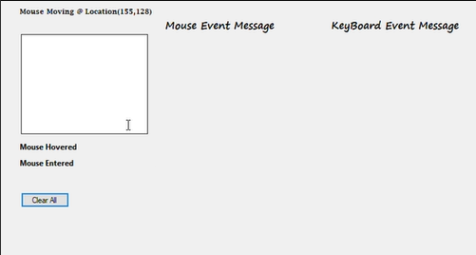

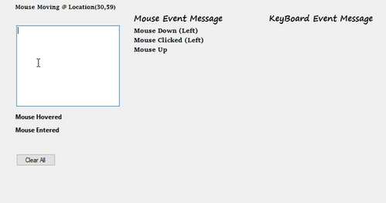

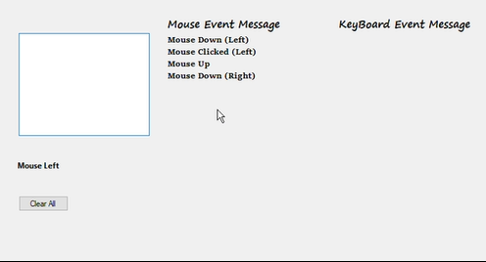

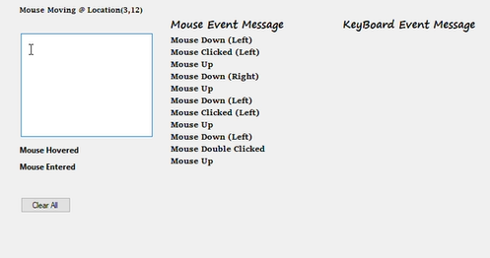

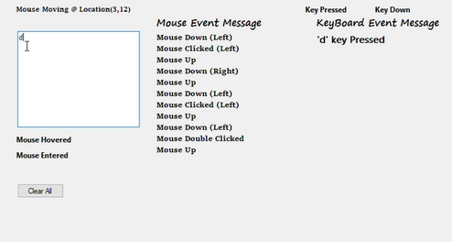

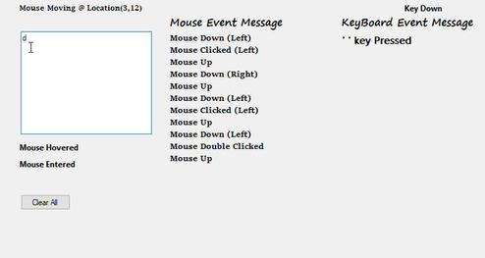

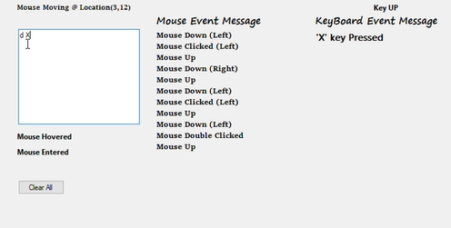

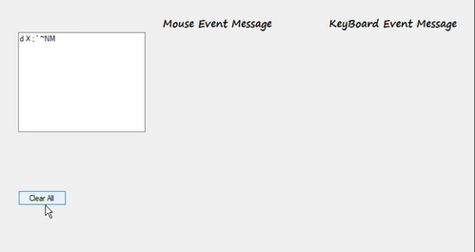

1. **Develop a winform application to create a Digital clock.**

using System;

using System.Collections.Generic;

using System.ComponentModel;

using System.Data;

using System.Drawing;

using System.Linq;

using System.Text;

using System.Threading.Tasks;

using System.Windows.Forms;

namespace Digital_Clock

{

public partial class Form1 : Form

{

public Form1()

{

InitializeComponent();

}

private void timer1_Tick(object sender, EventArgs e)

{

clock_lb.Text = DateTime.Now.ToString("hh:mm:ss tt");

Date_lb.Text = DateTime.Now.ToString("MMMM dd yy dddd");

}

}

}

**Output:**

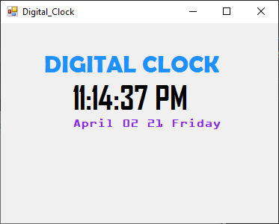

1. **Develop a C# winform application for creating paint window.**

using System;

using System.Collections.Generic;

using System.ComponentModel;

using System.Data;

using System.Drawing;

using System.Linq;

using System.Text;

using System.Threading.Tasks;

using System.Windows.Forms;

namespace PaintWindow

{

public partial class Form1 : Form

{

Graphics g;

int x = -1, y = -1;

bool moving = false;

Pen pen;

public Form1()

{

InitializeComponent();

g = panel1.CreateGraphics();

g.SmoothingMode = System.Drawing.Drawing2D.SmoothingMode.AntiAlias;

pen = new Pen(Color.Black, 5);

pen.StartCap = pen.EndCap = System.Drawing.Drawing2D.LineCap.Round;

}

private void panel1_MouseDown(object sender, MouseEventArgs e)

{

moving = true;

x = e.X;

y = e.Y;

}

private void panel1_MouseUp(object sender, MouseEventArgs e)

{

moving = false;

x = -1;

y = -1;

}

private void panel1_MouseMove(object sender, MouseEventArgs e)

{

if(moving && x!=-1 && y!=-1 )

{

g.DrawLine(pen, new Point(x,y), e.Location);

x = e.X;

y = e.Y;

}

}

private void pictureBox1_Click(object sender, EventArgs e)

{

PictureBox p = (PictureBox)sender;

pen.Color = p.BackColor;

}

private void clr_Btn_Click(object sender, EventArgs e)

{

Application.Restart();

}

}

}

**Output:**

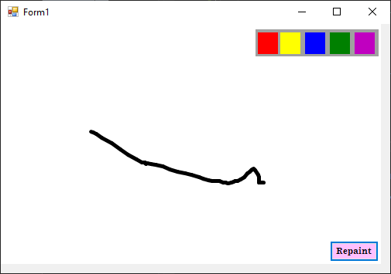

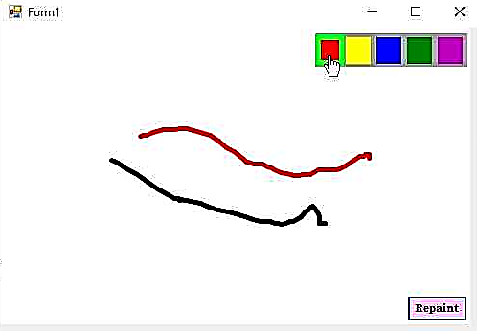

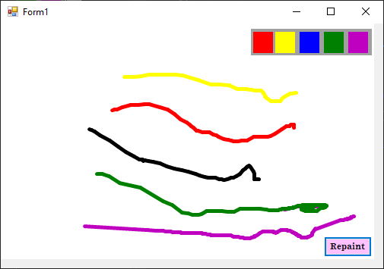

1. **Develop a winform application program for Prefix Game.**

**24. Create a note taking windows form application.**

using System;

using System.Collections.Generic;

using System.ComponentModel;

using System.Data;

using System.Drawing;

using System.Linq;

using System.Text;

using System.Threading.Tasks;

using System.Windows.Forms;

namespace Note_Taking_App

{

public partial class Note_Taking_App : Form

{

DataTable table;

public Note_Taking_App()

{

InitializeComponent();

}

private void Note_Taking_App_Load(object sender, EventArgs e)

{

table = new DataTable();

table.Columns.Add("Title", typeof(string));

table.Columns.Add("Messages", typeof(string));

Title_List_DGV.DataSource = table;

Title_List_DGV.Columns["Messages"].Visible = false;

Title_List_DGV.Columns["Title"].Width = 200;

}

private void New_Click(object sender, EventArgs e)

{

Title_txt.Clear();

Message_txt.Clear();

}

private void Save_Click(object sender, EventArgs e)

{

if (Title_txt.Text != "")

{

table.Rows.Add(Title_txt.Text, Message_txt.Text);

Title_txt.Clear();

Message_txt.Clear();

}

else

MessageBox.Show("Please Enter Title!", "Note Taking App");

}

private void Read_Click(object sender, EventArgs e)

{

try

{

int index = Title_List_DGV.CurrentCell.RowIndex;

if (index > -1)

{

Title_txt.Text = table.Rows[index].ItemArray[0].ToString();

Message_txt.Text = table.Rows[index].ItemArray[1].ToString();

}

}

catch(Exception exc)

{

MessageBox.Show("Please Select any Title!", "Note Taking App");

}

}

private void Delete_Click(object sender, EventArgs e)

{

try

{

int index = Title_List_DGV.CurrentCell.RowIndex;

table.Rows[index].Delete();

}

catch (Exception exc)

{

MessageBox.Show("Please Select any Title!", "Note Taking App");

}

}

}

}

**Output:**

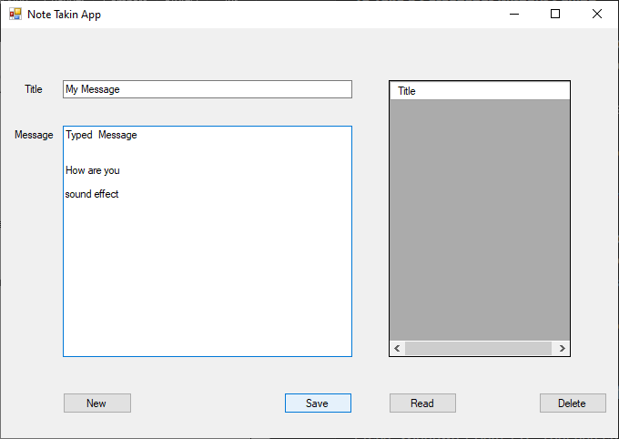

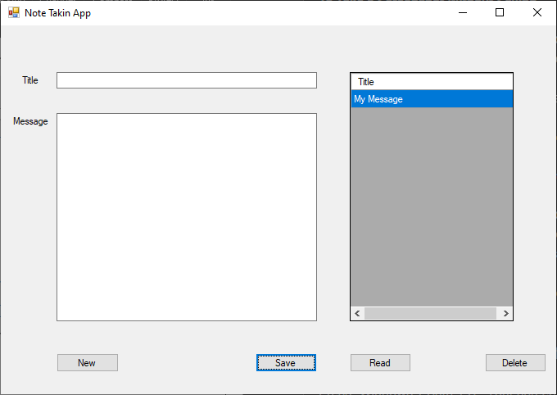

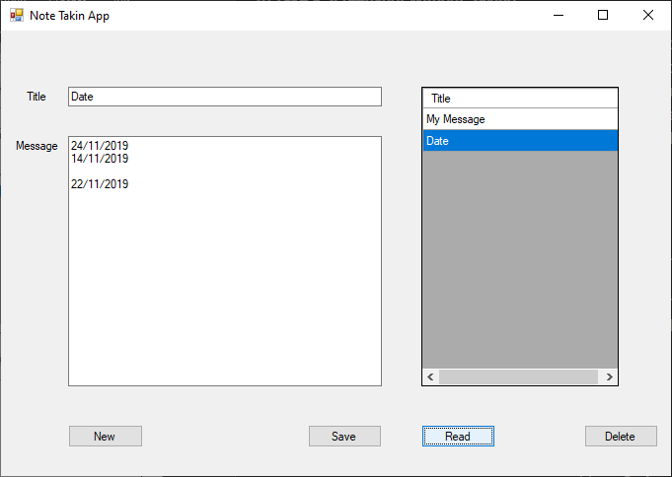

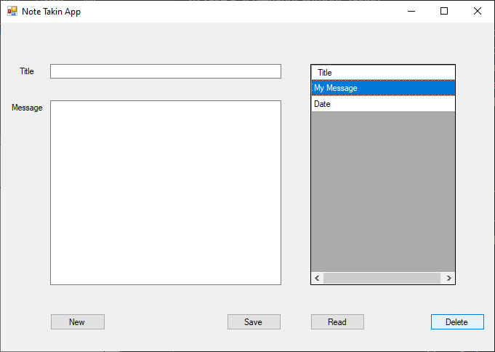

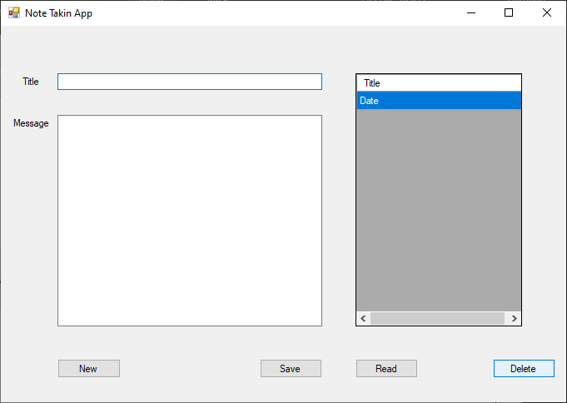

1. **Design a windows form application to upload and download files.**
2. **Design a quiz program in windows application.**

using System;

using System.Collections.Generic;

using System.ComponentModel;

using System.Data;

using System.Drawing;

using System.Linq;

using System.Text;

using System.Threading.Tasks;

using System.Windows.Forms;

namespace Quiz_Form_App

{

public partial class QuizApp : Form

{

int[] score_arr=new int[6];

int qtn_no;

public QuizApp()

{

InitializeComponent();

panel1.Visible = false;

pictureBox1.SizeMode = PictureBoxSizeMode.StretchImage;

}

private void start_Click(object sender, EventArgs e)

{

prev.Visible = false;

panel1.Visible = true;

start.Visible = false;

qtn_no = 1;

askQuestion(qtn_no);

}

private void Next_Click(object sender, EventArgs e)

{

RadioButton[] corrct_Ans = {null,ans2,ans3,ans2,ans3,ans1};

if (corrct_Ans[qtn_no].Checked)

score_arr[qtn_no] = 10;

else

score_arr[qtn_no] = 0;

if (qtn_no < 5)

{

for (int i = 1; i < corrct_Ans.Length; i++)

corrct_Ans[i].Checked = false;

askQuestion(++qtn_no);

}

else

submit();

}

private void prev_Click(object sender, EventArgs e)

{

askQuestion(--qtn_no);

}

private void askQuestion(int qtn_no)

{

if(qtn_no==5)

Next.Text = "submit";

else

Next.Text = "Next";

switch(qtn_no)

{

case 1:

prev.Visible = false;

pictureBox1.Image=new Bitmap("C:\\Users\\Sanjay-PC\\source\\repos

\\Sanjay_C#_Lab\\Quiz_Form_App\\Quiz_Images\\prime.png") ;

qtn.Text = "1. Who is the current Prime Minister of India?";

ans1.Text = "Rahul Gandhi";

ans2.Text = "Narendra Modi";

ans3.Text = "Hemanth raj";

ans4.Text = "Priyanka Gandhi";

break;

case 2:

prev.Visible = true;

pictureBox1.Image = new Bitmap("C:\\Users\\Sanjay- PC

\\source\\repos\\Sanjay_C#_Lab\\Quiz_Form_App\\Quiz_Images\\

AlbertEinstein.png");

qtn.Text = "2. Name of the Scientist";

ans1.Text = "Vijay Vincent";

ans2.Text = "Rajath Mams";

ans3.Text = "Einstien";

ans4.Text = "Newton";

break;

case 3:

pictureBox1.Image = new Bitmap("C:\\Users\\Sanjay-PC\\source

\\repos\\Sanjay_C#_Lab\\Quiz_Form_App\\Quiz_Images\\solveIt.png");

qtn.Text = "3. Answer = ";

ans1.Text = "10";

ans2.Text = "9";

ans3.Text = "0";

ans4.Text = "1";

break;

case 4:

pictureBox1.Image = new Bitmap("C:\\Users\\Sanjay-PC\\source\\repos

\\Sanjay_C#_Lab\\Quiz_Form_App\\Quiz_Images\\2011.png");

qtn.Text = "4. Who Won the ICC Worldcup 2011? ";

ans1.Text = "RCB";

ans2.Text = "Australia";

ans3.Text = "India";

ans4.Text = "England";

break;

case 5:

pictureBox1.Image = new Bitmap("C:\\Users\\Sanjay-PC\\source\\repos

\\Sanjay_C#_Lab\\Quiz_Form_App\\Quiz_Images\\sky.png");

qtn.Text = "5. What is the Color of Sky? ";

ans1.Text = "Blue";

ans2.Text = "green";

ans3.Text = "Orange";

ans4.Text = "Red";

break;

}

}

private void submit()

{

panel1.Visible = false;

int score = score_arr.Sum();

Label res =new Label();

res.Size = new Size(500, 200);

res.Location = new Point(this.Height/2, this.Width/2);

res.Font = new Font("Ariel", 20, FontStyle.Bold);

res.Text = "Your Score is " + score+" /50";

this.Controls.Add(res);

}

}

}

**Output:**

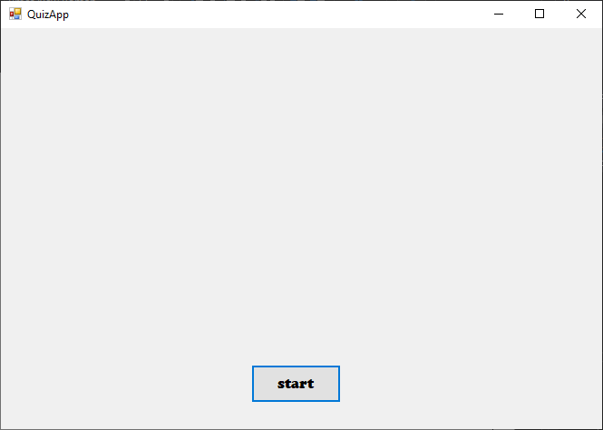

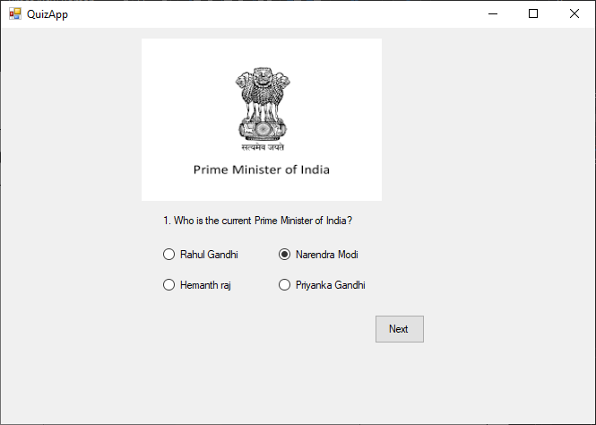

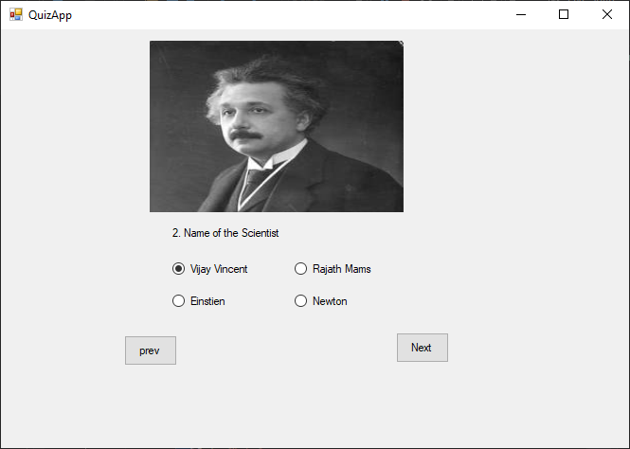

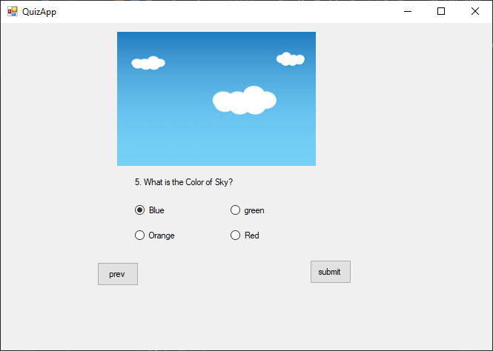

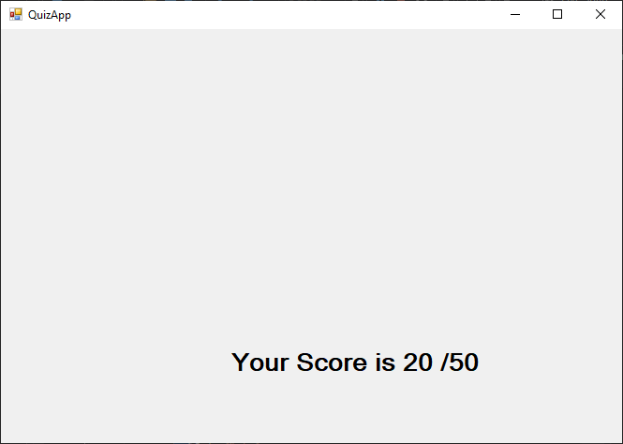

1. **Design a web application form using ads rotator control and create effective assignment.**
2. **Creating Game Tic Tac Toe with WPF.**

using System.Windows;

using System.Windows.Controls;

namespace Tic_Toe_App

{

/// <summary>

/// Interaction logic for MainWindow.xaml

/// </summary>

public partial class MainWindow : Window

{

int turn,round,pl1_pt,pl2_pt;

public MainWindow()

{

InitializeComponent();

turn = 1;

}

private void Button_Click(object sender,RoutedEventArgs e)

{

Button btn = sender as Button;

if(turn==1)

{

btn.Content = "X";

p_turn.Content= "Player Turn: 2 (0)";

turn = 2;

}

else if(turn==2)

{

btn.Content = "O";

p_turn.Content = "Player Turn: 1 (X)";

turn = 1;

}

round += 1;

btn.IsEnabled = false;

win(btn.Content.ToString());

}

private void win(string btnContent)

{

if (( Button1.Content as string == btnContent &

Button2.Content as string == btnContent &

Button3.Content as string == btnContent) |

( Button4.Content as string == btnContent &

Button5.Content as string == btnContent &

Button6.Content as string == btnContent) |

( Button7.Content as string == btnContent &

Button8.Content as string == btnContent &

Button9.Content as string == btnContent) |

( Button1.Content as string == btnContent &

Button4.Content as string == btnContent &

Button7.Content as string == btnContent) |

( Button2.Content as string == btnContent &

Button5.Content as string == btnContent &

Button8.Content as string == btnContent) |

( Button3.Content as string == btnContent &

Button6.Content as string == btnContent &

Button9.Content as string == btnContent) |

( Button1.Content as string == btnContent &

Button5.Content as string == btnContent &

Button9.Content as string == btnContent) |

( Button3.Content as string == btnContent &

Button5.Content as string == btnContent &

Button7.Content as string == btnContent ))

{

if (btnContent == "X")

{

disableButtons();

MessageBox.Show("Player 1 Wins");

Player1_lb.Content = "Player1(X)\n " + (++pl1_pt);

}

else if (btnContent == "O")

{

disableButtons();

MessageBox.Show("Player 2 Wins");

Player2_lb.Content = "Player2(O)\n " + (++pl2_pt);

}

if (turn == 1)

turn = 2;

else

turn = 1;

Reset_All();

}

else if(round==9)

{

MessageBox.Show("Draw");

Reset_All();

}

}

private void disableButtons()

{

foreach(Button btn in WrapPanel1.Children)

{

btn.IsEnabled = false;

}

}

private void Reset_All()

{

foreach (Button btn in WrapPanel1.Children)

{

round = 0;

p_turn.Content = "Player Turn: "+turn;

btn.Content = "";

btn.IsEnabled = true;

}

}

private void Reset_Click(object sender, RoutedEventArgs e)

{

Reset_All();

}

}

}

**Output:**

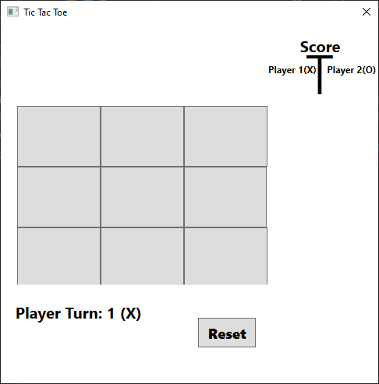

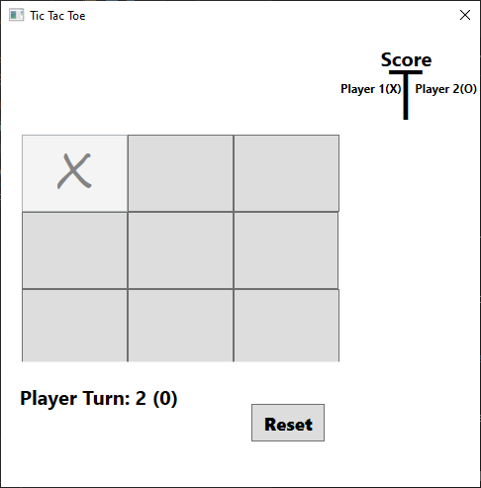

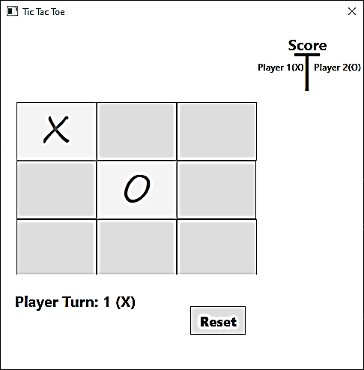

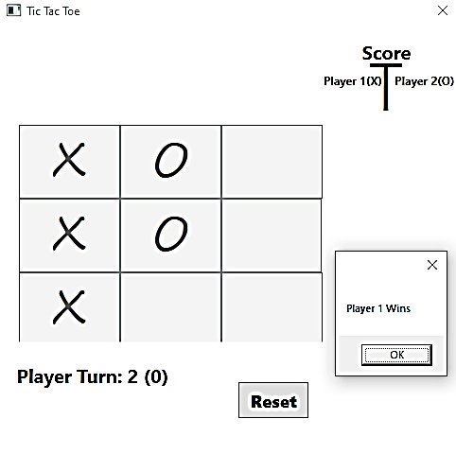

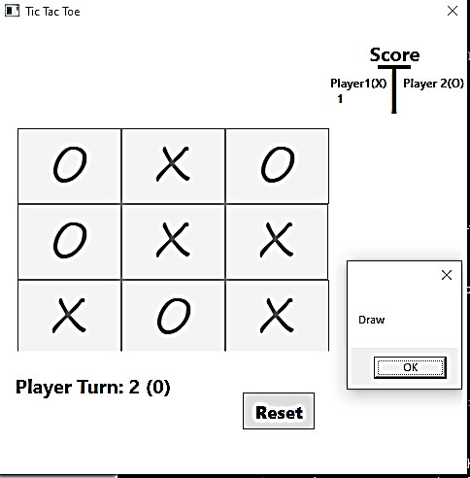

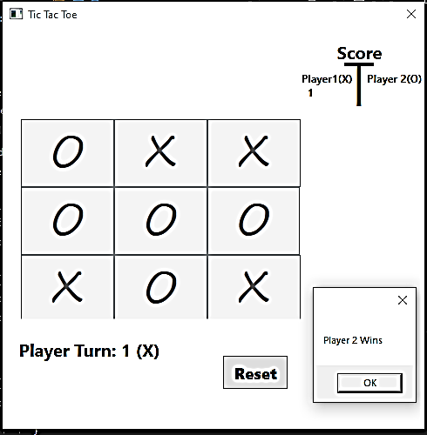

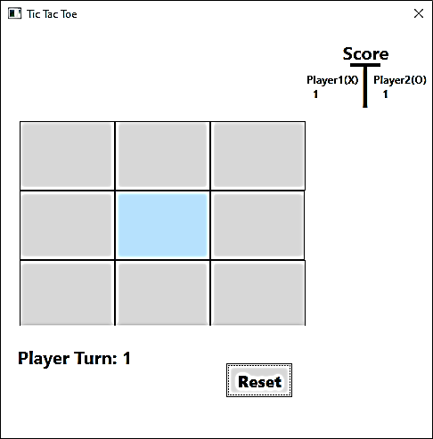

1. **Develop an ASP.NET application program to create a Sign-Up page using validation controls.**
2. **Create a modal popup extender using C# ASP.NET.**