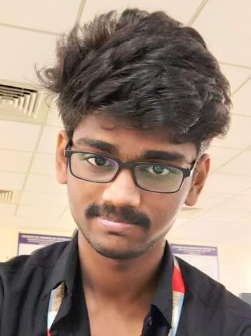

**SANJAY. M**

Python Enthusiast | HTML/CSS Proficient | Linux System Administrator | AWS Cloud Engineer | Frontend Developer | Full Stack Developer

**Contact Details**

4/20, Sekkilar Street,

Municipal Colony Erode, 638004

**+91 77086 53220**

[**mss681956@gmail.com**](mailto:mss681956@gmail.com)[**SanjayM08 | LinkedIn**](https://www.linkedin.com/in/sanjaym08/)

[**SanjayM08 | GitHub**](https://github.com/sanjaym08)

**EDUCATION**

# KSR Institute for Engineering and Technology,

TIRUCHENGODE — *BE CSE*

JUNE 2019 - JUNE 2023

7.07 CGPA (till 7th Semester)

# The Sengunthar Higher Secondary School, ERODE —

*+2 (Math-CSE)*

JUNE 2017 - JULY 2019

68.3% in 12th

**Government Higher Secondary School,** ERODE — *10th*

JUNE 2007 - MAY 2017

83.2% in 10th

**PROJECTS**

# Tracing the latency report of data in GCP using Kubernetes Engine for Improving the Performance – Build using Google Cloud Platform, Python, Kubernetes Cluster, Container, Terraform, Load Balancer and Pub/Sub *(Final Semester)*

This is My Final Year Project the Project is Tracing the latency of data in Google cloud platform using Kubernetes Engine

# Crude Oil Price Prediction in IBM *(IBM)*

This is My Mini Project. The Project is Price Prediction for Crude Oil That we did in IBM.

**SKILLS**

* Python Programing
* Linux System Administration
* AWS Service
* Web Development (HTML, CSS and JavaScript)
* SQL Programing
* Git and GitHub

**Additional**

* **Great Learning Python Developer**
* **Great Learning AWS Developer**
* **I continue to code on the HackerRank platform for Python.**

**LANGUAGES**

Tamil, English.

**HOBBIES**

Gaming, Editing, Watching Movies.