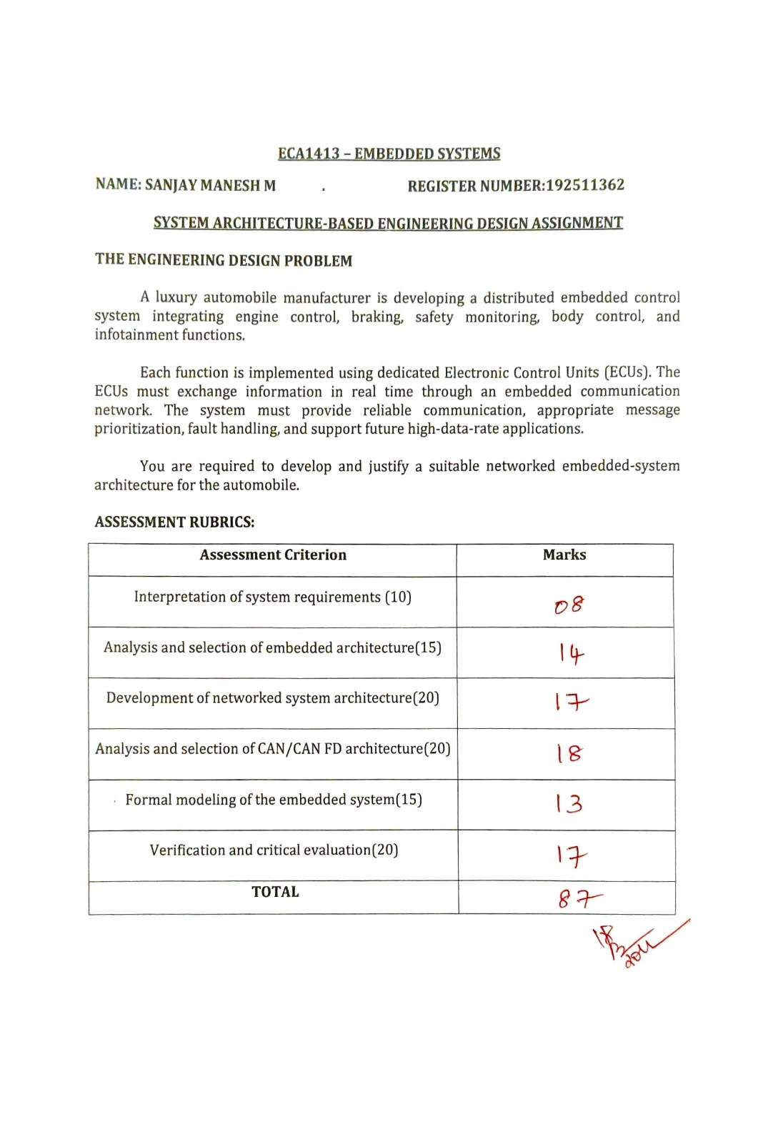

ABSTRACT
Electric vehicles rely on interconnected embedded controllers to manage battery performance, electric propulsion, thermal regulation, steering assistance, and driver-assistance functions. These functions require continuous monitoring of electrical and physical parameters, real-time processing, and reliable communication between Electronic Control Units (ECUs).
This report proposes a distributed embedded architecture for an electric vehicle using a Battery Management System (BMS), Motor Control ECU, Thermal Management ECU, Steering Control ECU, Advanced Driver-Assistance System (ADAS) ECU, and a vehicle communication gateway. The design considers different processing architectures, including microcontrollers, microprocessors, and System-on-Chip devices, according to the computational requirements of each subsystem.
The proposed system uses CAN and CAN FD for suitable control and status messages, with automotive Ethernet considered for applications requiring higher data bandwidth. A network gateway manages authorized communication between different vehicle domains. Battery thermal protection is selected as the safety-related function for formal modeling because excessive battery temperature can affect battery life, performance, and vehicle safety.
The report also examines failure conditions such as temperature-sensor drift, cooling-pump malfunction, communication bus-off, and excessive ADAS network traffic. Verification techniques, including state-machine analysis, simulation, hardware-in-the-loop testing, and fault injection, are proposed to evaluate system behavior. The architecture is intended as a conceptual engineering design that requires detailed safety analysis, hardware selection, and practical validation before production deployment.

STAGE 1 – IDENTIFY AND ANALYZE THE SYSTEM REQUIREMENTS

1.1 Problem description
An electric vehicle manufacturer requires an embedded control architecture capable of coordinating battery monitoring, electric motor operation, thermal management, steering assistance, and driver-assistance functions.
Each major function is assigned to a dedicated ECU. These controllers must operate independently where necessary while exchanging relevant data through a reliable in-vehicle communication network.
The primary engineering challenge is to ensure that electrical and thermal conditions are monitored accurately, motor-control operations meet their timing requirements, safety-related faults are detected, and high-bandwidth applications do not interfere with essential vehicle functions.

1.2 Functional requirements
The proposed system includes the following functional requirements.
Function | Requirement
Battery management | Monitor cell voltage, pack current, and battery temperature
Motor control | Regulate motor torque and coordinate inverter operation
Thermal management | Control coolant pumps, fans, and valves according to temperature conditions
Steering control | Process steering input and monitor steering-assistance operation
ADAS | Process permitted sensor information and generate driver-assistance outputs
Gateway communication | Route and filter authorized messages between network segments
Fault detection | Detect abnormal measurements, missing messages, and controller faults
Energy monitoring | Estimate relevant battery operating parameters and support energy management

1.3 Responsibilities of the individual ECUs
Battery Management System (BMS): Monitors cell voltage, battery current, and temperature. It estimates battery state of charge and checks whether operating conditions remain within the defined limits. Depending on the design, it can request power limitation or contactor isolation when a serious fault is detected.
Motor Control ECU: Processes accelerator demand, motor-position information, and other relevant feedback. It calculates motor-control commands and coordinates operation with the power inverter.
Thermal Management ECU: Monitors battery and powertrain temperatures and controls cooling pumps, fans, and valves. It aims to keep components within their permitted operating ranges.
Steering Control ECU: Processes steering-angle and torque-related inputs and controls the steering-assistance actuator where applicable. It monitors relevant faults and implements the specified fallback response.
ADAS ECU: Processes information from cameras, radar, or other supported sensors to provide functions such as lane monitoring and obstacle detection. It may require substantial processing and memory resources.
Vehicle Gateway: Transfers authorized messages between communication domains, applies filtering and rate limits, and helps isolate failures or unnecessary traffic.

1.4 Real-time requirements
Different ECUs have different timing requirements. Motor-control loops and safety-related monitoring may require predictable response times, whereas some diagnostic and infotainment-related transfers can tolerate greater delay.
The architecture must therefore define message priorities, sampling rates, task execution deadlines, and communication timeouts.
For example, if the BMS detects a critical battery temperature, it must communicate the relevant fault or power-limitation request within a defined deadline. The motor controller must then handle the request according to the vehicle's safety requirements.
The exact timing values must be derived from the selected hardware and system requirements rather than assumed without analysis.

1.5 Processing, memory and input/output requirements
ECU | Processing requirements | Typical inputs and outputs
BMS | Deterministic monitoring and estimation | Cell voltage, current, temperature, contactor control
Motor Control | Fast real-time control | Accelerator demand, motor position, inverter commands
Thermal Management | Periodic control and fault monitoring | Temperature sensors, pump and fan commands
Steering Control | Real-time actuator control | Steering angle, torque, actuator feedback
ADAS | High computational capacity | Camera and radar data, driver-assistance outputs
Gateway | Message routing and filtering | CAN/CAN FD frames, Ethernet messages
Memory capacity must support firmware, runtime data, calibration values, diagnostics, and any required event records. Input and output interfaces must also be compatible with the selected sensors and actuators.

1.6 Reliability and fault-tolerance requirements
The system must detect abnormal sensor readings, lost communication, controller resets, and relevant actuator failures.
Possible mechanisms include watchdog timers, sensor plausibility checks, communication timeouts, diagnostic monitoring, voltage monitoring, and defined fallback actions. Additional sensing or independent monitoring may be required where justified by the safety analysis.
For example, a temperature reading that changes unexpectedly should be checked against other available measurements and system conditions before it is used for a safety-related decision.

1.7 Safety-critical and non-critical functions
Battery protection, motor torque control, and steering control may contain safety-critical functions. ADAS functions can also be safety-critical depending on their intended role and level of authority.
The architecture should separate communication domains and prevent high-bandwidth or non-critical traffic from disrupting essential control operations. The precise safety classification of each function must be established through hazard analysis.

1.8 Conclusion
The requirements analysis identifies battery monitoring, real-time motor control, thermal regulation, communication reliability, and fault containment as key design priorities. These requirements guide processor selection, network design, and safety-related modeling.
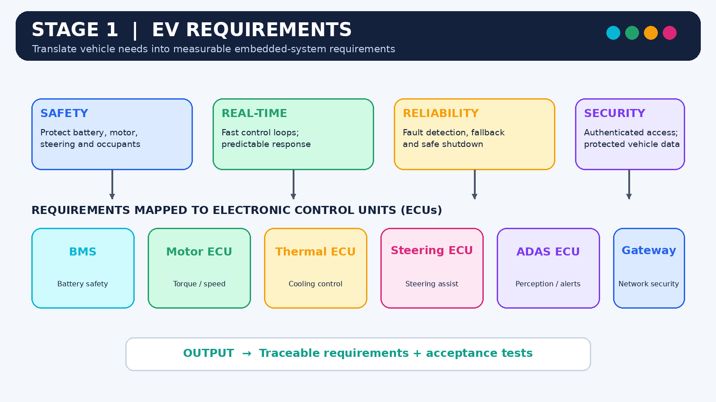

STAGE 2 – SELECT THE EMBEDDED PROCESSING ARCHITECTURE

2.1 Introduction
The processing architecture determines how each ECU performs its calculations, manages memory, handles input/output operations, and responds to time-critical events.
Because electric-vehicle subsystems have different computational workloads, a heterogeneous architecture is appropriate. It uses different processor types according to the requirements of each function.

2.2 Comparison of processing architectures
Parameter | MCU | MPU | DSP | SoC
Main purpose | Embedded control | General-purpose computing | Signal processing | Integrated computing
Real-time control | Well suited with appropriate design | Depends on software and platform | Suitable for supported signal workloads | Depends on architecture
Memory | Often integrated | Often supports larger external memory | Application-dependent | Integrated and/or external
Power consumption | Often low | Moderate to high | Workload-dependent | Workload-dependent
Typical EV use | BMS, motor, thermal control | Complex computing applications | Specialized signal processing | ADAS and advanced computing

2.3 Analysis of alternatives
Microcontroller Unit (MCU): An MCU combines a processor core with memory and peripherals such as timers, analog-to-digital converters, and communication interfaces. It is suitable for battery monitoring, motor control, and thermal regulation because these functions often require predictable execution and direct hardware interaction.
Microprocessor Unit (MPU): An MPU provides computing resources for complex software and operating systems. It may be suitable for advanced vehicle services, although deterministic behavior requires appropriate platform and software design.
Digital Signal Processor (DSP): A DSP accelerates mathematical operations such as filtering and signal analysis. It may be useful in specialized sensing or signal-processing workloads but is not required as the main controller for every subsystem.
System-on-Chip (SoC): An SoC can integrate CPU cores, graphics, AI accelerators, and communication interfaces. It is appropriate for computationally intensive functions such as ADAS perception when the selected device supports the required workload.

2.4 Proposed processor selection
ECU | Proposed architecture | Engineering reason
BMS | Safety-capable automotive MCU | Sensor monitoring, estimation, diagnostics
Motor Control | Real-time automotive MCU | Predictable control and inverter interaction
Thermal Management | Automotive MCU | Sensor acquisition and actuator control
Steering Control | Safety-capable MCU or suitable safety controller | Real-time response and fault monitoring
ADAS | High-performance SoC/MPU | Camera/radar processing and complex algorithms
Gateway | Automotive networking MCU or suitable SoC | Message routing, filtering, and domain separation
The specific devices must be selected according to computational requirements, safety capabilities, peripheral compatibility, environmental ratings, and available engineering support.

2.5 Design decision 1
A heterogeneous processing architecture is recommended because battery, motor, thermal, and steering functions require efficient control-oriented processors, while ADAS may require substantially greater computational capacity.

2.6 Conclusion
The proposed processor allocation balances control responsiveness, computational capacity, power consumption, and design complexity. The final selection must be supported by processor utilization estimates, memory analysis, timing measurements, and relevant safety requirements.
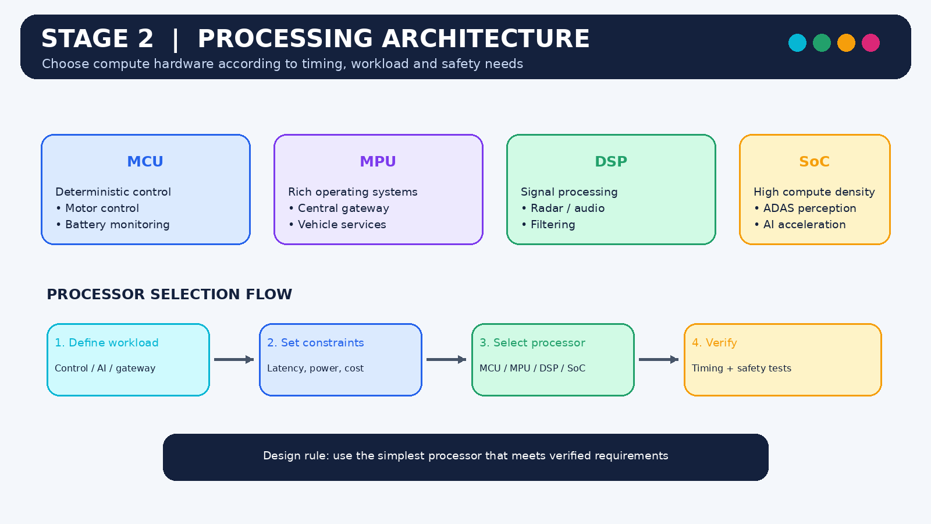

STAGE 3 – DEVELOP THE DISTRIBUTED ECU AND NETWORK ARCHITECTURE

3.1 Proposed architecture
The system is organized into powertrain, thermal, chassis-control, and advanced-computing domains. The battery, motor, and thermal-management controllers exchange the information required for coordinated electric propulsion and battery protection.
The steering ECU maintains its own control responsibilities. The ADAS ECU processes high-volume sensor data, and the vehicle gateway connects selected domains using authorized routing rules.

3.2 Internal organization of an ECU
A typical control ECU contains the following components:
- Sensor interface: Receives voltage, current, temperature, position, or other sensor measurements.
- Signal conditioning: Filters or converts incoming signals into usable digital values.
- Processing unit: Executes control algorithms, diagnostics, and communication tasks.
- Memory: Stores firmware, calibration data, runtime variables, and diagnostic records.
- Communication controller and transceiver: Exchange messages with other ECUs.
- Actuator interface: Drives outputs such as pumps, valves, contactors, or supported control interfaces.
- Power monitoring: Detects relevant power-supply abnormalities and supports reset or fault-handling logic.
A simplified data path is:
Sensors → Input interface → Processing unit → Control decision → Output interface → Actuator
The ECU can simultaneously exchange status and control messages over the in-vehicle network.

3.3 ECU responsibilities and data exchange
ECU | Information received | Information produced
BMS | Cell voltage, pack current, battery temperature | Battery status, fault flags, power-limit requests
Motor Control | Accelerator demand, motor feedback, permitted power limits | Torque commands, motor status, inverter diagnostics
Thermal Management | Battery and powertrain temperatures | Pump, fan, and valve commands; thermal status
Steering Control | Steering input, actuator feedback | Steering-assistance commands and fault status
ADAS | Camera/radar data and permitted vehicle-state information | Driver-assistance outputs and system status
Gateway | Messages from connected networks | Filtered, authorized, and routed messages

3.4 Example of system operation
During vehicle operation, the BMS continuously evaluates battery measurements. If the battery temperature rises above a warning threshold, the thermal-management controller may increase cooling effort according to its control strategy.
If the temperature continues to rise, the BMS may request reduced power from the motor controller. The controllers coordinate through defined messages, while each retains its own local monitoring and diagnostic responsibilities.
If the temperature reaches a critical limit or a relevant fault is detected, the system follows the battery protection strategy defined by the vehicle's safety analysis. This could involve further power limitation or battery isolation when appropriate.

3.5 Network segmentation
The architecture should separate the powertrain-control network from high-bandwidth ADAS and other less critical services. A gateway connects selected network domains while enforcing access restrictions and traffic limits.
The gateway should not become a single point of failure for essential local control. Battery monitoring, motor-control protections, and thermal fault detection must retain the local capabilities required by their safety design.

3.6 Proposed communication domains
- Powertrain network: BMS and Motor Control ECU.
- Thermal-control network: Thermal Management ECU and relevant powertrain controllers.
- Chassis-control network: Steering Control ECU and permitted vehicle-status interfaces.
- High-bandwidth network: ADAS sensor processing and related data services.
- Gateway: Authorized communication between the domains.
The final network topology depends on required message rates, deadlines, payload sizes, electrical constraints, and available hardware.

3.7 Conclusion
The distributed architecture assigns clear responsibilities to individual ECUs and supports coordinated operation through controlled communication. Local control capability, network segmentation, and explicit interfaces reduce unnecessary coupling between subsystems and improve maintainability.
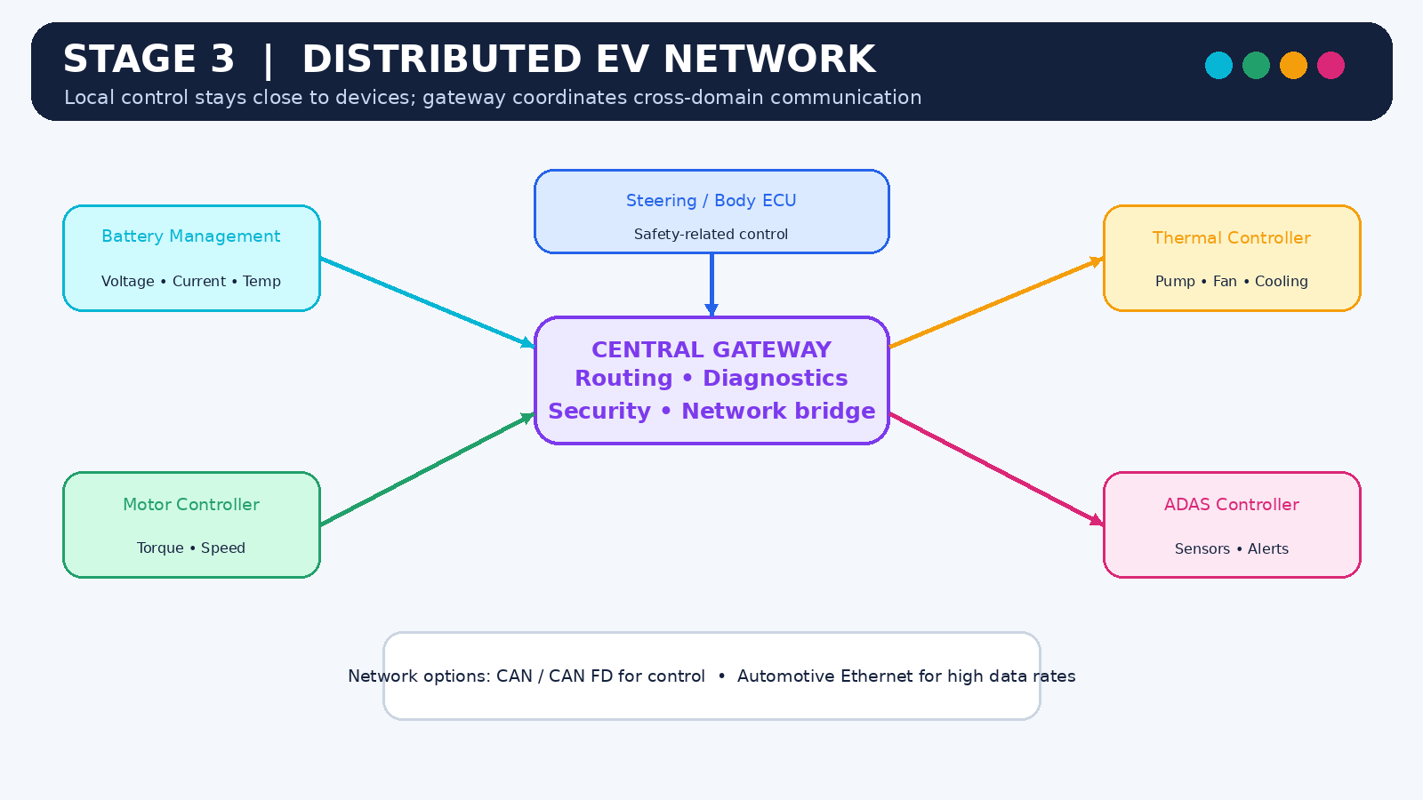

STAGE 4 – EVALUATE CAN, CAN FD, AND HIGH-BANDWIDTH COMMUNICATION

4.1 Introduction
Communication networks allow vehicle controllers to share sensor measurements, operating status, fault information, and control requests.
Classical CAN and CAN FD are suitable for many automotive control messages. Applications that transfer much larger quantities of data, such as camera-related information, may require automotive Ethernet or another high-bandwidth interface.

4.2 Classical CAN
Classical CAN is a message-oriented protocol that allows several ECUs to communicate over a shared bus. Messages use identifiers that participate in arbitration, so higher-priority messages can gain bus access ahead of lower-priority messages.
Classical CAN supports data fields of up to 8 bytes per frame. It is well suited to compact status messages and many distributed control applications.

4.3 CAN FD
CAN FD extends CAN with data fields of up to 64 bytes and the option of a faster data-phase bit rate when the hardware and network configuration support it.
It can reduce the number of frames needed to transfer larger application messages. However, the physical network, transceivers, bit timing, and connected controllers must be compatible with the selected configuration.

4.4 Automotive Ethernet
Automotive Ethernet provides higher bandwidth for applications that transfer large data volumes. It can support ADAS data flows and other advanced computing services that exceed the practical capacity of a CAN-based control network.
Ethernet does not automatically guarantee deterministic control behavior or safety. Network design, traffic scheduling, system architecture, and the relevant protocol stack must meet the application's requirements.

4.5 Communication technology comparison
Feature | Classical CAN | CAN FD | Automotive Ethernet
Typical role | Compact control messages | Control and larger messages | High-bandwidth data exchange
Maximum payload per frame | 8 bytes | 64 bytes | Depends on Ethernet frame and higher-layer protocol
Arbitration | CAN priority arbitration | CAN priority arbitration | Depends on network and protocol configuration
Bandwidth | Relatively limited | Higher payload efficiency; faster data phase possible | High compared with CAN-based networks
Main design concern | Bus loading and message timing | Bit timing and physical-layer compatibility | Traffic management, topology, and protocol configuration

4.6 Example of message prioritization
Suppose three ECUs attempt to transmit standard CAN messages simultaneously.
ECU | Illustrative identifier | Message
BMS | 0x090 | Critical battery-status information
Motor Control | 0x180 | Motor operating status
Thermal Management | 0x320 | Cooling-system status
Assuming the same standard identifier format and applicable arbitration rules, the message with identifier 0x090 has the highest priority among these three.
The other ECUs wait and attempt transmission again when the bus becomes available. This mechanism prioritizes bus access, but it does not alone prove that all messages meet their deadlines. Worst-case response-time analysis must consider message duration, blocking, higher-priority traffic, and other sources of delay.
These identifiers are examples only and are not a proposed production message allocation.

4.7 Example of payload efficiency
Consider an application that needs to transfer a 24-byte battery diagnostic record.
Classical CAN can carry at most 8 data bytes in one frame, so the application data would require at least three Classical CAN data frames before accounting for transport-protocol overhead.
CAN FD can carry 24 data bytes in a single frame, provided the selected frame format and network configuration support it.
This can reduce framing overhead for suitable transfers. The actual benefit depends on message frequency, protocol overhead, and network load.

4.8 Design decision 2
A hybrid communication architecture is recommended:
- Use CAN FD for suitable BMS, motor-control, and thermal-control messages where larger payloads or increased data-phase throughput are beneficial.
- Use Classical CAN for lower-bandwidth auxiliary functions where it meets timing and payload requirements.
- Use automotive Ethernet for ADAS or other applications requiring substantially higher data throughput.
- Use a controlled gateway to exchange only authorized information between the network segments.
The final design must verify compatibility, message scheduling, bus loading, physical-layer performance, and safety-related timing requirements.

4.9 Conclusion
A hybrid network can balance control-message reliability, payload efficiency, and high-bandwidth data transfer. However, the selected protocols and data rates must be validated against the actual ECU hardware, wiring topology, message schedule, and system deadlines.
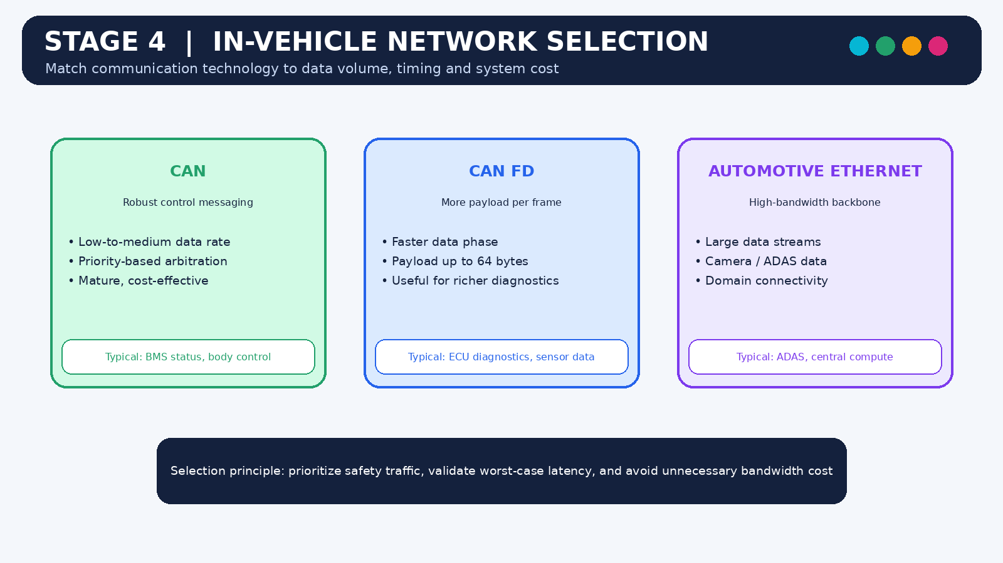

STAGE 5 – FORMALLY MODEL BATTERY THERMAL PROTECTION

5.1 Selected safety-related function
Battery thermal protection is selected because excessive temperature can affect battery performance, accelerate degradation, and create hazardous conditions.
The protection function must monitor battery measurements, coordinate cooling, identify abnormal sensor information, and initiate the specified response when operating limits are exceeded.

5.2 Selected modeling technique
A Finite State Machine (FSM) is used to represent the high-level behavior of the battery thermal-protection function.
The FSM defines states, transition conditions, and actions. It supports systematic review of normal operation, increasing temperature, thermal mitigation, and fault handling.

5.3 Inputs and outputs
Inputs:
- Battery cell-temperature measurements.
- Battery voltage and current information.
- Cooling-system feedback.
- Sensor-validity flags.
- BMS and thermal-controller diagnostic information.
- Temperature-warning and critical-threshold conditions.
Outputs:
- Cooling requests.
- Thermal status messages.
- Power-limitation requests.
- Fault notifications.
- A defined protection response when critical conditions are detected.
The actual thresholds and protection actions must be derived from battery specifications and the vehicle's safety requirements.

5.4 Defined states
State | Description
S0 – Normal | Battery temperature remains within the normal operating region
S1 – Temperature Rising | Temperature approaches or exceeds a warning threshold
S2 – Thermal Mitigation | Cooling effort is increased according to the control strategy
S3 – Power Limitation | A power-limit request is issued when required by the protection strategy
S4 – Critical Protection | A defined critical protection action is initiated
SF – Sensor or System Fault | Invalid measurements or relevant control faults are detected
SR – Recovery Assessment | Conditions are checked before normal operation is resumed
These are conceptual states. A production implementation may combine or divide them differently according to the control strategy.

5.5 State-transition behavior
During normal operation, the BMS monitors battery measurements and evaluates whether the temperature is within the expected range.
If the temperature rises above the warning threshold, the system enters the temperature-rising state and requests appropriate thermal mitigation. If cooling is insufficient and the temperature continues to rise, the system may request power limitation.
If a critical threshold is reached, the defined protection action is initiated. Depending on the battery design, this may include limiting operation or opening contactors under the conditions specified by the safety strategy.
If the temperature sensor provides invalid or implausible information, the system enters a fault-handling path rather than treating the measurement as trustworthy. Recovery is permitted only after the required conditions are checked.

5.6 State-transition table
Current state | Event or condition | Next state | Action
Normal | Temperature exceeds warning threshold | Temperature Rising | Increase monitoring and evaluate cooling
Temperature Rising | Cooling response required | Thermal Mitigation | Request increased cooling
Thermal Mitigation | Temperature continues rising | Power Limitation | Request reduced power where specified
Power Limitation | Critical threshold reached | Critical Protection | Execute defined protection strategy
Any relevant state | Invalid temperature data detected | Sensor or System Fault | Reject invalid measurement and initiate diagnostics
Thermal Mitigation | Temperature returns to acceptable range | Recovery Assessment | Verify stability and cooling response
Recovery Assessment | Recovery criteria satisfied | Normal | Resume permitted operation
Any applicable state | Critical controller or actuator fault | Fault Handling | Apply the specified fault response

5.7 Safety properties
The model should satisfy the following properties:
- Invalid temperature measurements must not be treated as valid battery conditions.
- A detected critical temperature condition must initiate the required protection action within its specified deadline.
- Failure of the cooling system must be detected when adequate feedback is available.
- Recovery must occur only after the required conditions have been verified.
- Loss of non-critical communication must not disable essential local battery monitoring.
- A power-limitation or isolation request must be handled according to the vehicle's defined safety strategy.
These properties require precise conditions and timing limits before formal verification can establish that the implementation satisfies them.

5.8 Design decision 3
A finite state machine is recommended for the high-level battery thermal-protection model because it clearly represents normal operation, rising temperature, mitigation, protection, fault handling, and recovery.
The model can be used to generate test cases and check whether all relevant events lead to the expected states and actions. Detailed temperature-control algorithms and battery-specific thresholds require additional modeling.

5.9 Conclusion
Formal modeling provides a structured representation of battery thermal-protection behavior. It helps identify missing transitions, ambiguous fault responses, and unsafe recovery paths before implementation and supports systematic verification.
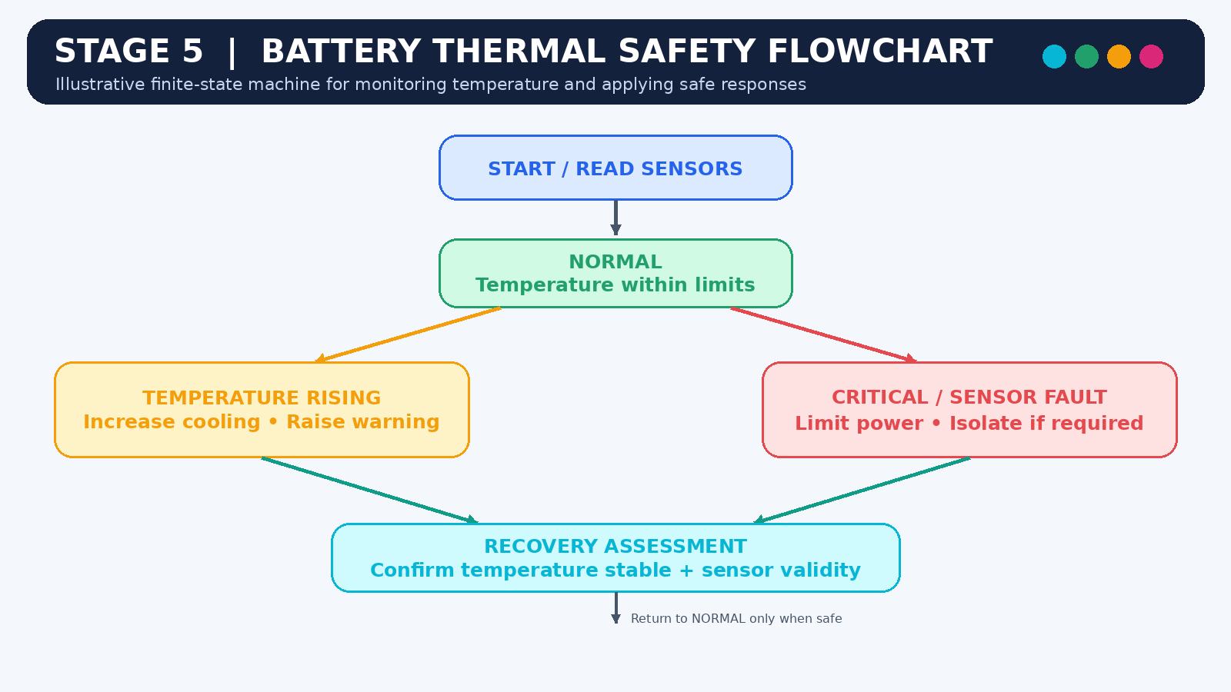

STAGE 6 – VERIFY AND CRITICALLY EVALUATE THE ARCHITECTURE

6.1 Real-time performance evaluation
The architecture allocates control functions to dedicated ECUs and separates high-bandwidth computing from selected control networks. However, real-time performance must be demonstrated rather than assumed.
The evaluation should include processor execution time, interrupt latency, message transmission time, gateway delay, bus utilization, and worst-case response time.
The design must verify that critical battery, motor-control, thermal, and steering operations meet their allocated deadlines under representative worst-case workloads.

6.2 Communication reliability
CAN and CAN FD include error-detection and fault-confinement mechanisms. Additional application-level protections may be required to detect missing, stale, implausible, or unexpected data.
Useful techniques include message timeouts, plausibility checks, sequence or freshness monitoring where appropriate, diagnostic reporting, and controlled degraded operation.
Gateway filtering should be tested to ensure that permitted messages pass correctly while unauthorized or excessive traffic is restricted.

6.3 Fault tolerance and redundancy
Fault handling should be determined through hazard and risk analysis. Depending on the subsystem, appropriate measures may include independent monitoring, redundant sensing, watchdog supervision, power-supply monitoring, and validated degraded operating modes.
Redundancy should not be added indiscriminately. It must be justified by the failure modes, safety requirements, and independence of the proposed redundant elements.

6.4 Failure scenario 1 – Battery temperature-sensor drift
Affected component: BMS temperature-sensing subsystem.
Failure: A temperature sensor gradually reports a value that differs from the actual battery temperature.
Potential effect: The BMS may underestimate the battery temperature and fail to request sufficient cooling or power limitation.
Detection and mitigation: Compare readings against other available temperature measurements, expected thermal behavior, and sensor diagnostic limits. Use plausibility checks and fault monitoring, and initiate the defined degraded or protective response when measurement confidence is insufficient.
Verification: Introduce simulated sensor bias and drift across representative operating conditions. Confirm that the diagnostic logic detects the fault and that the required protection response occurs.

6.5 Failure scenario 2 – Cooling-pump malfunction
Affected component: Battery thermal-management system.
Failure: A coolant pump stops operating or provides insufficient flow while the battery is under load.
Potential effect: Battery temperature may rise even though the controller has requested cooling.
Detection and mitigation: Monitor available pump feedback, coolant-flow information, temperature trends, and actuator diagnostics. If cooling performance is inadequate, request appropriate power limitation and initiate the specified protection strategy.
Verification: Simulate pump failure and reduced-flow conditions. Check fault detection, temperature response, communication between the thermal controller and BMS, and the timing of protective actions.

6.6 Failure scenario 3 – CAN FD bus-off
Affected component: Powertrain communication network.
Failure: A communication controller enters the bus-off state after repeated communication errors.
Potential effect: Other ECUs may stop receiving important battery, motor, or thermal status messages.
Detection and mitigation: Monitor controller error states, apply communication timeouts, report the fault, and follow the predefined degraded-operation strategy. Essential local protection functions must continue where possible. Any recovery or reconnection behavior must be controlled and validated.
Verification: Inject communication errors or simulate a bus-off event. Confirm that missing messages are detected and that the affected ECUs respond according to their specified fault-handling requirements.

6.7 Failure scenario 4 – ADAS traffic overload
Affected component: Gateway and shared network resources.
Failure: The ADAS domain generates excessive traffic because of a software fault or abnormal data transmission.
Potential effect: Messages sharing network resources may experience increased delay, and gateway processing capacity may be exceeded.
Detection and mitigation: Use network segmentation, traffic rate limits, message allow-lists, resource monitoring, and suitable bandwidth allocation. Critical control messages must be protected by architecture and verified timing analysis rather than relying on priority alone.
Verification: Generate high traffic loads on the ADAS side and measure the latency, loss, and deadline compliance of relevant control messages.

6.8 Verification plan
Test | Objective | Expected result
BMS functional test | Check battery measurement processing | Measurements and diagnostics operate as specified
Sensor drift test | Evaluate detection of biased temperature data | Invalid measurements are detected and handled
Cooling-pump fault test | Test loss of cooling capability | Required mitigation and protection actions occur
CAN FD bus-off test | Evaluate communication failure handling | Missing messages and fault states are detected
Network load test | Measure message timing under heavy traffic | Required deadlines are met
Gateway isolation test | Test excessive ADAS traffic | Critical communication remains within specified limits
FSM transition test | Check thermal-protection states | Valid transitions and required actions occur
Power and thermal test | Measure resource use and operating conditions | Values remain within specified limits
Integration test | Test coordinated ECU operation | End-to-end behavior matches requirements

6.9 Critical evaluation
Advantages
- Dedicated ECUs support modular development and maintenance.
- MCU-based controllers suit many real-time control functions.
- A high-performance ADAS processor supports computationally intensive workloads.
- Network segmentation helps contain unnecessary or abnormal traffic.
- Battery thermal-protection modeling improves the clarity of safety-related behavior.
- Defined fault scenarios provide a basis for systematic testing.
Limitations
- Gateway filtering and multiple network domains increase design complexity.
- CAN and CAN FD have finite bandwidth.
- Temperature estimation and battery protection depend on sensor quality and suitable algorithms.
- High-performance processors introduce additional software, power, and thermal-management requirements.
- Safety assurance requires detailed analysis, traceable requirements, and test evidence.
- The conceptual model does not demonstrate that a real implementation meets its deadlines or safety targets.

6.10 Conclusion
The proposed architecture provides a structured basis for evaluating communication performance, thermal protection, and fault handling. The four failure scenarios illustrate how sensor, actuator, network, and traffic-related faults can affect system behavior and how targeted tests can evaluate the proposed mitigations.
The design must undergo detailed timing analysis, hardware validation, safety assessment, and integration testing before it can be considered suitable for deployment.
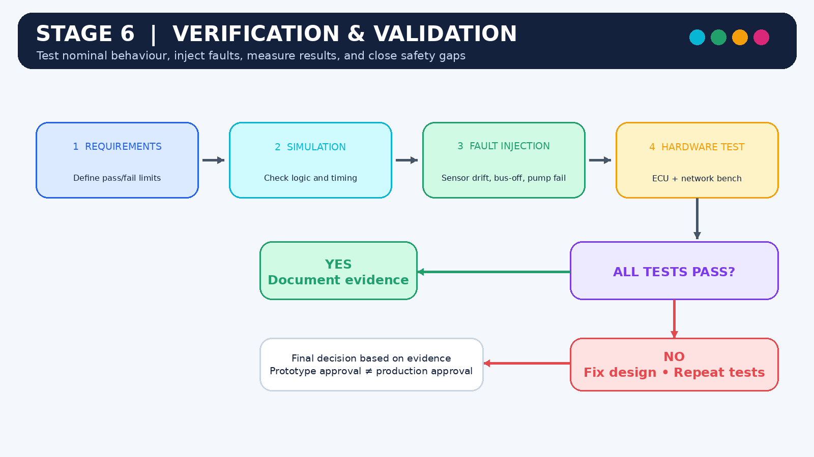

FINAL ENGINEERING DECISION
The proposed architecture is suitable for further engineering development and prototype evaluation. However, production deployment would be premature without evidence that the system meets its quantitative performance, safety, electrical, and reliability requirements.
The architecture provides a reasonable conceptual foundation through distributed control, appropriate processor allocation, controlled communication, and battery thermal-protection modeling. These features do not by themselves establish production readiness.

Required improvements before deployment
- Select automotive-qualified processors, sensors, actuators, and communication transceivers.
- Establish quantitative task deadlines, message periods, and communication requirements.
- Complete worst-case timing and network-load analysis.
- Perform hazard analysis and define the required functional-safety measures.
- Verify the battery thermal-protection model and fault transitions.
- Validate temperature sensing, cooling control, and power-limitation behavior.
- Conduct communication fault injection, environmental testing, and electromagnetic compatibility testing.
- Confirm that gateway or ADAS failures cannot compromise essential local control.
- Document verification results and address all identified safety-related defects.

OVERALL CONCLUSION
This report proposed a distributed embedded architecture for an electric vehicle incorporating battery management, motor control, thermal management, steering control, and ADAS functions. A heterogeneous processing design assigns control-oriented workloads to suitable microcontrollers while allowing high-performance computing devices to handle advanced sensor-processing applications.
The proposed communication architecture combines CAN, CAN FD, and automotive Ethernet according to the payload and performance requirements of each domain. A controlled gateway manages communication between selected network segments, while local control responsibilities reduce unnecessary dependence on other ECUs.
Battery thermal protection was modeled using a finite state machine to represent normal operation, increasing temperature, thermal mitigation, power limitation, critical protection, and fault handling. The verification plan addressed sensor drift, cooling-pump malfunction, CAN FD bus-off, and excessive ADAS traffic.
Overall, the proposed architecture demonstrates how distributed embedded-system design can support electric-vehicle functionality, modularity, and systematic fault analysis. However, the design remains conceptual until its hardware, timing, safety, and communication properties have been verified through engineering analysis and practical testing.

OVERVIEW CHART
DESIGN ASSIGNMENT

