CS222 - Algorithm Design

Dr. Arpita Korwar

*Assignment – 1 : Sorting*

Authors :

* Sanjay Marreddi 1904119
* Prakhar Mathur 1906328
* Rishabh Tripathi 1904129

1. **Merge sort :**

*The values obtained using our code are as follows:*

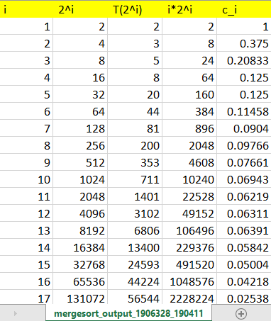

*Observations about the fraction $C_{i}= T(n)/nlogn$*

* The Expected value of $C_{i}$ is 0.070271 ms.
* The Variance of $C_{i}$ is 0.000589 ms^2.
* Note that the above values of Expectation and Variance keep changing due to the randomness, but order will be same.
* The values of the **’s** is becoming smaller as the value of **i** increases.
* The ci values are essentially a comparison of time taken and the idealistic $nlogn$ time complexity.
* So, the reducing value of $C_{i}$**’s** signify that our algorithm is working fine.

*Complexity Analysis of our* ***Merge Sort*** *:*

Time Complexity :

*Best* Case : O($nlogn$)

*Average* Case : O($nlogn$)

*Worst* Case : O($nlogn$)

Space Complexity : O($n$)

1. **Quick sort :**

*The values obtained using our code are as follows:*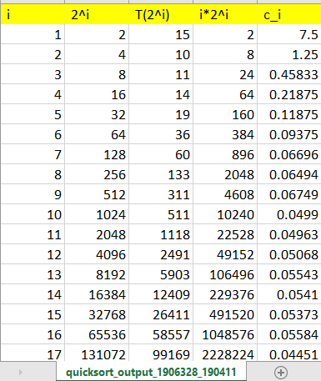

*Observations about the fraction $C_{i}= T(n)/nlogn$*

* The Expected value of $C_{i}$ is 0.060093 ms.
* The Variance of $C_{i}$ is 0.000394 ms^2.
* Note that the above values of Expectation and Variance keep changing due to the randomness, but order will be same.
* The values of the **’s** is becoming smaller as the value of **i** increases.
* The ci values are essentially a comparison of time taken and the idealistic $nlogn$ time complexity.
* So, the reducing value of $C_{i}$**’s** signify that our algorithm is working fine.

*Complexity Analysis of our* ***Quick Sort*** *:*

Time Complexity :

*Best* Case : O($nlogn$)

*Average* Case : O($nlogn$)

*Worst* Case : O($nlogn$) *{ Though it is O(n^2) in general, we reduced by using Median-of-3 method for randomly picking Pivot}*

Space Complexity : O($logn$) *{Due to function call stack }*

----- The End -----