CS222 - Algorithm Design

Dr. Arpita Korwar

# *Assignment – 2 : Fibonacci series using recursion*

Authors :

* Prakhar Mathur 1906328
* Sanjay Marreddi 1904119
* Rishabh Tripathi 1904129

*Problem Statement*

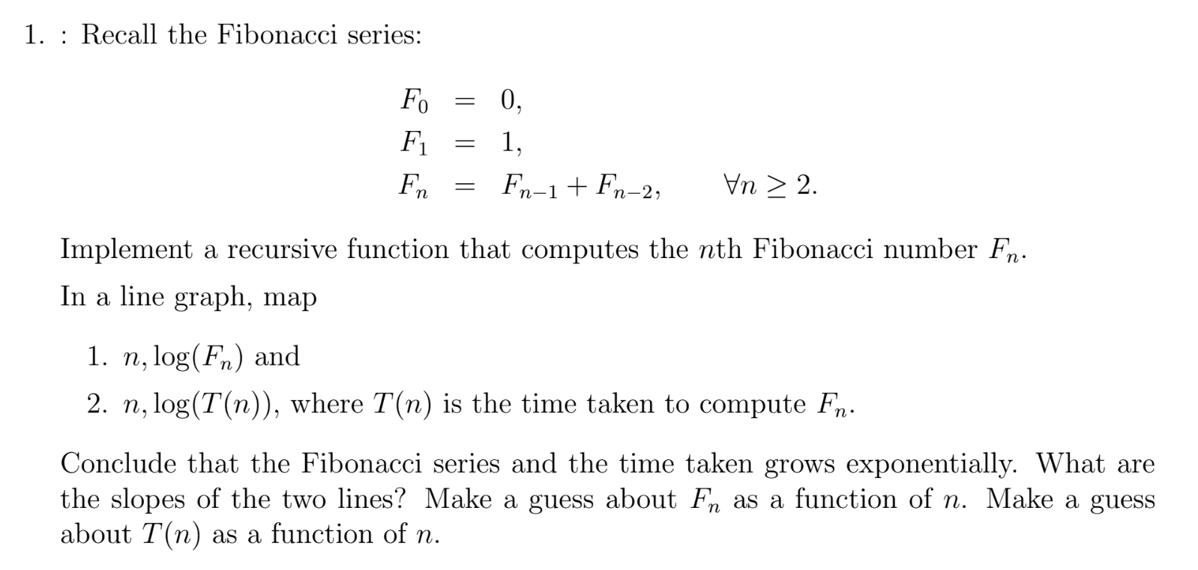

The values of $n, log\left(F_{n}\right), log⁡(T\left(n\right))$ obtained using our code are as follows:

Line graph of $n vs log\left(F_{n}\right)$:

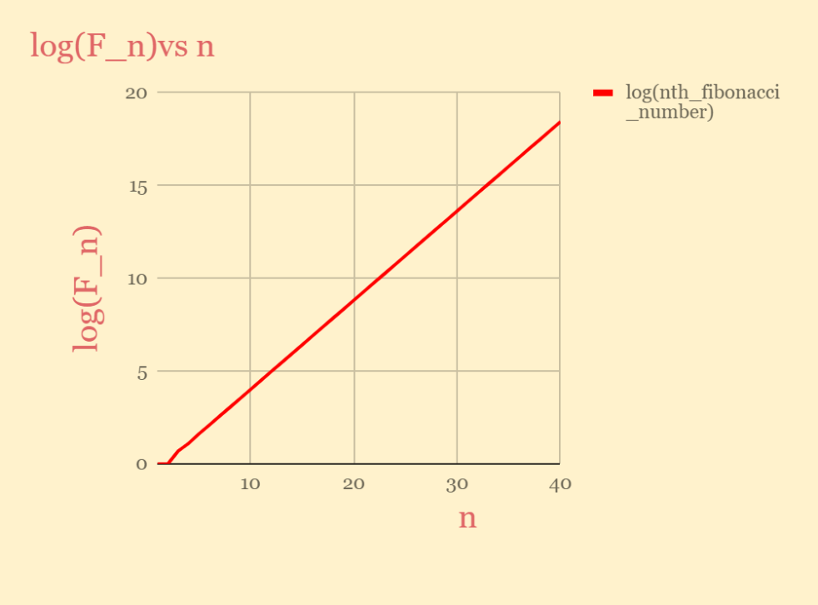

Line graph of $n vs log{(T(n)})$:

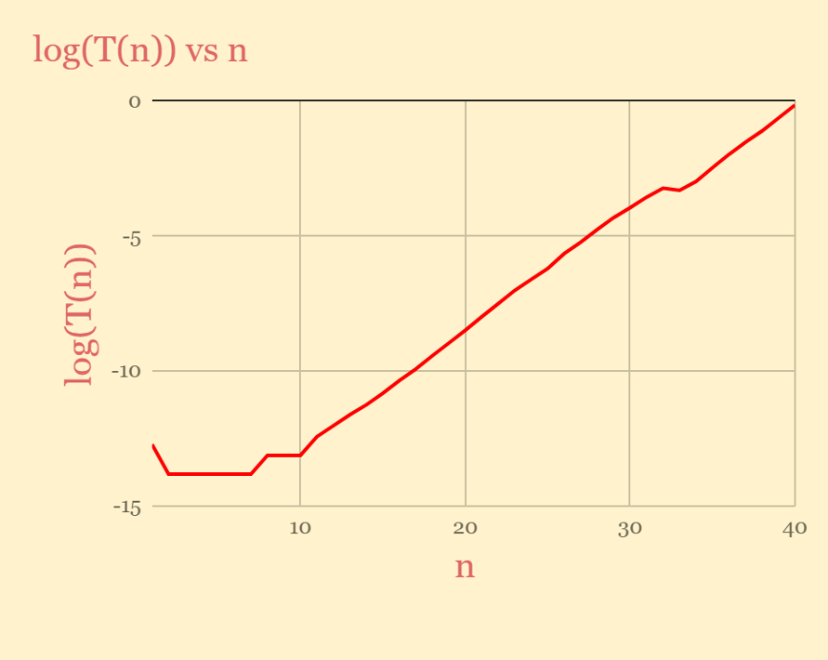

The slopes of both the above graphs are almost **constant** i.e., **logarithms** of $T\left(n\right)$ and $F_{n}$ are constant which implies that they are **exponential** in nature.

*So, we can conclude that the Fibonacci series and the time taken grows exponentially.*

The slopes of the two lines are as follows:

> $n vs log\left(F_{n}\right) has a slope of 0.4804468921$

$$>n vs log{(T(n)}) has a slope of 0.3846896294$$

*Let us guess/compute the $F_{n}$ and* ***T(n****) as a function of n using above values:*

*Since we observed that slopes are constant,*

d(log($F_{n}$))/dn = *constant* ($Here it is 0.4804468921$)

∫d(log($F_{n}$)) = ∫0. $4804468921$ dn

log($F_{n}$) = 0. $4804468921$**n** + **k** *( Integration constant)*

$F_{n}$ = e^(0. $4804468921$**n**+**k**)

$F_{n}$ = A*(e^(0. $4804468921$**n**)) (*A is constant)*

*In the similar way, the function for T(n) will be of the form:*

$T(n)$ = B*(e^(0. $3846896294$**n**)) (*B is constant)*

--- The End ---