CS222 - Algorithm Design

Dr. Arpita Korwar

# *Assignment 7 - Extended Euclid’s algorithm*

Authors :

* Prakhar Mathur 1906328
* Sanjay Marreddi 1904119
* Rishabh Tripathi 1904129

*Problem Statement*

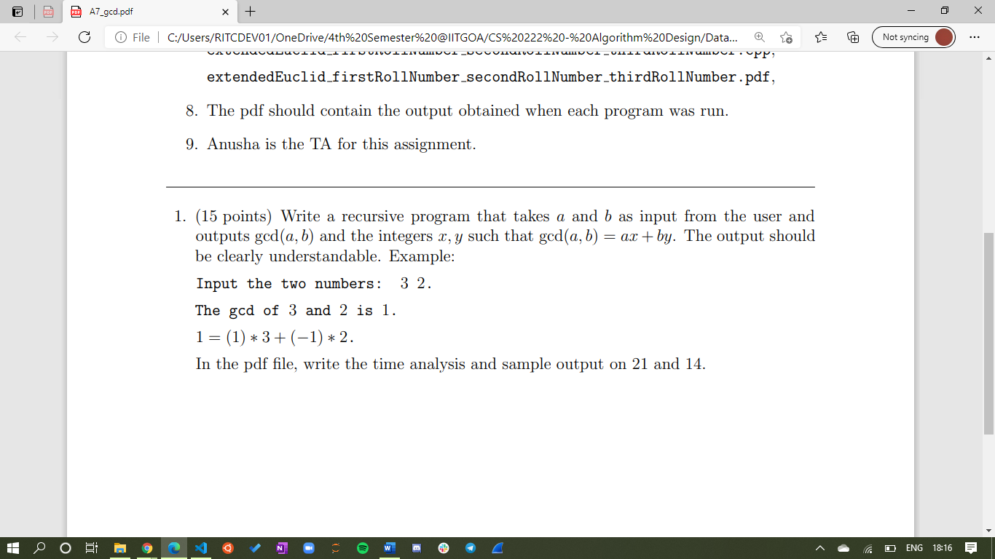

Here is the Sample Input and Output:

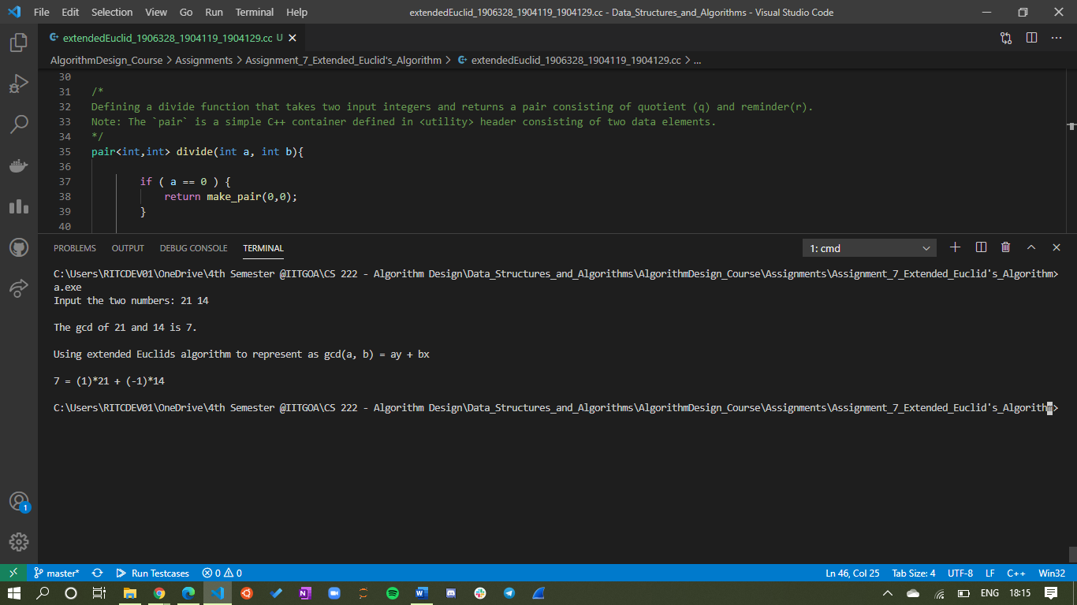

Time Complexity

If the input **a** is of **m** bits, **b** is of **n** bits,

* The complexity of divide (int a , int b) is of **O($m×n$)**
* The complexity of gcd (int a , int b) is of **O($m^{2}×n$)**