CS222 - Algorithm Design

Dr. Arpita Korwar

# *Assignment 8 - Strassen’s matrix multiplication*

Authors :

* Prakhar Mathur 1906328
* Sanjay Marreddi 1904119
* Rishabh Tripathi 1904129

*Problem Statement*

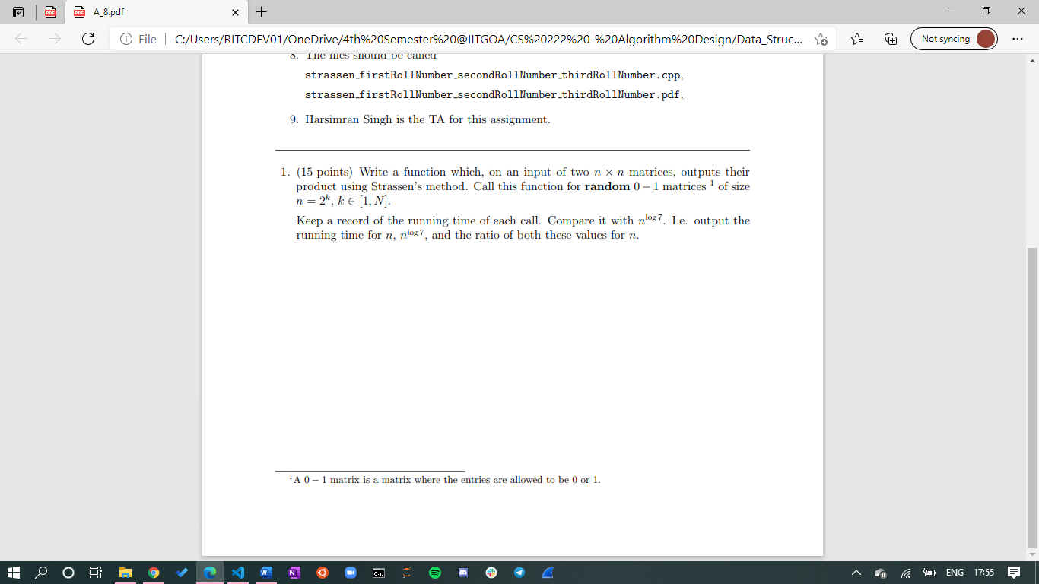

*Here is the output obtained* which contains for each n, the time taken for the matrix multiplication function, n ^log 7, and their ratio :

