CS222 - Algorithm Design

Dr. Arpita Korwar

# *Assignment 9 - Graph Algorithms 1*

Authors :

* Prakhar Mathur 1906328
* Sanjay Marreddi 1904119
* Rishabh Tripathi 1904129

*Sample Input & Output*

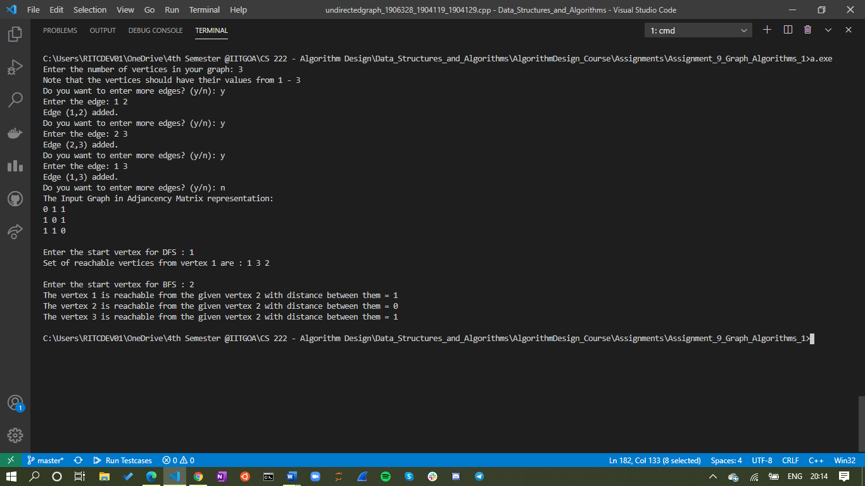

*Time Complexity (Undirected, Adjancency Matrix)*

The Time Complexity of **DFS(int n)** is **O(|V|^2)**

The Time Complexity of **BFS(int n)** is **O(|V|^3)** (In general it is O(|V|^2), but here in order to find *min distance*, we need this much.)

where E,V denote the set of Edges & Vertices respectively of the graph.