**SEVERLESS IOT DATA PROCESSING**

**WATER QUALITY MONITERING**

**PHASE - 3**

**DEVELOPMENT PART – 1**

**STEP 1:**

Sign-in to the IBM Cloud Platform.

Create a new project for your development in the IBM cloud platform.

Manage your IBM cloud platform.

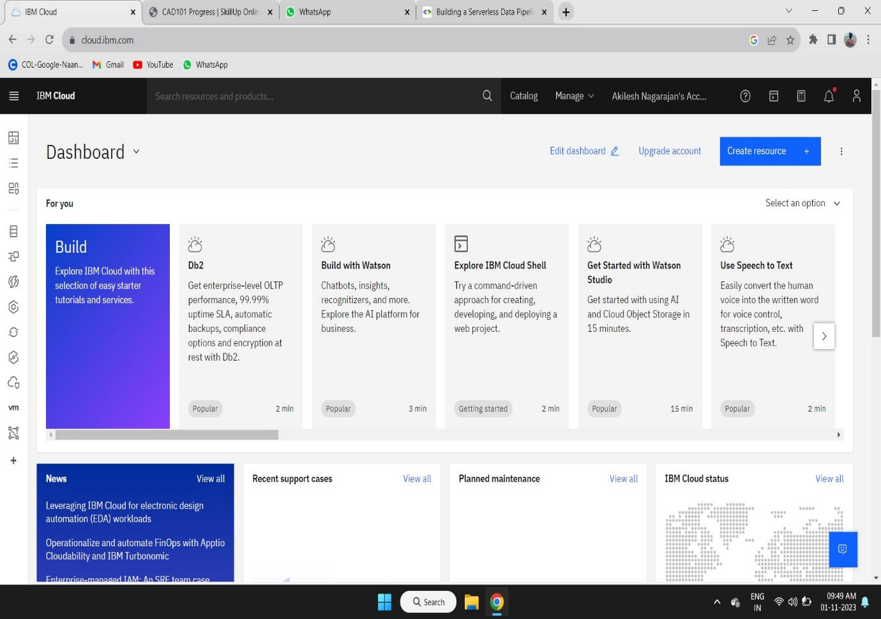

**STEP 2:**

Create your IOT Platform in the IBM cloud Platform for storing the data form the IOT Sensor.

The IOT Sensor take the data for water quality form the different source of water form different places.

When the data is taken form the water the IOT Sensor pushes the data to the IOT Platform in the IBM Cloud Platform.

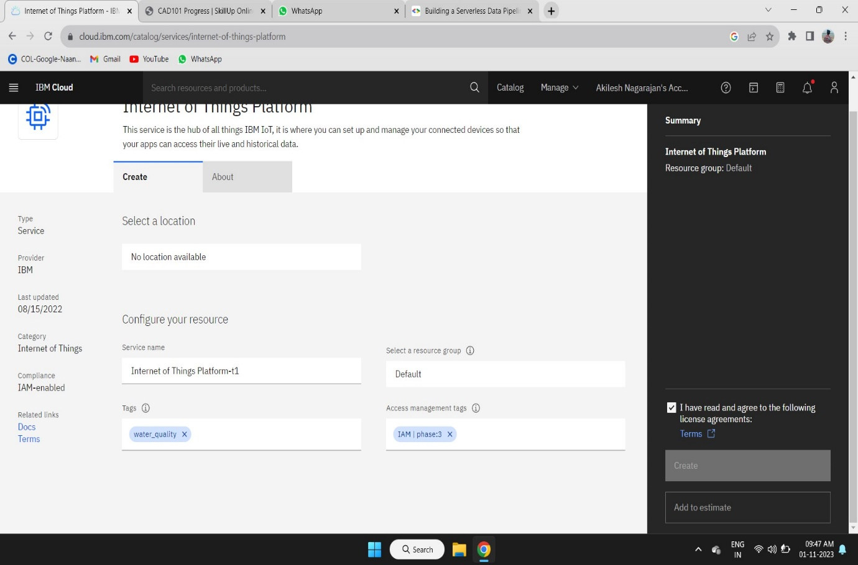

**STEP 3:**

We need to create a function in the IBM Cloud Platform to deploy the code for data processing.

Function service has the all package to run the code in IBM Cloud Platform.

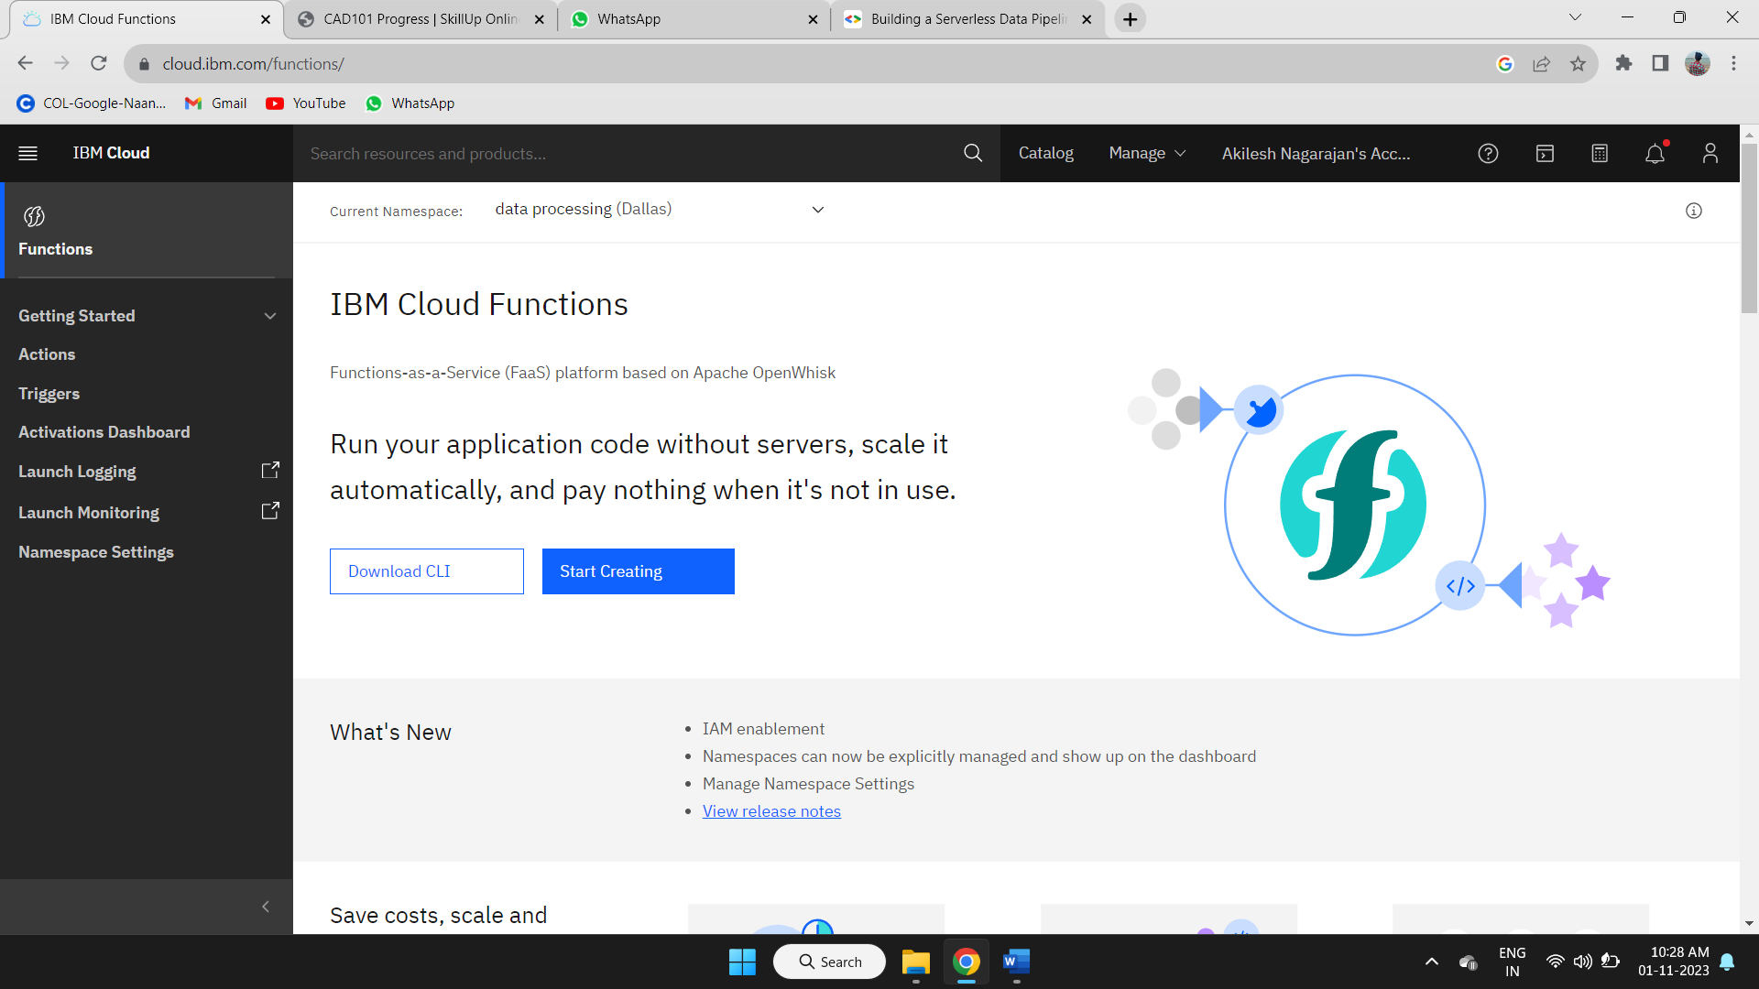

**STEP 4:**

Create a new namespace for your project in your IBM Cloud Platform.

Follow the steps given in the IBM Cloud Platform to create a new namespace.

Then we have to create a action to deploy the code for tiggering the code when the data is loaded in the IOT Platform.

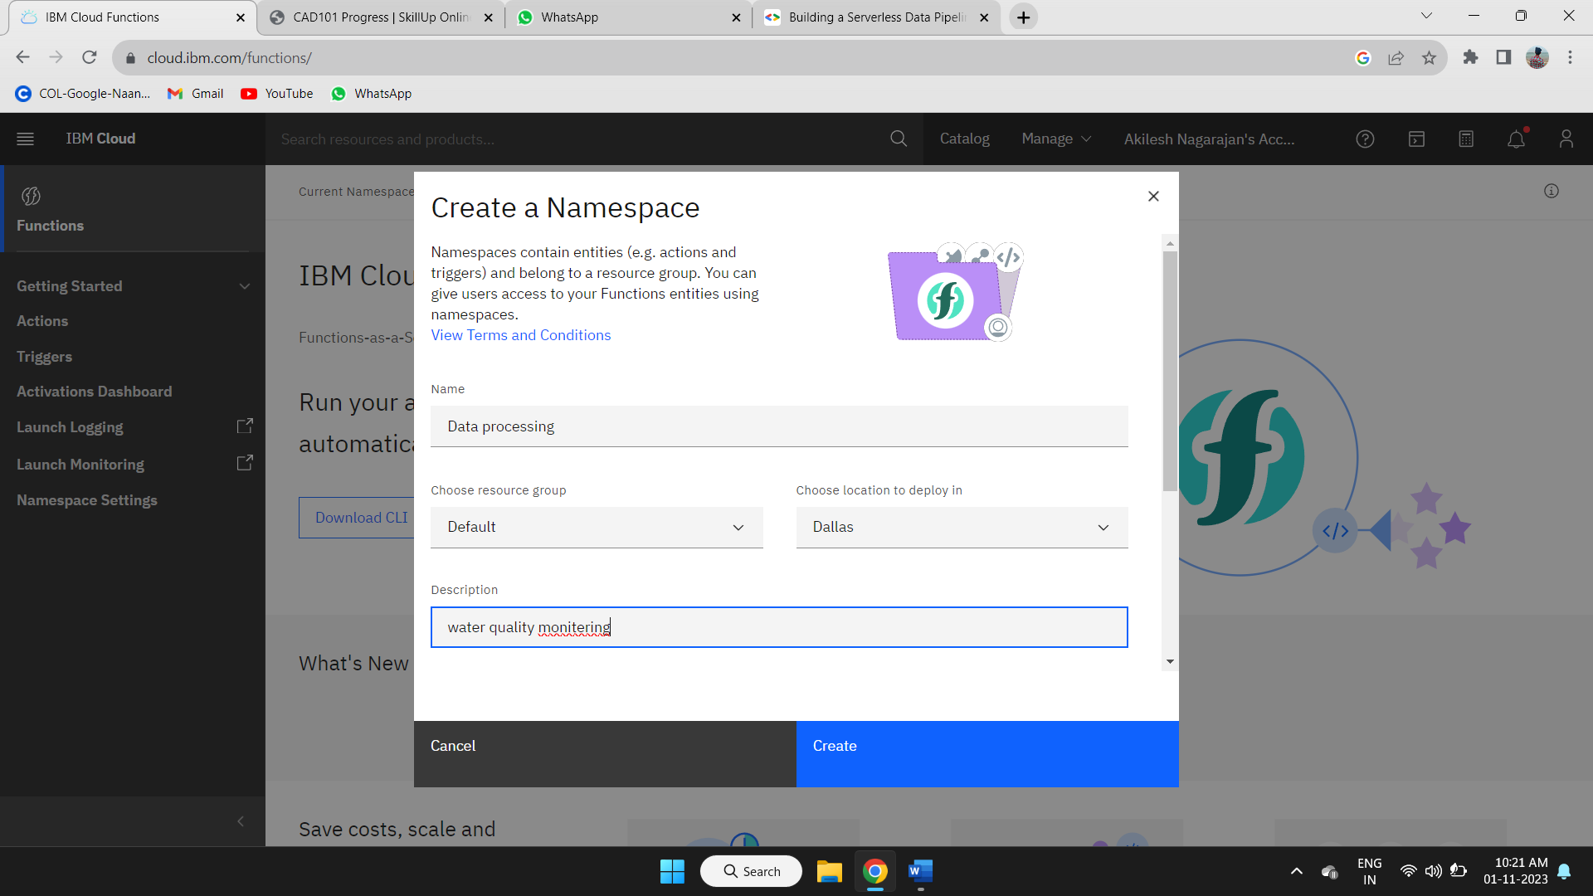

**STEP 5:**

After creating a specified namespace to your project in functions we need to create a action in the current namespace.

Follow the steps given in the IBM Cloud Platform for creating a new action in current namespace available in the function service.

After creating the action deploy your project code in it.

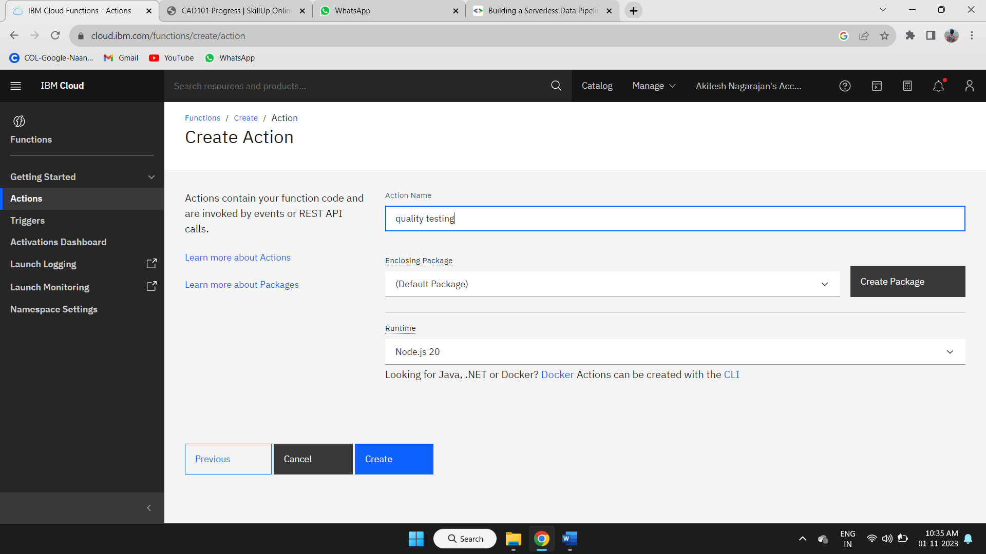

**STEP 6:**

After creating the action deploy your project code in the IBM Cloud Platform in function service platform.

There is the code space to deploy your code in the function service of IBM Cloud Platform.

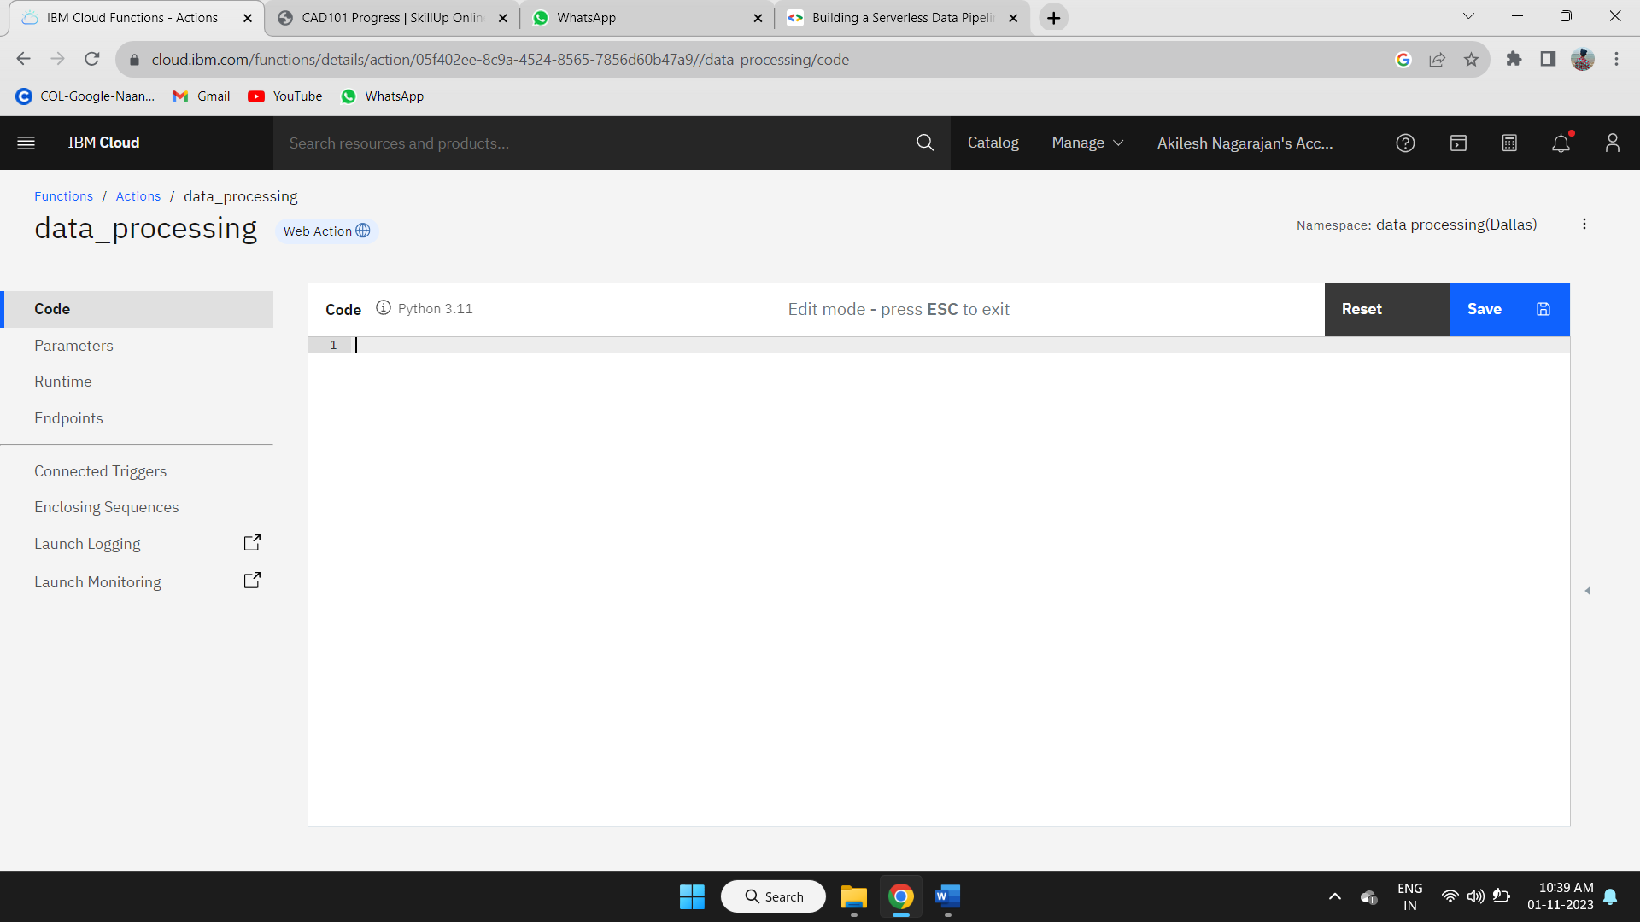

**STEP 7:**

Deploy your code in the code space given in the action of current namespace in the function service.

After deploying the code in the code space save it for further process.

