**SEVERLESS IOT DATA PROCESSING**

**WATER QUALITY MONITERING**

**PHASE - 4**

**DEVELOPMENT PART – 2**

**STEP 1:**

After deploying your project source code in the code space in the action field in the function service.

Before invoking we need to save the code in the IBM Cloud Platform.

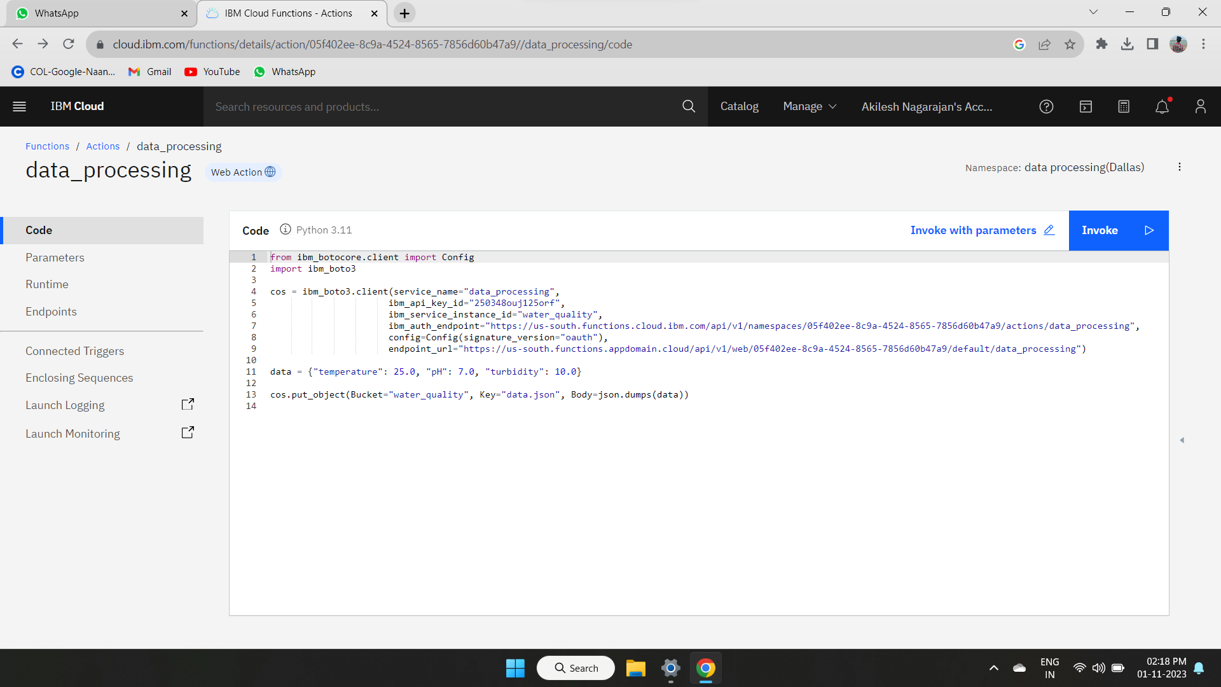

**STEP 2:**

After that we need give the data to the code in the action form where we loaded the data.

Here we use the cloud park for data service in IBM Cloud Platform.

Where the data form the IOT Sensors are loaded when the data is available in the IOT Platform.

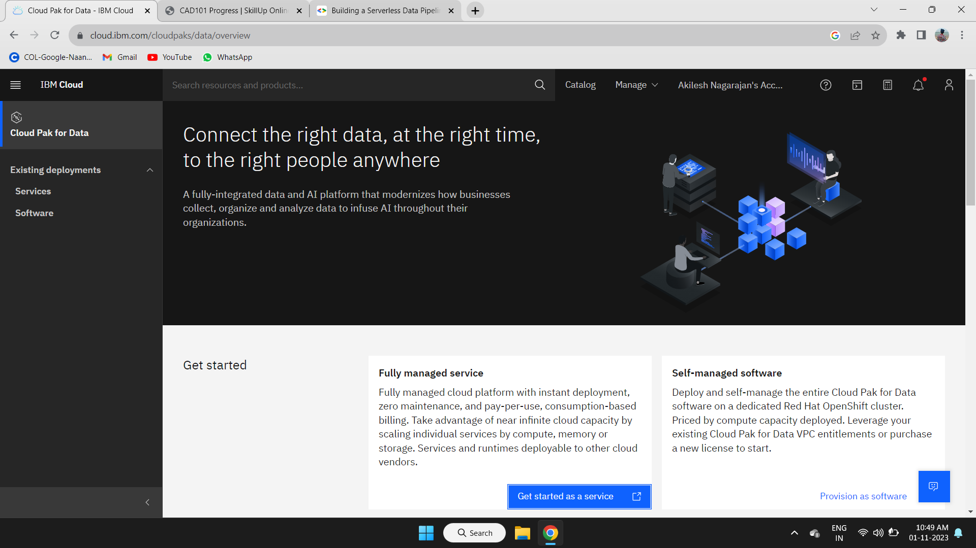

**STEP 3:**

We have to get the access to the Object Storage in the IBM Cloud Platform.

First we have to open the Object storage service in the IBM Cloud Platform.

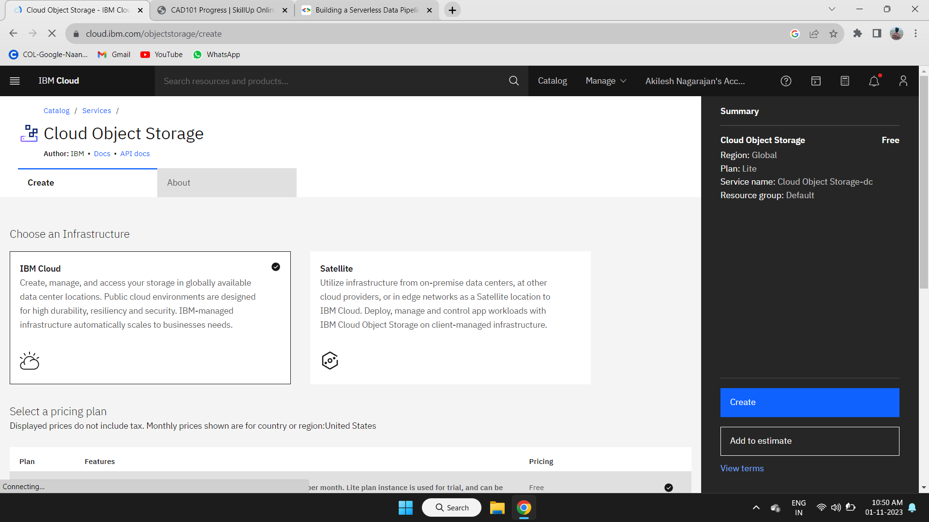

**STEP 4:**

Create the new Object Storage in the Cloud Object Storage for storing the data in the cloud after processing using the code.

Follow the steps given in the IBM Cloud Platform to create the new object storage.

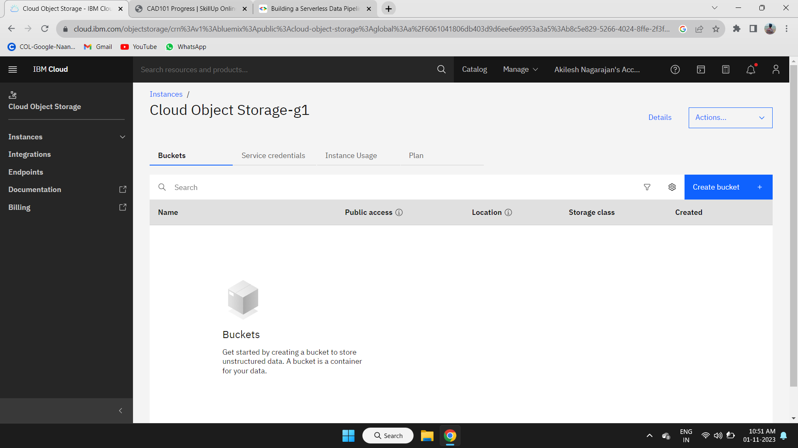

**STEP 5:**

After creating the object storage in the Cloud Object Storage service in the IBM Cloud Platform.

We need to Create the Buckets to store the processed data form the code in the action of the function service.

Follow the steps given in the IBM cloud Platform to create the bucket in the object storage available in the Cloud Object Storage.

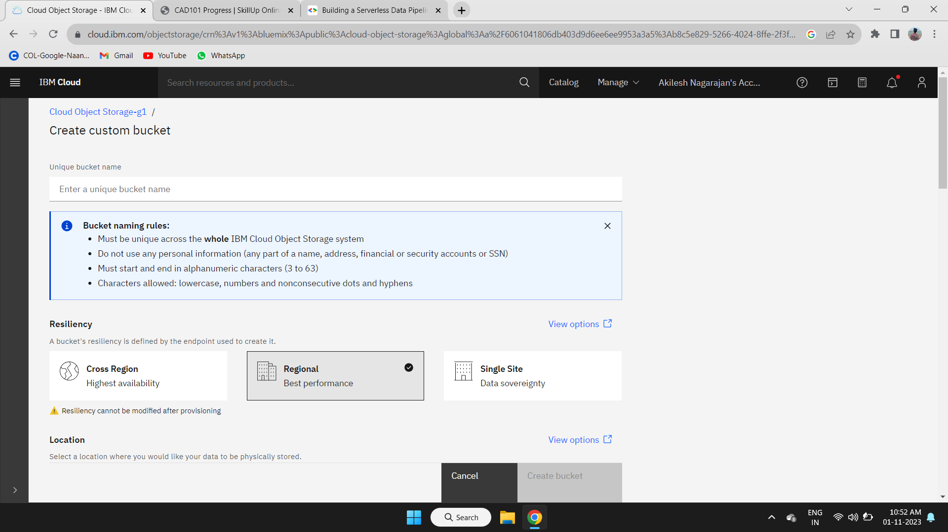

**STEP 6:**

After creating the custom bucket in the object storage. We can upload the data if we want to use.

We have to set the code in the action space in the function service to store the processed data in the bucket in the object storage to visualize the processed data.



**STEP 7:**

If we need to upload the file to the cloud object storage in the bucket we created in IBM Cloud Platform.

Follow the steps given in the IBM Cloud Platform to upload the files to the current bucket created in the cloud object storage.

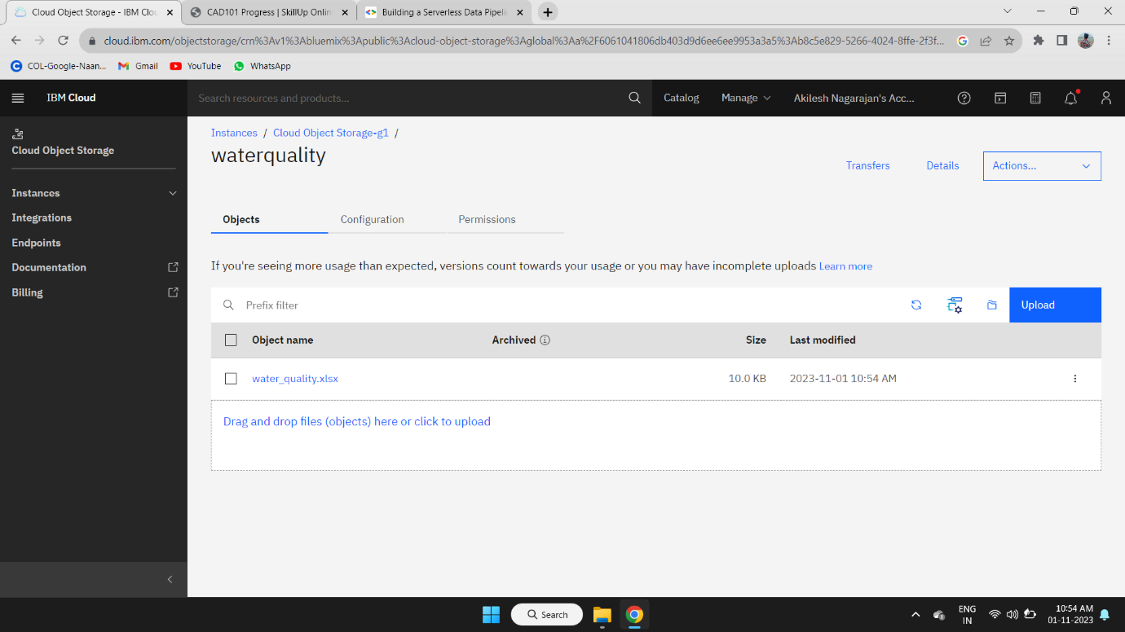

**STEP 8:**

After the invoking of code in the code space of action in the namespace of function service.

The data are updated in the object storage in cloud object storage when ever the code is completed in invoking.