**SERVERLESS IOT DATA PROCESSING**

**PROJECT TITLE:**

**“WATER QUALITY MONITERING”**

**INTRODUCTION:**

Water quality is a critical aspect of environmental conservation and public health. Monitoring the quality of water bodies in real-time is essential to detect and mitigate pollution events promptly. This project presents a novel approach to water quality monitoring using serverless IoT data processing.

The proposed system leverages a network of IoT sensors strategically placed in water bodies, continuously collecting data on parameters such as pH levels, turbidity, dissolved oxygen, and temperature. These sensors transmit the data to a serverless architecture hosted in the cloud.

In the serverless environment, incoming data is processed in real-time using IBM functions. These functions analyze the sensor data, perform quality checks, and calculate key water quality indicators. Anomalies and deviations from established water quality standards trigger immediate alerts to relevant authorities and stakeholders through SMS or email notifications.

The processed data is stored in a scalable cloud database for historical analysis and visualization. Users can access a web-based dashboard to view real-time water quality metrics and trends over time. The dashboard provides insights into the health of the monitored water bodies and facilitates data-driven decision-making for environmental agencies.

By combining serverless computing and IoT technology, this project offers a cost-effective, scalable, and efficient solution for continuous water quality monitoring. It empowers environmental agencies to respond proactively to pollution events, safeguarding the integrity of our water resources and ensuring the well-being of communities dependent on them.

**PROBLEM STATEMENT:**

Develop a serverless IoT solution for efficient water management that can monitor and control water usage in real-time, predict leaks, optimize distribution, and provide data analytics for sustainable water resource management.

**PROBLEM DEFINITION:**

The project aims to transform a home into a smart living space using IBM Cloud Functions for IoT data processing. The goal is to collect data from various smart devices, process it in real-time, and automate routines for energy efficiency and home security. This involves designing the smart home setup, implementing data collection and processing, and leveraging IBM Cloud for storage and analysis**.**

**DESIGN THINKING:**

**1.Data Integration:** Identify and integrate smart devices such as thermostats, motion sensors, and cameras into the smart home ecosystem.

**2.Data Collection**: Set up data collection from these devices, utilizing IoT protocols.

**3.Real-time Processing**: Implement real-time data processing using IBM Cloud Functions.

**4.Automation**: Develop automated routines for energy efficiency (e.g., adjusting thermostat settings) and home security (e.g., sending alerts on motion detection)

**5.Storage and Analysis**: Store data in IBM Cloud Object Storage and analyze it to gain insights into energy consumption, security events, and patterns.

**6.Idea:** Consider leveraging IBM Cloud services like IBM IoT Platform for data collection and IBM Cloud Functions for serverless processing.

**7.Develop**: Integrate other IBM Cloud services as needed, such as IBM Cloud Object Storage for data storage and IBM Watson for advanced analytics.

**8.deploy:** Deploy your fully developed solution on IBM Cloud, ensuring scalability and reliability.

Configure security measures to protect sensitive water quality data.

**9.Share and Scale:** Explore opportunities to scale your water quality monitoring system to other regions or use cases**.**

**ADVANTAGES :**

**1.Real-time Data Processing**: Serverless IoT systems can process data in real-time, allowing for immediate detection and response to water quality issues. This is crucial for preventing contamination or addressing environmental concerns promptly.

**2.Cost Efficiency**: Serverless computing models, like those offered by cloud providers, such as AWS Lambda or IBM Cloud Functions, are cost-efficient because you only pay for the compute resources used during data processing. This can be particularly advantageous for organizations with variable data processing demands.

**3.Scalability**: Serverless architectures can automatically scale to handle varying workloads, ensuring that you can process data from a few sensors or thousands of them without the need for manual intervention. This scalability is essential for handling data from large geographical areas or during spikes in data volume.

**4.Flexibility and Agility**: Serverless platforms provide a flexible environment where you can easily update and modify your data processing pipelines as requirements evolve. This agility is essential for adapting to changing water quality standards, regulations, or sensor technologies.

**5.Reduced Infrastructure Management**: Serverless computing abstracts infrastructure management tasks, such as server provisioning and maintenance. This allows teams to focus on developing and improving the water quality monitoring algorithms and applications without the overhead of managing hardware.

**6.Integration with IoT Devices**: Serverless platforms often offer seamless integration with IoT devices and protocols, making it easier to collect data from sensors placed in various locations, such as rivers, lakes, or water treatment facilities.

**7.Event-Driven Processing**: Serverless functions can be triggered by events, such as data arrivals from IoT sensors. This event-driven architecture ensures efficient and timely data processing, reducing latency in monitoring water quality.

**Project Objectives:**

**1.Real-time Data Processing:**

Develop a serverless architecture that can process incoming IoT sensor data in real-time to provide instant insights into water quality.

**2.Data Analytics and Visualization:**

Implement advanced data analytics to identify trends, anomalies, and potential issues in water quality, and create interactive visualizations for easy interpretation.

**3.Scalability:**

Ensure the system can easily scale to handle increased data loads as more sensors are added to the network.

**4. Cost Efficiency:**

Optimize the serverless architecture to minimize costs while maintaining high performance, ensuring efficient use of cloud resources.

**5. Data Security:**

Implement robust security measures to protect sensitive water quality data, including encryption, access control, and compliance with data protection regulations.

**6.Predictive Maintenance:**

Develop algorithms that predict when sensors may require maintenance or replacement based on historical data and sensor readings.

**7.Machine Learning Integration:**

Explore the integration of machine learning models to improve the accuracy of water quality predictions and anomaly detection.

**8.Alerting and Notification System:**

Create a system that generates alerts and notifications when water quality falls below acceptable levels, ensuring rapid response to potential issues.

**9. Integration with IBM Services:**

Utilize IBM Cloud services, such as Watson IoT and Watson Studio, to enhance the project's capabilities and leverage AI for insights.

**10. Documentation and Knowledge Sharing:**

Maintain comprehensive project documentation and share knowledge to encourage collaboration and innovation in the field of IoT-based water quality monitoring.

**11.Performance Monitoring:**

Implement monitoring and reporting mechanisms to continually assess the performance and efficiency of the serverless architecture.

**12.Sustainability:**

Investigate sustainable practices in the deployment of IoT sensors to reduce the environmental impact of the project.

**Project Phases:**

1.Project Definition and Scope:

- Define the project's goals and objectives.

-Determine the scope, including the locations for water quality monitoring and the parameters to be measured.

2.Research and Feasibility Analysis:

- Research existing IoT water quality monitoring solutions and technologies.

- Assess the feasibility of using IBM Cloud for this project.

3.Data Collection and Sensors:

- Select appropriate IoT sensors for water quality measurement.

- Develop a plan for deploying sensors and collecting data.

4.Serverless Architecture Design:

- Plan the serverless architecture on IBM Cloud, considering components like AWS Lambda, Azure Functions, or IBM Cloud Functions.

- Design the architecture for data ingestion, processing, storage, and analysis.

5.Data Processing and Analysis:

- Create serverless functions to process and analyze incoming data.

- Implement algorithms for water quality assessment.

6.Data Storage:

- Choose suitable storage solutions, such as IBM Cloud Object Storage or a database service.

- Store processed data securely and in a structured format.

7.Real-time Monitoring and Alerts:

- Implement real-time monitoring of water quality parameters.

- Set up alerting mechanisms for abnormal data patterns.

8.Visualization and Reporting:

- Create dashboards for data visualization using tools like IBM Watson Studio or Grafana.

- Generate automated reports for stakeholders.

9.Deployment and Scaling:

- Deploy the system on IBM Cloud, ensuring scalability for future expansion.

- Monitor resource usage and scaling as needed.

**Benefits:**

**1.Real-time Monitoring:**

Detect water quality issues immediately.

**2.Predictive Analysis:**

Predict water quality changes to take preventive measures.

**3.Environmental Impact:**

Contribute to better management of water resources.

**4.Cost-Effective:**

Serverless architecture can scale based on demand, reducing operational costs.

**5.Scalability:**

Easily expand the monitoring network to cover a larger area.

**DEVELOPMENT:**

**STEP 1:**

Sign-in to the IBM Cloud Platform.

Create a new project for your development in the IBM cloud platform.

Manage your IBM cloud platform.

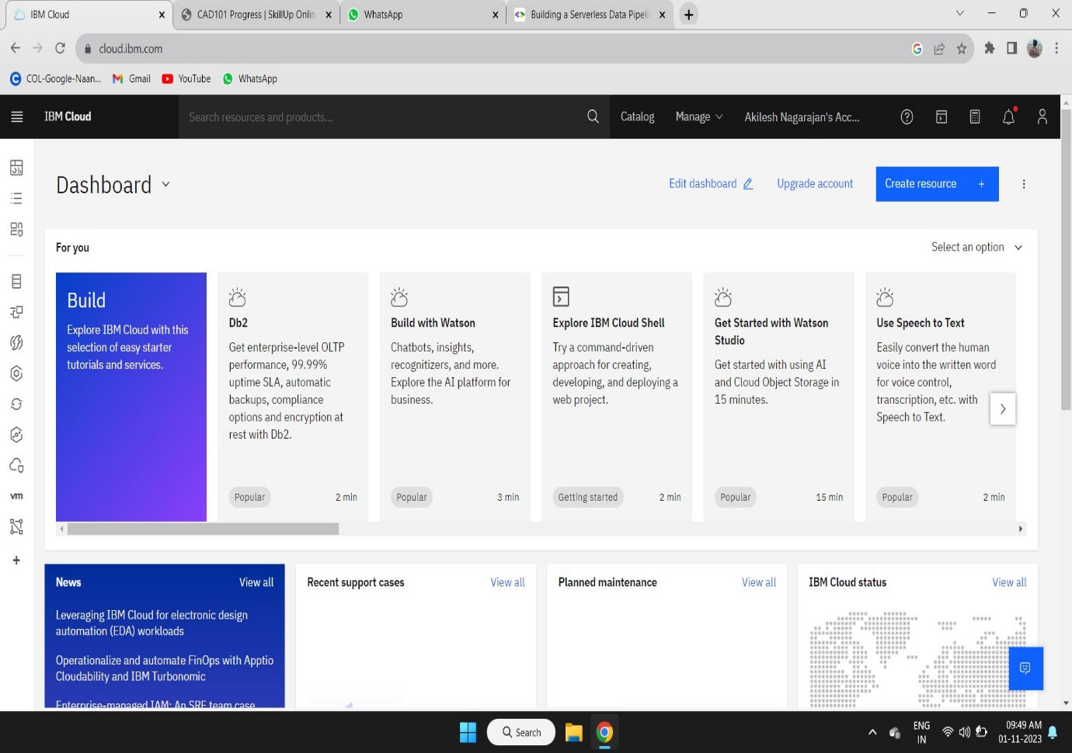

**STEP 2:**

Create your IOT Platform in the IBM cloud Platform for storing the data form the IOT Sensor.

The IOT Sensor take the data for water quality form the different source of water form different places.

When the data is taken form the water the IOT Sensor pushes the data to the IOT Platform in the IBM Cloud Platform.

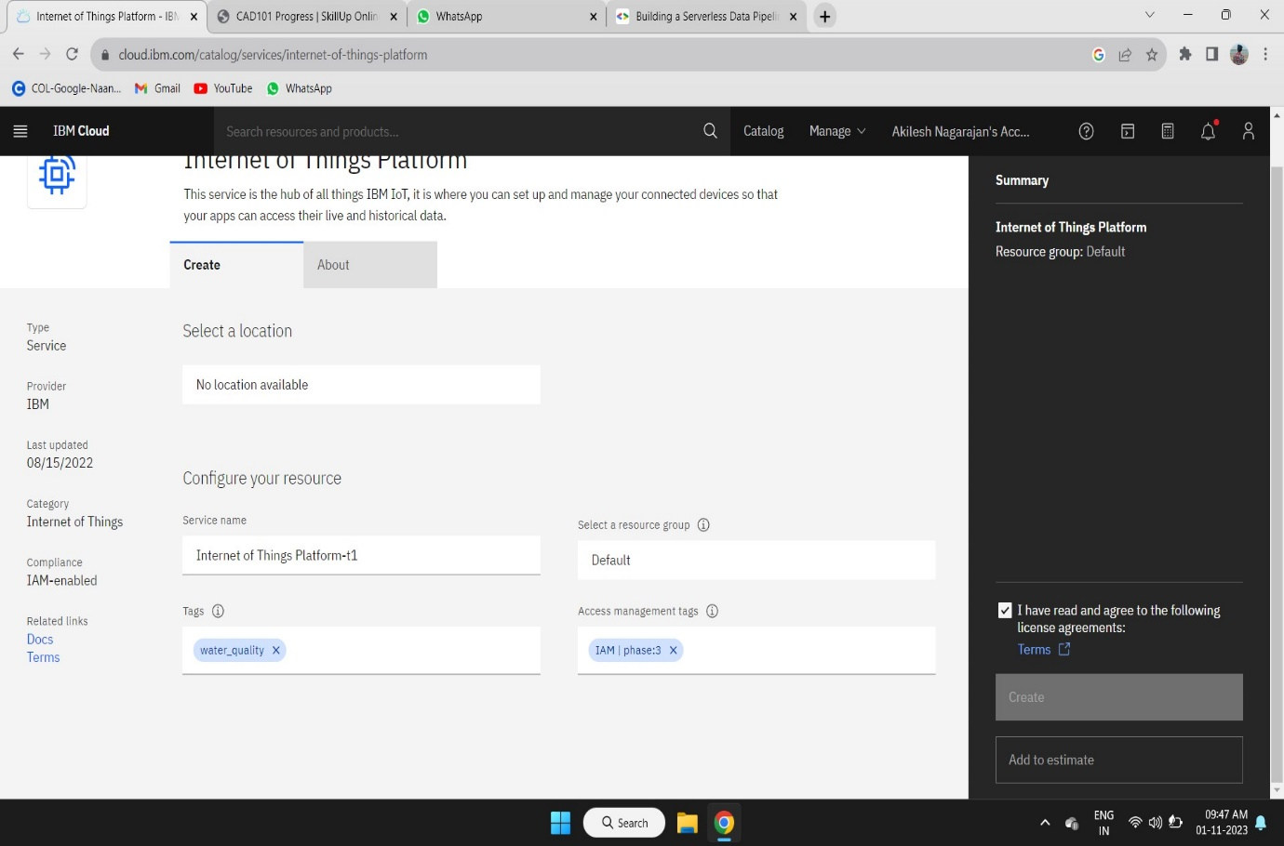

**STEP 3:**

We need to create a function in the IBM Cloud Platform to deploy the code for data processing.

Function service has the all package to run the code in IBM Cloud Platform.

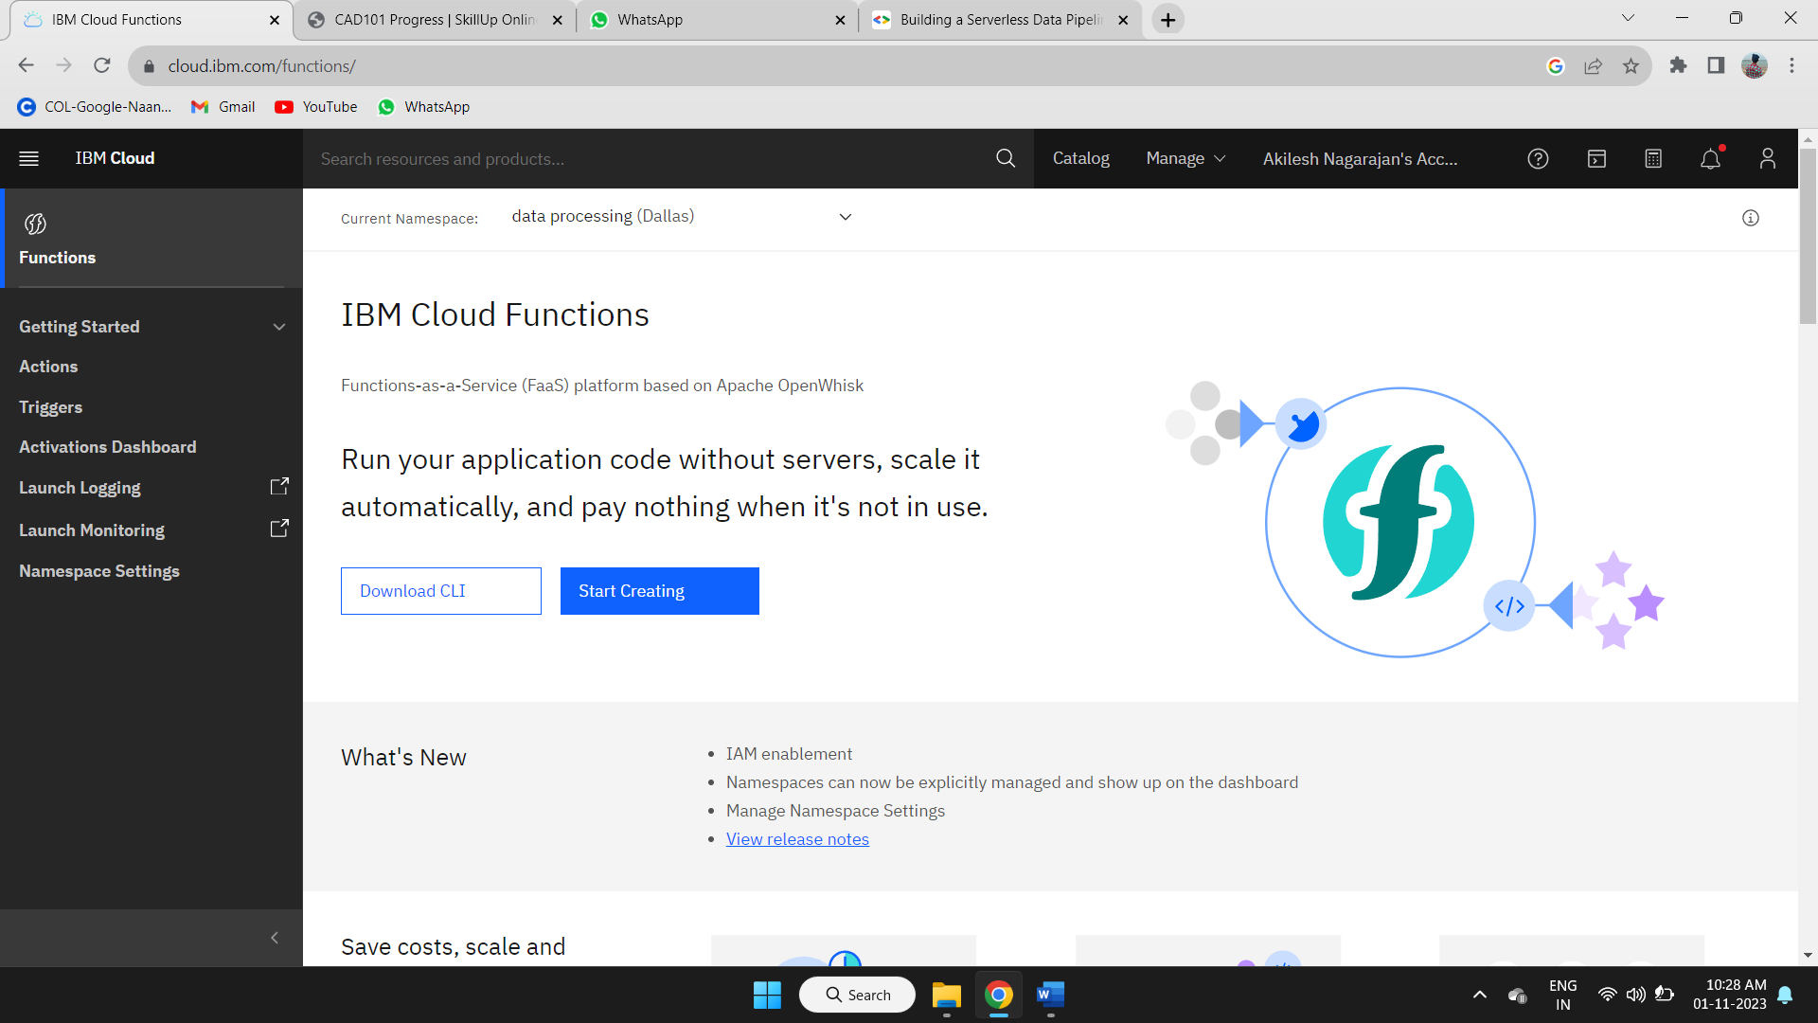

**STEP 4:**

Create a new namespace for your project in your IBM Cloud Platform.

Follow the steps given in the IBM Cloud Platform to create a new namespace.

Then we have to create a action to deploy the code for tiggering the code when the data is loaded in the IOT Platform.

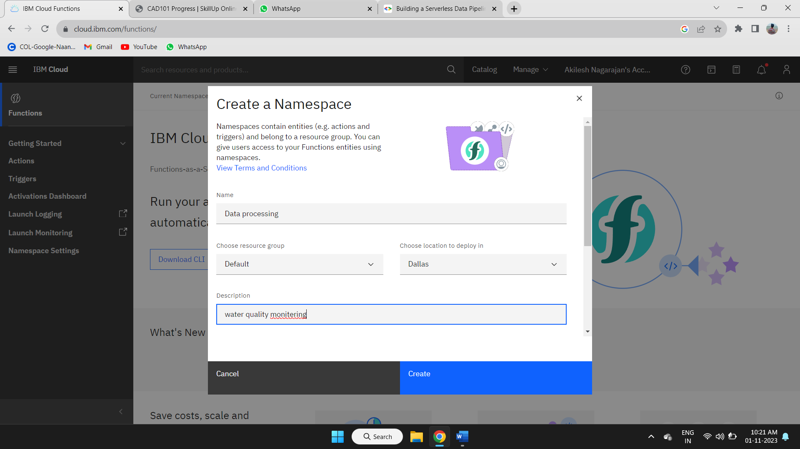

**STEP 5:**

After creating a specified namespace to your project in functions we need to create a action in the current namespace.

Follow the steps given in the IBM Cloud Platform for creating a new action in current namespace available in the function service.

After creating the action deploy your project code in it.

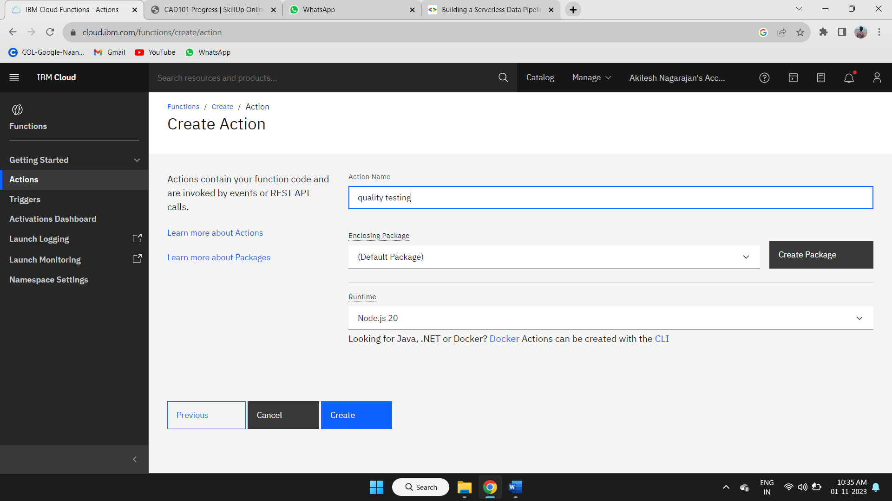

**STEP 6:**

After creating the action deploy your project code in the IBM Cloud Platform in function service platform.

There is the code space to deploy your code in the function service of IBM Cloud Platform.

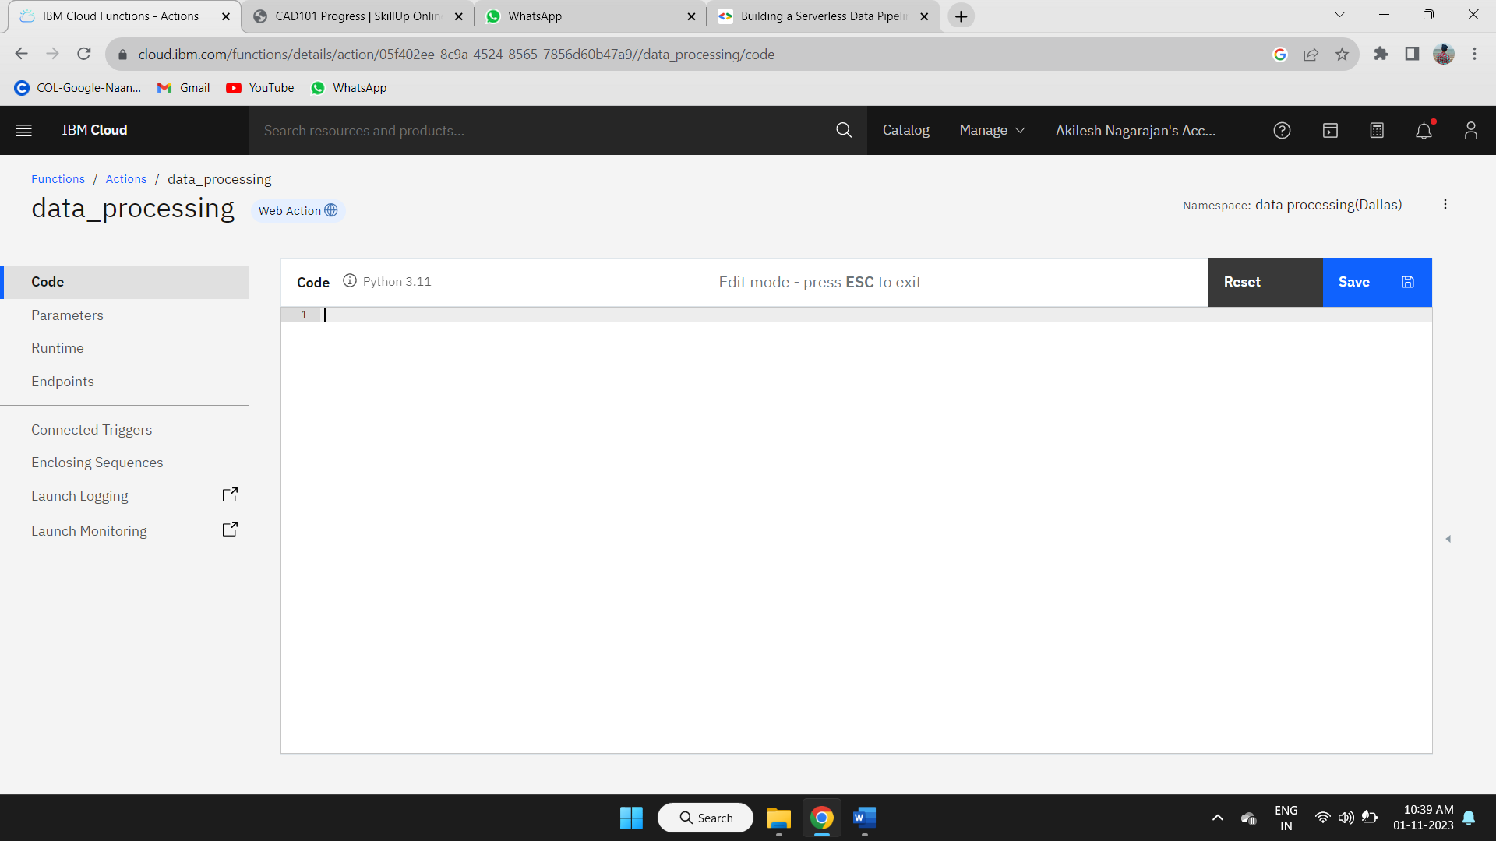

**STEP 7:**

Deploy your code in the code space given in the action of current namespace in the function service.

After deploying the code in the code space save it for further process.

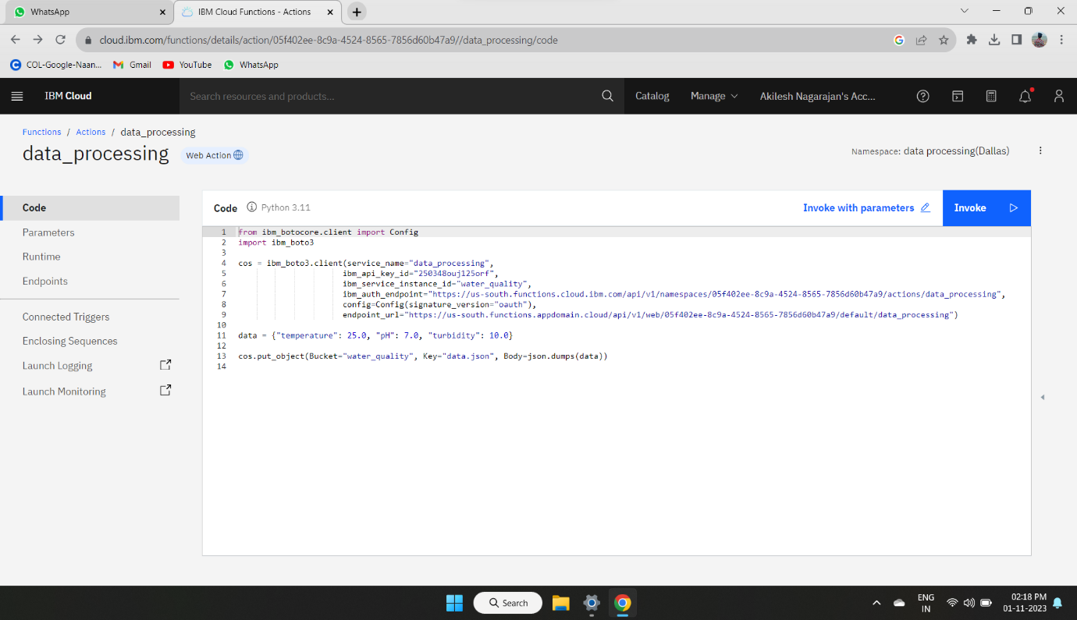

**STEP 8:**

After that we need give the data to the code in the action form where we loaded the data.

Here we use the cloud park for data service in IBM Cloud Platform.

Where the data form the IOT Sensors are loaded when the data is available in the IOT Platform.

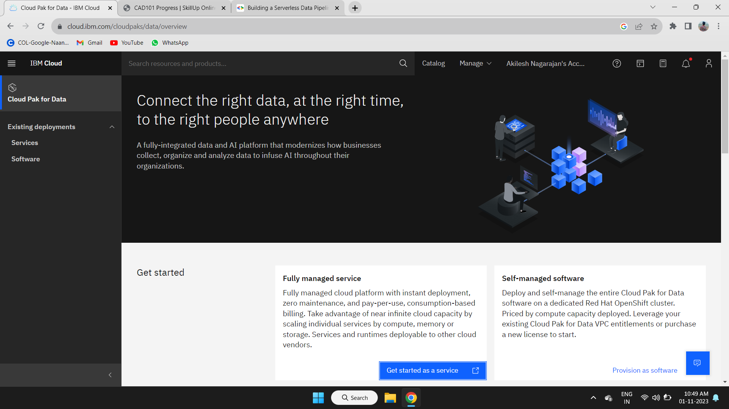

**STEP 9:**

We have to get the access to the Object Storage in the IBM Cloud Platform.

First we have to open the Object storage service in the IBM Cloud Platform.

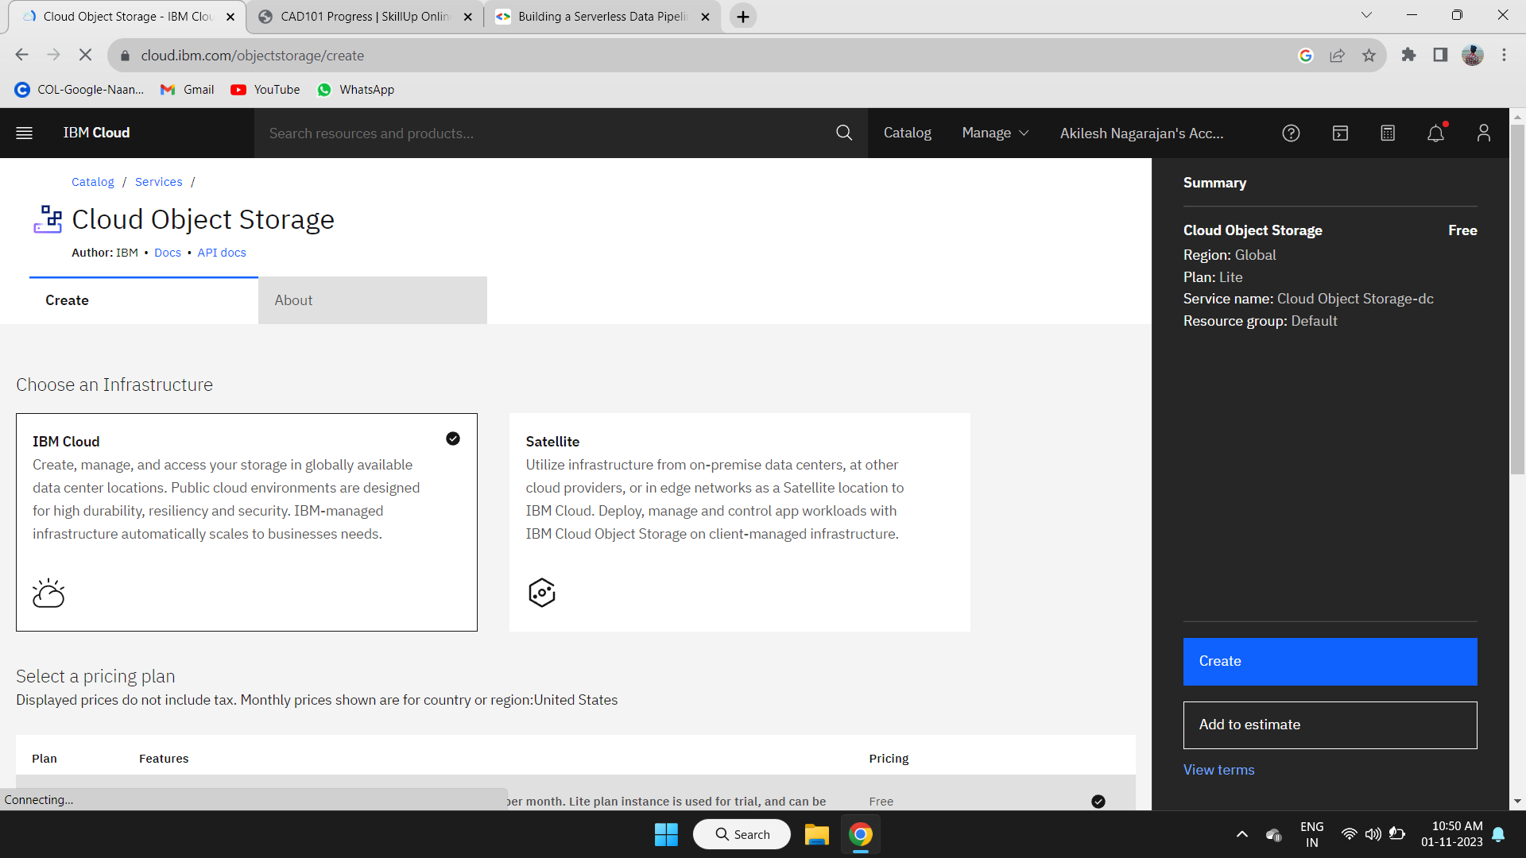

**STEP 10:**

Create the new Object Storage in the Cloud Object Storage for storing the data in the cloud after processing using the code.

Follow the steps given in the IBM Cloud Platform to create the new object storage.

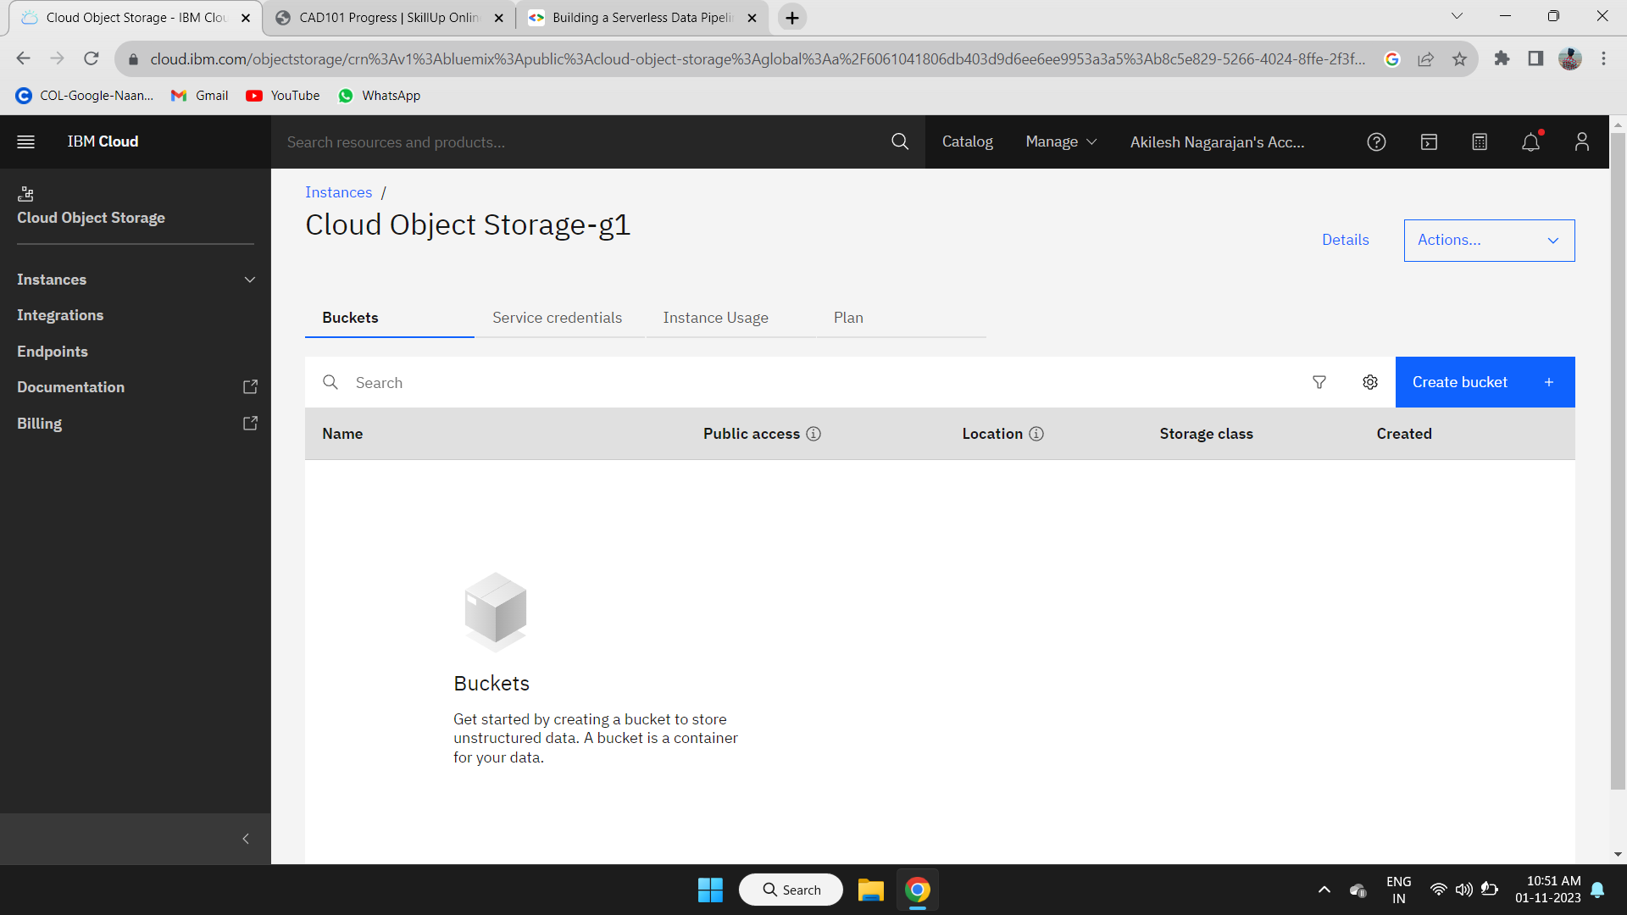

**STEP 11:**

After creating the object storage in the Cloud Object Storage service in the IBM Cloud Platform.

We need to Create the Buckets to store the processed data form the code in the action of the function service.

Follow the steps given in the IBM cloud Platform to create the bucket in the object storage available in the Cloud Object Storage.

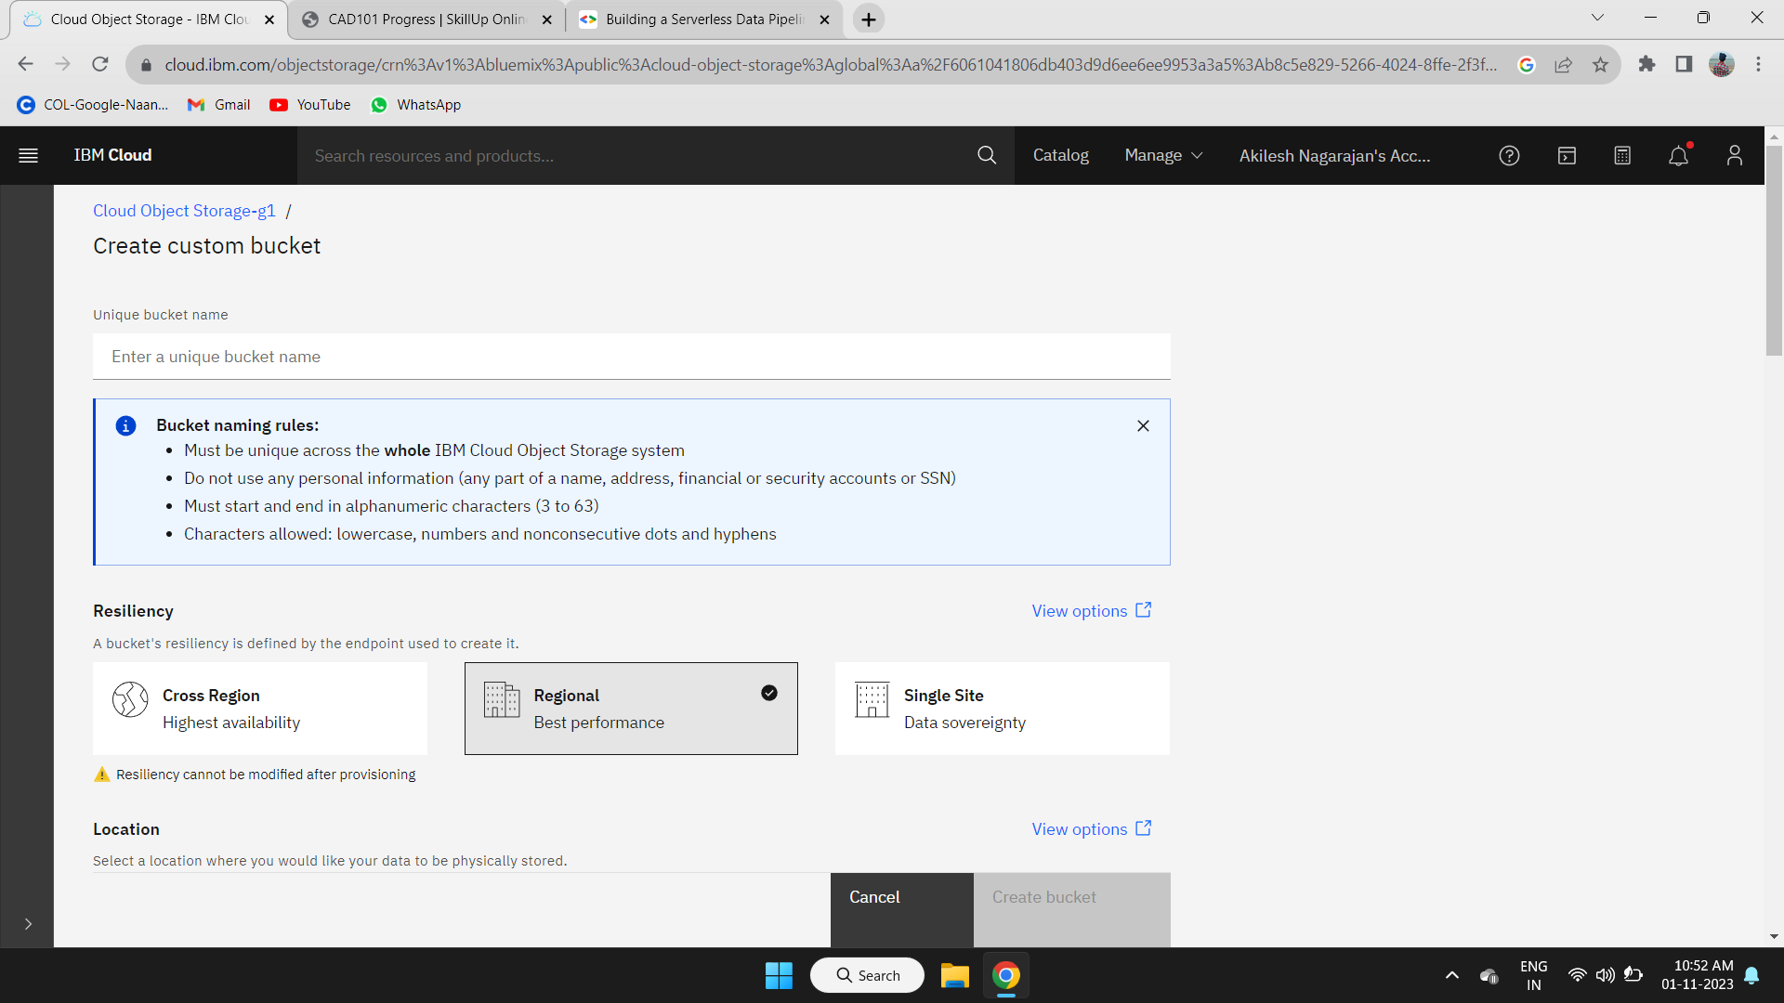

**STEP 12:**

After creating the custom bucket in the object storage. We can upload the data if we want to use.

We have to set the code in the action space in the function service to store the processed data in the bucket in the object storage to visualize the processed data.



**STEP 13:**

If we need to upload the file to the cloud object storage in the bucket we created in IBM Cloud Platform.

Follow the steps given in the IBM Cloud Platform to upload the files to the current bucket created in the cloud object storage.

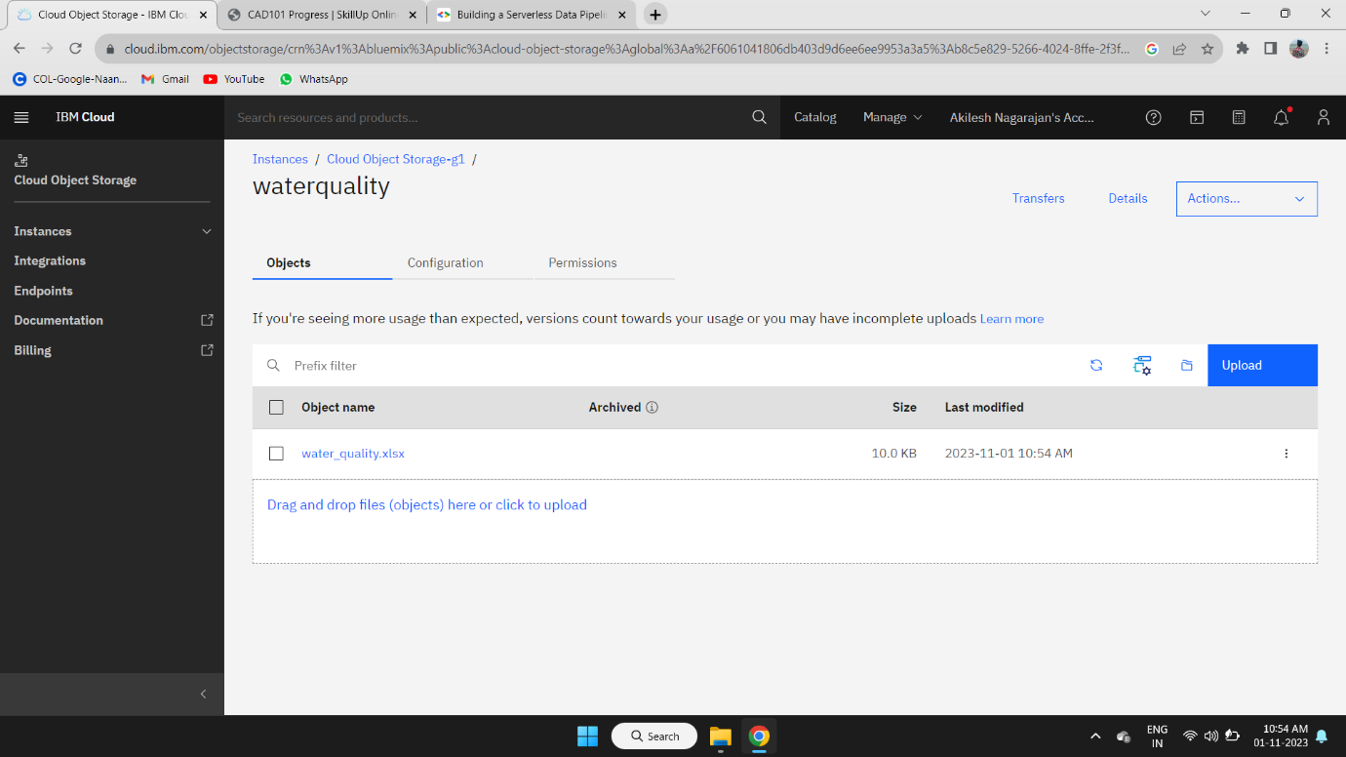

**STEP 14:**

After the invoking of code in the code space of action in the namespace of function service.

The data are updated in the object storage in cloud object storage when ever the code is completed in invoking.

**CONCLUSION:**

‘Water Quality Monitoring with Serverless IoT Data Processing' presents a scalable and efficient solution for real-time water quality monitoring. By integrating IoT devices, IoT Core Platform, IBM functions, and data storage services, this project enables the collection, processing, and analysis of water quality data.

The serverless architecture ensures cost-effectiveness and flexibility in handling varying data volumes. With a real-time dashboard for visualization and an alerting system for immediate response to water quality deviations, this project offers a robust tool for environmental monitoring and protection.

The successful implementation of this project demonstrates the potential for serverless IoT solutions in addressing critical environmental challenges and underscores the importance of data-driven decision-making for water resource management.