Assignment-08
H-no.: 2303a51689

# Test-Driven Development with AI – Generating and Working with Test Cases
# Task 1: Email Validation using TDD
Prompt :
# I am developing a user registration system that requires reliable email validation. I want to use Test-Driven Development (TDD) to ensure that my email validation function works correctly.Must contain @ and characters and not start or end with special characters.Should not allow multiple @ symbols.AI should generate test cases covering valid and invalid email formats.Implement is_valid_email(email) to pass all AI-generated test cases.
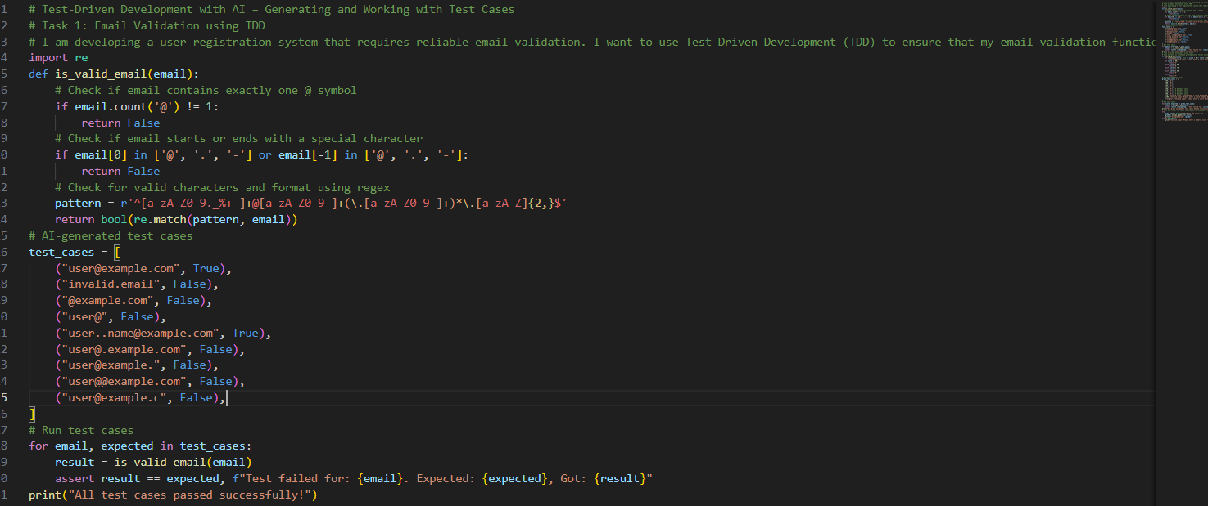

Task-2: Grade Assignment using Loops
Prompt :
# I am building an automated grading system for an online examination platform.AI should generate test cases for assign_grade(score) where:90–100 → A ,80–89 → B, 70–79 → C, 60–69 → D, Below 60 → F.Include boundary values (60, 70, 80, 90).Include invalid inputs such as -5, 105, "eighty".Implement the function using a test-driven approach.Atlast take user input for score and display the assigned grade.
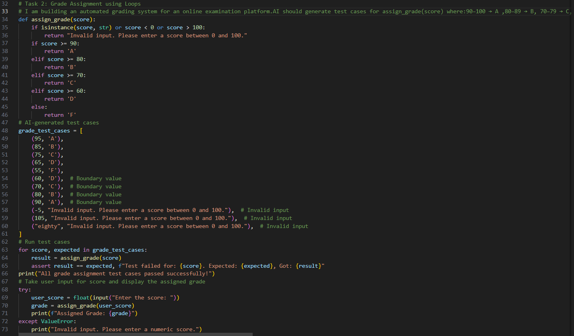
Task 3: Sentence Palindrome Checker
Prompt :
# I want to develop a text processing utility to analyze sentences.Take user input to check and display.AI should generate test cases for is_sentence_palindrome(sentence), Ignore case, spaces, and punctuation, Test both palindromic and non-palindromic sentences,Example:– "A man a plan a canal Panama" → True
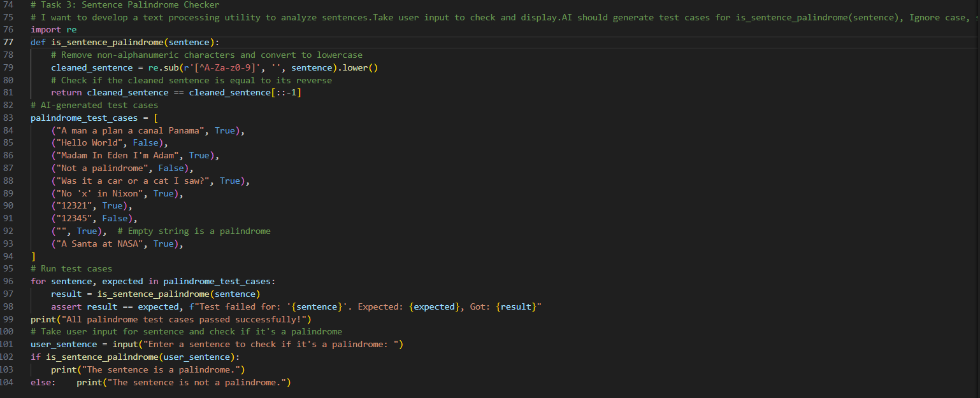
Task 4: ShoppingCart Class
Prompt:
# I am designing a shopping cart module for an e-commerce application. I want to implement a ShoppingCart class that allows users to add items, remove items, and calculate the total price, Validate correct addition,removal, and cost calculation, Handle empty cart scenarios
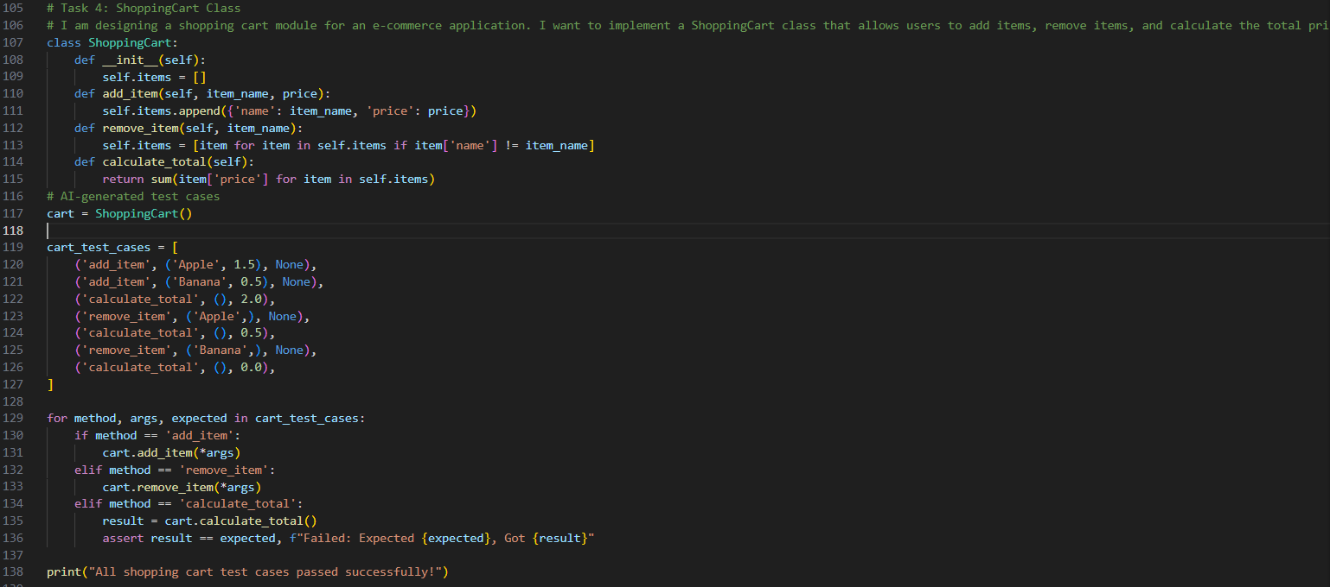
Task 5: Date Format Conversion
Prompt:
# I am creating a utility function to convert date formats for reports.AI should generate test cases for convert_date_format(date_str) Input format must be "YYYY-MM-DD" Output format must be "DD-MM-YYYY", Example:– "2023-10-15" → "15-10-2023"
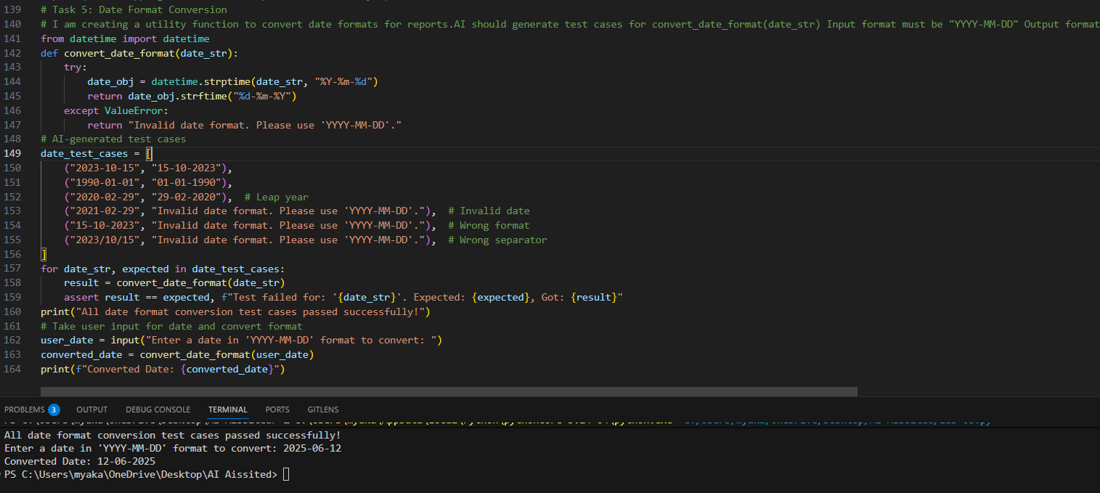
Code Explanation :
# Task 1: Email Validation using TDD
The is_valid_email function checks if the email contains exactly one '@' symbol, does not start or end with special characters, and matches a regex pattern for valid email formats. AI-generated test cases cover various valid and invalid email scenarios to ensure the function's correctness.
# Task 2: Sentence Palindrome Checker
The is_sentence_palindrome function removes non-alphanumeric characters and spaces, then checks if the cleaned sentence is a palindrome.
# Task 3: Character Frequency Counter
The count_character_frequency function counts occurrences of each character in a string and returns a dictionary.
# Task 4: Shopping Cart Class
The ShoppingCart class manages items in a cart, allowing addition, removal, and total price calculation.
# Task 5: Date Format Conversion
The convert_date_format function converts date strings from "YYYY-MM-DD" to "DD-MM-YYYY" format using datetime parsing.

