PMAgent
New Features Guide
Overview · Timeline · Milestones · Workstreams · and more
Covering releases 3.6, 3.7 and 3.7.1
A plain-language guide for everyday users

Contents

About this guide
This guide covers everything PMAgent added across three recent releases — 3.6, 3.7 and 3.7.1. It is written for everyday users: each section says what a feature does, why it helps, and where to find it.
PMAgent organizes work as Organizations → Projects → Tickets. You move tickets across a board, plan them into sprints, schedule them on a timeline, and collaborate in real time.
A note on the pictures: the screens below are clean illustrations of a sample project (“Mobile Banking App”) drawn to show each feature clearly.

1. The project Overview dashboard
New in 3.7
When you open a project you now land on its Overview — a manager’s-eye dashboard that answers “how is this project doing?” at a glance.
- Status — open vs. done counts, a to-do / in-progress / done bar, and a sprint-vs-ad-hoc split.
- Active sprint — progress, days left, and a live burndown chart.
- Blockers — the tickets that are stuck (marked Blocked or waiting on unfinished work); click one to open it.
- Milestones — your next target dates with a readiness ring; add one inline and tick it off when reached.
- Capacity & recent activity — open tickets per teammate, plus a Project summary card (Beta).
- Always live — every card updates as teammates make changes, with no refresh needed.
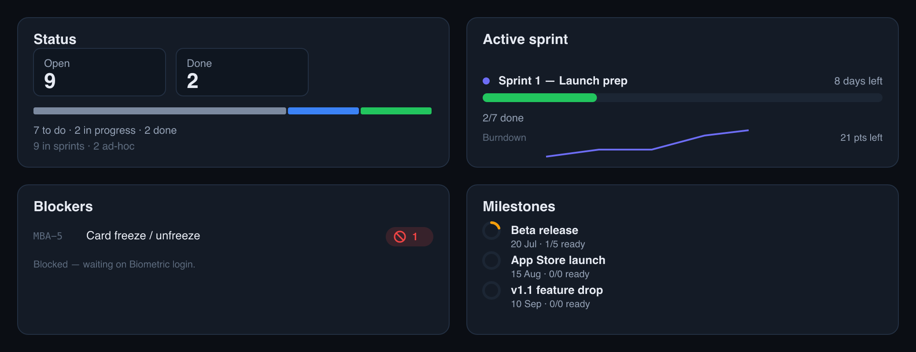
The project Overview: status, active sprint, blockers and milestones.
Where to find it: The Overview leaf at the top of a project in the sidebar (it’s the project’s landing page).

2. Timeline (Gantt)
New in 3.7 · mobile polish in 3.7.1
A horizontal timeline of every scheduled ticket, so you can see what happens when.
- Bars by date — each ticket runs from its start to its due date, colored by status; a single date shows as a one-day marker.
- Milestones & dependencies — milestones appear as diamonds, a “today” line marks the date, and arrows connect a ticket to the ones it waits on.
- Zoom & filter — switch Day / Week / Month, jump to Today, and filter by assignee, sprint, label, status or workstream.
- Unscheduled tray — tickets with no dates wait in a collapsible tray at the bottom.
- Drag to schedule (desktop) — drag a bar to move it, drag its ends to resize, drop an unscheduled item onto the timeline, or drag a milestone — every change offers Undo.
- Phone-friendly — on a small screen the left list narrows to just the ticket code so the bars get the room.
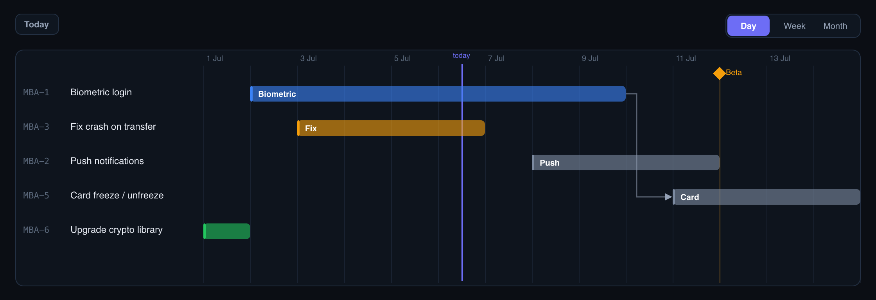
The Timeline: status-colored bars, a milestone diamond, a dependency arrow and the “today” line.
Where to find it: The Timeline leaf in the sidebar.

3. Milestones & release readiness
New in 3.7 · manage/rename/delete in 3.7.1
Milestones are your big target dates — a beta, a store launch. PMAgent tracks how ready each one is.
- Add inline — give a milestone a name and date right on the Overview; tick it off when you reach it.
- Readiness ring — shows how many of the tickets due before that date are already done.
- Manage anytime — click the pencil on the Milestones card to rename, change a date, or delete a milestone (deleting is limited to admins).
- Everywhere it matters — milestones also show on the Timeline and power the Reports “Release readiness” view.

4. Sprint vs Ad-hoc work
New in 3.7
Not all work fits neatly in a sprint. Every ticket is now either Sprint work (planned) or Ad-hoc (operational work that lives outside sprints).
- Set it in the drawer — the ticket panel has a Workstream field (Sprint work / Ad-hoc).
- Focus a lane — the board and list have an All / Sprint work / Ad-hoc tab; creating a ticket on the Ad-hoc tab makes it ad-hoc automatically.
- Safe switching — moving a ticket to Ad-hoc removes it from its sprint (you’re warned first); the bulk menu can change several at once.
- Carried through — CSV export/import include a Workstream column, and Reports’ workload shows a sprint-vs-ad-hoc split per person.

5. Faster ticket creation
New in 3.7
Create tickets where you are, with the fields you already know.
- Quick-add tokens — type a title with !high (priority), @name (assignee) and #sprint; a live preview shows exactly what will be set before you press Enter.
- New from template — pick Bug report or Feature to start a ticket pre-filled with a sensible structure.
- Inline subtasks — inside a ticket, type a subtask title and press Enter — repeat for fast batch entry. Each new subtask inherits the parent’s workstream.
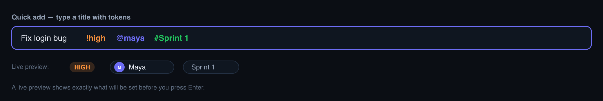
Quick-add tokens with a live preview of the priority, assignee and sprint that will be set.

6. Scheduling a ticket: Start & Due dates
Workstream & subtasks in 3.7 · Start date in 3.7.1
Open any ticket to set its schedule and see its structure in one place.
- Details — assignee, story points, Start date, Due date, Sprint and Workstream. The Start date is new: say when work begins, not just when it’s due.
- Subtasks — a done-counter (e.g. 1/2) and an inline “new subtask” box for fast entry.
- Relationships — blocked-by / blocks with an automatic red Blocked badge that clears when the blocker is done.
- Spec readiness — a ring shows how complete the ticket’s spec is.
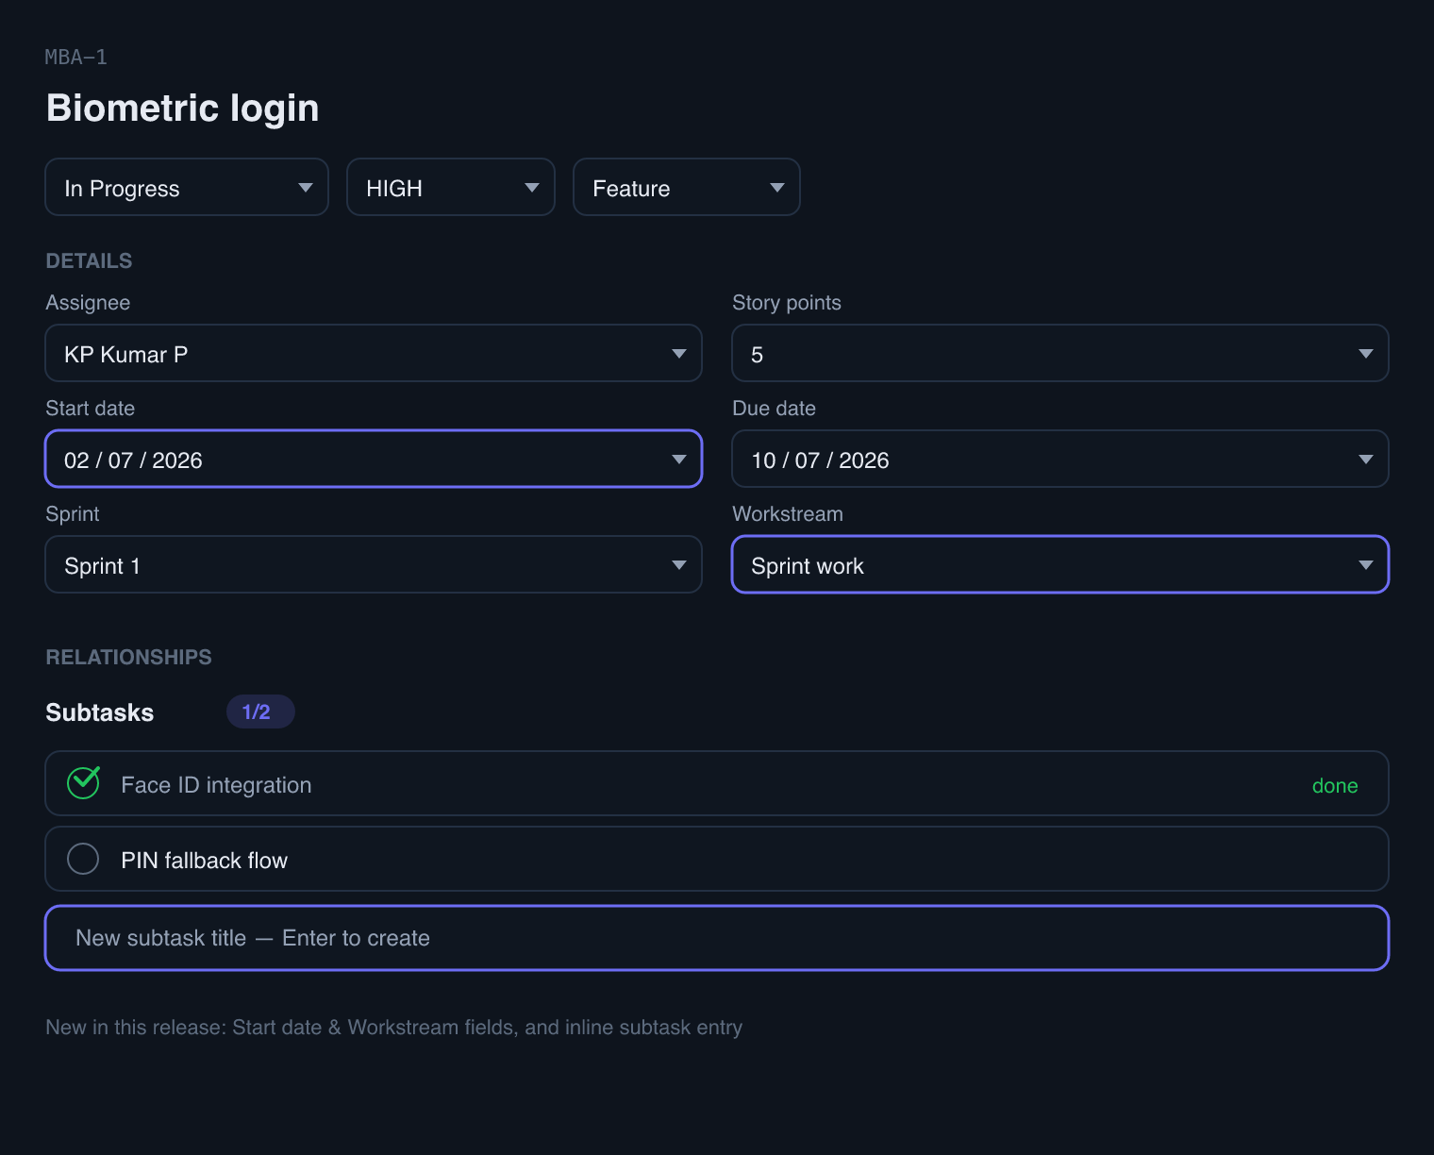
The ticket panel — the new Start date and Workstream fields, plus inline subtask entry, are highlighted.
Where to find it: Click any card on the board or any row in the list.

7. The Board, upgraded
Tabs & filters in 3.7 · subtask chips in 3.7.1
The board gained focus tools and clearer cards.
- Workstream tabs — All / Sprint work / Ad-hoc to focus one lane.
- Multi-select filters — priority, type, assignee and sprint filters each let you pick several values at once.
- Clearer cards — a subtask counter (e.g. 1/2) when a ticket has subtasks, a red Blocked badge, the priority, and viewer avatars.
- Create in place — a “+ subtask” button on a card jumps straight into adding one; quick-add sits on every column.
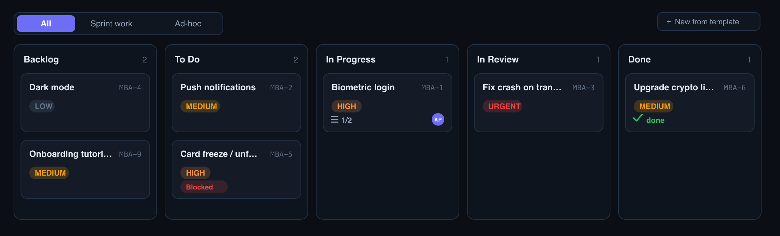
The board with workstream tabs, a subtask counter on “Biometric login”, and a Blocked badge.
Where to find it: The Board leaf in the sidebar (or the Board/List toggle).

8. The List view
Column chooser in 3.7 · Due column in 3.7.1
A sortable, filterable table of your tickets — now yours to arrange.
- Choose your columns — a Columns button toggles Status, Priority, Assignee, Sprint, Workstream, Start, Due, Points and Updated (Key + Title always show).
- Resize & remember — drag a column’s edge to resize it; your column choices and widths are remembered.
- Multi-select filters — every filter accepts several values at once.
- CSV in and out — export exactly what you see, or import (with labels and assignee); a Sample CSV is one click away.
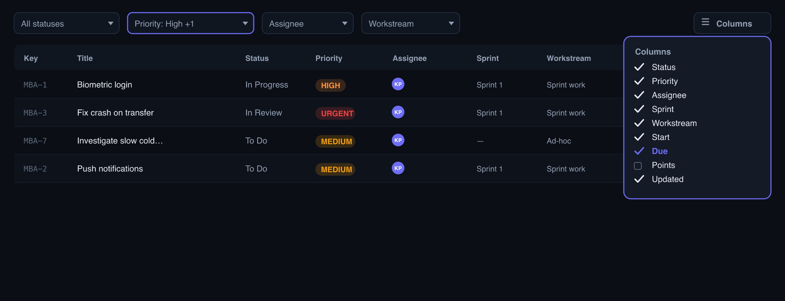
The List with multi-select filters and the Columns chooser — the new “Due” column highlighted.
Where to find it: The List leaf in the sidebar (or the Board/List toggle).

9. Sprint management
New in 3.7
Run a sprint without opening every ticket.
- Editable goal — click the pencil to set or change the sprint goal inline.
- Manage rows — expand a sprint to see its tickets as rows: change status and assignee inline, see priority and points, jump to a ticket, or move it to another sprint.
- Focus a big sprint — a small assignee/status filter narrows the list; everything updates live.
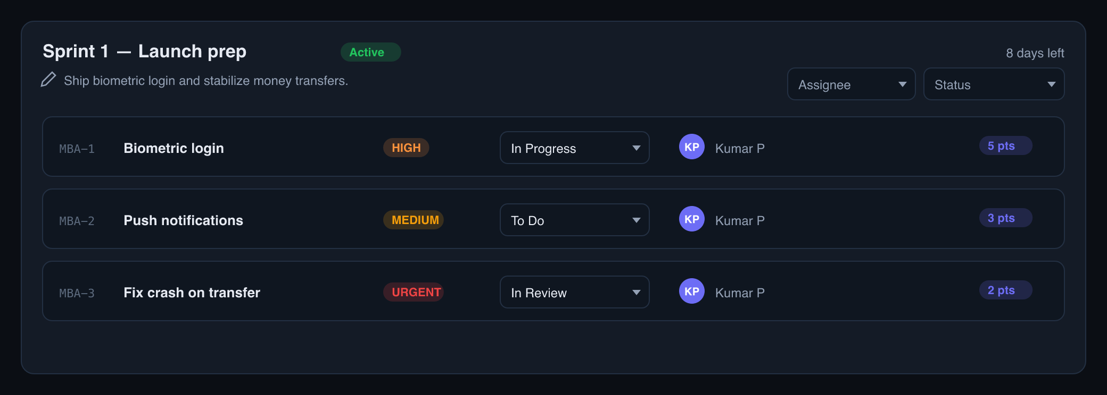
An expanded sprint — editable goal, inline status selects, assignees and point chips.
Where to find it: The Sprints leaf in the sidebar.

10. Reports & release readiness
Release readiness new in 3.7
Read-only charts that build themselves as you work.
- Velocity — story points completed per finished sprint.
- Cycle & lead time — how long tickets take, as typical and slow-end numbers over the last 90 days.
- Workload — open tickets per person, with a sprint-vs-ad-hoc split.
- Release readiness — a completion donut for the whole project, plus each upcoming milestone’s done/open counts.
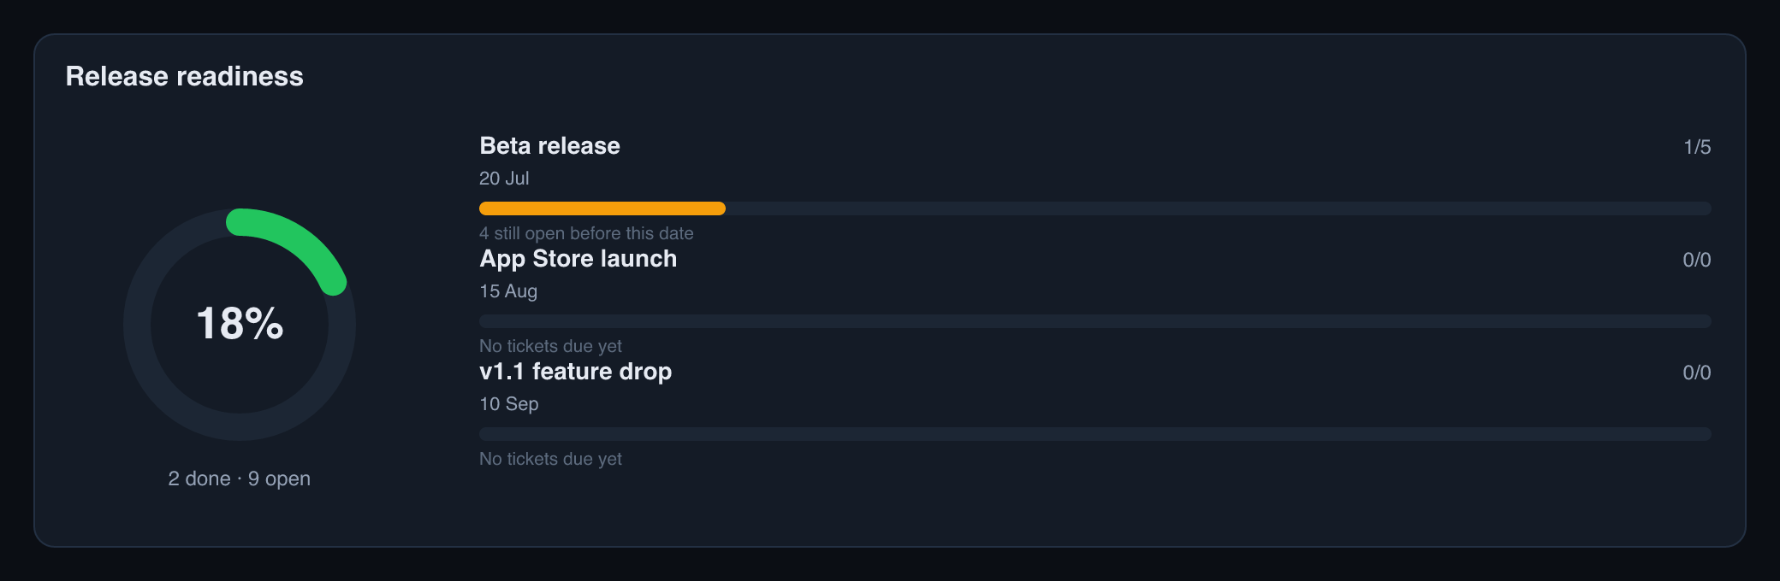
Release readiness — a completion donut and per-milestone progress.
Where to find it: The Reports leaf in the sidebar.

11. Everyday improvements
New in 3.6
A polish pass made the whole app feel more finished.
- Settings in the sidebar — a gear + “Settings” entry in the workspace tree at both organization and project levels.
- Richer notifications — the bell shows a per-type icon and label on every item: assigned, comment, mention, unblocked, and “all subtasks done”.
- Smarter CSV import — imports now bring labels and the assignee along too (unknowns are skipped, never an error).
- Mobile & clarity — touch-friendly fixes such as reachable comment reactions, plus clearer empty and loading states.
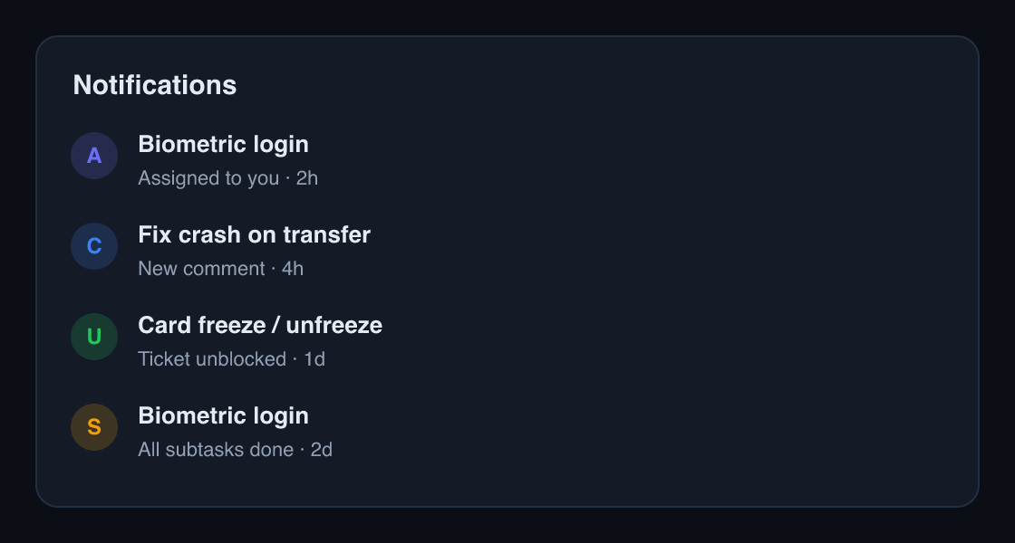
The notification bell — each item now carries a per-type icon and a label.

12. AI features — a Beta preview
Placeholders in 3.7
You’ll notice a few buttons tagged “Beta” — Draft with AI, Auto-fill from prompt, and a Project summary card on the Overview.
These mark where AI will plug in with the upcoming agent release. They’re visible on purpose so you know it’s coming, but they don’t do anything yet — no AI runs today.

Appendix — what changed in each release

Release 3.6 — Polish & hardening
- Settings entry points added to the sidebar tree (org & project).
- Notification bell: a per-type icon and label on every item.
- CSV import now maps a Labels column and an Assignee column.
- Mobile/touch fixes (reachable comment reactions) and clearer empty/loading states.

Release 3.7 — Review-driven planning surfaces
- Project Overview dashboard becomes the project landing page.
- Timeline (Gantt) with milestones, dependencies, and drag-to-schedule + Undo.
- Real milestones with readiness rings.
- Sprint vs Ad-hoc “workstream” across board tabs, drawer, bulk, CSV and reports.
- Quick-add tokens and inline subtask creation.
- Multi-select filters on the board and list.
- Sprint view: inline status/assignee and an editable goal.
- List column chooser with resizable, remembered widths.
- Reports: Release readiness (donut + milestone readiness).
- Beta AI affordances (visible placeholders, no AI yet).

Release 3.7.1 — Gap closure
- Start date field added to the ticket panel.
- Manage milestones: rename, change date, or delete.
- The Sprints page updates live when teammates make changes.
- Subtask progress counters (e.g. 1/2) on board cards.
- A Due column option in the List’s Columns chooser.
- The Timeline’s left list narrows on phones so the bars get the space.

