# Sparkline Chat Application

**CONTENTS OF THIS FILE**

--------------------------------------------------------------------------------------------------

* Introduction

* Package

* Deployment

* WorkFlow

*INTRODUCTION*

---------------------------------------------------------------------------------------------------

The **"Sparkline Chat” application** enables users to chat in the single room. It shows the status of users also like (*who has joined or who has left the room*). The application simply ask user to enter username to enter into the chat.

There is no registration or password required. As user enters his/her username , he/she will be registered into the system.

The **"Sparkline Chat” application** contains two modules.

* 1) Web App (*SkarplineChat.App)* - Enables user interaction.
* 2) Web ApI (*SkarplineChat.Api*) - A layer between application and database which interact with application and database.

*PACKAGE CONTENT*

---------------------------------------------------------------------------------------------------

The package contains following items.

* Web App
* Web API
* Database script

*DEPLOYMENT*

---------------------------------------------------------------------------------------------------

* Deploy both WebApp and WebApi on IIS or any public URL.
* Replace the value of ServiceURL by your deployed WebApi URL in Web App.

<add key="ServiceURL" value="http://localhost:5539/" />

* Run the database scripts on sql server.
* Replace the <connectionStrings> in the Web Api with your databse connection string.

<add name="SkarplineChatDBEntities" connectionString="metadata=res://*/Model.SkarplineChatModel.csdl|res://*/Model.SkarplineChatModel.ssdl|res://*/Model.SkarplineChatModel.msl;provider=System.Data.SqlClient;provider connection string=&quot;data source=SS_DESK01;initial catalog=SkarplineChatDB;integrated security=True;MultipleActiveResultSets=True;App=EntityFramework&quot;" providerName="System.Data.EntityClient" />

*WORKFLOW*

---------------------------------------------------------------------------------------------------

Navigate to web application in browser. The following screen will be displayed which will ask user to enter username and press "Login" button. As there is no registration required so user will be registered automatically as he enters his username.

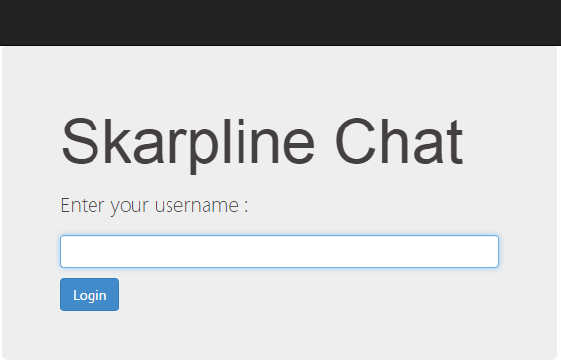

When user logged in then following screen will be visible where user can see chats of various users. User can also send message in the same chat and start interaction with the other users.

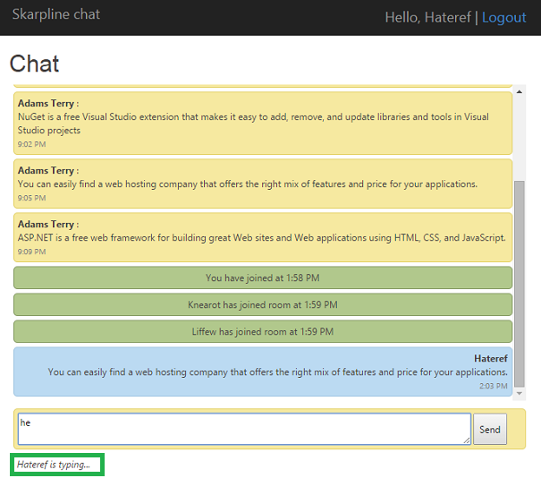

There are some extra features added in this application .

* ***Who is typing...*** - As user starts typing in the textbox there is a label under message textbox showing the name of user.
* ***Who is erasing...*** - As user erasing the content in the textbox there is a label under message textbox showing the name of user.
* ***Who has joined room*** - As any user joined the chat room then chat window will show the name of user in the green box alongwith time.
* ***Who has left room*** - As any user left the chat room then chat window will show the name of user in the red box alongwith time.

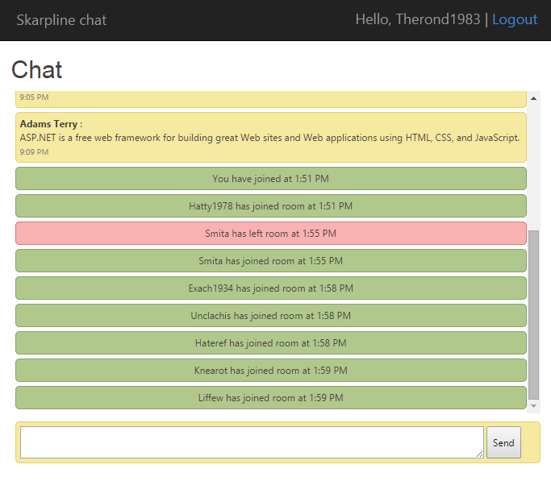

In the right side of the chat page, users can see the list of active/online users. Active users list will get updated as any user joined / left the chat room.

