Record Task- Implemented Changes
- Browser Persistence: Updated browser behavior to reopen the application at the last accessed route after closing and reopening the browser.
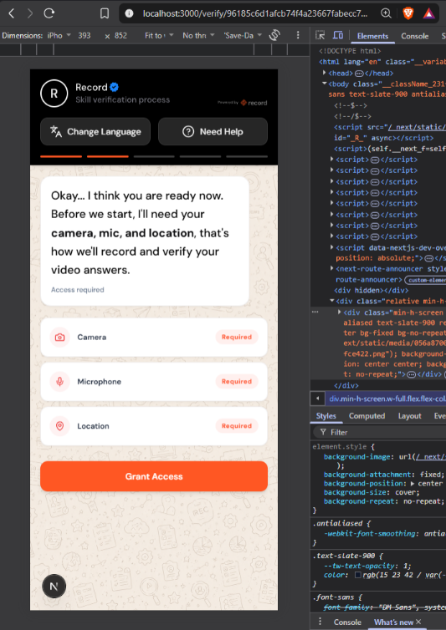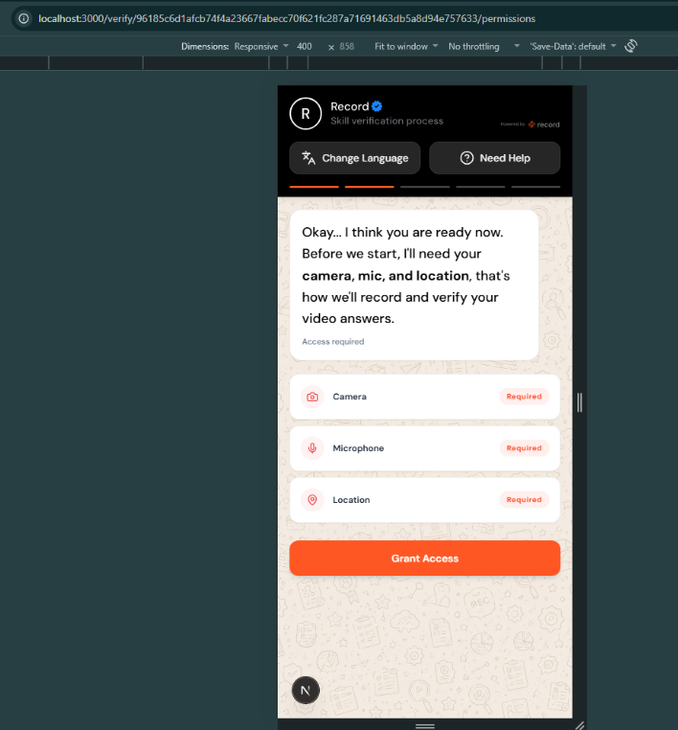
- Multiple Language Support: Added support for different languages to improve accessibility for users.
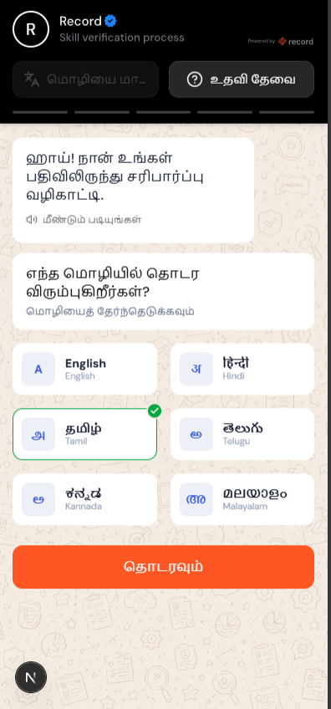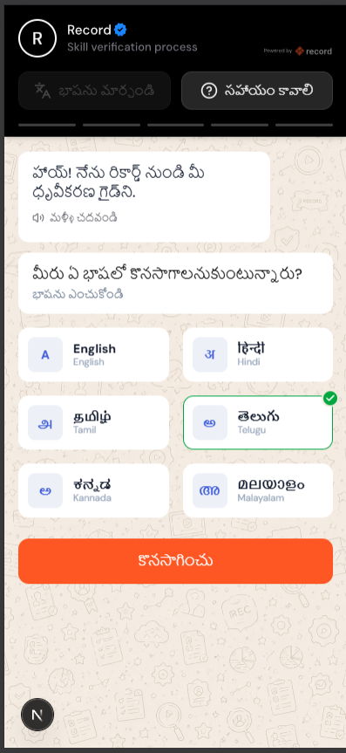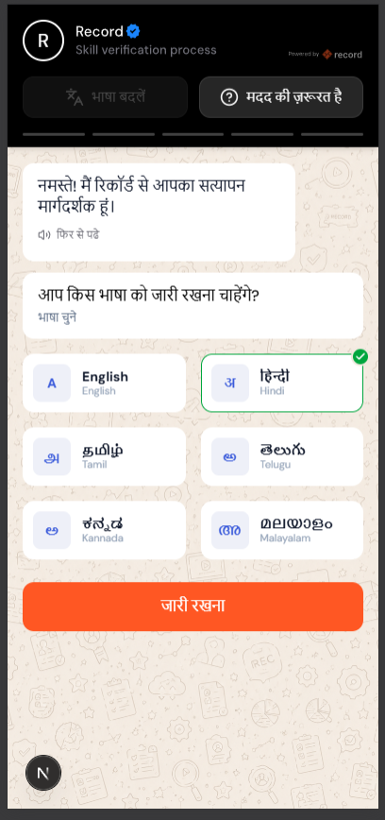
Google Translate Integration: Integrated Google Translate to enable translation of application content into different languages.
- MongoDB to AWS S3 Migration: Migrated video storage from MongoDB GridFS to Amazon S3 and AWS IAM role-based authentication.
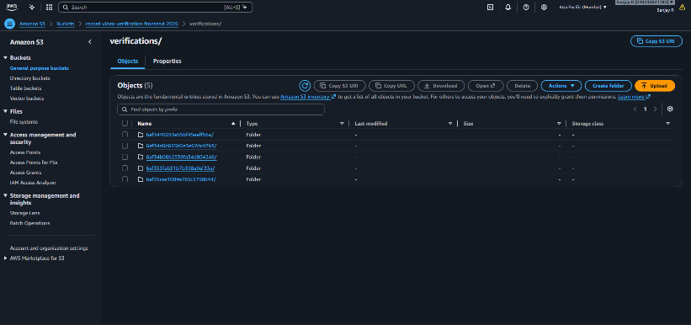
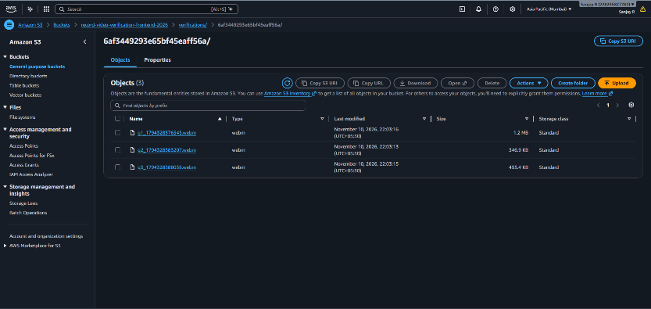
- React to Next.js Migration: Migrated the existing React (Vite) frontend to Next.js using the App Router.
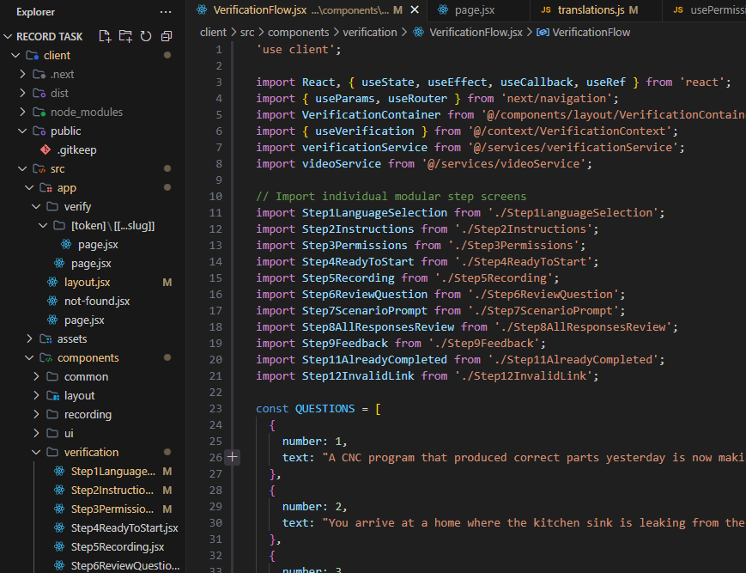
- Mandatory Location and PIN Code: Made location information mandatory and added PIN code collection to the verification process.
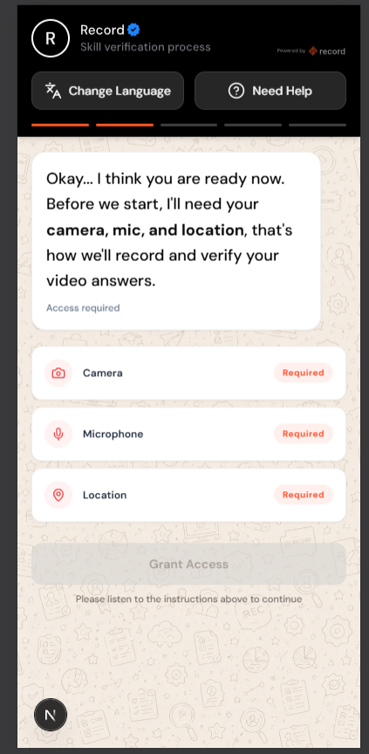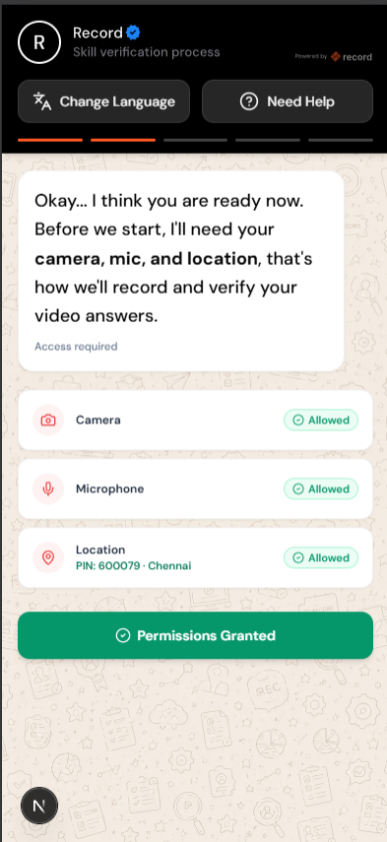

- Ready-to-Start Page Enhancement: Implemented word-by-word reading of the displayed instructions before allowing users to start the verification process.

