VIRTUAL RESEARCH ATTACHMENT PROGRAM

UTP - VIT

SOFTWARE TOOL FOR DESIGNING SIGNAL CONDITIONING CIRCUIT USE IN TEMPERATURE MEASUREMENT

BY

SANJAY S – 19BEC1370

A project report submitted to

Associate Professor Dr. NORDIN SAAD

ELECTRICAL AND ELECTRONICS ENGINEERING DEPARTMENT

FACULTY OF ENGINEERING



|  |  |
| --- | --- |
| TITLE | PAGE NO. |
| 1. Introduction    1. Background    2. Research motivation    3. Problem statement    4. Scope of the project | 3 |
| 1. Temperature measurement in industries    1. Thermistor    2. RTD    3. Solid state temperature sensor    4. Thermocouple | 4 |
| 1. Methodology    1. Introduction    2. Methodology flow    3. Project Activities and Timeline    4. Proposed work and relevant information | 5 |
| 1. Conclusion    1. Conclusions    2. Sample Design    3. Sample Design and Software Tool | 8 |

**Chapter 1**

**INTRODUCTION**

* 1. **BACKGROUND**

In oil and gas industry, the operating temperature for industrial processes varies according to the fluid or materials being processed. It is required to measure temperature that varies according to the range associated to a particular process. A thermocouple measurement system is to be used. A three terminal solid-state sensor is to be used; A three terminal solid-state sensor is to be used to provide reference compensation.

* 1. **RESEARCH MOTIVATION**

This project is to design and develop a software tool that can be used, given relevant parameters, to develop a complete signal conditioning circuit for the measurement system using instrumentational amplifier to be connected to a suitable n bit unipolar successive approximation register ADC with a suitable voltage reference

* 1. **PROBLEM STATEMENT**

To develop a software tool to aid in designing a signal conditioning circuit for temperature measurement.

* 1. **SCOPE OF THE PROJECT**

The project's major goal is to create an efficient tool for determining the values of the components used in signal conditioning circuit design in a more timely and accurate manner. We can reduce human calculation errors while solving linear equations and functions to determine values by doing so.

**CHAPTER 2**

**TEMPERATURE MEASUREMENT IN INDUSTRIES**

**2.1 THERMISTOR**

It's a thermometer or resistor whose resistance is proportional to temperature. It is a type of resistance which is strongly dependent on temperature. It uses change in electrical resistance due to temperature change in certain materials. It is generally made of sintering mixes of metal oxides such as manganese, nickel, cobalt, and copper are commonly used. Thermistor as NTC (negative temperature coefficient) as temperature increases the resistance decreases. It is high sensitivity hence its very responsive. Available in various shapes such as beads, rods, discs and washers.

**2.2 RESISTANCE TEMPERATURE DETECTOR (RTD)**

It is resistance of the conductor changes with temperature. In RTD the element is chosen such as way that the element should exhibit relatively large change in resistance whenever there is a change in temperature, it should be stable. It should not have permanent change in temperature coefficient and resistance with use or age. It has low response time and it has relatively larger temperature measurement ranges as temperature compared to thermistors. Commonly used metals for RTD are platinum, nickel and copper.

**2.3 SOLID STATE TEMPERATURE SENSOR**

A solid-state sensor uses PN junction of a diode to measure the temperature change. Small IC temperature sensor used to convert the temperature input into proportional current output due to which we can measure the temperature more easily and effectively. As a result, it's ideal for temperature measurement and control applications in the -55 to 150 Celsius range, where solid-state stability, linearity, and accuracy are required. It is more used in size considerate devices such as PC boards or heat sinks.

**2.4 THERMOCOUPLE**

A thermocouple is a temperature measuring sensor. It consists of two different types of metals, joined together at one end, when these junctions are heated or cooled, a voltage difference is created which can be correlated to the temperature. Due to which it can use wide range of temperature measurement making it more versatile temperature sensor. It is mainly used in industrial usages and applications which work, in very high range of temperature values.

**CHAPTER 3**

**METHODOLOGY**

**TEMPERATURE MEASUREMENT USING THERMOCOUPLE**

**3.1 INTRODUCTION**

We choose K type thermocouple as temperature measuring sensor since thermocouple is a flexible temperature sensor. It has two ends: a hot end junction and a cold end junction, which is also referred to as a reference junction. A thermoelectromotive force is generated by the differential between the two end junctions, resulting in a voltage difference across the two junctions. Current flows as a result of the voltage difference, and we can calculate the temperature by measuring the current because they are proportionate.

**3.2 METHODOLOGY**

In the ideal scenario, the reference junction temperature is set to 0 degrees Celsius. However, because maintaining 0 degrees in the reference junction is challenging in the past, we now employ a solid-state sensor in the reference junction to maintain a consistent temperature throughout the measurement.

The current produced by this temperature differential is only a few mV, which is insufficient for any device to function. As a result, we employ an instrumentational amplifier to amplify the current from mV to the range of (1 to 10 V). So that we can calculate the temperature and process and measure the temperature difference.

**3.3 PROJECT ACTIVITY AND TIMELINE**

Week 1:

* Thermocouple temperature measuring system is understood.
* Analysed and measured a variety of industrial environments.
* Developed a software tool for designing signal conditioning circuits using an excel spreadsheet.

Week 2:

* The signal conditioning circuit was designed, and the measuring software was modified.
* Validation and verification have been completed.

Week 3:

* Creating report for the project and verification.

Week 4:

* Submission of the report.

**3.4** **PROPOSED WORK AND RELEVANT INFORMATION**

Software tool information:

The software which we used in excel. In this excel sheet if we enter the important information such as

1.Vt1- minimum temperature of industrial operation

2. Vt2- minimum temperature of industrial operation.

3. T1- minimum operating temperature

4. T2- maximum operating temperature

4. TMP-Solid state sensor output scaling factor.

5. R1- Inbuilt resistance of instrumentational amplifier.

With these values we can get all the other resistance and voltages values used for designing the signal conditioning circuit.

1.M- voltage value produced in thermocouple terminal

2.Vc- compensation voltage value

3.S- sensitivity of the thermocouple sensor

4.Cf- compensation factor

5.MG- modified gain value

6.Rg- external resistance used in instrumentational amplifier

7.V1- voltage divider terminal voltage

8.R1- resistance used in voltage divider terminal

9.V2- voltage across thermocouple terminal

10.R2- resistance used in thermocouple terminal



You can enter your values to the corresponding variables, you will get the values of the remaining parameters to design the signal conditioning circuit more efficiently.

**CHAPTER – 4**

**CONCLUSION**

**4.1 CONCLUSION:**

The purpose of the study is to develop a tool that can simplify the process of creating a signal conditioning circuit much faster and more efficient. We do not have to solve linear equations, obtain values, alter the gain, reframe the equation, and recalculate the values. These will be challenging and time consuming. As a result, this software application will be more valuable, providing precise design parameters while also saving a significant amount of time. We estimated numbers for five different industrial scenarios. We compared the results of the manual calculation and the software tool, and discovered that the software tool gives more precise design values.

**4.2 Design Sample:**

**Case 1: OIL REFINERY (550 To 900 C)**

V(550) = 22.776 mV

V(900) = 37.326 mV

Aim output voltage ( 0 to 10V)

TMP = 10mV/C

Linear equation:

0= 0.022776M + Vc

10= 0.037326M+ Vc

Solving the equation we get

M=687.2

Vc= -15.651

Vout = 687.2Vtc- 15.651

Sensitivity S = (0.037.326-0.022776)/(900-550)

S = 0.0415 mV/C

Compensation factor= TMP/S = 10/0.0415 = 240.96

Modified gain= 687.2/240.96 = 2.85

Vout = 2.85( 240.96 Vtc – 5.49 + Vcomm)

2.85 = 1 + (2*R1)/Rg

R1 = 25k

Solving for Rg we get

Rg = 27027

-5.49 = (1k/(R1+1k))*(-10)

Solving for R1 we get

R1= 821.49

R2/1k = 240.96

R2= 240.96k

With these values we can design the signal conditioning circuit given below

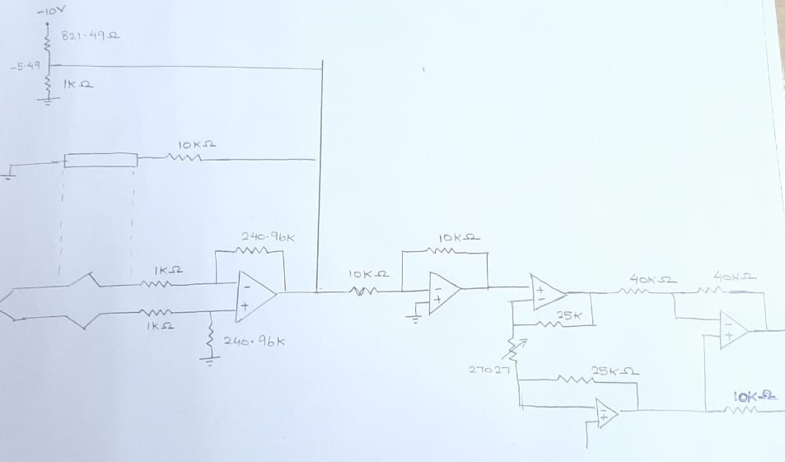

**Case 2: REFORMING OF NATURAL GAS (750 to 900 C)**

V(750) = 31.213 mV

V(900) = 37.326 mV

Aim output voltage ( 0 to 10V)

TMP = 10mV/C

Linear equation:

0= 0.031213M + Vc

10= 0.037326M+ Vc

Solving the equation we get

M=1635.8

Vc= -51.058

Vout = 1635.8Vtc- 51.058

Sensitivity S = (0.037326-0.031213)/(900-750)

S = 0.04075 mV/C

Compensation factor= TMP/S = 10/0.04075 = 242.378

Modified gain= 1635.8/245.378= 6.66

Vout = 6.66( 242.378 Vtc – 7.658 + Vcomm)

6.66 = 1 + (2*R1)/Rg

R1 = 25k

Solving for Rg we get

Rg = 8833.92

-7.658 = (1k/(R1+1k))*(-10)

Solving for R1 we get

R1= 305.82

R2/1k = 245.378

R2= 245.378k

With these values we can design the signal conditioning circuit given below

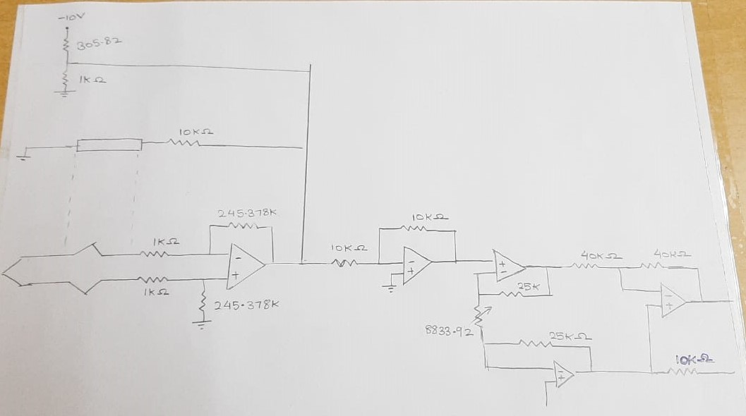

**Case 3: STEEL INDUSTRY (600 To 950 C)**

V(600) = 24.905 mV

V(950) = 39.314 mV

Aim output voltage ( 0 to 10V)

TMP = 10mV/C

Linear equation:

0= 0.024905M + Vc

10= 0.039314M+ Vc

Solving the equation we get

M=694.01

Vc= -17.284

Vout = 694.01Vtc- 17.284

Sensitivity S = (0.039314-0.024905)/(950-600)

S = 0.0411 mV/C

Compensation factor= TMP/S = 10/0.0411 = 242.90

Modified gain= 694.01/242.90= 2.857

Vout = 2.857( 242.90 Vtc – 6.049 + Vcomm)

2.857 = 1 + (2*R1)/Rg

R1 = 25k

Solving for Rg we get

Rg = 26925.14

-6.049 = (1k/(R1+1k))*(-10)

Solving for R1 we get

R1= 653.16

R2/1k = 242.90

R2= 242.90k

With these values we can design the signal conditioning circuit given below

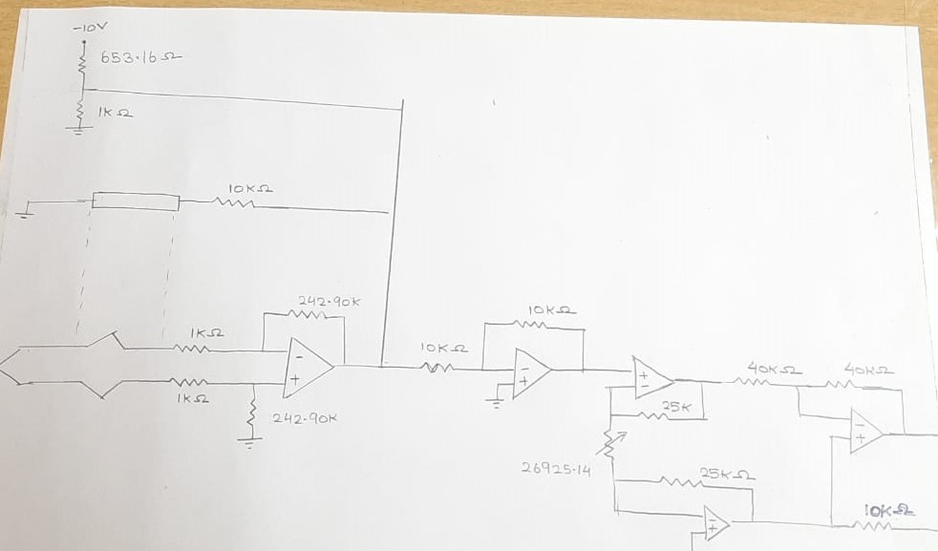

**Case 4: ETHYLENE PRODUCTION ( 650 to 900C)**

V(650) = 27.025mV

V(950) = 37.326mV

Aim output voltage ( 0 to 10V)

TMP = 10mV/C

Linear equation:

0= 0.027025M + Vc

10= 0.037326M+ Vc

Solving the equation we get

M=970.496

Vc= -26.227

Vout = 970.496Vtc- 26.227

Sensitivity S = (0.037326-0.027.025)/(900-650)

S = 0.0412 mV/C

Compensation factor= TMP/S = 10/0.0412 = 242.62

Modified gain= 970.496/242.62= 3.99

Vout = 3.99 ( 242.62Vtc – 6.556+ Vcomm)

3.99 = 1 + (2*R1)/Rg

R1 = 25k

Solving for Rg we get

Rg = 16722.40

-6.049 = (1k/(R1+1k))*(-10)

Solving for R1 we get

R1= 525.32

R2/1k = 242.90

R2= 242.62k

With these values we can design the signal conditioning circuit given below

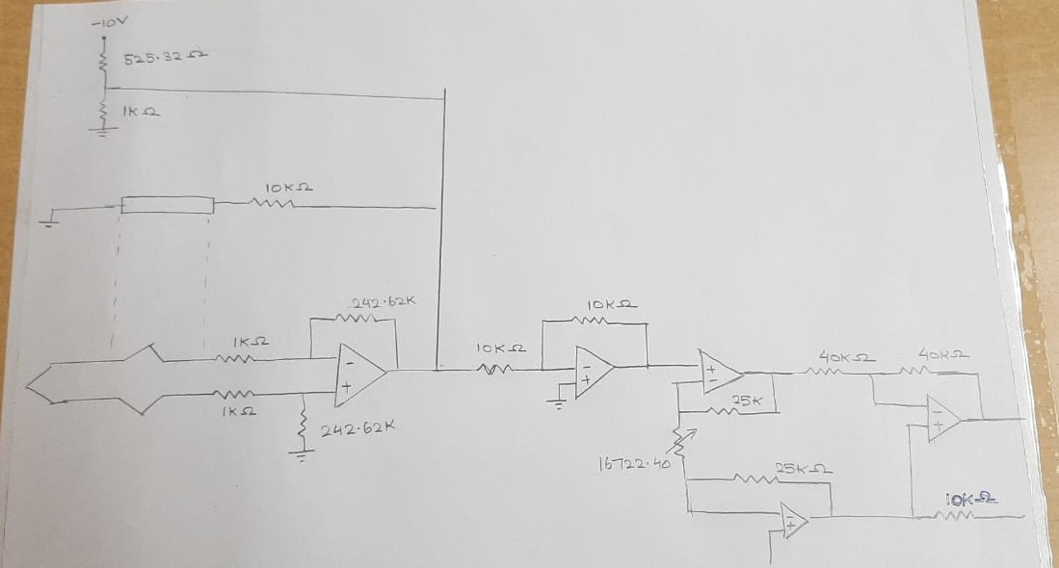

**Case 5: COAL PROCESSING (450 To 1000C)**

V(450) = 18.516mV

V(1000) = 41.276mV

Aim output voltage ( 0 to 10V)

TMP = 10mV/C

Linear equation:

0= 0.018516M + Vc

10= 0.041276M+ Vc

Solving the equation we get

M=439.36

Vc= -8.135

Vout = 439.36Vtc- 8.135

Sensitivity S = (0.041276-0.018516)/(1000-450)

S = 0.0413 mV/C

Compensation factor= TMP/S = 10/0.0413 = 242.13

Modified gain= 439.36/242.13= 1.813

Vout = 1.813( 242.13 Vtc – 4.487 + Vcomm)

1.813= 1 + (2*R1)/Rg

R1 = 25k

Solving for Rg we get

Rg = 61500.61

-4.487 = (1k/(R1+1k))*(-10)

Solving for R1 we get

R1= 1228.66

R2/1k = 242.13

R2= 242.13k

With these values we can design the signal conditioning circuit given below

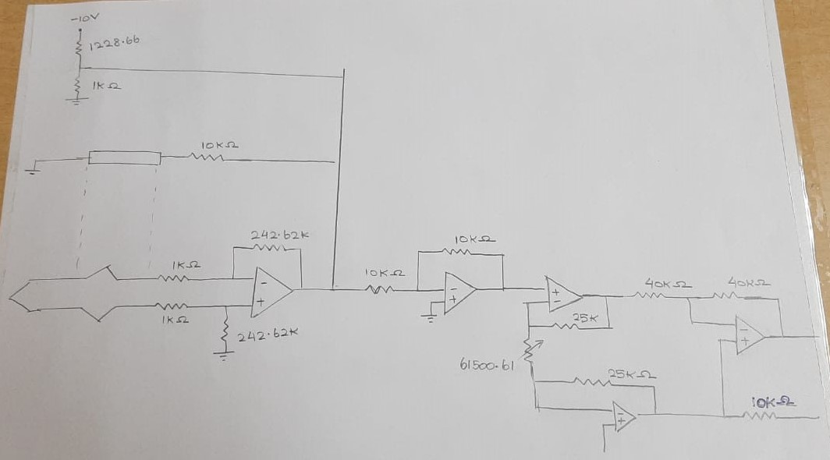

**4.3 SAMPLE DESIGN ON SOFTWARE TOOL**

We tabulated the values for all of the above-mentioned 5 situations using the software tool and obtained more accurate results, as shown below.

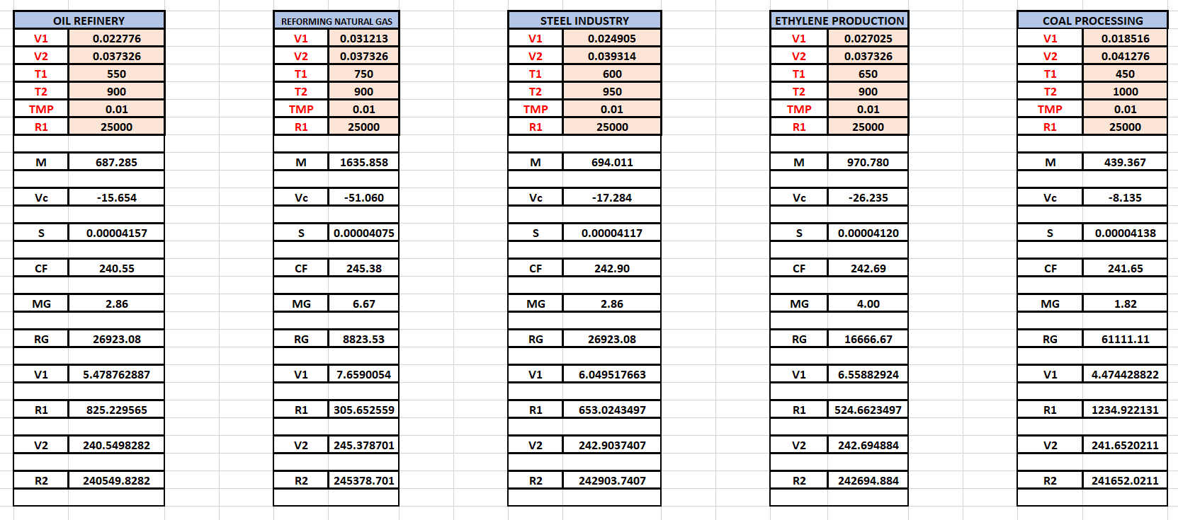

**REFERENCES**

* Q. WANG, Z. G. DONG, and D. W. CHEN. “Implement of High precision Temperature Acquisition System Based on CS5524,”Automation & Instrumentation, 2011, 26(5):58-60.
* Z. Q. Sun, J. M. Zhou , and H. J. Sun. “Uncertainty in the Temperature Measurement System Using Thermocouples,” Chinese Journal of Sensors and Actuators, 2007, 20(5):1061-1063.
* Z. H. Gao, X. P. Liu, and T. Zhan. “The research of tempration control system based on type-k thermocouple,” Machinery Design & Manufacture, 2011(4):7-9.
* Y. ZHANG, S. W. ZHANG. “A Design of High Accurate Temperature Measuring System Based on Platinum Resistance Transducers,” Chinese Journal of Sensors and Actuators, 2010, 23(3):311-314.
* M. J. Shi, H. Zhang, and D. Q. He. “Design of High Accurate Platinum Resistance Temperature Measurement System Based on LabVIEW,”2012, 20(4):924-925,938.
* J. H. CHENG, B. Qi, and C. B. Qu. “Design and realization of a multichannel temperature measurement system of high-precision and low self-heating,” Transducer and Microsystem Technologies,2014,33(1):56-60.
* Y. Qian, Y. M. TANG, and H. C. Yin. “The Design of a Temperature Collection System Based on CPLD,” Chinese Journal of Electron Devices, 2006, 29(2):546-549.
* G. Q. Liu, D. H. Tang, and X. W. Li. “Design of a High Accuracy Measuring-temperature System Based on AT89C51,” Chinese Journal of Scientific Instrument, 2005, 26(8):258-262
* Zhu, Weimin, Jin Liu, Haima Yang, and Chaochao Yan. "Design of high precision temperature measurement system based on LabVIEW." Int. J. Adv. Comput*.* Sci. Appl*.* 6 (2015): 153-5.

**APPENDICES**

APPENDIX 1

