**Data Modeling**

A Logical data model is the version of data model that represent the business requirements of an organization and is developed before the physical data model. Logical Data Model include all require entities, attributes, key, groups and relationship that represent business information and define business rules.

Data Model is prepared by the systems architect or by a Senior Developer / Lead Developer. Data model is prepared only once the project scope is finalized.

Logical Data Model (Entity Level)

|  |  |  |
| --- | --- | --- |
| **Responsible Parties** | | |
| **Prepared By** | **Department/Group** | **Phone Number** |
| Sanjay Tamboli | Java development | 8141234784 |
| **Internal Contributors** | **Department/Group** | **Phone Number** |
|  |  |  |
| **External Contributors** | **Vendor/Organization** | **Phone Number** |
|  |  |  |

|  |  |  |  |  |
| --- | --- | --- | --- | --- |
| **Change Control Form** | | | | |
| **Version** | **Date** | **Description of Change(s)** | **Change By** | **Approval Date** |
|  |  |  |  |  |

**Example of Logical Data Model:**

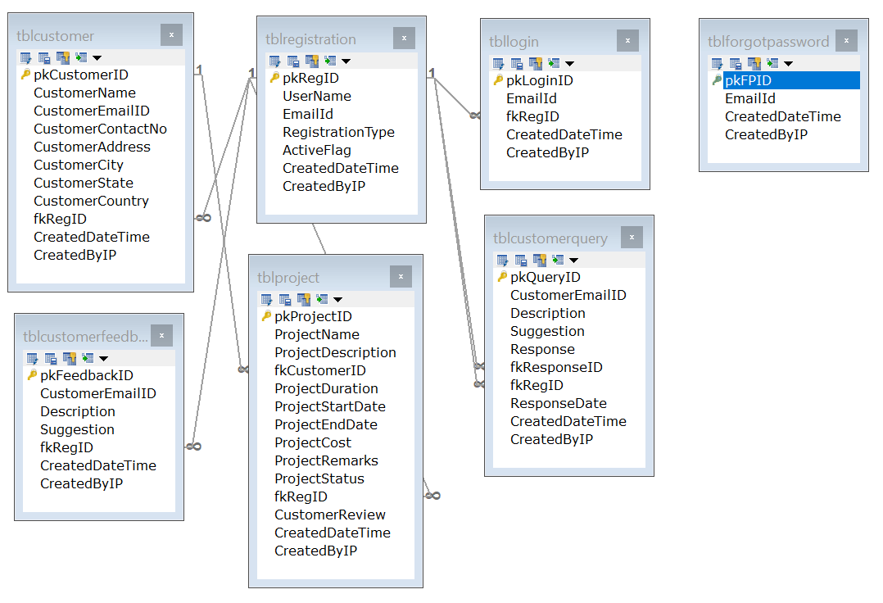

In this example, TOPS Technologies team has created a logical mapping for Customers, their project. It also reflects the structure of each table.