Activity Diagram Template

Activity Diagram

Activity Diagrams are prepared by either the Systems Analyst or Lead Developer. Activity diagrams are graphical representations of workflows of stepwise activities and actions with support for choice, iteration and concurrency. In the Unified Modeling Language, activity diagrams can be used to describe the business and operational step-by-step workflows of components in a system. An activity diagram shows the overall flow of control. Activity diagrams show the flow of activities through the system. Diagrams are read from top to bottom and have branches and forks to describe conditions and parallel activities. A fork is used when multiple activities are occurring at the same time. The diagram below shows a fork after activity.

**Business Development Executive Module**

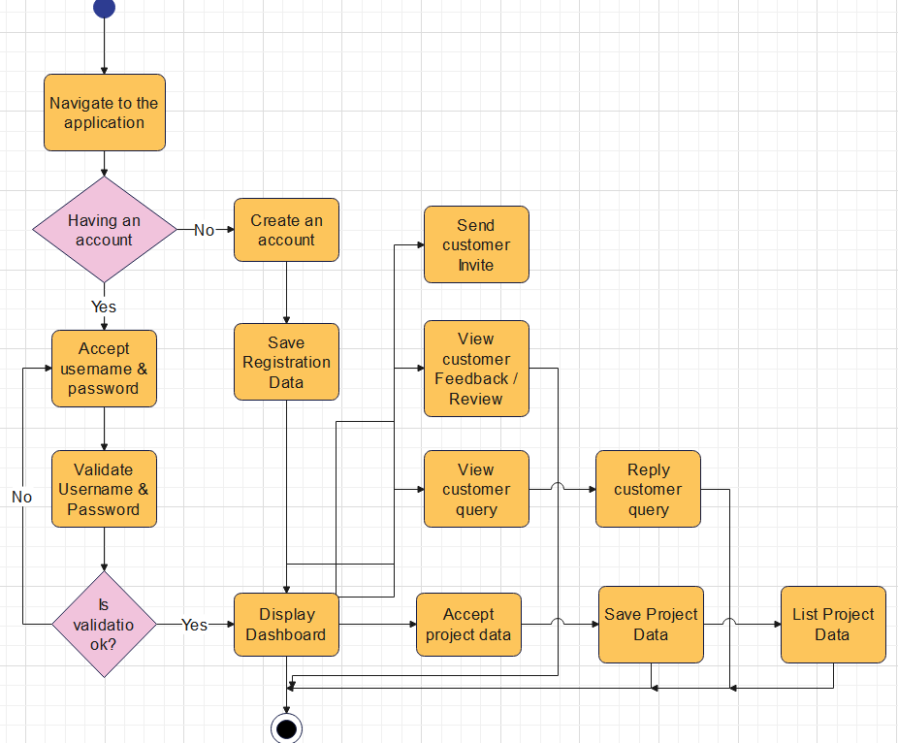

**Customer Module**

