A PROJECT REPORT
On
BUSINESS INTELLIGENCE SYSTEM
Submitted in partial fulfillment of the
Requirements for the degree of
BACHELOR OF TECHNOLOGY
In
Information and Communication Technology

Submitted by
117014094 – Sree Vidya.S



Under the Guidance of
Kumarashanmugam Balakrishnan
iNautix Technologies
April 2017

Acknowledgement
I would forever remain grateful tohonorable Prof. R. Sethuraman, Vice Chancellor for his encouragement in my academic life at SASTRA University.
I wish to express my profound gratitude toDr. S. Vaidhyasubramaniam, Dean - Planning & Development, Dr. S. Swaminathan, Director CeNTAB and Prof. G. Bhalachandran, Registrar for their overwhelming support provided during my course span in SASTRA University.
I am extremely thankful to Dr. K.S. Ravichandran, Associate Dean, Department of Information and Communication Technology for providing me the opportunity to do this project and for all the academic help extended in my project.
I sincerely express my gratitude to my manager Mr. Padmaraj Ramachandran and my team mentor Mr. Ramasubramanian Balasubramanian, iNAUTIX TECHNOLOGIES INDIA PVT LTD for their assistance and guidance for the successful implementation of project in a systematic and professional manner. I also express my gratitude to my mentor Mr. Manikandan Kathireson, iNAUTIX TECHNOLOGIES INDIA PVT LTD for always guiding me in the right direction to complete my project.
I also thank all the Teaching and Non-teaching staff, and those who have directly or indirectly helped me by extending their moral support and encouragement for completion of this project.
I thank God Almighty and my parents for helping me procure such a challenging and interesting project, and in completing the same in due course without much difficulty.

SYNOPSIS

In industry huge volume of data gets generated out of business transactions over a period of time. Effective data management is regarded as a solution to mitigate the challenges of modern business. Businesses use information systems at all levels of operation to collect, process and store data. Management aggregates and disseminates this data in the form of customized reports to carry out the daily operations.

Every organization needs a Management Information System to consolidate data as per the requirements of the organization, store data in a database and apply Business Intelligence on top of it by performing various Analytics on the data. In a multi-national organization, where a lot of data is generated every second, there is a need for improvement in communication, controlling data traffic and transaction brought in by use of information processing.

The main aim of this project is to develop a Business Intelligence System (BIS) using Java/Spring and Angular JS. In BIS, the information is recognized as a major resource of cost and time. It is designed in such a way that it avoids information overload and provides immediate linkage to the system. It helps to automate and streamline reporting. It produces dynamic reports based on data extracted and summarized from the organization’s underlying transaction processing systems.

TABLE OF CONTENTS

Chapter No. | TITLE | Page Number
1. | Introduction | 1
2. | Literature Review | 3
3. | System Configurations | 5
4. | System Analysis and Design | 6
5. | Implementation | 9
6. | Output Snapshots | 21
7. | Conclusion | 24
8. | References | 25

1.INTRODUCTION
1.1 INTRODUCTION TO THE COMPANY – iNAUTIX

1.1.1 INTRODUCTION
iNautix Technologies India Private Limited is a group company of Bank of New York Mellon - a leading financial services provider. iNautix provide technology development, business & technology operations and remote infrastructure management services for BNY Mellon and its subsidiaries. iNautix also develops and delivers comprehensive technology solutions and software development products for customers of BNY Mellon.

1.1.2 FOUNDERS
The Bank of New York Mellon was founded by Alexander Hamilton in 1784. Gerald Hassell is an American bank executive and is the Chairman and CEO of the Bank of New York Mellon from 2011. Suresh Kumar is the CEO of iNautix Technologies.

1.1.3 ABOUT COMPANY
iNautix Technologies, established in the year 2000,provides technology solutions to BNY Mellon. As an innovation-focused company, iNautix specializes in providing insightful and new age technology solutions to help meet clients' business needs end-to-end. Since its inception in 2000, iNautix has maintained a relentless commitment to develop products and solutions that are designed to improve operational efficiencies, make planning more dynamic and realistic, monitoring and evaluation simple, risk-free and methodical, increase productivity, enhance delivery performance and ensure success for our clients.

1.2 BACKGROUND OF THE PROJECT

1.2.1 OBJECTIVE
The ultimate aim is to develop a Business Intelligence System which will be effective for consolidation of data as per the requirements of the organization, store data in a database effectively and apply Business Intelligence to analyse the data.
1.2.2 OVERVIEW
Business Intelligence System is an application that is basically a management information system(MIS) coupled with business analytics. Based on the type of data inserted and the filter condition set by the user , analysis is done on the data and reports are generated.
The key stages of a BIS are :
- Data Sourcing
- Data Storage
- Data Analysis and
- Report Generation.
BIS enables efficient data storage and makes data management easy to handle. Business logic of the project is designed in such a way that it handles huge amount of data coming in through any number of files.
The data inside the database can be viewed through graphs, charts and also be exported into Excel sheets to view it in a consolidated manner. To analyze data , there is a provision given for the users to set the filter criteria to view only those records that match the criteria.
To get a specific view of the database , filters can be set to display few columns. BIS enables searching, sorting to be performed swiftly without any delay because of the usage of Spring and AngularJS.

2. LITERATURE REVIEW

2.1 EXISTING SYSTEM AND LIMITATIONS
The existing java application is a simple static application. It was a console-based application. Limitations of the existing system are:
- It did not involve user interfaces and hence was less user-friendly.
- Users with technical knowledge only were comfortable in working with it as it was a console-based application
- No proper error-handling mechanisms were used.
- If the user has given a wrong input, the program is to be run all over again.
- All the inputs that were given from the start, till the suspension stage has to be re-done again.
- There was not any feature that facilitated user to view the data in a graphical format or pictorial format.
- It contained huge lines of code.
- Its complexity was very high and hence, was very time-consuming.

2.2 PROPOSED SYSTEM

The major goal is to convert the static application into interactive dynamic application with better user interface. The goal is to create interactive, user-friendly application to upload data into the database and to view the data as per the user-given filter criteria. To develop an application that is:
- A RESTful Spring based java application.
- A Maven project that contains dependencies hardcoded inside a user-defined Project Object Model (POM) XML file.
- Apache POI is injected and is used to read data from database and generate Excel files from database.
- Data from multiple files are merged and inserted into a single database based on a primary key.
- HTTP commands are used to get data, put data, delete and update data to and from the database.
- Backend JAVA objects are converted into JSON for displaying in the front end.
- Enable filters to view the data in a way that is required for the users , hence reducing complexity during analysis.
- Low cost and reduced complexity as a result of injecting dependencies thus, encouraging code reusability.

3.SYSTEM CONFIGURATION

3.1 HARDWARE CONFIGURATION
Operating System: Windows 7 Enterprise
Installed Ram : 8 GB
Processor : Intel(R) Core(TM) CPU @ 3.20GHz

3.2 SOFTWARE CONFIGURATION
Software Version
Eclipse Kepler 4.3
HTML 5
CSS 3
AngularJS 1.9.1
jQuery 2.1.1
JavaScript 4.1.5

4.SYSTEM ANALYSIS AND DESIGN
4.1 SYSTEM ANALYSIS AND DESIGN
Systems development is systematic process which includes phases such as planning, analysis, design, deployment, and maintenance. System analysis is done to study the system to learn about its requirements. System design is the process of designing the models for the project using UML.
The purpose of OO analysis and design can described as:
- Identifying the objects of a system.
- Identify their relationships.
- Make a design which can be converted to executables using OO languages.
There are three basic steps where the OO concepts are applied and implemented. The steps can be defined as :
Object Oriented Analysis --> Object Oriented Design --> Object Oriented Implementation.

4.1.1 HIGH LEVEL DESIGN
UML stands for Unified Modeling Language. UML is a standard language for specifying, visualizing, constructing, and documenting the artifacts of software systems. In other words, it is often described as the successor of object oriented design and analysis.
The goal is for UML to become a common language for creating models of object oriented computer software. UML diagrams are not only made for developers but also for business users, common people and anybody interested to understand the system. The UML uses mostly graphical notations to express the design of software objects.

4.3 UML DIAGRAMS
4.3.1 USE CASE DIAGRAM
The purpose of use case diagram is to capture the dynamic aspect of a system. Use Case Diagrams are used to gather those requirements that influence the system internally and externally. They are most often requirements related to design. Therefore, when a system is studied to understand and gather its functionalities uses cases are constructed.
Here, the user is the only actor and thus, user's use-cases are as shown below :

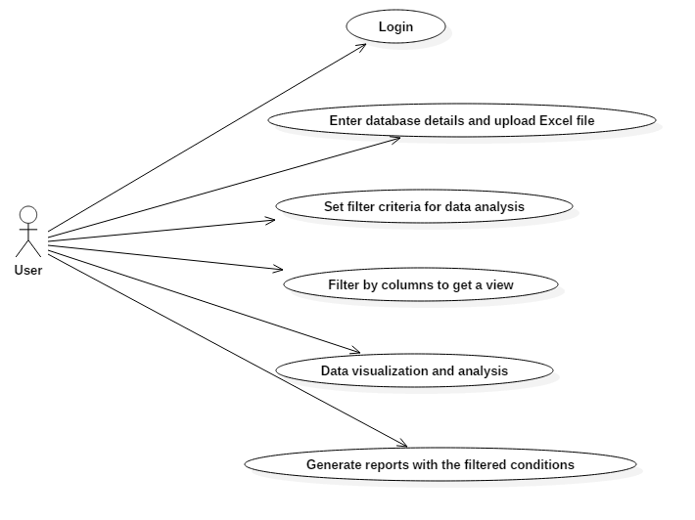

4.3.2 SEQUENCE DIAGRAMS
A sequence diagram is an interaction diagram that shows how objects operate with one another. A sequence diagram shows object interactions arranged in time sequence. It depicts the objects and classes involved in the scenario and the sequence of messages exchanged between the objects needed to carry out the functionality of the scenario.
A sequence diagram shows, as parallel vertical lines (lifelines), different processes or objects that live simultaneously, and, as horizontal arrows, the messages exchanged between them, in the order in which they occur. This allows the specification of simple runtime scenarios in a graphical manner.
Here , the user, business intelligence portal and database access layer are the 3 entities that interact with each other depicting use cases.

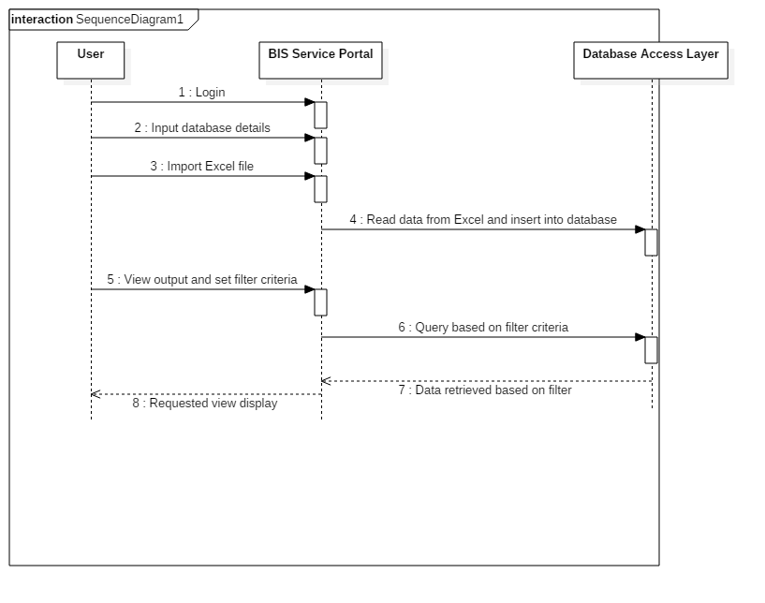

5.IMPLEMENTATION

5.1 PROBLEMS FACED
The process of development of any application involves certain issues which might be encountered in any of the various stages of the software development life cycle.

During development phase the problems that arose were:
- Issues in merging the excel files.
- Data in few columns were invalid.
- Mismatch in the data-types of the columns in database and excel file.

5.2 TECHNOLOGIES USED :
5.2.1 SPRING
Spring is a lightweight framework. It provides support to various frameworks such as Struts, Hibernate, EJB, etc. The framework, in broader sense, can be defined as a structure where we find solution of the various technical problems.
The Spring framework comprises several modules such as IOC (Inversion Of Control), AOP (Aspect-Oriented Programming), DAO (Data Access Object), Context, ORM (Object Relational Mapping), WEB MVC (Model View Controller), etc.
Spring helps to develop applications easily and allows dependency injection. Due to dependency injection, the code is loosely coupled thereby, reducing complexity.
The deployment descriptor i.e web.xml file loads first when the server loads and the xml file contains code for hooking up the dispatcher servlet which is responsiblefor hooking up the xml file that contains the configuration information or schema information to hook up the spring framework.
The web.xml file contains :
<web-app id = "WebApp_ID" version = "2.4"
xmlns = "http://java.sun.com/xml/ns/j2ee"
xmlns:xsi = "http://www.w3.org/2001/XMLSchema-instance"
xsi:schemaLocation = "http://java.sun.com/xml/ns/j2ee
http://java.sun.com/xml/ns/j2ee/web-app_2_4.xsd">
<display-name>Business Intelligence System</display-name>
<servlet>
<servlet-name>BIS</servlet-name>
<servlet-class>
org.springframework.web.servlet.DispatcherServlet
</servlet-class>
<load-on-startup>1</load-on-startup>
</servlet>
Spring.xml contains schema information to hook up the spring framework :
<beans xmlns="http://www.springframework.org/schema/beans"
xmlns:mvc="http://www.springframework.org/schema/mvc"
xmlns:xsi="http://www.w3.org/2001/XMLSchema-instance"
xmlns:aop="http://www.springframework.org/schema/aop"
xmlns:context="http://www.springframework.org/schema/context"
xsi:schemaLocation="http://www.springframework.org/schema/beans
http://www.springframework.org/schema/beans/spring-beans.xsd
http://www.springframework.org/schema/context
http://www.springframework.org/schema/context/spring-context.xsd
http://www.springframework.org/schema/mvc
http://www.springframework.org/schema/mvc/spring-mvc.xsd
http://www.springframework.org/schema/aop
http://www.springframework.org/schema/aop/spring-aop.xsd">
The beans can be configured after this for autowiring and aspect-oriented programming.

5.2.2 ARCHITECTURE OF SPRING FRAMEWORK
Architecture of Spring framework :
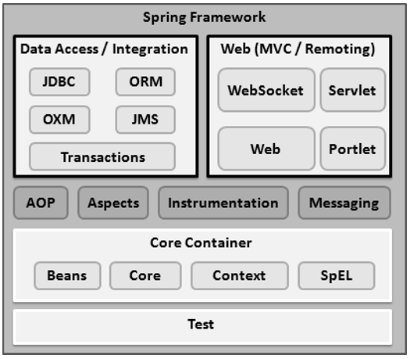
Figure 1 : Spring Framework Architecture

Spring framework provides 20 modules which can be used as per requirements of the application. The modules are broadly classified into 4 categories namely,
- The Core Container consists of the Core, Beans, Context, and Expression Language modules.
- The Data Access/Integration layer consists of the JDBC, ORM, OXM, JMS and Transaction modules.
- The Web layer consists of the Web, Web-MVC, Web-Socket, and Web-Portlet modules.
- The Miscellaneous layer which consists of the other important modules like ,
- Aspect-Oriented Programming
- Aspects
- Instrumentation
- Messaging and ,
- Testing.
- The above stated modules help in reducing the complexity of the code and makes testing easier for the QA team.

5.2.3 SPRING MVC
The Spring Web MVC framework provides Model-View-Controller (MVC) architecture. The MVC pattern results in separating the different aspects of the application (input logic, business logic, and UI logic), while providing a loose coupling between these elements.
- The Model encapsulates the application data and in general they will consist of POJO (Plain Old Java Object).
- The View is responsible for rendering the model data and in general it generates HTML output that the client's browser can interpret.
- The Controller is responsible for processing user requests and building an appropriate model and passes it to the view for rendering.

5.2.3.1 DISPATCHER SERVLET
Spring MVC uses Dispatcher Servlet for processing. Dispatcher Servlet class works as the front controller. It is responsible to manage the flow of the spring MVC application. It is used to handle all HTTP requests and responses.
Since it is integrated with Spring IOC container , it allows access to every feature that Spring has.
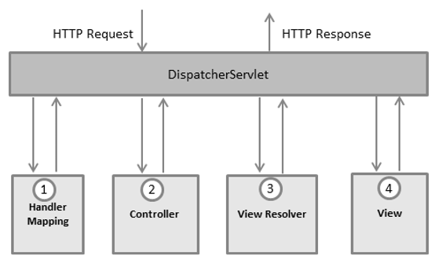
Figure 2 - Processing Workflow of Spring MVC

5.2.4 DEPENDENCY INJECTION
In Spring framework, dependencies are injected into the code with the help of pom.xml file. Dependencies are nothing but, jar files that reuses code. This helps in simplifying the code. Developers build the code and deploy it into an archive file thereby, making it reusable by other developers. These jars when specified with versions will be downloaded dynamically from the maven dependencies in XML file.

5.2.5 POI LIBRARY
Apache POI is a popular API that allows programmers to create, modify, and display MS Office files using Java programs. It contains classes and methods to decode the user input data or a file into MS Office documents.
It contains many components, out of which two are used to handle with Excel files:
- HSSF (Horrible SpreadSheet Format) ,used to read .xl format of Excel files.
- XSSF (XML SpreadSheet Format), used to read .xlsx format of Excel files.
POI library also helps in generating excel sheets with the data retrieved from the database.

5.2.6 JDBC TEMPLATE
Spring JdbcTemplate is a powerful mechanism to connect to the database and execute SQL queries. It takes care of creation and release of resources such as creating and closing of connection object. It handles the exception by the help of exception classes defined in the org.springframework.dao package.
We can perform all the database operations by the help of JdbcTemplate class such as insertion, updating, deletion and retrieval of the data from the database.
5.2.7AUTOWIRING
POJO, also known as bean contain the getters and setters of the attributes of a class. Beans can be initialized in XML files, thus avoiding the 'new' keyword in java program. This method uses memory efficiently.
Another method to allot memory for bean objects is by using REST API annotation '@Autowired'. This annotation helps to inject object dependency implicitly. It internally uses constructor or setter injection. There are many autowiring modes namely,
- byName
- byType
- constructor
- auto detect
5.2.8 XML

XML stands for Extensible Markup Language that stores and transports data. It was designed in a way to be both human readable and machine readable. The configuration and schema information are given in these files to download jars dynamically at runtime such as pom.xml as follows:
<project
xmlns="http://maven.apache.org/POM/4.0.0" xmlns:xsi="http://www.w3.org/2001/XMLSchema-instance"
xsi:schemaLocation="http://maven.apache.org/POM/4.0.0 http://maven.apache.org/maven-v4_0_0.xsd">
<modelVersion>4.0.0</modelVersion>
<groupId>com.tra.api</groupId>
<artifactId>21Jun</artifactId>
<packaging>jar</packaging>
<version>0.0.1-SNAPSHOT</version>
<name>21Jun Maven Webapp</name>
<url>http://maven.apache.org</url>
<dependencies>
<dependency>
<groupId>junit</groupId>
<artifactId>junit</artifactId>
<version>3.8.1</version>
<scope>test</scope>
</dependency>
<dependency>
<groupId>org.springframework</groupId>
<artifactId>spring-web</artifactId>
<version>4.2.3.RELEASE</version>
</dependency>
<dependency>
<groupId>com.fasterxml.jackson.core</groupId>
<artifactId>jackson-core</artifactId>
<version>2.8.2</version>
</dependency>
<dependency>
<groupId>org.springframework</groupId>
<artifactId>spring-beans</artifactId>
<version>4.3.8.RELEASE</version>
</dependency>
<dependency>
<groupId>com.fasterxml.jackson.core</groupId>
<artifactId>jackson-databind</artifactId>
<version>2.8.8</version>
</dependency>
<dependency>
<groupId>org.springframework</groupId>
<artifactId>spring-webmvc</artifactId>
<version>4.3.8.RELEASE</version>
</dependency>
<dependency>
<groupId>org.apache.poi</groupId>
<artifactId>poi</artifactId>
<version>3.7</version>
</dependency>
<dependency>
<groupId>org.springframework</groupId>
<artifactId>spring-aop</artifactId>
<version>4.3.8.RELEASE</version>
</dependency>
<dependency>
<groupId>log4j</groupId>
<artifactId>log4j</artifactId>
<version>1.2.17</version>
</dependency>
<dependency>
<groupId>org.springframework</groupId>
<artifactId>spring-context</artifactId>
<version>4.3.8.RELEASE</version>
</dependency>
<dependency>
<groupId>javax.servlet</groupId>
<artifactId>servlet-api</artifactId>
<version>2.4</version>
</dependency>
</dependencies>
<build>
<finalName>BIS portal</finalName>
</build>
</project>

5.2.8.1 SAX BUILDER

The org.jdom2.input.SAXBuilder class implements an interface called SAXEngine. SAXBuilder uses a third-party parser to perform the parsing duties. In the BIS application, SAXBuilder is used to parse XML files and builds a JDOM document.
Initially, SAXBuilder locates the third-party parser via JAXP, and then uses a set of drivers to build the documents. When the application is run in standalone mode, the inputs are taken from the XML files. To parse the XML file inputs, SAXBuilder is used.

5.2.9 APACHE LOG4J
The org.apache.log4j.Logger class is used for error handling in
the backend . Exceptions thrown during server's maintenance period or any other error during the execution of the program can be logged in the files that the developer specifies in the configurations file.
5.2.10 REST API
Representational state transfer (REST) or RESTful Web services are one way of providing interoperability between computer systems on the internet.In a RESTful Web service, requests made to a resource's URI will elicit a response that may be in XML, HTML, JSON or some other defined format. Using HTTP, as is most common, the kind of operations available include those predefined by the HTTP verbs GET, POST, PUT, DELETE and so on. By making use of a stateless protocol and standard operations, REST systems aim for fast performance, reliability, and the ability to grow, by re-using components that can be managed and updated without affecting the system as a whole, even while it is running.
The RESTful web service controller simply returns the object and the object data is written directly to the HTTP response as JSON/XML.

5.2.11 ANNOTATIONS
Annotation injection is performed before XML injection. Thus, the latter configuration will override the former for properties wired through both approaches.
Annotation wiring is not turned on in the Spring container by default. In the spring configuration xml file , the following has to be added :
<context:annotation-config/>

@RESPONSEBODY
When the @ResponseBody annotation is used on a method, Spring converts the return value and writes it to the http response automatically. Each method in the Controller class must be annotated with @ResponseBody.

@RESTCONTROLLER
Spring 4.0 introduced @RestController, a specialized version of the controller which is a convenience annotation that does nothing more than add the @Controller and @ResponseBody annotations. By annotating the controller class with @RestController annotation, you no longer need to add @ResponseBody to all the request mapping methods. The @ResponseBody annotation is active by default.

5.2.12 JAVASCRIPT
JavaScript is a high-level, dynamic, light-weight programming language. It is used to execute just-in-time dynamic inputs from the front end. It uses the concept of DOM(Document Object Model). It helps developers to develop rich interfaces with minimal server interactions. There are many advanced versions of JavaScript of which Angular JS is commonly used.

5.2.12.1 ANGULARJS
AngularJS is a JavaScript framework. It is a library written in JavaScript.
AngularJS is distributed as a JavaScript file, and can be added to a web page with a script tag:
<script src="https://ajax.googleapis.com/ajax/libs/angularjs/1.4.8/angular.min.js"></script>

AngularJS extends HTML with ng-directives:
- The ng-app directive defines an AngularJS application.
- The ng-model directive binds the value of HTML controls (input, select, and text-area) to application data.
- The ng-bind directive binds application data to the HTML view.
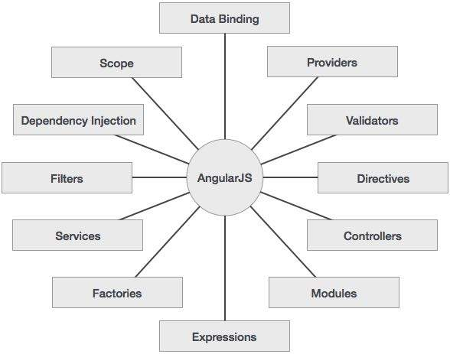
Figure 3 - Angular JS Concepts
- AngularJS provides capability to create Single Page Application in a very clean and maintainable way.
- AngularJS provides data binding capability to HTML thus giving user a rich and responsive experience
- AngularJS code is unit testable.
- AngularJS uses dependency injection and make use of separation of concerns.
- AngularJS provides reusable components.
- With AngularJS, developer write less code and get more functionality.
- In AngularJS, views are pure html pages, and controllers written in JavaScript do the business processing.
5.2.12.1.1 NG-TABLE DIRECTIVE
Ng-table directive enhances your HTML tables. It support sorting, filtering and pagination. Header row with titles and filters automatic generated. The package.json file contains the dependencies for the example. The content of package.json file are as follows:-
{
"name": "BISportal",
"version": "0.0.1",
"description": "BISportal",
"dependencies": {
"angular": "^1.4.4",
"bootstrap": "^3.3.5",
"ng-table": "^0.5.4"
}
}
The above json file loads the required code in the respective versions dynamically during execution.

6.OUTPUT SNAPSHOTS

6.1 INPUT PAGE

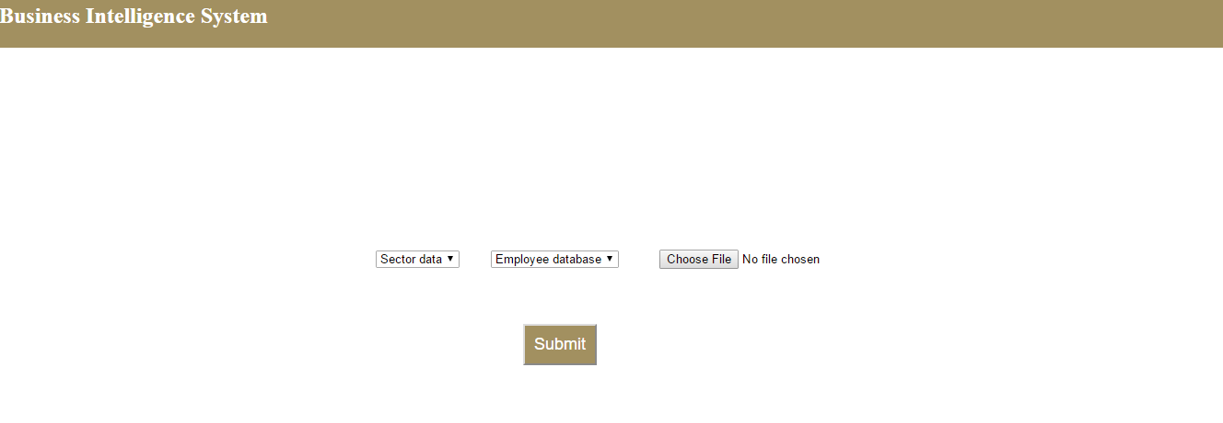

The input page where the data-type, database and the excel file is chosen.

6.2OUTPUT PAGE

When the Sector data is chosen as the data-type, this page gets displayed.

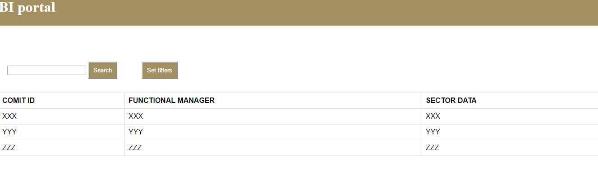

Associate Data- type :
When associate data is chosen as the data-type, this page is displayed :
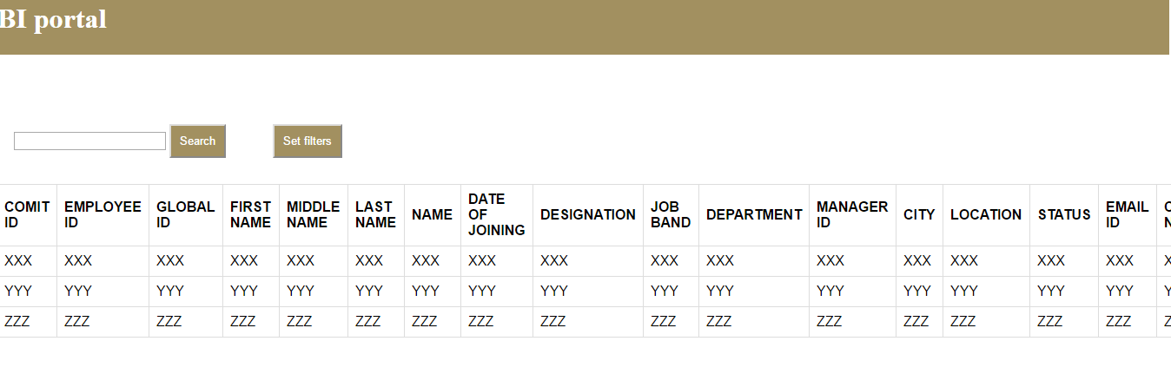

10.CONCLUSION

10.1 CONCLUSION
Thus, business intelligence system application has been developed using Spring framework, RESTful API and AngularJS. The application is designed to be a simple, user-friendly application that satisfied all the requirements of the user. The complexity was very low due to reusability of code through dependency injection thereby reducing execution time. AngularJS helped to improve the user interface experience by quick data access as the data objects were converted to JSON at runtime.
BIS is very helpful for data analysis and finding out data patterns. It is a lightweight application which can generate reports swiftly and dynamically.

10.2 FUTURE PLANS
Plans to be achieved in future is to create BIS application where
- Records can be displayed as a result of merging two or more databases;
- To improve reporting and analytical capabilities;
- Enterprise reporting
- Generating automated reports
- Databases configured to handle data efficiently
- Save frequently used queries in a data-structure for fast responses.

11.REFERENCES

- https://bnymellon-i.sabacloud.com/Saba/Webspf/leclassdetail.
- https://www.coursera.org/specializations/full-stack
- https://www.codecademy.com/learn/learn-angularjs
- http://htmlandcssbook.com/
- https://www.codecademy.com/learn/learn-java
- https://www.codecademy.com/learn/javascript
- https://spring.io/docs

